[doc sps="1.8" acron="abra" jtitle="Revista ABRA" stitle="Rev. ABRA" issn="1409-3928" pissn="1409-3928" eissn="2215-2997" pubname="Universidad Nacional, Costa Rica" license="http://creativecommons.org/licenses/by-nc-nd/3.0" volid="40" issueno="61" dateiso="20201200" season="July/Dec" order="01" fpage="01" lpage="22" pagcount="22" doctopic="oa" language="en"]DOI:[doi]10.15359/abra.40-61.1[/doi]
[toctitle]Artículo[/toctitle]

[doctitle language="en"]DYNAMIC ECONOMIC GROWTH: A NEW METHOD OF APPROACH[/doctitle]
[doctitle language="es"]CRECIMIENTO ECONÓMICO DINÁMICO: UN NUEVO MÉTODO DE ENFOQUE[/doctitle]

[author role="nd"][fname]Daniel[/fname] [surname]Villalobos Céspedes[/surname][/author]

[normaff id="aff1" ncountry="Costa Rica" norgname="Universidad Nacional" icountry="CR"][label]¹[/label] [orgdiv1]Escuela de Administración[/orgdiv1], [orgname]Universidad Nacional[/orgname], [country]Costa Rica[/country] [email]daniel.villalobos.cespedes@una.cr[/email][/normaff]

[xmlabstr language="en"][sectitle]Abstract[/sectitle]
[p]This paper looks at Harrod’s fundamental assumptions and equations in ‘An essay in dynamic theory’ as the foundation for suggesting a better understanding of his postulates on economic growth. The analysis we present attempts to measure the effects of resource composition on the field of economic growth by determining its elasticity and the coefficient of acceleration. By addressing new critical assumptions, key formulas, and methods of approach, some crucial findings provide a strong theoretical model with which to examine dynamic economic growth. Furthermore, this paper offers a brief review of Solow’s and Swan’s critiques of Harrod’s essay. This analysis could inspire further advances in the study of economic growth at the academic level and even in terms of government macroeconomic policies and business decisions.[/p][/xmlabstr]
[kwdgrp language="en"][sectitle]Keywords:[/sectitle] [kwd]Cobb and Douglas[/kwd]; [kwd]Keynes[/kwd]; [kwd]Harrod[/kwd]; [kwd]Domar[/kwd]; [kwd]Swan[/kwd]; [kwd]Solow[/kwd]; [kwd]Warranted/Natural rates of growth[/kwd]; [kwd]Effective/ Aggregated demands.[/kwd][/kwdgrp]

[xmlabstr language="es"][sectitle]Resumen[/sectitle]
[p]Esta investigación se basa en los supuestos y ecuaciones fundamentales de Harrod en ‘Un ensayo sobre teoría dinámica’ como núcleo central para sugerir una mejor comprensión de sus postulados sobre el crecimiento económico. El análisis que presentamos pretende medir los efectos de la composición de los recursos en el crecimiento económico determinando su elasticidad y el coeficiente de aceleración. Al abordar nuevos supuestos críticos, fórmulas clave y métodos de enfoque, hallazgos cruciales proporcionan un modelo teórico sólido para examinar el crecimiento económico dinámico. Además, esta investigación ofrece una breve revisión de las críticas de Solow y Swan a ese escrito de Harrod. Esta investigación podría inspirar mayores avances en el estudio del crecimiento económico al nivel académico e inclusive en términos de política macroeconómica de gobierno y decisiones empresariales.[/p][/xmlabstr]
[kwdgrp language="es"][sectitle]Palabras clave:[/sectitle] [kwd]Cobb and Douglas[/kwd]; [kwd]Keynes[/kwd]; [kwd]Harrod[/kwd]; [kwd]Domar[/kwd]; [kwd]Swan[/kwd]; [kwd]Solow[/kwd]; [kwd]Tasas de crecimiento requerido/natural: Demanda efectiva/agregada[/kwd][/kwdgrp].

[hist]Recibido: [received dateiso="20200210"]10/02/2020 [/received]
Aceptado: [accepted dateiso="20201111"]11/11/2020[/accepted][/hist]

[xmlbody][sec sec-type="intro"][sectitle]Introduction[/sectitle]

[p]To [xref ref-type="bibr" rid="r3"]Harrod (1939[/xref]) a dynamic theory necessarily involves thinking dynamically; it requires a mental revolution. His tentative and preliminary attempt is to “provide a framework of concepts relevant to the study of change” (p. 14). The axiomatic basis of his theory proposes that the level of a community’s income is the most important determinant of its supply of saving, that its rate of increase determines its demand for saving, and that both are equal. Harrod’s relevant concepts of warranted and natural rates of growth were questioned by [xref ref-type="bibr" rid="r6"]Solow (1956[/xref]) who understood that Harrod’s warranted concept is strictly related to full employment of the total labor force at each instant, which is not at all the case. In Harrod dynamic system, warranted means an unstable system, a system that oscillates, a moving equilibrium of advance, for which certain conditions are needed.[/p]
[p]In such a system, “the trend of growth may itself generate forces making for oscillation (…) maintaining a trend of increase” ([xref ref-type="bibr" rid="r3"]Harrod, 1939[/xref], p. 16) at a warranted rate; This author suggested that the value of capital goods (both fixed and circulating) “depends on the state of technology and the nature of the goods constituting the increment of output” but “not the whole of the new capital is destined to look after the increment of output of consumers’ goods” [xref ref-type="bibr" rid="r3"](Harrod, 1939[/xref], p. 17). The author begins his analysis by suggesting that producers are satisfied having produced neither more nor less than the right amount maintaining the same rate of growth. For it, “stock in hand and equipment available will be exactly at the level which they would wish to have them[xref ref-type="bibr" rid="r3"]” (Harrod, 1939[/xref], p. 22). In this quoted text the word ‘available’ means ‘able to be used’, ‘disposable’.[/p]
[p]By relaxing the ‘for the moment’ statement, it follows that there is no unique warranted rate; it depends upon the phase of the trade cycle and the level of activity and at full employment there exist a warranted rate ‘proper’ to the economy. Harrod’s dynamic theory is an attempt to answer [xref ref-type="bibr" rid="r5"]Keynes’s (1964[/xref], p. 4) following concern: “The question (...) of the volume of the available resources (…) has often been treated descriptively. But the pure theory of what determines the actual employment of the available resources has seldom been examined in great detail”. In view of foregoing, the main objective of this article is to provide a better understanding of Harrod’s dynamic theory by developing a new method of approach based on thinking in terms of trends of increase to reveal the divergence and/or convergence processes of natural and/or warranted rates of growth. [/p]
[p][xref ref-type="bibr" rid="r4"]Harrod (1960[/xref]) describes a dynamic theory as a set of relations between rates of increase (or decrease) of certain magnitudes, which, in turn, are thought of as laws expressing certain necessary relations. Based on this, we construct new formulas denoting relations between production, capital, labor and saving to achieve a new method of approach. The following two sections present the coefficient of acceleration and the resource composition dynamic to explain the natural and/or warranted trends of production growth. The concept of elasticity or velocity as it is relates to resource composition completes our fundamental theoretical model of economic growth which encompasses total, average and relative capital and labor contribution to production growth as well the role of saving in the capital accumulation process, as we propose in sections four and five.[/p]
[p]In his critique of [xref ref-type="bibr" rid="r3"]Harrod (1939[/xref]), [xref ref-type="bibr" rid="r6"]Solow (1956[/xref], p. 65) argued that “all theory depends on assumptions which are not quite true” and “a ‘crucial’ assumption is one on which the conclusions do depend sensitively, and it is important that crucial assumptions be reasonably realistic”. This allows us to analyze and discuss by briefly rethinking [xref ref-type="bibr" rid="r6"]Solow (1956[/xref]) and [xref ref-type="bibr" rid="r8"]Swan (1956[/xref])’s appraisal of [xref ref-type="bibr" rid="r3"]Harrod (1939[/xref]), which is the aim of section six. Finally, we state the conclusions and implications.[/p]

[subsec][sectitle]Natural and Warranted Growth Rate[/sectitle]

[p][xref ref-type="bibr" rid="r3"]Harrod (1939[/xref]) suggested that [graphic href="?a01v40n61"]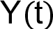[/graphic] is the existing level of income or output, so that [graphic href="?a01v40n61"]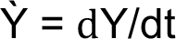[/graphic] expresses its increment and [graphic href="?a01v40n61"]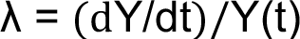[/graphic] is the actual rate of growth of Y(t), therefore:[/p]

[p][graphic href="?a01v40n61"]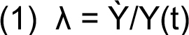[/graphic][/p]

[p]He also defined an average warranted rate of growth [graphic href="?a01v40n61"]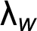[/graphic] which produces the right amount [graphic href="?a01v40n61"]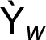[/graphic] at every point on the path of output:[/p]

[p][graphic href="?a01v40n61"]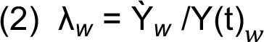[/graphic][/p]

[p]and [graphic href="?a01v40n61"][/graphic] would diverge from [graphic href="?a01v40n61"][/graphic] for random or seasonal causes. In total saving [graphic href="?a01v40n61"]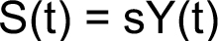[/graphic][graphic href="?a01v40n61"]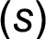[/graphic] “may be expected to vary, with the size of income, the phase of the trade cycle, institutional changes, etc.” ([xref ref-type="bibr" rid="r3"]Harrod, 1939[/xref], p. 16). At constant [graphic href="?a01v40n61"][/graphic], it follows that [graphic href="?a01v40n61"]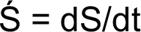[/graphic] and [graphic href="?a01v40n61"][/graphic] so that the growth of saving is equal to a fraction of the actual growth of income:[/p]

[p][graphic href="?a01v40n61"]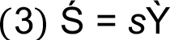[/graphic][/p]

[p]And for the warranted growth of output:[/p]

[p][graphic href="?a01v40n61"]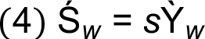[/graphic][/p]

[p]By equalizing equations (4) and (3), [graphic href="?a01v40n61"]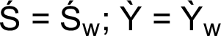[/graphic].[/p]

[p]Let [graphic href="?a01v40n61"]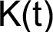[/graphic] stands for the value of capital goods (both circulating and fix capital) required for [graphic href="?a01v40n61"]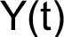[/graphic]. Let [graphic href="?a01v40n61"]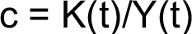[/graphic] be the actual average capital cost of production and when (c) remains constant, we can derive that [graphic href="?a01v40n61"][/graphic] this is “the value of the increment of capital stock in the period divided by the increment of total output” ([xref ref-type="bibr" rid="r3"]Harrod, 1939[/xref], p. 17) and if [graphic href="?a01v40n61"]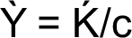[/graphic], per equation (1) [graphic href="?a01v40n61"]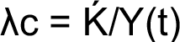[/graphic] and “depending on the proposition that actual saving in a period (…) is equal to the addition to the capital stock” (Harrod, 1939, p. 18) means that [graphic href="?a01v40n61"]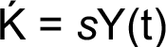[/graphic], and thus:[/p]

[p][graphic href="?a01v40n61"]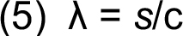[/graphic][/p]

[p]From equation (3) [graphic href="?a01v40n61"][/graphic] so [graphic href="?a01v40n61"]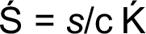[/graphic] and if [graphic href="?a01v40n61"]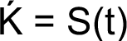[/graphic] then [graphic href="?a01v40n61"]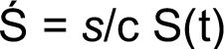[/graphic] and letting [graphic href="?a01v40n61"]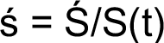[/graphic] be the rate of growth of saving:[/p]

[p][graphic href="?a01v40n61"]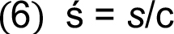[/graphic][/p]

[p]Thereby:[/p]

[p][graphic href="?a01v40n61"]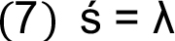[/graphic][/p]

[p]measures the amount of additional capital goods to the expected stock, then, where [graphic href="?a01v40n61"]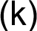[/graphic] is the rate of growth of capital, and thus from which:[/p]

[p][graphic href="?a01v40n61"]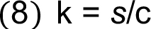[/graphic][/p]

[p]Linking this result to equation (5), [graphic href="?a01v40n61"]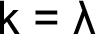[/graphic]; this revealed after replacing [graphic href="?a01v40n61"]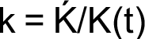[/graphic] in [graphic href="?a01v40n61"][/graphic]. So far Harrod’s assumptions explain by equations (5), (6) and (8) that in a dynamic and perhaps unstable economic system [graphic href="?a01v40n61"]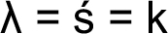[/graphic]is possible, where labor is assumed exogenous.[/p]
[p]In the warranted rate of growth, it is supposed that [graphic href="?a01v40n61"]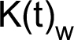[/graphic] and [graphic href="?a01v40n61"]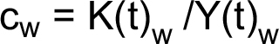[/graphic] and [graphic href="?a01v40n61"]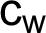[/graphic]remaining constant yields [graphic href="?a01v40n61"][/graphic] and[graphic href="?a01v40n61"]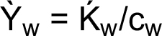[/graphic] per equation (2):[/p]

[p][graphic href="?a01v40n61"]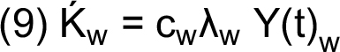[/graphic][/p]

[p]And if [graphic href="?a01v40n61"]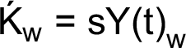[/graphic] it follows that:[/p]

[p][graphic href="?a01v40n61"]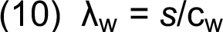[/graphic][/p]

[p]Defining [graphic href="?a01v40n61"][/graphic]as per equation (4) [graphic href="?a01v40n61"]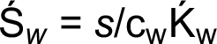[/graphic] and if [graphic href="?a01v40n61"]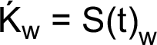[/graphic] then and let [graphic href="?a01v40n61"]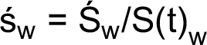[/graphic] be the warranted rate of growth of saving and to have:[/p]

[p][graphic href="?a01v40n61"]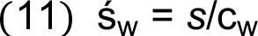[/graphic][/p]

[p]and from equation (5) it follows that:[/p]

[p][graphic href="?a01v40n61"]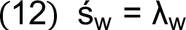[/graphic][/p]

[p]So warranted relative production growth could vary according to the warranted rate of saving growth. Furthermore [graphic href="?a01v40n61"]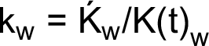[/graphic] so that [graphic href="?a01v40n61"]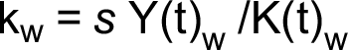[/graphic] is “conceived to vary with the current level of income, as distinct from its rate of growth” ([xref ref-type="bibr" rid="r3"]Harrod, 1939[/xref], p. 27):[/p]

[p][graphic href="?a01v40n61"]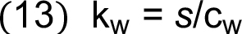[/graphic][/p]

[p]Per equations (13) and (10) [graphic href="?a01v40n61"]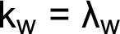[/graphic] and in a dynamic and perhaps unstable warranted economic system[graphic href="?a01v40n61"]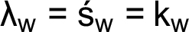[/graphic]. Equalizing equations (10) and (5) results in [graphic href="?a01v40n61"]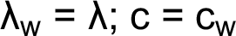[/graphic], which is Harrod’s fundamental equation, assuming “that all new capital goods are required for the sake of the increment of output of consumer’s goods accruing” (Harrod, 1939, p. 17). This assumption requires[graphic href="?a01v40n61"]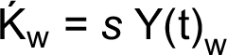[/graphic] at c=c w per equation (9) [graphic href="?a01v40n61"]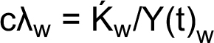[/graphic] and if [graphic href="?a01v40n61"]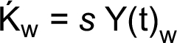[/graphic] then [graphic href="?a01v40n61"]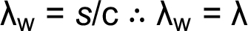[/graphic][/p]

[/subsec][subsec][sectitle]The Coefficient of Acceleration[/sectitle]

[p]Harrod’s warranted rate of growth is a subsystem at a given state of technology of the natural rate of growth system. Harrod’s assumption can be systematized by defining the multiplier coefficient; one component is:[/p]

[p][graphic href="?a01v40n61"]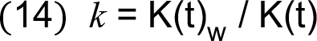[/graphic][/p]

[p]By replacing [graphic href="?a01v40n61"]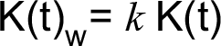[/graphic] in [graphic href="?a01v40n61"]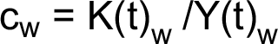[/graphic] it results in [graphic href="?a01v40n61"]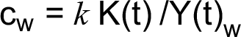[/graphic] and:[/p]

[p][graphic href="?a01v40n61"]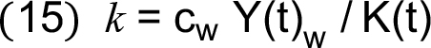[/graphic][/p]

[p]And [graphic href="?a01v40n61"][/graphic] and since [graphic href="?a01v40n61"]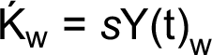[/graphic] and [graphic href="?a01v40n61"][/graphic] then:[/p]

[p][graphic href="?a01v40n61"]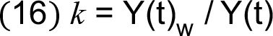[/graphic][/p]

[p]a counterpart of equation (14) showing how [graphic href="?a01v40n61"][/graphic]influences the rate of[/p]
[p]economic growth. In the case of saving [graphic href="?a01v40n61"]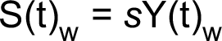[/graphic] and [graphic href="?a01v40n61"]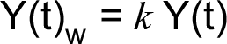[/graphic] so [graphic href="?a01v40n61"]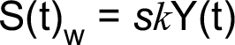[/graphic] and:[/p]

[p][graphic href="?a01v40n61"]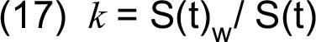[/graphic][/p]

[p]This is equivalent to equations (14) and (16).[/p]

[p]Natural/warranted rates of growth converge at [graphic href="?a01v40n61"]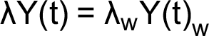[/graphic] and per equation (16):[/p]

[p][graphic href="?a01v40n61"]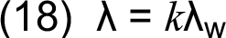[/graphic][/p]

[p]By matching equations (5) and (10) we get [graphic href="?a01v40n61"]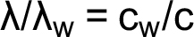[/graphic] and let [graphic href="?a01v40n61"]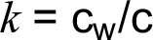[/graphic] stand for the counterpart of equation (14). Moreover,[graphic href="?a01v40n61"]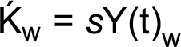[/graphic] it is equivalent to [graphic href="?a01v40n61"]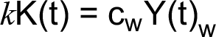[/graphic] so,[graphic href="?a01v40n61"]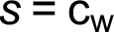[/graphic] thus warranted saving corresponds to warranted average capital contribution to warranted rate of production growth. In a dynamic economic system in which [graphic href="?a01v40n61"][/graphic] does not vary at a given instant, namely [graphic href="?a01v40n61"]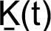[/graphic], from equation (14) [graphic href="?a01v40n61"]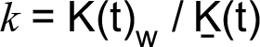[/graphic] and for sure [graphic href="?a01v40n61"]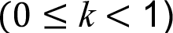[/graphic] and warranted growth rate is below the natural growth rate and it is a warranted ‘proper’ if full labor force employment is assumed. For this [graphic href="?a01v40n61"]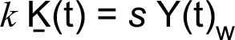[/graphic] and [graphic href="?a01v40n61"]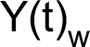[/graphic] tending to [graphic href="?a01v40n61"][/graphic] (e.g. for random or seasonal causes, the phase of the trade cycle, institutional changes) and [graphic href="?a01v40n61"]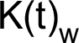[/graphic] is approaching [graphic href="?a01v40n61"]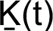[/graphic] and thus[graphic href="?a01v40n61"]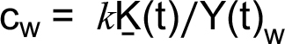[/graphic]; replacing in this expression [graphic href="?a01v40n61"]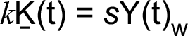[/graphic] results in[graphic href="?a01v40n61"]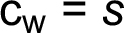[/graphic] and[graphic href="?a01v40n61"]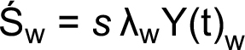[/graphic].[/p]
[p]Additionally, let us state that labor force [graphic href="?a01v40n61"]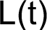[/graphic] is compounded by warranted employed [graphic href="?a01v40n61"]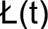[/graphic] and unemployed [graphic href="?a01v40n61"]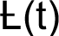[/graphic] labor force, to set that:[/p]

[p][graphic href="?a01v40n61"]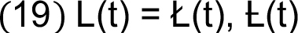[/graphic][/p]

[p]If [graphic href="?a01v40n61"]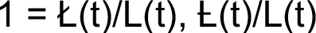[/graphic] the rate of warranted labor force is [graphic href="?a01v40n61"][/graphic]at a given instant. Then [graphic href="?a01v40n61"]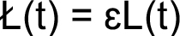[/graphic] and [graphic href="?a01v40n61"]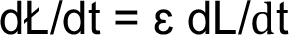[/graphic] so that [graphic href="?a01v40n61"]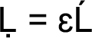[/graphic] and[graphic href="?a01v40n61"]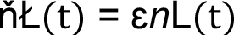[/graphic], where ([graphic href="?a01v40n61"]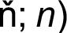[/graphic] (represent, in that order, the rates of growth of [graphic href="?a01v40n61"]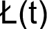[/graphic]and [graphic href="?a01v40n61"][/graphic]. At full employment [graphic href="?a01v40n61"]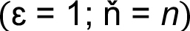[/graphic]hence [graphic href="?a01v40n61"]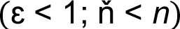[/graphic] exposes imbalanced market labor; [graphic href="?a01v40n61"]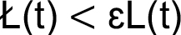[/graphic] . So, [graphic href="?a01v40n61"][/graphic] is the other component of the coefficient of acceleration.[/p]

[/subsec][subsec][sectitle]Resource Composition in Economic Growth[/sectitle]

[p]At [graphic href="?a01v40n61"]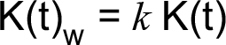[/graphic] and [graphic href="?a01v40n61"]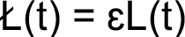[/graphic] the warranted resource composition at a given instant is:[/p]

[p][graphic href="?a01v40n61"][/graphic][/p]

[p]This denotes the line of moving equilibrium required for the inherent tendency of the system to instability, it is delineated by; [graphic href="?a01v40n61"]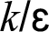[/graphic] the effective coefficient of acceleration of resource composition. By replacing [graphic href="?a01v40n61"]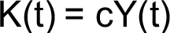[/graphic] in the previous equation we get:[/p]

[p][graphic href="?a01v40n61"][/graphic][/p]

[p]And [graphic href="?a01v40n61"][/graphic] appears to accelerate the average resources productivity; and [graphic href="?a01v40n61"]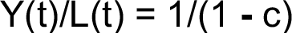[/graphic] thereby the prior equation becomes into [graphic href="?a01v40n61"]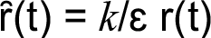[/graphic]. To better understand the above equation, it is necessary to specify the natural resource composition:[/p]

[p][graphic href="?a01v40n61"]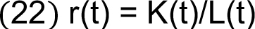[/graphic][/p]

[p]This equation is contained in equation (20) which simplified is [graphic href="?a01v40n61"]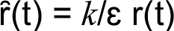[/graphic] and at [graphic href="?a01v40n61"]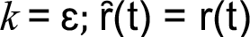[/graphic]; warranted and natural resource composition would converge. Taking the derivative of equation (21) in terms (t) of so that. Let [graphic href="?a01v40n61"]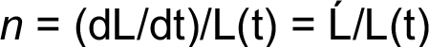[/graphic] be the rate of growth of labor and force [graphic href="?a01v40n61"]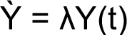[/graphic] and the rate of growth of production to have [graphic href="?a01v40n61"][/graphic][/p]

[p][graphic href="?a01v40n61"][/graphic][/p]

[p]and [graphic href="?a01v40n61"]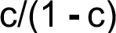[/graphic] describes the slope of [graphic href="?a01v40n61"]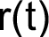[/graphic] and at determined instant [graphic href="?a01v40n61"]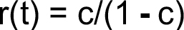[/graphic]. The fundamental equation of warranted resource composition and production growth rate emerges:[/p]

[p][graphic href="?a01v40n61"][/graphic][/p]

[p]It depicts the trend of [graphic href="?a01v40n61"]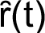[/graphic] at changes in [graphic href="?a01v40n61"]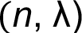[/graphic]; at [graphic href="?a01v40n61"]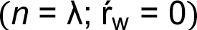[/graphic] it results in [xref ref-type="bibr" rid="r5"]Keynes’s (1964[/xref], p. 55) aggregate demand function, which “relates various hypothetical quantities of employment to the proceeds which their outputs are expected to yield”. At [graphic href="?a01v40n61"]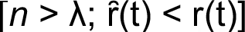[/graphic] increased unemployment of the labor force and potential economic growth is exhibited. If [graphic href="?a01v40n61"]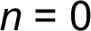[/graphic], r(t) remains the same [graphic href="?a01v40n61"]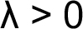[/graphic] and as long as both labor force and capital are available until they run out. It is denoted in this event that [graphic href="?a01v40n61"]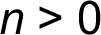[/graphic] represents increments in the number of workers required to restore retired workers. These results could be different at changes in [graphic href="?a01v40n61"][/graphic] induced by technological developments, among other circumstances; notable in the case that it makes [graphic href="?a01v40n61"]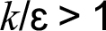[/graphic]and the economy becomes capital intensive. Under these conditions, (c) could diminish and [graphic href="?a01v40n61"]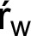[/graphic] could decline, but perhaps cushioned by augments in resource productivity [graphic href="?a01v40n61"][/graphic].[/p]
[p]Differentiating equation (20) with respect to results in [graphic href="?a01v40n61"][/graphic] so [graphic href="?a01v40n61"][/graphic] and given [graphic href="?a01v40n61"]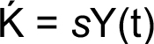[/graphic] and [graphic href="?a01v40n61"]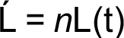[/graphic].[/p]

[p][graphic href="?a01v40n61"][/graphic][/p]

[p]Warranted resource composition follows the trajectory of natural resource composition at an acceleration at which capital requires a certain amount of labor and saving to yield a determined level of labor productivity. If increments in labor force cannot be employed at [graphic href="?a01v40n61"][/graphic] given [graphic href="?a01v40n61"]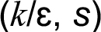[/graphic] , it could cause [graphic href="?a01v40n61"]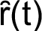[/graphic] to decline below [graphic href="?a01v40n61"][/graphic], revealing labor force unemployment and potential economic growth. From equation (25) two new outcomes are possible: the first showing that ceteris paribus labor contribution to production defines the slope of [graphic href="?a01v40n61"][/graphic] at each level of production; changes in ceteris paribus will cause oscillations of [graphic href="?a01v40n61"][/graphic] at [graphic href="?a01v40n61"][/graphic]:[/p]

[p][graphic href="?a01v40n61"][/graphic][/p]

[p]This shows that if [graphic href="?a01v40n61"]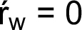[/graphic] then [graphic href="?a01v40n61"]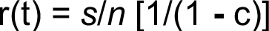[/graphic]. Given [graphic href="?a01v40n61"][/graphic] then:[/p]

[p][graphic href="?a01v40n61"][/graphic][/p]

[p]At [graphic href="?a01v40n61"][/graphic] and at[graphic href="?a01v40n61"]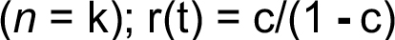[/graphic] which requires [graphic href="?a01v40n61"]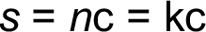[/graphic] and thus[graphic href="?a01v40n61"][/graphic]; it explains that ceteris paribus if [graphic href="?a01v40n61"]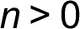[/graphic] inevitably [graphic href="?a01v40n61"]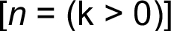[/graphic] to preserve [graphic href="?a01v40n61"][/graphic].[/p]

[p][graphic href="?a01v40n61"][/graphic].[/p]

[p]Suppose that [graphic href="?a01v40n61"]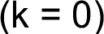[/graphic] at actual [graphic href="?a01v40n61"][/graphic] and as per equation (28) [graphic href="?a01v40n61"]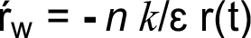[/graphic] and [graphic href="?a01v40n61"][/graphic] will fluctuate at [graphic href="?a01v40n61"][/graphic] ; due to [graphic href="?a01v40n61"][/graphic] then[graphic href="?a01v40n61"]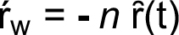[/graphic], explaining that actual [graphic href="?a01v40n61"][/graphic] might rise (decrease) as (n) varies and it could occur even if [graphic href="?a01v40n61"]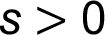[/graphic]. On the other hand, if ceteris paribus [graphic href="?a01v40n61"]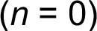[/graphic] equation (28) becomes [graphic href="?a01v40n61"][/graphic] and variations in (k) induce fluctuations of [graphic href="?a01v40n61"][/graphic] around [graphic href="?a01v40n61"][/graphic].1 The second result requires a definition of the production growth function, which is described in the following section.[/p]

[p]Let us introduce the above definition [graphic href="?a01v40n61"]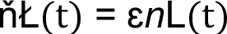[/graphic] after differentiating equation (20), to have:[/p]

[p][graphic href="?a01v40n61"][/graphic][/p]

[p][graphic href="?a01v40n61"]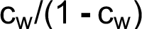[/graphic] is the slope of [graphic href="?a01v40n61"][/graphic] and [graphic href="?a01v40n61"]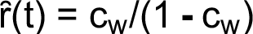[/graphic] at a given instant (t), hence:[/p]

[p][graphic href="?a01v40n61"][/graphic][/p]

[p]This is [xref ref-type="bibr" rid="r5"]Keynes’s (1964[/xref], p. 55) effective demand function, which is:[/p]

[quote]Simply the aggregate income (or proceeds) which the entrepreneurs expect to receive, inclusive of the incomes which they will hand on to the other factors of production, from the amount of current employment which they decide to give (…) the point on the aggregate demand function which becomes effective because, taken in conjunction with the conditions of supply, it corresponds to the level of employment which maximises the entrepreneur’s expectation of profit.[/quote]

[p]Matching equations (30) and (24), the possibility is shown for these two rates to coincide:[graphic href="?a01v40n61"]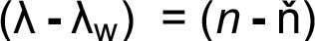[/graphic]and if in a specific point of time [graphic href="?a01v40n61"]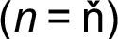[/graphic] then[graphic href="?a01v40n61"]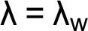[/graphic]. The rate [graphic href="?a01v40n61"]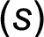[/graphic] plays a role in this point of equilibrium: inserting [graphic href="?a01v40n61"][/graphic] and [graphic href="?a01v40n61"]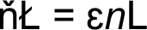[/graphic] into[graphic href="?a01v40n61"][/graphic] and after simplifying the result, [graphic href="?a01v40n61"][/graphic]and[graphic href="?a01v40n61"]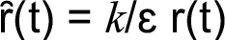[/graphic] in order for:[/p]

[p][graphic href="?a01v40n61"][/graphic][/p]

[p]Equalizing this equation with equation (26) and simplifying the result, [graphic href="?a01v40n61"][/graphic] and at[graphic href="?a01v40n61"][/graphic]; substituting this expression in equation (26) it is found that [graphic href="?a01v40n61"]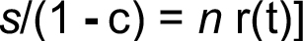[/graphic] and [graphic href="?a01v40n61"][/graphic]. In addition,[graphic href="?a01v40n61"][/graphic], which when replaced in the preceding definition gives [graphic href="?a01v40n61"][/graphic]. Similarly, [graphic href="?a01v40n61"]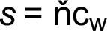[/graphic] so that equation (31) gives [graphic href="?a01v40n61"][/graphic] . If [graphic href="?a01v40n61"]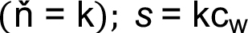[/graphic] and[graphic href="?a01v40n61"]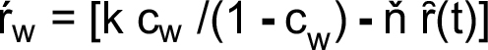[/graphic] then:[/p]

[p][graphic href="?a01v40n61"]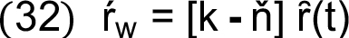[/graphic][/p]

[p]Once equations (32) and (28) are harmonized, [graphic href="?a01v40n61"][/graphic], hence:[/p]

[p][graphic href="?a01v40n61"][/graphic][/p]

[p]This equation elucidates the fundamental reasons why [graphic href="?a01v40n61"][/graphic] might fluctuate around [graphic href="?a01v40n61"]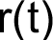[/graphic]; at [graphic href="?a01v40n61"]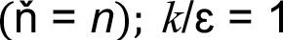[/graphic] it is unveiled that [graphic href="?a01v40n61"]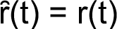[/graphic]; precisely at the point of warranted/natural rates of growth stability or at the equilibrium of effective aggregated demand functions, when [graphic href="?a01v40n61"][/graphic].[/p]

[/subsec][subsec][sectitle]Warranted and Natural Production Growth Function[/sectitle]

[p]This theoretical analysis suggests that Harrod’s dynamic economic growth basically combines capital goods namely [graphic href="?a01v40n61"]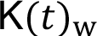[/graphic] and labor [graphic href="?a01v40n61"][/graphic] to provide a warranted level of production. The warranted production function might be:[/p]

[p][graphic href="?a01v40n61"][/graphic][/p]

[p]As per equation (20), the prior equation is transformed into:[/p]

[p][graphic href="?a01v40n61"][/graphic][/p]

[p]It defines the average warranted labor productivity at a given [graphic href="?a01v40n61"][/graphic];[graphic href="?a01v40n61"]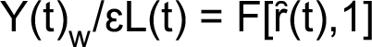[/graphic] the warranted average labor’s productivity curve and at [graphic href="?a01v40n61"][/graphic] then[graphic href="?a01v40n61"]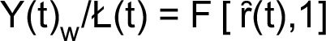[/graphic]:2[/p]

[p][graphic href="?a01v40n61"]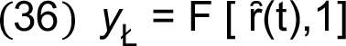[/graphic][/p]

[p]At [graphic href="?a01v40n61"][/graphic] function (35) turns into an effective warranted production function[graphic href="?a01v40n61"]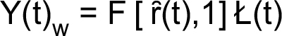[/graphic] whose derivative provides that [graphic href="?a01v40n61"][/graphic]which in terms of warranted[/p]
[p]average rate of labor’s productivity is:[/p]

[p][graphic href="?a01v40n61"]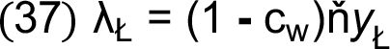[/graphic][/p]

[p]ceteris paribus [graphic href="?a01v40n61"]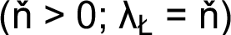[/graphic] capital’s and labor’s productivity remains the same.[/p]
[p]The derivative of function (32) in terms of [graphic href="?a01v40n61"]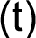[/graphic] gives:[/p]

[p][graphic href="?a01v40n61"]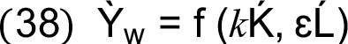[/graphic][/p]

[p]And if [graphic href="?a01v40n61"][/graphic] at a determined point of production processes, the previous function is [graphic href="?a01v40n61"]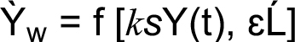[/graphic] and per equation (16) [graphic href="?a01v40n61"][/graphic] so that[/p]
[p]and since [graphic href="?a01v40n61"]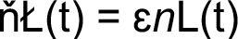[/graphic] then:[/p]

[p][graphic href="?a01v40n61"]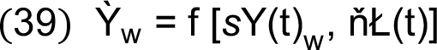[/graphic][/p]

[p]It follows that [graphic href="?a01v40n61"]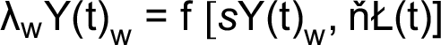[/graphic], so:[/p]

[p][graphic href="?a01v40n61"][/graphic][/p]

[p]At a warranted rate of growth, it is a condition [graphic href="?a01v40n61"][/graphic] which substituted in the above function, can be useful “when production takes place under the usual neoclassical conditions of variable proportions and constant returns to scale” ([xref ref-type="bibr" rid="r6"]Solow, 1956[/xref], p. 73):[/p]

[p][graphic href="?a01v40n61"][/graphic][/p]

[p]Let this be the warranted neoclassical condition, which is also Keynes’s effective demand; if[graphic href="?a01v40n61"]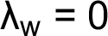[/graphic] in function (40) then [graphic href="?a01v40n61"]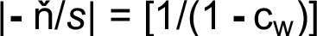[/graphic] and if [graphic href="?a01v40n61"][/graphic] then [graphic href="?a01v40n61"]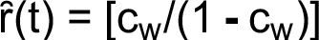[/graphic]. After inserting [graphic href="?a01v40n61"]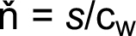[/graphic] in function (40) another result is: [graphic href="?a01v40n61"]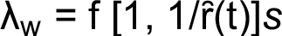[/graphic] where:[/p]

[p][graphic href="?a01v40n61"]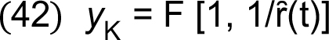[/graphic][/p]

[p]If [graphic href="?a01v40n61"]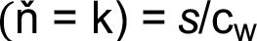[/graphic] then [graphic href="?a01v40n61"]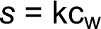[/graphic], so that:[/p]

[p][graphic href="?a01v40n61"]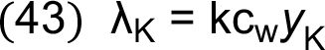[/graphic][/p]

[p]If [graphic href="?a01v40n61"][/graphic] the result will be [graphic href="?a01v40n61"]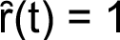[/graphic] and by equalizing equations (43) and (37)[graphic href="?a01v40n61"]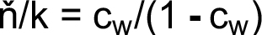[/graphic] where [graphic href="?a01v40n61"]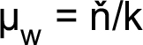[/graphic] is the elasticity or velocity of [graphic href="?a01v40n61"][/graphic], so that:[/p]

[p][graphic href="?a01v40n61"]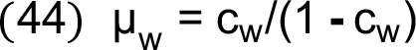[/graphic][/p]

[p]Now it is feasible to measure [graphic href="?a01v40n61"][/graphic] at each instant:[/p]

[p][graphic href="?a01v40n61"]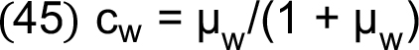[/graphic][/p]

[p]When production processes are labor intensive it occurs that [graphic href="?a01v40n61"]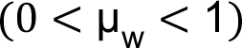[/graphic] and capital contribution to production growth could be lesser tan that of labor. In a capital-intensive production process [graphic href="?a01v40n61"]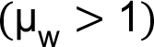[/graphic] and capital contribution will be greater than that of labor.[/p]

[p]When [graphic href="?a01v40n61"]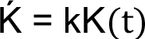[/graphic] function (38) reveals warranted production growth at both [graphic href="?a01v40n61"][/graphic] and [graphic href="?a01v40n61"][/graphic] levels: [graphic href="?a01v40n61"]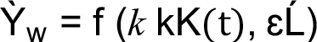[/graphic]. Also [graphic href="?a01v40n61"][/graphic] and, hence:[/p]

[p][graphic href="?a01v40n61"]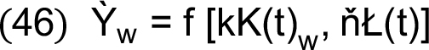[/graphic][/p]

[p]Equalizing this function with function (39) results in [graphic href="?a01v40n61"]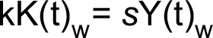[/graphic] which proves that [graphic href="?a01v40n61"][/graphic], as suggested before. Function (46) can also be expressed as [graphic href="?a01v40n61"]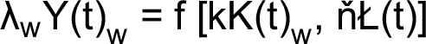[/graphic] and [graphic href="?a01v40n61"][/graphic] so that:[/p]

[p][graphic href="?a01v40n61"][/graphic][/p]

[p]This also arises from function (40) after substituting [graphic href="?a01v40n61"]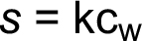[/graphic]. Multiplying both sides of that function by [graphic href="?a01v40n61"]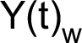[/graphic] results in[graphic href="?a01v40n61"][/graphic] and [graphic href="?a01v40n61"][/graphic] reveals total contribution of capital and labor to the value of [graphic href="?a01v40n61"]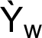[/graphic] For the additional capital it is:[/p]

[p][graphic href="?a01v40n61"]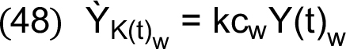[/graphic][/p]

[p]where [graphic href="?a01v40n61"]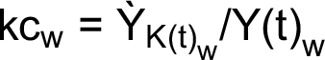[/graphic]and let [graphic href="?a01v40n61"]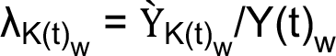[/graphic] be the average contribution of capital, so that:[/p]

[p][graphic href="?a01v40n61"]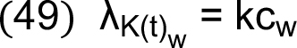[/graphic][/p]

[p]And the relative contribution is:[/p]

[p][graphic href="?a01v40n61"]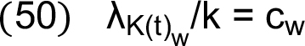[/graphic][/p]

[p]For the added labor total contribution is:[/p]

[p][graphic href="?a01v40n61"]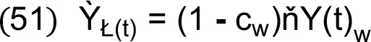[/graphic][/p]

[p]And [graphic href="?a01v40n61"]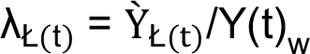[/graphic] is its average contribution, from which:[/p]

[p][graphic href="?a01v40n61"]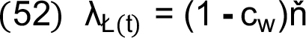[/graphic][/p]

[p]and its relative contribution is:[/p]

[p][graphic href="?a01v40n61"]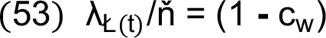[/graphic][/p]

[p]Per equations (49) and (52) which are equivalents of equations (43) and[/p]
[p](37), respectively, function (47) is redefined as:[/p]

[p][graphic href="?a01v40n61"]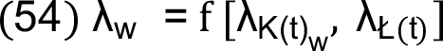[/graphic][/p]

[p]The warranted rate of growth is influenced by the fundamental conditions of the natural rate of growth. In function (38) [graphic href="?a01v40n61"][/graphic] and if [graphic href="?a01v40n61"][/graphic] and [graphic href="?a01v40n61"]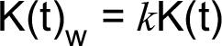[/graphic] then:[/p]

[p][graphic href="?a01v40n61"][/graphic][/p]

[p]This function makes visible the available capital and labor force effectively employed in a specific period of production. Per this new function [graphic href="?a01v40n61"][/graphic] and thus:[/p]

[p][graphic href="?a01v40n61"][/graphic][/p]

[p]This function is useful in depicting dynamic instability in the economic growth system due to the fact that [graphic href="?a01v40n61"]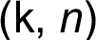[/graphic] are related to the natural increments of capital and labor force, and for this reason might reveal the unemployment of those available resources at [graphic href="?a01v40n61"][/graphic]. Suppose [graphic href="?a01v40n61"]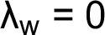[/graphic], so:[/p]

[p][graphic href="?a01v40n61"]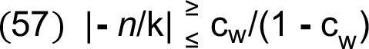[/graphic][/p]

[p]In this case [graphic href="?a01v40n61"]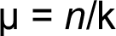[/graphic] is the elasticity or velocity of natural resource composition, which should be greater or lesser than or equal to the velocity of warranted resource composition [graphic href="?a01v40n61"]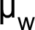[/graphic]; [graphic href="?a01v40n61"]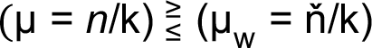[/graphic]. This will depend on the momentums of the economic growth system, where movements are depicted by the product mass by velocity and [graphic href="?a01v40n61"]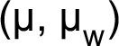[/graphic] reflects the oscillating movements in the gravitational field of economic growth [graphic href="?a01v40n61"]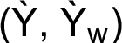[/graphic] tracked by [graphic href="?a01v40n61"]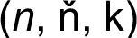[/graphic] and accelerated by [graphic href="?a01v40n61"][/graphic].[/p]
[p]Natural momentum: [graphic href="?a01v40n61"][/graphic] where the masses are[graphic href="?a01v40n61"]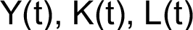[/graphic] so that the respective velocities are [graphic href="?a01v40n61"]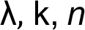[/graphic] from which[graphic href="?a01v40n61"]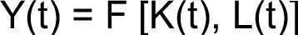[/graphic] in momentum zero and [graphic href="?a01v40n61"]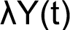[/graphic] is the variation of [graphic href="?a01v40n61"][/graphic] at velocity as a result of the velocity [graphic href="?a01v40n61"][/graphic] by mass [graphic href="?a01v40n61"]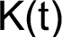[/graphic] for capital and velocity [graphic href="?a01v40n61"]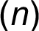[/graphic] by mass [graphic href="?a01v40n61"][/graphic] for labor force: [graphic href="?a01v40n61"]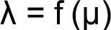[/graphic]. In this case, some centrifugal forces include ignition of a field in motion toward instability, increase in population, accumulation of capital and savings, science, technological improvement and the work/leisure preference schedule ([xref ref-type="bibr" rid="r3"]Harrod R. F., 1939[/xref], p. 30). Warranted momentum: [graphic href="?a01v40n61"][/graphic][/p]
[p]is the product of such masses by such velocities [graphic href="?a01v40n61"]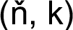[/graphic] whose outcome is warranted economic growth:[graphic href="?a01v40n61"]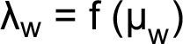[/graphic]. It is a moving equilibrium caused by the circumstances operating as centripetal and other inertial forces, conjugated by [graphic href="?a01v40n61"]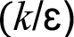[/graphic]; including government policies (e.g. monetary, fiscal, commerce), the trade cycle and level of activity, producer and labor organizations and rules ([xref ref-type="bibr" rid="r3"]Harrod R. F., 1939[/xref], p. 22).[/p]
[p]These two momentums can be exposed by conjunction: [graphic href="?a01v40n61"][/graphic] so that [graphic href="?a01v40n61"][/graphic] and thus [graphic href="?a01v40n61"][/graphic] hence:[/p]

[p][graphic href="?a01v40n61"][/graphic][/p]

[p]In that system [graphic href="?a01v40n61"]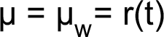[/graphic] at [graphic href="?a01v40n61"]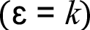[/graphic] ceteris paribus but if [graphic href="?a01v40n61"]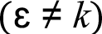[/graphic] the previous equation turns into:[/p]

[p][graphic href="?a01v40n61"][/graphic][/p]

[p]Which is [graphic href="?a01v40n61"]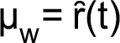[/graphic]: “The acceleration principle is presented as a leading dynamic determinant” but “there is no inherent tendency for these two (momentums) to coincide” ([xref ref-type="bibr" rid="r3"]Harrod R. F., 1939[/xref], pp. 26, 30). The role of [graphic href="?a01v40n61"][/graphic] can be clarified by equation (56) by [graphic href="?a01v40n61"]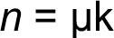[/graphic] or [graphic href="?a01v40n61"]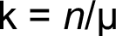[/graphic] and:[/p]

[p][graphic href="?a01v40n61"][/graphic][/p]

[p]The natural production function can also be defined simply by Solow’s[/p]
[p]production function:[/p]

[p][graphic href="?a01v40n61"][/graphic][/p]

[p]whose derivative is [graphic href="?a01v40n61"]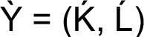[/graphic] so [graphic href="?a01v40n61"][/graphic]and the[/p]
[p]natural rate of growth is:[/p]

[p][graphic href="?a01v40n61"][/graphic][/p]

[p]And if [graphic href="?a01v40n61"]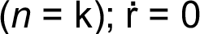[/graphic] we get the equivalent of function (41) which is also Keynes’s aggregated demand:[/p]

[p][graphic href="?a01v40n61"][/graphic][/p]

[p]At [graphic href="?a01v40n61"]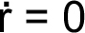[/graphic] and [graphic href="?a01v40n61"]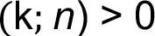[/graphic] it implies a diminishing contribution. At [graphic href="?a01v40n61"]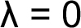[/graphic] in equation (62):[/p]

[p][graphic href="?a01v40n61"][/graphic][/p]

[p]This exposes the reasons why equation (57) is expressed as inequality. Also:[/p]

[p][graphic href="?a01v40n61"]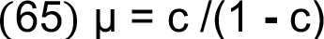[/graphic][/p]

[p][graphic href="?a01v40n61"]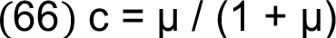[/graphic][/p]

[p]Let [graphic href="?a01v40n61"]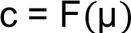[/graphic] to obtain 1): [graphic href="?a01v40n61"]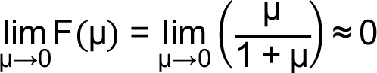[/graphic] and 2) [graphic href="?a01v40n61"]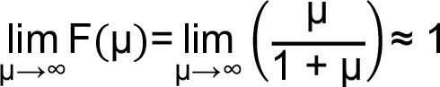[/graphic] to conclude that [graphic href="?a01v40n61"]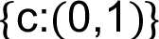[/graphic] thereby [graphic href="?a01v40n61"]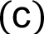[/graphic] descends horizontal asymptote as [graphic href="?a01v40n61"]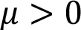[/graphic].[/p]

[/subsec][subsec][sectitle]Saving and Capital Accumulation[/sectitle]

[p]Inserting [graphic href="?a01v40n61"]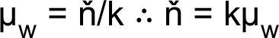[/graphic] into function (47) results in [graphic href="?a01v40n61"]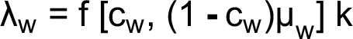[/graphic] where [graphic href="?a01v40n61"][/graphic] and thus [graphic href="?a01v40n61"]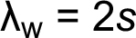[/graphic] at constant returns to scale. But we can compute the rate of saving by equation (47) after differentiating equation (20) to obtain[graphic href="?a01v40n61"]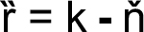[/graphic] so that[graphic href="?a01v40n61"][/graphic] from which [graphic href="?a01v40n61"][/graphic] and by[graphic href="?a01v40n61"]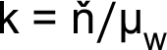[/graphic] will result [graphic href="?a01v40n61"][/graphic] in order to [graphic href="?a01v40n61"]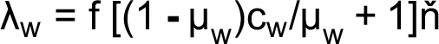[/graphic] where[graphic href="?a01v40n61"][/graphic] and because [graphic href="?a01v40n61"]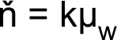[/graphic].[/p]

[p][graphic href="?a01v40n61"][/graphic][/p]

[p]And defining [graphic href="?a01v40n61"]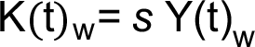[/graphic] so that:[/p]

[p][graphic href="?a01v40n61"]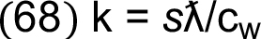[/graphic][/p]

[p]be the effective or recorded capital growth rate where [graphic href="?a01v40n61"][/graphic] symbolizes the recorded production growth rate. This function turns into:[/p]

[p][graphic href="?a01v40n61"][/graphic][/p]

[p]Here [graphic href="?a01v40n61"][/graphic] can be disclosed as follows:[/p]

[p][graphic href="?a01v40n61"][/graphic][/p]

[p][graphic href="?a01v40n61"][/graphic] is the warranted rate of saving to get [graphic href="?a01v40n61"]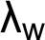[/graphic] at each instant, which must be compared with the effective [graphic href="?a01v40n61"][/graphic]; this outcome is also obtained per equation (68). Multiplying both sides of this equation by the recorded [graphic href="?a01v40n61"][/graphic] the result is the level of saving [graphic href="?a01v40n61"]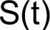[/graphic] at each instant. From this results must be possible to derive the capital depreciation and the replacement and new capital into capital accumulation process ([xref ref-type="bibr" rid="r11"]Villalobos C. D., 2020[/xref]). If [graphic href="?a01v40n61"]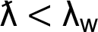[/graphic] the economy makes inefficient use of saving resulting in an excess of capital accumulation and low depreciation.[/p]

[/subsec][subsec][sectitle]Steady Natural Rate of Growth[/sectitle]

[p]“A steady rate of increase implies that a constant fraction of income is saved. If the fraction of income saved is increasing or decreasing, that implies an accelerating or decelerating increase of income” ([xref ref-type="bibr" rid="r4"]Harrod R. F., 1960[/xref]). By inserting [xref ref-type="bibr" rid="r3"]Harrod’s (1939[/xref]) definition [graphic href="?a01v40n61"][/graphic], from which [graphic href="?a01v40n61"]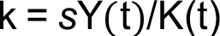[/graphic], into equation (62) we get [xref ref-type="bibr" rid="r8"]Swan’s (1956[/xref]) basic formula [graphic href="?a01v40n61"]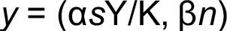[/graphic], which illustrates “the connection between capital accumulation and the growth of the productive labor force” [xref ref-type="bibr" rid="r8"](Swan T. W., 1956[/xref], p. 334) measured by resources’ share (income) on production growth at constant returns to scale following [xref ref-type="bibr" rid="r1"]Cobb and Douglas’s (1928[/xref]) production function, instead of resources’ contribution to production growth; from function (62) [graphic href="?a01v40n61"][/graphic] after substituting the above definition we obtain the natural economic growth rate:[/p]

[p][graphic href="?a01v40n61"]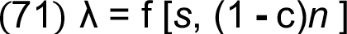[/graphic][/p]

[p]Inserting [graphic href="?a01v40n61"][/graphic] into the above function we get [graphic href="?a01v40n61"]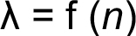[/graphic] and if [graphic href="?a01v40n61"]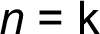[/graphic] then [graphic href="?a01v40n61"]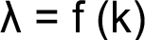[/graphic]. Also, this function provides a key result after inserting [graphic href="?a01v40n61"]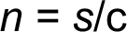[/graphic]:[/p]

[p][graphic href="?a01v40n61"]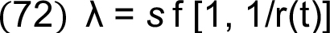[/graphic][/p]

[p]This explains that increments in production per unit of capital to labor are determined by the appropriate level of saving. This previous function is a key component in both [xref ref-type="bibr" rid="r6"]Solow’s (1956[/xref]) fundamental equation and [xref ref-type="bibr" rid="r8"]Swan’s (1956[/xref], p. 335) “basic formula for the rate of growth of output”. However, Swan’s basic formula provides an essential relationship between resources’ share on production growth , “when production takes place under the usual neoclassical conditions of variable proportions and constant returns to scale” [xref ref-type="bibr" rid="r6"](Solow, 1956, p. 73[/xref]) and resources’ contribution to production growth [graphic href="?a01v40n61"]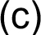[/graphic];[graphic href="?a01v40n61"][/graphic] and [graphic href="?a01v40n61"]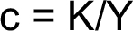[/graphic] so [graphic href="?a01v40n61"]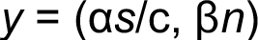[/graphic] and by adding [graphic href="?a01v40n61"][/graphic] Swan’s basic formula becomes3:[/p]

[p][graphic href="?a01v40n61"]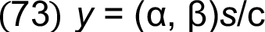[/graphic][/p]

[p]Swan’s basic formula can be expressed as [graphic href="?a01v40n61"]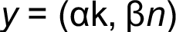[/graphic] which is the counterpart of function (62)4; provided that [graphic href="?a01v40n61"]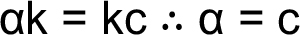[/graphic], function (43) is [graphic href="?a01v40n61"]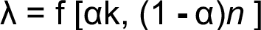[/graphic] and at [graphic href="?a01v40n61"]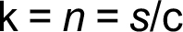[/graphic] results in [graphic href="?a01v40n61"]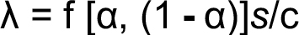[/graphic]:[/p]

[p][graphic href="?a01v40n61"]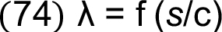[/graphic][/p]

[p]It also explains that rate [graphic href="?a01v40n61"][/graphic] is required for steady [graphic href="?a01v40n61"][/graphic]; [graphic href="?a01v40n61"]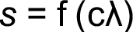[/graphic] which can be obtained from equation 62 or 63. From function (56) the corresponding warranted rate of economic growth is [graphic href="?a01v40n61"][/graphic] so that:[/p]

[p][graphic href="?a01v40n61"][/graphic][/p]

[p]Or also:[/p]

[p][graphic href="?a01v40n61"][/graphic][/p]

[p]And for Swan’s basic formula: [graphic href="?a01v40n61"]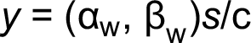[/graphic]. Equation (28) can, therefore, be renewed as follows:[/p]

[p][graphic href="?a01v40n61"][/graphic][/p]

[p]This reveals the tendency of warranted resource composition as ceteris paribus the rate of saving varies, denoting an unbalanced production growth. Per equation (24), that condition of economic growth instability can be expressed as [graphic href="?a01v40n61"]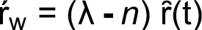[/graphic] and at [graphic href="?a01v40n61"][/graphic] will result in:[/p]

[p][graphic href="?a01v40n61"][/graphic][/p]

[p]It is clear that the natural rate of growth is determined by velocities, the rate of saving and the average capital’s contribution. Harrod’s instability of economic growth motivates [xref ref-type="bibr" rid="r6"]Solow’s (1956[/xref]) ‘A model of long-run growth’ providing the fundamental equation [graphic href="?a01v40n61"]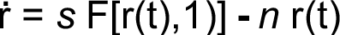[/graphic], which describes the potential trajectory of [graphic href="?a01v40n61"][/graphic]. Solow’s equation comes from the derivative of natural resource composition according to equation (23): [graphic href="?a01v40n61"][/graphic] and [graphic href="?a01v40n61"][/graphic] so that [graphic href="?a01v40n61"]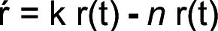[/graphic]and after replacing [graphic href="?a01v40n61"][/graphic] results in [graphic href="?a01v40n61"]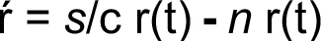[/graphic] and if [graphic href="?a01v40n61"][/graphic]:[/p]

[p][graphic href="?a01v40n61"]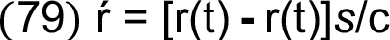[/graphic][/p]

[p]This equation is tautological, reason for which it reveals only a steady natural rate of growth in Solow’s fundamental equation. By partially reverting Solow’s equation it will yield [graphic href="?a01v40n61"][/graphic] and we can rewrite it as follows:[/p]

[p][graphic href="?a01v40n61"]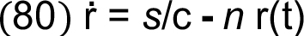[/graphic][/p]

[p]which can be achieved for labor by following the previous process: [graphic href="?a01v40n61"]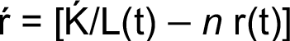[/graphic] and then substituting [graphic href="?a01v40n61"][/graphic] to get the counterpart of[/p]
[p]equation (26):[/p]

[p][graphic href="?a01v40n61"][/graphic][/p]

[p]And [graphic href="?a01v40n61"][/graphic]:[/p]

[p][graphic href="?a01v40n61"][/graphic][/p]

[p]And [graphic href="?a01v40n61"]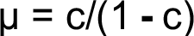[/graphic] is a result of the derivative of Solow´s production function [graphic href="?a01v40n61"]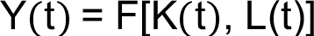[/graphic] to achieve function (62) and at [graphic href="?a01v40n61"]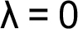[/graphic]:[/p]

[p][graphic href="?a01v40n61"]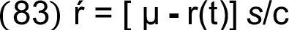[/graphic][/p]

[p]At [graphic href="?a01v40n61"][/graphic] and if [graphic href="?a01v40n61"]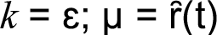[/graphic].[/p]

[/subsec][/sec][sec sec-type="conclusions"][sectitle]Conclusions[/sectitle]

[p]As the introduction claims, the purpose of this study is to provide a better understanding of Harrod’s dynamic theory and to offer a new method of approach to attack some gaps. By working on the fundamental assumptions and suggestions supporting Harrod’s basic concepts and equations, we devised a new set of relations that provides an analytical model for dynamic economic growth. An interesting contribution of this study is having found new formulas with which to measure the coefficient of acceleration, resource composition, the rate of thrift for the require capital accumulation at each instant and their influence in the instability of warranted and natural production function. We also derived velocity as the elasticity of resource composition with which precise capital and labor contribution to production growth ([xref ref-type="bibr" rid="r9"]Villalobos C. D., 2019[/xref]; [xref ref-type="bibr" rid="r10"]2019a[/xref]; [xref ref-type="bibr" rid="r11"]2020[/xref]).[/p]
[p]We conclude that warranted and natural rates of growth belong to the same system but they do not necessarily converge due to the fact that full employment of resources might be difficult to achieve. When convergence between these rates of growth occurs it appears as a moving equilibrium depending on the velocities of warranted and natural rates of growth in capital and labor, the state of the art or technique acting as the accelerator of warranted resource composition, and the capital and saving accumulation, among other centrifugal and centripetal social forces.[/p]
[p]In such a system, [xref ref-type="bibr" rid="r6"]Solow’s (1956[/xref], p. 73) basic conclusion could occur as a moving equilibrium where momentarily the system can adjust at the rate of growth of the labor force but not approach a state of steady proportional expansion. [xref ref-type="bibr" rid="r1"]Cobb and Douglas (1928[/xref]) questioned whether the increase in production is purely fortuitous or is primarily caused by technique, and the degree to which it responds to changes in the quantity of labor or capital. This strongly asserts Harrods’ natural and warranted rates of growth divergence, because natural rates of growth could be influenced by random events, but the warranted rate could assure that the processes of distribution are modeled at all closely upon those of the production of value, as suggested by [xref ref-type="bibr" rid="r1"]Cobb and Douglas (1928[/xref]). It cannot occur only ‘by a fluke’ ([xref ref-type="bibr" rid="r8"]Swan T. W., 1956[/xref], p. 343), not as an odd piece of luck but as a consequence of demand-supply adjustments ([xref ref-type="bibr" rid="r6"]Solow, 1956[/xref], p. 77).[/p]
[p]ieve that these results could contribute to improving economic scientific knowledge on economic growth and be useful in enhancing government macroeconomic policies for a better allocation of available economic resources. This, in turn, will help to maintain a dynamic yet stable warranted rate of economic growth, thereby making business decisions less risky. New research in this field must pay explicit attention to variables such as the rate of interest, capital and labor costs and product pricing to achieve advances based on in this new model.[/p][/sec][/xmlbody]

[refs][sectitle]References[/sectitle]

[ref id="r1" reftype=“journal"][authors role="nd"][pauthor][surname]Cobb[/surname], [fname]W. C.[/fname][/pauthor], & [pauthor][surname]Douglas[/surname], [fname]H. P.[/fname][/pauthor][/authors] ([date dateiso="19280000" specyear="1928"]1928[/date]). [arttitle]A theory of production[/arttitle]. [source]The American Economic Review[/source], [volid]18 [/volid]([issueno]1[/issueno]), [pages]139-165[/pages].[/ref]
[ref id="r2" reftype=“journal"][authors role="nd"][pauthor][surname]Domar[/surname], [fname]E. D.[/fname][/pauthor][/authors] ([date dateiso="19460000" specyear="1946"]1946[/date]). [arttitle]Capital Expansion, Rate of Growth, and Employment. [/arttitle] [source]Econometrica[/source], [volid]14[/volid]([issueno]02[/issueno]), [pages]137-147[/pages].[/ref]
[ref id="r3" reftype=“journal"][authors role="nd"][pauthor][surname]Harrod[/surname], [fname]R. F.[/fname][/pauthor] [/authors]([date dateiso="19390000" specyear="1939"]1939[/date]). [arttitle]An essay in dynamic theory[/arttitle]. [source]The Economic Journal[/source], [volid]49[/volid] ([issueno]193[/issueno]), [pages]14-33[/pages]. doi: [pubid idtype="doi"]https://doi.org/10.2307/2225181[/pubid].[/ref]
[ref id="r4" reftype=“journal"][authors role="nd"][pauthor][surname]Harrod[/surname], [fname]R. F.[/fname][/pauthor] [/authors]([date dateiso="19600000" specyear="1960"]1960[/date]). [arttitle]Second essay in dynamic theory[/arttitle]. [source]The Economic Journal[/source], [volid]70[/volid] ([issueno]178[/issueno]), [pages]277-293[/pages]. doi: [pubid idtype="doi"]https://doi.org/10.2307/2228728.[/pubid][/ref]
[ref id="r5" reftype="book"][authors role="nd"][pauthor][surname]Keynes[/surname], [fname]J. M.[/fname][/pauthor] [/authors]([date dateiso="19640000" specyear="1964"]1964[/date]). [source]The general theory of employment, interest, and money[/source] ([volid]First [/volid]ed.). [publoc]United States of America[/publoc]: [pubname]A Harvest/HBJ Book[/pubname].[/ref]
[ref id="r6" reftype=“journal"][authors role="nd"][pauthor][surname]Solow[/surname], [fname]M. R.[/fname][/pauthor] [/authors]([date dateiso="19560000" specyear="1956"]1956[/date]). [arttitle]A contribution to the theory of economic growth. [/arttitle][source]The Quarterly Journal of Economics[/source], [volid]70[/volid]([issueno]1[/issueno]), [pages]65-94[/pages]. doi: [pubid idtype="doi"]https://doi. org/10.2307/1884513.[/pubid][/ref]
[ref id="r7" reftype=“journal"][authors role="nd"][pauthor][surname]Solow[/surname], [fname]M. R.[/fname][/pauthor][/authors] ([date dateiso="19570000" specyear="1957"]1957[/date]). [arttitle]Technical change and the aggregate production function.[/arttitle] [source]The Review of Economics and Statistics[/source], [volid]39 [/volid]([issueno]3[/issueno]), [pages]312-320[/pages]. doi: [pubid idtype="doi"]https://doi.org/10.2307/1926047.[/pubid][/ref]
[ref id="r8" reftype=“journal"][authors role="nd"][pauthor][surname]Swan[/surname], [fname]T. W.[/fname][/pauthor] [/authors]([date dateiso="19560000" specyear="1956"]1956[/date]). [arttitle]Economic growth and capital accumulation[/arttitle]. [source]Economic Record [/source]([issueno]32[/issueno]), [pages]334-361[/pages]. Doi: [pubid idtype="doi"]https://doi.org/10.1111/j.1475-4932.1956. tb00434.x[/pubid].[/ref]
[ref id="r9" reftype=“journal"][authors role="nd"][pauthor][surname]Villalobos[/surname], [fname]C. D.[/fname][/pauthor] [/authors]([date dateiso="20190000" specyear="2019"]2019[/date]). [arttitle]Crecimiento económico: Convergencia y divergencia.[/arttitle] [source]Economía y Sociedad[/source], [volid]24[/volid]([issueno]55[/issueno]), [pages]1-30[/pages]. doi: [pubid idtype="doi"]http://dx.doi. org/10.15359/eys.23-55.3.[/pubid][/ref]
[ref id="r10" reftype=“journal"][authors role="nd"][pauthor][surname]Villalobos[/surname], [fname]C. D.[/fname][/pauthor][/authors] ([date dateiso="20190000" specyear="2019a"]2019a[/date]). [arttitle]Crecimiento económico: Contribución y participación de los recursos.[/arttitle] [source]ABRA[/source], [volid]40[/volid]([issueno]59[/issueno]). doi: [pubid idtype="doi"]https://doi. org/10.15359/abra.39-59.1[/pubid][/ref]
[ref id="r11" reftype=“journal"][authors role="nd"][pauthor][surname]Villalobos[/surname], [fname]C. D.[/fname][/pauthor][/authors] ([date dateiso="20200000" specyear="2020"]2020[/date]). [arttitle]Economic growth: Productivity, thrift and capital accumulation. [/arttitle][source]Economía y Sociedad[/source], [volid]25[/volid]([issueno]57[/issueno]).[/ref][/refs]

[fngrp][fn id="fn1" fntype="other"][label]¹[/label] Recall [xref ref-type="bibr" rid="r6"]Solow’s (1956[/xref], p. 70) assumption: “if the capital-labor ratio (…) should ever be established, it will be maintained, and capital and labor will grow thenceforward in proportion. By constant returns to scale, real output will also grow at the same relative rate n, and output per head of labor force Will be constant”. It does not necessarily reflect a natural rate of growth, because for to be stable it is required that. At capital investment must increase proportionally to to keep value ever established; to say: and of course proves that and productive curve also keeps its value but and if then will be higher than before showing a greater level of production by the amount. Hence, explains a new (lower) position of the natural rate of growth because of which indicates a greater potential for economic growth, and the prior location becomes the warranted rate of growth denoting unemployed labor force perhaps due to shortage of capital which inhibits. [xref ref-type="bibr" rid="r7"]Solow (1957[/xref]) makes an effort to better explain this issue. Additionally: “Even without technological progress, capital accumulation increases labor productivity, at least to a certain point, both because more capital is used per workman in each industry and because there is a shift of labor to industries that use more capital and can afford to pay a higher wage[xref ref-type="bibr" rid="r2"]” (Domar E. , 1946[/xref], pp. 138-139)[/fn]
[fn id="fn2" fntype="other"][label]²[/label] In contrast Solow’s productivity curve (1956, pp. 69-71) depicts natural labor productivity according to [xref ref-type="bibr" rid="r3"]Harrods’ definition (1939[/xref], p. 30).[/fn]
[fn id="fn3" fntype="other"][label]³[/label] In [xref ref-type="bibr" rid="r8"]Swan’s (1956[/xref]) basic formula, any point represents Harrod’s warranted rate of growth and any point in corresponds to Harrod’s natural rate of growth: so, at an equilibrium point 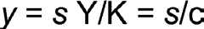[/fn]
[fn id="fn4" fntype="other"][label]⁴[/label][xref ref-type="bibr" rid="r1"]Per Cobb and Douglas’s (1928[/xref]) production function, on which [xref ref-type="bibr" rid="r8"]Swan’s (1956[/xref]) unclassical case is based, it can be proven that 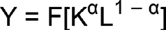 and by partial derivative in terms of so that 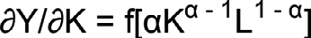and let be the rate of profit or capital return to yield 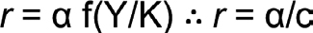 and thus α = r c; by replacing this result in function (73), we get 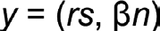 as per [xref ref-type="bibr" rid="r8"]Swan’s (1956[/xref], p. 335) footnote No. 5. [/fn][/fngrp] [/doc]

