[doc sps="1.7" acron="eys" jtitle="Economía y Sociedad" stitle="Economía y Sociedad" issn="2215-3403" pissn="1409-1070" eissn="2215-3403" pubname="Universidad Nacional, Costa Rica" license="http://creativecommons.org/licenses/by-nc-sa/4.0" volid="22" issueno="52" dateiso="20171200" season="July/Dec" order="04" fpage="67" lpage="87" pagcount="21" doctopic="oa" language="es"]
Doi: http://dx.doi.org/[doi]10.15359/eys.22-52.4[/doi]

[toctitle]Artículo[/toctitle]

[doctitle language="es"]IDENTIFICACIÓN DE FACTORES QUE AFECTAN LAS INDUSTRIAS INDIVIDUALES[/doctitle]

[doctitle language="en"]IDENTIFICATION OF FACTORS AFFECTING INDIVIDUAL INDUSTRIES[/doctitle]

[author role="nd" corresp="n" deceased="n" eqcontr="nd"][fname]Maryam Sadat[/fname] [surname]Mirzadeh[/surname][xref ref-type="aff" rid="aff1"]¹[/xref]
[fname]Yashar[/fname] [surname]Salamzadeh[/surname][xref ref-type="aff" rid="aff2"]²[/xref]
[fname]Aidin[/fname] [surname]Salamzadeh[/surname][xref ref-type="aff" rid="aff3"]³[/xref][/author]
[normaff id="aff1" ncountry="Iran" norgname="Farabi Institute of Virtual Higher Education" icountry="IR"][label][sup]1[/sup][/label] [role]MA[/role], [orgname]Farabi Institute of Higher Education[/orgname], [city]Mehrshahr[/city], [country]Iran[/country]. E-mail: [email]mirzadeh.mba93@gmail.com[/email][/normaff]
[normaff id="aff2" ncountry="Iran" norgname="Farabi Institute of Virtual Higher Education" icountry="IR"][label][sup]2[/sup][/label][role] Senior Lecturer[/role], [orgname]Farabi Institute of Higher Education[/orgname], [city]Mehrshahr[/city], [country]Iran[/country]. E-mail: [email]yasharsalamzadeh@gmail.com[/email][/normaff]
[normaff id="aff3" ncountry="Iran" norgname="University of Tehran" icountry="IR"][label][sup]3[/sup][/label] [role]PhD researcher[/role], [orgdiv1]Faculty of Entrepreneurship[/orgdiv1], [orgname]University of Tehran[/orgname], [city]Tehran[/city], [country]Iran[/country]. E-mail: [email]salamzadeh@ut.ac.ir[/email] [/normaff]

[xmlabstr language="es"][sectitle]Resumen[/sectitle]
[p]En el mundo moderno de hoy, el alto conocimiento y la tecnología se están convirtiendo rápidamente en una ventaja competitiva. Las industrias individuales son consideradas como uno de los sectores clave en la industria del país. Clasificar los factores que afectan a este tipo de industrias nos hace estar más familiarizados con su efectividad y, por tanto, tomar acciones para mejorarlos en las empresas basadas en el conocimiento. Con el fin de alcanzar este objetivo, tras revisar las investigaciones que se han realizado en el área de industrias individuales, a través del método de campo y utilizando un cuestionario aplicado por el investigador, el presente estudio investiga y clasifica los factores que afectan al establecimiento de estas industrias. [/p]
[p]En cuanto a su finalidad, se trata de una investigación aplicada, y en términos de recogida de datos, se considera una encuesta descriptiva. Utilizando el método censal se recolectaron 60 cuestionarios. Los factores efectivos se clasificaron utilizando el software SPSS y técnica TOPSIS. [/p]
[p]Los resultados de este estudio sugieren que los factores de contenido ocupan el primer lugar y los factores contextuales y estructurales, el segundo y tercer lugar, respectivamente. Por lo tanto, se recomienda a ejecutivos y gerentes en industrias individuales enriquecer las normas de empresa conjunta y los valores y creencias dominantes en las empresas basadas en el conocimiento, con el fin de lograr el crecimiento y el desarrollo de este tipo de industrias.[/p][/xmlabstr]
[kwdgrp language="es"][sectitle]Palabras clave:[/sectitle] [kwd]Industrias únicas[/kwd]; [kwd]Industrias basadas en el conocimiento[/kwd]; [kwd]Política industrial[/kwd]; [kwd]Clasificación[/kwd]; [kwd]TOPSIS[/kwd][/kwdgrp]

[xmlabstr language="en"][sectitle]Abstract[/sectitle]
[p]High knowledge and technology are rapidly becoming a competitive advantage in today’s world. Individual industries are considered one of the key sectors in the country’s industry. Ranking the factors that affect these industries makes us more familiar with their effectiveness and helps us take actions to improve such factors in knowledge-based companies. Consequently, based on previous research studies on Individual Industries, field observations, and a questionnaire prepared by the researchers, the current study explores and classifies the factors affecting the establishment of these industries. [/p]
[p]Regarding its purpose, this is an applied research, and regarding data collection, it is a descriptive survey. Using purposive sampling, 60 questionnaires were collected and effective factors were classified applying the SPSS software and the TOPSIS technique. [/p]
[p]This study suggests that content factors are ranked first place, while contextual and structural factors are ranked second and third, respectively. Therefore, executives and managers in single industries are recommended to strengthen joint enterprise norms and dominant values and beliefs in knowledge-based companies in order to help the growth and development of single industries.[/p][/xmlabstr]
[kwdgrp language="en"][sectitle]Keywords:[/sectitle] [kwd]Single Industries[/kwd]; [kwd]Knowledge-Based Industries[/kwd]; [kwd]Industrial Policy[/kwd]; [kwd]Ranking[/kwd]; [kwd]TOPSIS[/kwd][/kwdgrp].

[hist]Fecha de recepción: [received dateiso="20170219"]19-02-2017[/received].
Aceptado el [accepted dateiso="20170804"]04-08-2017[/accepted].[/hist]
Fechas de reenvíos: 23-02-2017, 06-03-2017, 26-06-2017, 27-06-2017, 31-07-2017, 02-08-2017.
Publicado el 18-10-2017.

- [xmlbody][subsec][sectitle]Introduction[/sectitle]

[p]The general definition of knowledge includes factors of creation, dissemination and development of the information. Using technology, analytic tools, as well as human knowledge and intelligence as programs to increase productivity of the firms, the application of knowledge in the production of economic products is becoming pervasive (Gorji & Alipourian, [xref ref-type="bibr" rid="r14"]2011[/xref]; Khajeheian, [xref ref-type="bibr" rid="r19"]2016[/xref]). Many companies have recognized the activities associated with high-tech technologies and invested on them. Using single industries leads to an increase in global competitiveness, reducing production costs or improving productivity. Thus, manufacturers in single industries have to move fast and accurate in implicating technologies (Law, [xref ref-type="bibr" rid="r20"]2010[/xref]). High-tech industries are considered as an essential part of the economy. For instance, about 12% of all the jobs in the US economy are related to high technologies, and their productivity is approximately equivalent to 23%. Despite the economic recession and failure encountered by all parts of the economy, high-tech industries still act as proactively against recession. Currently, 52.6% of total employment in the US is dedicated to high-tech industries (Wolf & Terrell, [xref ref-type="bibr" rid="r34"]2016[/xref]). In the knowledge-based companies, managing decision-making and planning strategic plans are shaped based on their knowledge (Salamzadeh, Kesim & Salamzadeh, [xref ref-type="bibr" rid="r29"]2016[/xref]). In fact, the success and failure of the projects in such companies depends on the coordination of the knowledge management and organization’s strategies, current and future actions and evaluating their status. The objectives and expectations related to production and efficiency of such companies will then be clear through their knowledge strategy. In fact, capabilities of knowledge-based companies will increase through relying on knowledge (Cabrita, Cruz-Machado & Cabrita, [xref ref-type="bibr" rid="r2"]2013[/xref]).[/p]

[p]Creating and implementing technological innovations through increasing living standards, employment rate, productivity, and competition plays an important role in the economic development of companies (Sadeghi, Azar & Rad, [xref ref-type="bibr" rid="r25"]2012[/xref]; Khajeheian & Tadayoni, [xref ref-type="bibr" rid="r19"]2016[/xref]). A large share of the recent growth in the US belongs to single or service industries in which single technology-based services are frequently used. Moreover, information and communication technology is rapidly developing and growing around the world. However, to survive in this competition, attention should be paid to the status of single industries, industrial policies, statement of the role of competitors and market (Crandall & Jackson, [xref ref-type="bibr" rid="r7"]2011[/xref]). Innovation policy includes growth of software platforms, which requires proper combination of cross-functional and multi-disciplinary policies across diverse fields, such as education, research, finance and public procurement through science, technology and innovation policies.[/p]

[p]Industrial policy is defined as a concept against economic structural change. Industrial policy, which is generally defined by governments, leads any country to achieve sustainable industry. However, there is always a possible gap between what is designed and what is done. Then, an analysis, which investigates the mismatch between design and implementation of policies, on the one hand, and interaction of these factors, on the other hand, can be very helpful (Lo & Wu, [xref ref-type="bibr" rid="r22"]2014[/xref]). Strong industrial policies and careful, creative and knowledge based planning as well as new and knowledge-based industries increase the competitive status in the market and industry (Battaglia, [xref ref-type="bibr" rid="r1"]2014[/xref]; Dhéret & Morosi, [xref ref-type="bibr" rid="r9"]2014[/xref]). In other words, industrial policy is defined as a special role in the manufacturing sector, particularly as a source of productivity growth, innovation, learning and flexibility (Gambarotto, Bolisani & Scarso, [xref ref-type="bibr" rid="r13"]2011[/xref]; Chang, Andreoni & Kuan, [xref ref-type="bibr" rid="r4"]2013[/xref]; Elia, Petti, & Sarcina, [xref ref-type="bibr" rid="r11"]2016[/xref]). First of all, this study investigates the factors influencing the status of single industries and, then, it ranks these factors and determines the status of single industries.[/p]

- [/subsec][subsec][sectitle]Literature Review[/sectitle]

[p]Organizational Knowledge Hypotheses[/p]

[p]Organizational knowledge leads to activities including the creation, storage, sharing and exploitation in the organization. Management decisions are made based on tactical and organizational knowledge. The organizations can increase flexibility and adaptability in business context and focus on activities aimed at productivity (Chang et al., [xref ref-type="bibr" rid="r4"]2013[/xref]).[/p]

[p]The Main Elements Of The Single Industries’ Strategies[/p]

[p]The followings includes new strategies related to single industries: (i) Priority will be given to value creation and quality of life, (ii) creating a network for data transfer, (iii) pace of innovation in the industry, (iv) creating innovative ideas, and (v) creating transparency and participation in administrative affairs (Federal Ministry of Education and Research, [xref ref-type="bibr" rid="r12"]2014[/xref]).[/p]

[p]Characteristics Of Knowledge-Based Industries[/p]

[p]Characteristics of knowledge-based industries are as follows: knowledge-based industries promote industrial development and increases generated revenue consciously that these higher earnings will be inclusive and sustainable; in addition to the economic growth, due to their technological capabilities, knowledge-based industries will improve and change their structure. Knowledge-based industries would diversify products, increase the rate of growth, adjust production volatility and reduce them and, in fact, knowledge-based industries provide political tools for technology, innovation and product development nationwide. Experts of knowledge-based companies are individuals with high level of knowledge, skills and abilities. In contrast, competition rules and the market approaches could be educated and gained wherever it is needed. Rather than skills on the job, skills of the profession are of importance in meeting standards of skills, and they will be benefited from flexible and up to date standards (Hawkins, Rudy & Wallace, [xref ref-type="bibr" rid="r16"]2002[/xref]).[/p]

[p]Role Of Training On The Establishment Of Single Industries[/p]

[p]Training of human resources is one of the factors affecting the establishment of the single industries. Emerging economy in the industry with the help of science-based high-tech is considered as a key to the economic development. Skills acquired by manpower, training and its use in the technology of the industry leads industrial manufacturing capabilities to have fundamental differences and distinctions and would be considered as a competitive advantage for country’s industry (Hatakenaka, [xref ref-type="bibr" rid="r15"]2015[/xref]). Companies that do not utilize high-tech industries, employers who do not teach their employees and managers and do not invest on high-tech industries, will release their production with lower quality, often been in the traditional form, and the value of social enterprise will be greatly reduced.[/p]

[subsec][sectitle]Role of government in the establishment of the status of single industries[/sectitle]

[p]The governments play a constructive role in improving and establishing the status of single industries in industrial policy. They are obliged to make policy in order to control inflation and promote the employment. Single industries are considered as a major stimulus in monetary and fiscal policies in industrial countries. Conservative measures were taken with regard to the growth of industries and promoting the high-tech products including tax cut for these industries. Tax cuts will reduce production costs, thus will have a positive impact on aggregate demand, market share and increasing efficiency. In addition to establishing and legislating facilitating laws to improve the performance of knowledge-based industries, the governments are obliged to support them as well. Knowledge-based companies need governmental support from the phase of production of high-tech products to the phase of completion and realization of the ultimate goals, which may be prolonged (Deutch, [xref ref-type="bibr" rid="r8"]2005[/xref]).[/p]

[/subsec][subsec][sectitle]Role of information and communication infrastructures in the establishment of the status of single industries[/sectitle]

[p]Information and communication infrastructures are among factors in the establishment of the single industries in the industrial policies. The purpose and need for these infrastructures in single industries are as follows: in order to develop at the national level, the company is obliged to eliminate the challenges of the information age to ensuring the ease of promotion of information and resources among different company’s sectors; as a result, the company’s information will update. The company requires strong infrastructure in order to encourage national products and manufacturing components of information and communications technologies, creating and developing strong information technologies infrastructures across the country and creating a competitive advantage in the market in order to empowerment of human resources with new technology (Matthew, Joro & Manasseh, [xref ref-type="bibr" rid="r23"]2015[/xref]).[/p]

[/subsec][subsec][sectitle]Elements of the success of knowledge-based companies[/sectitle]

[p]The following elements have an impact on the success of single industries and the use of high technologies: corporate culture that leads to the successful use and implementation of these technologies, commitment of senior managers in the successful implementation of the single industries, involvement of employees, employees training, performing teamwork, empowering a group which are involved in performing, appropriate information and communication infrastructures, performance measurement, determining performance measurement criteria and knowledge-based structure (Heaidari, Moghimi & Khanifar, [xref ref-type="bibr" rid="r17"]2011[/xref]). In terms of efficiency, are at a higher level in comparison with their counterparts who use less technology than manufacturing companies, which deal with high-tech industries. Research activities in these companies are far ahead; research and development units are more active.[/p]
[p]In fact, knowledge-based companies are idea-driven and could have commercial activities based on created ideas and be competitive. In classification of industries according to various spheres of technology four areas are mentioned; high-tech industries, industries with higher technology than the average, industries with lower technology than the average, low-tech industries. This study will look ahead to high-tech industries. Chen ([xref ref-type="bibr" rid="r5"]2012[/xref]), in a study entitled “Varying significance of influencing factors in developing high-tech industries”, mentioned the most important factors in the development of single industries as follows; the most powerful factors are the development of investment and academic institutions and the government in US and in China, respectively. Careful planning and execution also can be regarded as another influential factor. In the 21st century, single industries’ clusters have arisen in several categories including companies with single industries, technology parks, science cities, regions with the processing of single technologies (Chen, [xref ref-type="bibr" rid="r5"]2012[/xref]).[/p]
[p]Sharabi, Arian & Simonovich ([xref ref-type="bibr" rid="r31"]2012[/xref]) in a study entitled “Factors affecting the development of high-tech visuals and government sectors’ staff” have investigated the different single industries in public and private companies: (i) Criteria of meeting the objectives: with regard to high-tech industries, private organizations only consider economic issues, while in the government agencies consensus to reach an agreement among people are considered as well, (ii) Degree of activity and the value of the level: the simple activity and confirmation of the limited value exists in a private organization, while in government agencies complex and based on values activities serving different groups of sometimes conflicting exists, (iii) Law: Private organizations are not limited to a particular law framework, while government agencies should act within the framework of law, (iv) Auditing: private organizations are being less audited, while government agencies are audited several times by different groups, (v) Political affiliations: there is no political affiliation in a private organization, while there is strongly exists in government agencies (Sharabi et al., [xref ref-type="other" rid="sharabi2012"]2012[/xref]).[/p]
[p]Cloodt, Hagedoorn & Van Kranenburg ([xref ref-type="bibr" rid="r6"]2006[/xref]), in a study entitled “Mergers and acquisitions: Their effect on the innovative performance of companies in high-tech industries”, concluded that development in a multi-sectorial context can be considered as an alternative for single industries such as aerospace, defense, computers, office machinery, electronics and communication. However, since this performance is innovative, if all the required technologies are not taught this development will have a damaging effect on the company’s activities and organizational procedures (Cloodt et al, [xref ref-type="bibr" rid="r6"]2006[/xref]). Industry in companies with high-tech industry includes advanced production technologies, communication services and software and services related to the computer (Chathoth, [xref ref-type="bibr" rid="r3"]2005[/xref]).[/p]
[p]Tan and Leewongcharoen ([xref ref-type="bibr" rid="r32"]2005[/xref]), in a study entitled “Factors contributing to IT industry success in developing countries: The case of Thailand”, consider availability of skilled workforce professionals to encourage foreign investors to set up single industries in a country to be useful. Chen ([xref ref-type="bibr" rid="r5"]2012[/xref]), in a study entitled “Investigating the value of investments in the industrial technology based on multi factors of dynamic model”, explain that to move towards the development of knowledge-based companies three factors of high-tech industries, compressed technology industries and capital-intensive industries (R & D) are needed. Capital-intensive industries and research and development units need high capital and high financial support, and increase of the efficiency of these investments to the market should be determined before the investment. The growth of high-tech industries is higher in the mature phase comparing with the growth phase and this reflects the effect of life cycle in the stock prices.[/p]

- [/subsec][/subsec][subsec][sectitle]Research methodology[/sectitle]

[subsec][sectitle]3.1 Research objectives[/sectitle]

[p] This study is of philosophy of positivism. The approach, according to its philosophy, is inductive. Through examining the hypothesis and research questions according to the observations and results of questionnaires, the subject is analyzed and the results are extracted in this approach. Given that the descriptive goal of this study is to rate and determine the factors affecting the status of single industries in industrial policy, inductive approach and strategy is a case study. Since the description and the determination of ranking of factors that affect the status of single industries in industrial policy are examined, the method used in this research is descriptive-survey. According to the mentioned purposes, this study is applied and according to the nature and method of research is divination-correlational. Library and field data collection methods will be included. The main purpose is to determine the rating and ranking of the factors that affect the status of single industries in industrial policies.[/p]

[/subsec][subsec][sectitle]3.2. Statistical population[/sectitle]

[p]The population of this study includes the employees of the Oil Exploration Company, a subset of Iranian National Oil Company, located in Tehran province (central office). The Oil Exploration Company is active in the upstream sector of the oil industry in technical fields and exploration services such as providing geophysical services and studies, design and capturing seismic data processing, interpret and explain the seismic data, compression magnetic tapes, providing technical, exploration, and drilling of oil wells.[/p]

[/subsec][subsec][sectitle]3.3. Statistical sampling[/sectitle]

[p]Statistical sampling of the Oil Exploration Company’s employees is done. It includes staff of quality control unit, research and development unit, middle managers, engineers and technicians. Purposive sampling method was used. The criteria was as follows: (i) To have more than five years of experience, (ii) To have a relevant graduate degree, (iii) To have at least five years of managerial experience, and (iv) To have at least one relevant publication in journals, magazines or well-known media. Based on the aforementioned criteria, 60 individuals were selected and surveyed. The relevant questionnaire was distributed among them and finally the answered questionnaires have been collected.[/p]

- [/subsec][/subsec][subsec][sectitle]Conceptual model[/sectitle]

[p]The conceptual model is shown in figure [xref ref-type="other" rid="Figura1"]1[/xref], according to the research literature and other proposed models.[/p]

[figgrp id="f1"][graphic href="?a04v22n52"]
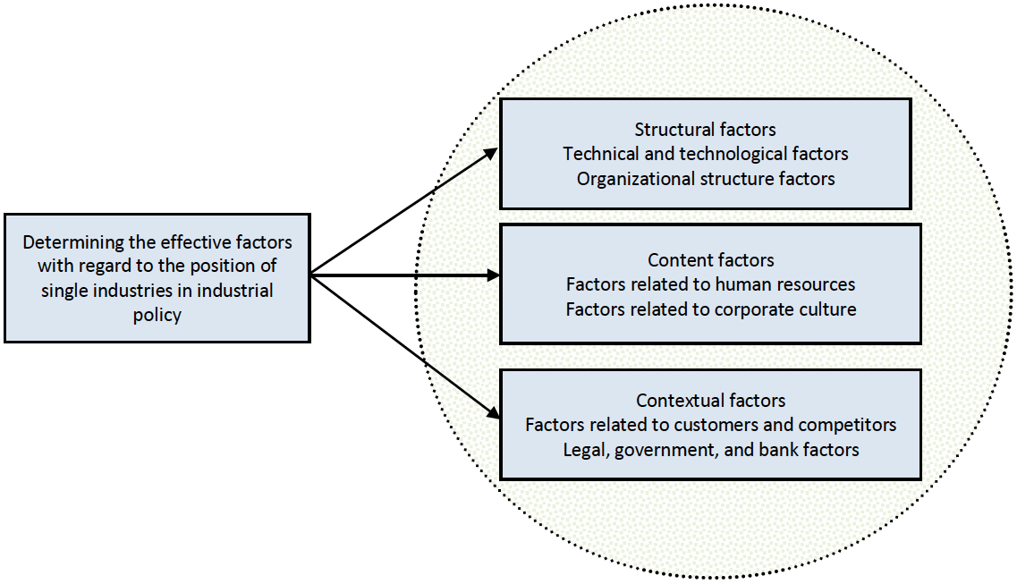
[/graphic]

[label]Figure 1[/label]. [caption]Conceptual model of research (Source: self-elaborated)[/caption][/figgrp]

[subsec][sectitle]4.1. Research questions and hypotheses[/sectitle]

[p]The question that is raised in this study is what are the most important technical and technological factors in knowledge-based companies that affect improving the status of single industries in the industrial policy? And, consequently, the specific questions that are raised include:[/p]

- [list listtype="roman-lower"][li]Do the technical and technological factors in knowledge-based companies have an effect on improving the situation of single industries in the industrial policy?[/li]
- [li]Do the organizational structure factors of companies in the single industries have an effect on improving the status of single industries in the industrial policy?[/li]
- [li]Do the factors related to the human resources have an effect on improving the status of single industries in the industrial policy?[/li]
- [li]Can the factors related to corporate culture improve the status of single industries in industrial policy?[/li]
- [li]Can the factors related to the customers and competitors of knowledge-based companies improve the status of single industries?[/li]
- [li]Can observing the law, the role of government and the banks affect promoting the status of single industries?[/li][/list]

[/subsec][subsec][sectitle]4.2. Research variables[/sectitle]

[p]Independent Variable[/p]

[p]The independent variables in this study are: structural factors, content factors and contextual factors.[/p]

[p]Structural factors are one of the independent variables of the present study that the technical knowledge of managers and employees is one of its subsets. Knowledge and the ability to exploit it in the organizations is the key to success and the ability to overcome the human obstacles in any organization. Increasing the competency level of managers and the employees in single industries, the application of modern management skills, including encouraging the teamwork among employees, are among structural factors which will be investigated in this study (Donate & Guadamillas, [xref ref-type="bibr" rid="r10"]2011[/xref]).[/p]

[p]Human resources as one of the content factors play an important role in the growth and development of knowledge-based companies as a brain ware factor. Human resources are the most important asset and the source of a knowledge-based company’s creativity. Skills of the human resources lead to the creativity and innovation in manufacturing and presenting the services. In other words, knowledge-based organizations embark on re-creation with their help. Corporate culture is specific to each organization and in fact distinguishes this organization from other organizations. There are common ideas, beliefs, and expectations in an organization that the human resources have to observe and implement them to achieve organizational objectives. Laws and regulations in all sectors and levels are among another important factor in the success of knowledge-based organizations for better performance of knowledge-based organizations. The more compliance with legal rules leads these companies to be more successful.[/p]

[p]Dependent variable[/p]

[p]Determining the factors affecting the status of single industries in industrial policy is considered as the dependent variable in this research, which aims to rank the factors influencing the establishment of the status of single industries in industrial policy.[/p]

[/subsec][subsec][sectitle]4.3. Data collection instrument[/sectitle]

[p]Secondary data, including literature, history and definition of operational vocabulary of the study, was collected using library and document methods through the study of texts, articles, documents, books, reports, specialized journals and research, carried out by means of note taking forms and tables contained in the texts. Field research methods with data collecting tools, researcher-made questionnaire, in-depth interviews, and observing a knowledge-based company was used for collecting the primary research data that includes respondents’ answers with regard to research variables. The questionnaire has 46 questions with rating scale and was developed in two parts. The first part includes the demographic questions with 6 items. The second section investigates the importance of each indicator that contributes to the promotion of the single industries with 40 questions (items).[/p]

[/subsec][subsec][sectitle]4.4. Validity or authority of the data collecting instrument and reliability[/sectitle]

[p]The Cronbach’s alpha reliability coefficient was used to ensure the reliability of the questionnaire. Cronbach’s alpha coefficient of 0.7 is acceptable for research. As it is shown in [xref ref-type="table" rid="t1"]table 1[/xref], alpha coefficient was 0.917, which is higher than the accepted standard, confirming the reliability of the questionnaire. Experts’ opinions have been applied to check the validity of the questionnaire.[/p]

[tabwrap id="t1"][label]Table 1[/label]. [caption]Cronbach’s Alpha Reliability Coefficient (Source: SPSS outputs)[/caption]

[graphic href="?a04v22n52"]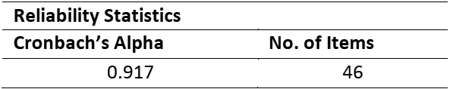[/graphic][/tabwrap]

- [/subsec][/subsec][subsec][sectitle]Findings[/sectitle]

[p]71.7% of respondents were male and 28.3% of them were female, of which 11.7% less than 30 years, 65% between 30 and 40 years, 13.3% between 40 and 50 years, 8.3% between 50 and 60 years, and 1.7% over 60 years old. 10% of them were AS, 33.3% were BS, 30% were MS, 25% were supervisors, and 1.7% was deputies. The familiarity with the topic of the status of “single” industries in three columns of frequency, frequency percentage, and cumulative percentage is shown in [xref ref-type="table" rid="t2"]table 2[/xref].[/p]

[tabwrap id="t2"][label]Table 2[/label]. [caption]The degree of familiarity with the status of “single” industries (Source: SPSS outputs)[/caption]

[graphic href="?a04v22n52"]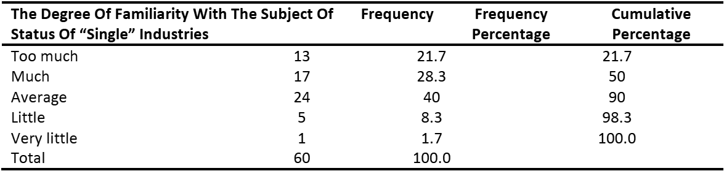[/graphic][/tabwrap]

[p]The results of the analysis are divided into three categories:[/p]
- [list listtype="roman-lower"][li]Structural factors (22)[/li]
- [li]Content factors (7)[/li]
- [li]Contextual factors (7)[/li][/list]

[p]TOPSIS is a method for decision-making in an uncertain environment. Thus, providing the ability to deal with the uncertainty of human judgment is important in assessing global challenges (Salamzadeh, Ardakani & Zanjirchi, [xref ref-type="bibr" rid="r27"]2009[/xref]). The results of the analysis and ranking of this study through TOPSIS will be expressed in the following tables. The results of ranking the structural factors are presented in tables [xref ref-type="table" rid="t3"]3[/xref] and [xref ref-type="table" rid="t4"]4[/xref].[/p]

[p]In [xref ref-type="table" rid="t3"]Table 3[/xref], “di” stands for the direct interval extension of TOPSIS method, which provides the final ranking of alternatives. Also, “cli” is calculated as follows:[/p]

[equation id="e1"][graphic href="?a04v22n52"]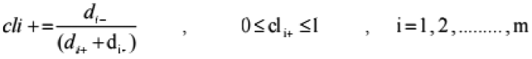[/graphic][/equation]

[p]The best (optimal) alternative can be determined according to the preference rank order of (cli).[/p]

[tabwrap id="t3"][label]Table 3[/label]. [caption]Ranking the structural factors (Source: TOPSIS outputs)[/caption]
[graphic href="?a04v22n52"]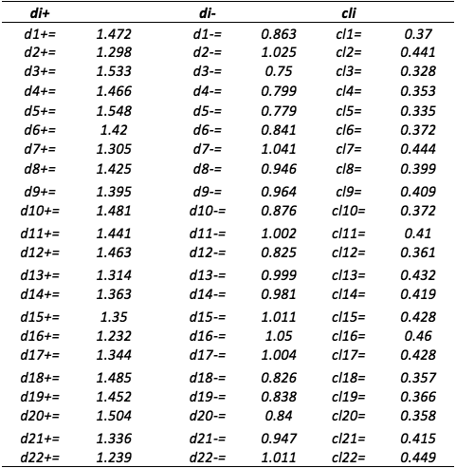[/graphic][/tabwrap]

[p]According to the calculations, the structural factors are classified as follows and some apparently significant factors are not significant in this case. For instance, increase the level of employees’ empowerment is not significant in this case. Maybe it is because of the nature of single industries. Moreover, competition between employees was considered more important than technical knowledge of the staff and managers. In addition to this, organizational positioning with regard to its environment, as well as cooperation among staff are of paramount importance. [/p]

[tabwrap id="t4"][label]Table 4[/label]. [caption]Classification of structural factors (Source: TOPSIS outputs)[/caption]

[graphic href="?a04v22n52"]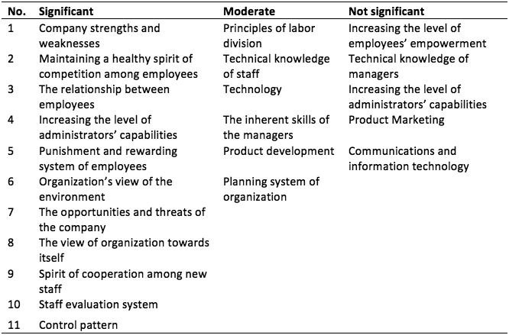[/graphic][/tabwrap]

[p]The results of the ranking of the content factors of research are presented in tables [xref ref-type="table" rid="t5"]5[/xref] and [xref ref-type="table" rid="t6"]6[/xref].[/p]

[tabwrap id="t5"][label]Table 5[/label]. [caption]Ranking the content factors (Source: TOPSIS outputs)[/caption]

[graphic href="?a04v22n52"]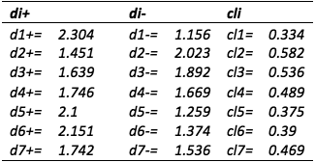[/graphic][/tabwrap]

[p]The same calculation is conducted for content factors. According to the findings, common organizational norms are more important than work engagement and creativity of staff. Dominant values and beliefs are also more significant than how those values are formed. [/p]

[tabwrap id="t6"][label]Table 6[/label]. [caption]Classification of content factors (Source: TOPSIS outputs)[/caption]

[graphic href="?a04v22n52"]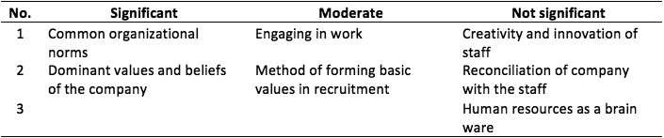[/graphic][/tabwrap]

[p]The results of the ranking of the contextual factors of research are presented in tables [xref ref-type="table" rid="t7"]7[/xref] and [xref ref-type="table" rid="t8"]8[/xref].[/p]

[tabwrap id="t7"][label]Table 7[/label]. [caption]Ranking the contextual factors (Source: TOPSIS outputs)[/caption]

[graphic href="?a04v22n52"]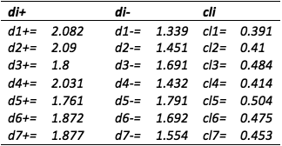[/graphic][/tabwrap]

[p]According to [xref ref-type="table" rid="t8"]Table 8[/xref], government’s support is the most important element, while legislating facilitating laws, bank’s support and facilitating the competition laws are considered less important. It might be due to the current state of the existing banking and competition laws. [/p]

[tabwrap id="t8"][label]Table 8[/label]. [caption]Classification of contextual factors (Source: TOPSIS outputs)[/caption]

[graphic href="?a04v22n52"]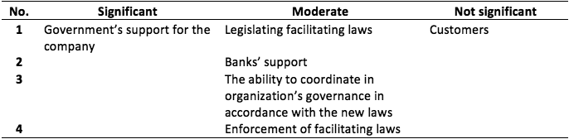[/graphic][/tabwrap]

[p]The following spider diagram analyzes the independent variable indices (Figure [xref ref-type="fig" rid="f2"]2[/xref]). The impact of human potential on the growth and status of these industries in industrial policy with an index of 0.465 is of the highest rank, the impact of organizational potential on the growth and status of these industries in industrial policy, with an index of 0.426, is in the second rank, the impact of regional potential on the growth and status of these industries in industrial policy, with an index rating of 0.422, is in the third rank, and the impact of ranking on the status of these industries in industrial policy, with an index of 0.401, is in the fourth rank.[/p]

[figgrp id="f2"][graphic href="?a04v22n52"]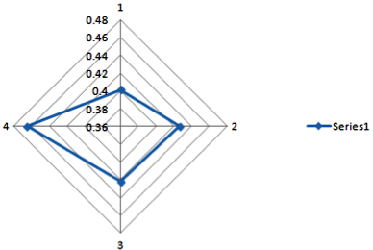[/graphic]

[label]Figure 2[/label]. [caption]The spider diagram of examined indices- independent variable of the research (Source: SPSS outputs)[/caption][/figgrp]

- [/subsec][subsec][sectitle]Conclusion[/sectitle]

[p]The hypothesis of this study has been developed to rank the factors affecting the establishment of status of “single” industries in industrial policy. Desired data were collected through questionnaires, which have been distributed among 60 members of the samples. First, the data was analyzed through investigating the frequency tables. Cronbach’s alpha and experts’ opinion were used in order to investigate the validity and reliability of the questionnaire. As is can be understood from the theory of this test and the expert opinion the developed questionnaire is valid and reliable. After ensuring the two above categories enjoying TOPSIS techniques, the hypothesis of this study was ranked, once individually and once together; the results suggest that content factors are of the highest importance and rank affecting the establishment of the status of single industries in industrial policy and indices of common organizational norms considered as the highest and the most important factor is in this group. Contextual factors and customers’ index is in the second rank. Structural factors with inherent managers’ skills index are ranked third in this category.[/p]
[p]Poorzaman, Yusefi, Soleimani, & Hemmatyar ([xref ref-type="bibr" rid="r24"]2014[/xref]), in a study entitled “The role of critical success on corporate entrepreneurship”, concluded that cultural dimensions, developing a culture of learning and acquisition of skills is of key importance in order to promote knowledge-based companies, while the knowledge, skills and capacity of staff creativity affect their ability and capacity dimensions. Training, development and recruitment of the empowerment and implicating control aspects such as evaluation policies based on knowledge-based activities can be very effective (Poorzaman et al., [xref ref-type="bibr" rid="r24"]2014[/xref]; Salamzadeh, Nejati & Salamzadeh, [xref ref-type="bibr" rid="r28"]2014[/xref], Salamzadeh, YousefNia, Radovic Markovic & Salamzadeh, [xref ref-type="bibr" rid="r29"]2016[/xref]). Sepehrdoust and Shabkhaneh ([xref ref-type="bibr" rid="r30"]2015[/xref]), in a study entitled “Impact of knowledge-based components on organizational productivity”, indicate that the four main variables of the knowledge-based economy; the education variable, information and communication technology innovations, economic incentives and regulations institutional are of greatest impact on growth and productivity of knowledge-based companies. Wang and Chang ([xref ref-type="bibr" rid="r33"]2014[/xref]), in a study entitled “Building exploration and exploitation in the high-tech industry: The role of relationship learning”, came to the conclusion that learning is of maintenance and support role in high-tech industries, learning improves and tuning information, and upgrades the abilities and capacities in people, products and services. Learning outcomes lead to the promotion of innovation in the development of production and products. [/p]
[p]According to the results of the above study and previous studies, similarities and contradictions are obtained as follows. In the present study, content factors are of the highest impact on determining the ranking of factors on the status of single industries in industrial policy that studied indicators in this category of factors are those related to human resources and corporate culture. The results of this study are consistent with the results of Tan et al. ([xref ref-type="bibr" rid="r32"]2005[/xref]), with regard to the efficiency of human resources and Cloodt et al. ([xref ref-type="bibr" rid="r6"]2006[/xref]) with regard the effective role of education. Among the factors influencing the determination of ranking in this study, are contextual factors, which the role of the government as one of the effective indices were investigated and ranked after structural and content factors. Sharabi et al. ([xref ref-type="bibr" rid="r31"]2012[/xref]), pointed out on the role of law and its impact on single industries. This part of the issue is quite similar to the investigation of index of legal elements of the contextual factors of the present study, the difference is that he contend that kind and implementing of laws on public and private institutions are different, and depending on the purpose, the degree of activity, the level of value, political affiliation, etc. will be different.[/p]

- [/subsec][subsec][sectitle]Directions for future research[/sectitle]

[p]Due to the importance of content factors in establishing the status of single industries in industrial policy, and to achieve a satisfactory result with regard to enriching the corporate culture and corporate culture management, the followings are recommended. Corporate culture management is a process that continuously identifies current and desired corporate culture and takes actions in order to change the existing culture and developing good values and patterns. Of course, this process is influenced by the culture of external environment, and its procedures are as follows: identification of current corporate culture, explaining the desired corporate culture, comparing the current status with the desired status of corporate culture, change and development of corporate culture, evaluation of programs of change and development of corporate culture and maintain and support the corporate culture. With regard to the understanding of internal culture of knowledge-based companies, closing it to the elevation status of this industry and recognizing the external factors of corporate culture and assessment of their impact, can reach an appropriate corporate culture among staff to promote the company’s level in the single industries.[/p][/subsec][/xmlbody]

[refs][sectitle]References[/sectitle]

[ref id="r1" reftype=“journal"][authors role="nd"][pauthor][surname]Battaglia[/surname], [fname]A.[/fname][/pauthor][/authors] ([date dateiso="20140000" specyear="2014"]2014[/date]). [arttitle]Creative industries and knowledge economy development in Rome: the example of Pietralata District[/arttitle]. [source] International Journal of Knowledge-Based Development, [/source] [volid]5[/volid] ([issueno]3[/issueno]), [pages]238-252[/pages]. doi: [url]https://doi.org/10.1504/ijkbd.2014.065316[/url] [/ref]
[ref id="r2" reftype=“journal"][authors role="nd"][pauthor][surname]Cabrita[/surname], [fname]M.[/fname][/pauthor], [pauthor][surname]Cruz-Machado[/surname], [fname]V.[/fname][/pauthor], & [pauthor][surname]Cabrita[/surname], [fname]C.[/fname][/pauthor][/authors] ([date dateiso="20130000" specyear="2013"]2013[/date]). [arttitle]Managing creative industries in the context of knowledge-based urban development.[/arttitle] [source] International Journal of Knowledge-Based Development,[/source] [volid]4[/volid]([issueno]4[/issueno]), [pages]318-337[/pages]. Doi: [url]https://doi.org/10.1504/ijkbd.2013.058524[/url] [/ref]
[ref id="r3" reftype="book"][authors role="nd"][pauthor][surname]Chathoth[/surname], [fname]P.[/fname][/pauthor][/authors] ([date dateiso="20050000" specyear="2005"]2005[/date]).[source] Strategic alliances in the high-tech industry.[/source] [pubname]Logos-Verlag[/pubname]: [publoc]Germany[/publoc]. [url]https://doi.org/10.4324/9780080914343.ch10[/url] [/ref]
[ref id="r4" reftype="book"][authors role="nd"][pauthor][surname]Chang[/surname], [fname]H-J.[/fname][/pauthor], [pauthor][surname]Andreoni[/surname], [fname]A.[/fname][/pauthor] & [pauthor][surname]Kuan[/surname], [fname]M.[/fname][/pauthor] [/authors]([date dateiso="20130000" specyear="2013"]2013[/date]). [source]International industrial policy experiences and the lessons for the UK[/source] ([moreinfo]Working Paper No. 450[/moreinfo]). Retrieved from [url]https://www.cbr.cam.ac.uk/fileadmin/user_upload/centre-for-business-research/downloads/working-papers/wp450.pdf[/url] [/ref]
[ref id="r5" reftype=“thesis"][authors role="nd"][pauthor][surname]Chen[/surname], [fname]X.[/fname][/pauthor] [/authors]([date dateiso="20120000" specyear="2012"]2012[/date]). [source]Varying Significance of Influencing Factors in Developing High-Tech Clusters: Using Cities of the U.S. and China as Example[/source] ([thesgrp]Master's Thesis[/thesgrp]). Retrieved from web site of Columbia University: [url]https://academiccommons.columbia.edu/.../Xia_Chen-HIGH-TECH_CLUSTERS.pdf[/url] [/ref]
[ref id="r6" reftype=“journal"][authors role="nd"][pauthor][surname]Cloodt[/surname], [fname]M.[/fname][/pauthor], [pauthor][surname]Hagedoorn[/surname], [fname]J.[/fname][/pauthor], & [pauthor][surname]Van Kranenburg[/surname], [fname]H.[/fname][/pauthor] [/authors]([date dateiso="20060000" specyear="2006"]2006[/date]). [arttitle]Mergers and acquisitions: Their effect on the innovative performance of companies in high-tech industries.[/arttitle] [source]Research policy, [/source][volid]35[/volid]([issueno]5[/issueno]), [pages]642-654[/pages]. doi: [url]https://doi.org/10.1016/j.respol.2006.02.007[/url] [/ref]
[ref id="r7" reftype=“journal"][authors role="nd"][pauthor][surname]Crandall[/surname], [fname]R.[/fname][/pauthor], & [pauthor][surname]Jackson[/surname], [fname]C.[/fname][/pauthor][/authors] ([date dateiso="20110000" specyear="2011"]2011[/date]). [arttitle]Antitrust in high-tech industries.[/arttitle] [source]Review of Industrial Organization, [/source][volid]38[/volid]([issueno]4[/issueno]), [pages]319-362.[/pages] doi: [url]https://doi.org/10.1007/s11151-011-9298-4[/url] [/ref]
[ref id="r8" reftype="book"][authors role="nd"][pauthor][surname]Deutch[/surname], [fname]J.[/fname][/pauthor][/authors] ([date dateiso="20050000" specyear="2005"]2005[/date]). [source]What should the government do to encourage technical change in the energy sector?[/source] [moreinfo](Report No.120). Retrieved from web site of MIT Joint Program on the Science and Policy of Global Change:[/moreinfo] [url]http://web.mit.edu/globalchange/www/MITJPSPGC_Rpt120.pdf[/url] [/ref]
[ref id="r9" reftype=“journal"][authors role="nd"][pauthor][surname]Dhéret[/surname], [fname]C.[/fname][/pauthor], & [pauthor][surname]Morosi[/surname], [fname]M.[/fname][/pauthor][/authors] ([date dateiso="20140000" specyear="2014"]2014[/date]). [arttitle]Towards a New Industrial Policy for Europe.[/arttitle] [source]European Policy Centre,[/source] ([issueno]78[/issueno]). Retrieved from [url]http://aei.pitt.edu/57931[/url] [/ref]
[ref id="r10" reftype=“journal"][authors role="nd"][pauthor][surname]Donate[/surname], [fname]M. J.[/fname][/pauthor], & [pauthor][surname]Guadamillas[/surname], [fname]F.[/fname][/pauthor][/authors] ([date dateiso="20110000" specyear="2011"]2011[/date]). [arttitle]Organizational factors to support knowledge management and innovation.[/arttitle] [source] Journal of Knowledge Management,[/source] [volid]15[/volid]([issueno]6[/issueno]), [pages]890-914[/pages]. doi: [url]https://doi.org/10.1108/13673271111179271[/url] [/ref]
[ref id="r11" reftype=“journal"][authors role="nd"][pauthor][surname]Elia[/surname], [fname]G.[/fname][/pauthor], [pauthor][surname]Petti[/surname], [fname]C.[/fname][/pauthor], & [pauthor][surname]Sarcina[/surname], [fname]A.[/fname][/pauthor][/authors] ([date dateiso="20160000" specyear="2016"]2016[/date]). [arttitle]Promoting communities of innovation: Do industrial policies matter?[/arttitle] [source] International Journal of Knowledge-Based Development, [/source][volid]7[/volid]([issueno]3[/issueno]), [pages]207-224.[/pages] doi: [url]https://doi.org/10.1504/ijkbd.2016.078522[/url] [/ref]
[ref id="r12" reftype="book"][authors role="nd"][cauthor]Federal Ministry of Education and Research[/cauthor].[/authors] ([date dateiso="20140000" specyear="2014"]2014[/date]). [source]The new High-Tech Strategy Innovations for Germany, federal ministry of education and research.[/source] Retrieved from [url]https://www.bmbf.de/pub/HTS_Broschuere_eng.pdf[/url][/ref]
[ref id="r13" reftype=“journal"][authors role="nd"][pauthor][surname]Gambarotto[/surname], [fname]F.[/fname][/pauthor], [pauthor][surname]Bolisani[/surname], [fname]E.[/fname][/pauthor], & [pauthor][surname]Scarso[/surname], [fname]E.[/fname][/pauthor][/authors] ([date dateiso="20110000" specyear="2011"]2011[/date]). [arttitle]Mapping knowledge territories for development policies.[/arttitle] [source] International Journal of Knowledge-Based Development, [/source][volid]2[/volid]([issueno]1[/issueno]), [pages]16-33[/pages]. doi: [url]https://doi.org/10.1504/ijkbd.2011.040624[/url] [/ref]
[ref id="r14" reftype=“journal"][authors role="nd"][pauthor][surname]Gorji[/surname], [fname]E.[/fname][/pauthor], & [pauthor][surname]Alipourian[/surname], [fname]M.[/fname][/pauthor] [/authors]([date dateiso="20110000" specyear="2011"]2011[/date]). [arttitle]The Knowledge Economy and the Knowledge Assessment Methodology.[/arttitle][source] Iranian Economic Review, [/source][volid]15[/volid]([issueno]29[/issueno]), [pages]43-72[/pages]. Retrieved from [url]https://ier.ut.ac.ir/article_32722.html[/url] [/ref]
[ref id="r15" reftype=“journal"][authors role="nd"][pauthor][surname]Hatakenaka[/surname], [fname]S.[/fname][/pauthor][/authors] ([date dateiso="20150000" specyear="2015"]2015[/date]). [arttitle]The role of higher education institutions in innovation and economic development.[/arttitle][source] International Higher Education,[/source] [volid]47[/volid]. doi: [url]https://doi.org/10.6017/ihe.2007.47.7961[/url] [/ref]
[ref id="r16" reftype="book"][authors role="nd"][pauthor][surname]Hawkins[/surname], [fname]B.[/fname][/pauthor], [pauthor][surname]Rudy[/surname], [fname]J.[/fname][/pauthor] & [pauthor][surname]Wallace[/surname], [fname]W.[/fname][/pauthor][/authors] ([date dateiso="20020000" specyear="2002"]2002[/date]).[source] Technology Everywhere: A Campus Agenda for Educating and Managing Workers in the Digital Age [/source](Vol. [volid]6[/volid]). Retrieved from [url]https://www.educause.edu/ir/library/pdf/pub7006a.pdf[/url] [/ref]
[ref id="r17" reftype="book"][authors role="nd"][pauthor][surname]Heaidari[/surname], [fname]M.[/fname][/pauthor], [pauthor][surname]Moghimi[/surname], [fname]S.[/fname][/pauthor] & [pauthor][surname]Khanifar[/surname], [fname]H.[/fname][/pauthor][/authors] ([date dateiso="20110000" specyear="2011"]2011[/date]). [source]The critical success factors in implementing knowledge management: agricultural organization in Islamic Republic of Iran,[/source] [volid]1[/volid]([issueno]2[/issueno]), [pages]45-64.[/pages] Retrieved from [url]http://farabi.ut.ac.ir/elmi/teachers/Article_B_41.pdf[/url] [/ref]
[ref id="r18" reftype=“journal"][authors role="nd"][pauthor][surname]Khajeheian[/surname], [fname]D.[/fname][/pauthor][/authors] ([date dateiso="20160000" specyear="2016"]2016[/date]). [arttitle]Telecommunication Policy: Communication Act Update.[/arttitle] [source] Global Media Journal, [/source][volid]9[/volid]([issueno]1[/issueno]), [pages]135-141[/pages]. Retrieved from [url]http://www.gmj.uottawa.ca/1601/v9i1_khajeheian.pdf[/url] [/ref]
[ref id="r19" reftype=“journal"][authors role="nd"][pauthor][surname]Khajeheian[/surname], [fname]D.[/fname][/pauthor], & [pauthor][surname]Tadayoni[/surname], [fname]R.[/fname][/pauthor][/authors] ([date dateiso="20160000" specyear="2016"]2016[/date]). [arttitle]User innovation in public service broadcasts: creating public value by media entrepreneurship.[/arttitle] [source] International Journal of Technology Transfer and Commercialisation, [/source][volid]14[/volid]([issueno]2[/issueno]), [pages]117-131[/pages]. doi: [url]https://doi.org/10.1504/ijttc.2016.081635[/url] [/ref]
[ref id="r20" reftype=“journal"][authors role="nd"][pauthor][surname]Law[/surname], [fname]K. M.[/fname][/pauthor][/authors] ([date dateiso="20100000" specyear="2010"]2010[/date]). [arttitle]Factors affecting sustainability development: high-tech manufacturing firms in Taiwan.[/arttitle][source] Asia Pacific Management Review, [/source][volid]15[/volid]([issueno]4[/issueno]), [pages]619-633[/pages]. Retrieved from [url]http://apmr.management.ncku.edu.tw/comm/updown/DW1012213796.pdf[/url] [/ref]
[ref id="r21" reftype=“journal"][authors role="nd"][pauthor][surname]Lee[/surname], [fname]K. C.[/fname][/pauthor], [pauthor][surname]Lee[/surname], [fname]S.[/fname][/pauthor], & [pauthor][surname]Kang[/surname], [fname]I. W.[/fname][/pauthor][/authors] ([date dateiso="20050000" specyear="2005"]2005[/date]). [arttitle]KMPI: measuring knowledge management performance.[/arttitle][source] Information & Management, [/source][volid]42[/volid]([issueno]3[/issueno]), [pages]469-482[/pages]. doi: [url]https://doi.org/10.1016/j.im.2004.02.003[/url] [/ref]
[ref id="r22" reftype=“journal"][authors role="nd"][pauthor][surname]Lo[/surname], [fname]D.[/fname][/pauthor], & [pauthor][surname]Wu[/surname], [fname]M.[/fname][/pauthor][/authors] ([date dateiso="20140000" specyear="2014"]2014[/date]). [arttitle]The state and industrial policy in Chinese economic development.[/arttitle] In:[source] Salazar-Xirinachs, J. M. and Nübler, I. and Kozul-Wright, R., (eds.), Transforming Economies: Making industrial policy work for growth, jobs and development. [/source][publoc]Geneva[/publoc]: [pubname]International Labour Office[/pubname], [pages]307-326[/pages]. Retrieved from [url]http://eprints.soas.ac.uk/20572[/url] [/ref]
[ref id="r23" reftype=“journal"][authors role="nd"][pauthor][surname]Matthew[/surname], [fname]D.[/fname][/pauthor], [pauthor][surname]Joro[/surname], [fname]I. D.[/fname][/pauthor], & [pauthor][surname]Manasseh[/surname], [fname]H.[/fname][/pauthor][/authors] ([date dateiso="20150000" specyear="2015"]2015[/date]). [arttitle]The Role of Information Communication Technology in Nigeria Educational System[/arttitle], [source]International Journal of Research in Humanities and Social Studies[/source], [volid]2[/volid]([issueno]2[/issueno]), [pages]48-66[/pages]. [url]http://www.ijrhss.org/pdf/v2-i2/8.pdf[/url] [/ref]
[ref id="r24" reftype=“journal"][authors role="nd"][pauthor][surname]Poorzaman[/surname], [fname]J.[/fname][/pauthor], [pauthor][surname]Yusefi[/surname], [fname]E.[/fname][/pauthor], [pauthor][surname]Soleimani[/surname], [fname]M.[/fname][/pauthor] & [pauthor][surname]Hemmatyar[/surname], [fname]M.[/fname][/pauthor][/authors] ([date dateiso="20140000" specyear="2014"]2014[/date]). [arttitle]The Role of Critical Success Factors for Implementing Knowledge Management on Corporate Entrepreneurship[/arttitle], [source]International Research Journal of Management Sciences[/source], [volid]2[/volid]([issueno]3[/issueno]), [pages]91-99[/pages]. Retrieved from [url]http://irjmsjournal.com/wp-content/uploads/paper351.pdf[/url] [/ref]
[ref id="r25" reftype=“journal"][authors role="nd"][pauthor][surname]Sadeghi[/surname], [fname]A.[/fname][/pauthor], [pauthor][surname]Azar[/surname], [fname]A.[/fname][/pauthor], & [pauthor][surname]Rad[/surname], [fname]R. S.[/fname][/pauthor][/authors] ([date dateiso="20120000" specyear="2012"]2012[/date]). [arttitle]Developing a fuzzy group AHP model for prioritizing the factors affecting success of high-Tech SME's in Iran: A Case Study[/arttitle].[source] Procedia-Social and Behavioral Sciences, [/source][volid]62[/volid], [pages]957-961[/pages]. Retrieved from [url]https://doi.org/10.1016/j.sbspro.2012.09.163[/url] [/ref]
[ref id="r26" reftype=“journal"][authors role="nd"][pauthor][surname]Salamzadeh[/surname], [fname]A.[/fname][/pauthor], [pauthor][surname]Kesim[/surname], [fname]H. K.[/fname][/pauthor], & [pauthor][surname]Salamzadeh[/surname], [fname]Y.[/fname][/pauthor][/authors] ([date dateiso="20160000" specyear="2016"]2016[/date]). [arttitle]Entrepreneurial universities and branding: A conceptual model proposal.[/arttitle][source] World Review of Science, Technology and Sustainable Development, [/source][volid]12[/volid]([issueno]4[/issueno]), [pages]300-315[/pages]. doi: [url]https://doi.org/10.1504/wrstsd.2016.082188[/url] [/ref]
[ref id="r27" reftype=“journal"][authors role="nd"][pauthor][surname]Salamzadeh[/surname], [fname]Y.[/fname][/pauthor], [pauthor][surname]Ardakani[/surname], [fname]S.[/fname][/pauthor], & [pauthor][surname]Zanjirchi[/surname], [fname]M.[/fname][/pauthor][/authors] ([date dateiso="20090000" specyear="2009"]2009[/date]). [arttitle]What should we do now? Analysis of the globalization challenges in Iranian SMEs: a Study on Food Industries of Hamadan Province using Fuzzy MADM Approach[/arttitle]. [source]Annals of University of Bucharest, Economic and Administrative Series[/source], [volid]3[/volid], [pages]165-178[/pages]. [url]http://annalseas.faa.ro/download/10%2520Yashar.pdf[/url] [/ref]
[ref id="r28" reftype=“journal"][authors role="nd"][pauthor][surname]Salamzadeh[/surname], [fname]Y.[/fname][/pauthor], [pauthor][surname]Nejati[/surname], [fname]M.[/fname][/pauthor], & [pauthor][surname]Salamzadeh[/surname], [fname]A.[/fname][/pauthor][/authors] ([date dateiso="20140000" specyear="2014"]2014[/date]). [arttitle]Agility path through work values in knowledge-based organizations: a study of virtual universities.[/arttitle] [source]Innovar, [/source][volid]24[/volid]([issueno]53[/issueno]), [pages]177-186[/pages]. doi: [url]https://doi.org/10.15446/innovar.v24n53.43942[/url] [/ref]
[ref id="r29" reftype=“journal"][authors role="nd"][pauthor][surname]Salamzadeh[/surname], [fname]Y.[/fname][/pauthor], [pauthor][surname]YousefNia[/surname], [fname]M.[/fname][/pauthor] [pauthor][surname]Radovic Markovic[/surname], [fname]M.[/fname][/pauthor] & [pauthor][surname]Salamzadeh[/surname], [fname]A.[/fname][/pauthor] [/authors]([date dateiso="20160000" specyear="2016"]2016[/date]). [arttitle]Strategic management development: the role of learning school on promotion of managers’ competence[/arttitle], [source]Economía y Sociedad[/source], [volid]21[/volid]([issueno]50[/issueno]), [pages]1-25[/pages]. doi: [url]https://doi.org/10.15359/eys.21-50.4[/url] [/ref]
[ref id="r30" reftype=“journal"][authors role="nd"][pauthor][surname]Sepehrdoust[/surname], [fname]H.[/fname][/pauthor], & [pauthor][surname]Zamani Shabkhaneh[/surname], [fname]S.[/fname][/pauthor][/authors] ([date dateiso="20150000" specyear="2015"]2015[/date]). [arttitle]Impact of Knowledge-based Components on Total Factor Productivity of MENA Countries.[/arttitle] [source]Iranian Economic Review[/source], [volid]19[/volid]([issueno]2[/issueno]), [pages]149-163[/pages]. Retrieved from [url]https://ier.ut.ac.ir/article_56076_7434.html[/url] [/ref]
[ref id="r31" reftype=“journal"][authors role="nd"][pauthor][surname]Sharabi[/surname], [fname]M.[/fname][/pauthor], [pauthor][surname]Arian[/surname], [fname]O.[/fname][/pauthor], & [pauthor][surname]Simonovich[/surname], [fname]J.[/fname][/pauthor][/authors] ([date dateiso="20120000" specyear="2012"]2012[/date]). [arttitle]High-Tech and Public Sectors Employees' Perception of Factors Influencing Promotion[/arttitle]. [source]International Journal of Business and Social Science[/source], [volid]3[/volid]([issueno]1[/issueno]), [pages]116-130[/pages]. Retrieved from [url]http://citeweb.info/20122428425[/url] [/ref]
[ref id="r32" reftype=“journal"][authors role="nd"][pauthor][surname]Tan[/surname], [fname]F. B.[/fname][/pauthor], & [pauthor][surname]Leewongcharoen[/surname], [fname]K.[/fname][/pauthor][/authors] ([date dateiso="20050000" specyear="2005"]2005[/date]). [arttitle]Factors contributing to IT industry success in developing countries: The case of Thailand[/arttitle]. [source]Information Technology for Development[/source], [volid]11[/volid]([issueno]2[/issueno]), [pages]161-194[/pages]. doi: [url]https://doi.org/10.1002/itdj.20009[/url] [/ref]
[ref id="r33" reftype=“journal"][authors role="nd"][pauthor][surname]Wang[/surname], [fname]CH.[/fname][/pauthor] & [pauthor][surname]Chang Hu[/surname], [fname]L.[/fname][/pauthor][/authors] ([date dateiso="20140000" specyear="2014"]2014[/date]). [arttitle]Building exploration and exploitation in the high-tech industry: The role of relationship learning[/arttitle]. [source]Technological Forecasting and Social Change[/source], [volid]81[/volid], [pages]331-340[/pages]. doi: [url]https://doi.org/10.1016/j.techfore.2013.04.008[/url] [/ref]
[ref id="r34" reftype="book"][authors role="nd"][pauthor][surname]Wolf[/surname], [fname]M.[/fname][/pauthor] & [pauthor][surname]Terrell[/surname], [fname]D.[/fname][/pauthor][/authors] ([date dateiso="20160000" specyear="2016"]2016[/date]). [source]The high-tech industry, what is it and why it matters to our economic future?[/source] Retrieved from [url]http://digitalcommons.ilr.cornell.edu/key_workplace/1566[/url][/ref][/refs][/doc]

