[doc sps="1.8" acron="rge" jtitle="Revista Geográfica de América Central" stitle="Rev. Geog. Amér. Central" issn="1011-484X" pissn="1011-484X" eissn="2215-2563" pubname="Universidad Nacional, Costa Rica" license="http://creativecommons.org/licenses/by-nc-sa/4.0" volid="69" issueno="2" dateiso="20221200" season="July/Dec" order="07" fpage="199" lpage="224" pagcount="26" doctopic="oa" language="es"]Doi:[doi]10.15359/rgac.69/2.7[/doi]
[toctitle]Artículo[/toctitle]

[doctitle language="en"]Spatial analysis of changes in land use, vegetation and water bodies in the state of Nayarit, Mexico, 1993-2014[/doctitle]
[doctitle language="es"]Análisis espacial de los cambios de uso de suelo, vegetación y cuerpos de agua en el estado de Nayarit, México, 1993-2014[/doctitle]

[author role="nd"][fname]Isaías[/fname] [surname]Moreno-González[/surname][xref ref-type="aff" rid="aff1"]¹[/xref][authorid authidtp="orcid"]0000-0002-6356-4319[/authorid][/author]
[author role="nd"][fname]Noel Bonfilio[/fname] [surname]Pineda-Jaimes[/surname][xref ref-type="aff" rid="aff2"]² [/xref][authorid authidtp="orcid"]0000-0002-0861-0853[/authorid][/author]
[author role="nd"][fname]Luis Ricardo[/fname] [surname]Manzano-Solís[/surname][xref ref-type="aff" rid="aff3"]³ [/xref][authorid authidtp="orcid"]0000-0002-6634-2930[/authorid][/author]
[author role="nd"][fname]Xanat Antonio[/fname] [surname]Némiga[/surname][xref ref-type="aff" rid="aff4"]⁴[/xref] [authorid authidtp="orcid"]0000-0002-8827-6575[/authorid][/author]
[author role="nd"][fname]Jesús Trinidad[/fname] [surname]Ponce-Palafox[/surname] [xref ref-type="aff" rid="aff5"]⁵ [/xref][authorid authidtp="orcid"]0000-0002-1088-7114[/authorid][/author]
[author role="nd"][fname]Arnulfo Issai[/fname] [surname]Jiménez-Ante[/surname] [xref ref-type="aff" rid="aff6"]⁶[/xref] [/author]

[normaff id="aff1" ncountry="Mexico" norgname="Universidad Autónoma del Estado de México" icountry="MX"][label][sup]¹[/sup][/label][role]Master's in spatial analysis and geoinformatics.[/role] [orgdiv1]Facultad de Geografía[/orgdiv1], [orgname]Universidad Autónoma del Estado de México[/orgname], [city]Toluca[/city], [country]México[/country]. [orgdiv2]He has collaborated in the area of Cartography and Territory, in the “Subdirección de Geografía y Medio Ambiente, Western State Coordination of the Central South Regional Directorate of the National Institute of Statistics and Geography of Mexico. [/orgdiv2]Correo electrónico: [email]isamoreg@gmail[/email] https://orcid.org/0000-0002-6356-4319.[/normaff]
[normaff id="aff2" ncountry="Mexico" norgname="Universidad Nacional Autónoma de México" icountry="MX"][label][sup]2[/sup][/label] [role]Doctor.[/role] [orgdiv1]Facultad de Geografía[/orgdiv1], [orgname]Universidad Autónoma del Estado de México[/orgname], [city]Toluca[/city], [country]México[/country]. [orgdiv2] Currently works at the Faculty of Geography of the Autonomous University of the State of Mexico. His research and teaching focuses on the application of Geographic Information Systems in the areas of Land Management, Multi-criteria Evaluation, Land Cover and Land Use Change Models and Geospatial Analysis. He currently collaborates in the Academic Area of Geography, Planning and Sustainable Land Management.[/orgdiv2] Correo electrónico: [email]nbpinedaj@guaemex.mx[/email] https://orcid.org/0000-0002-0861-0853.[/normaff]
[normaff id="aff3" ncountry="Mexico" norgname="Universidad Autónoma del Estado de México" icountry="MX"][label][sup]³[/sup][/label] [role]Doctor.[/role] [orgdiv1]Facultad de Geografía[/orgdiv1], [orgname]Universidad Autónoma del Estado de México[/orgname], [city]Toluca[/city], [country]México[/country]. [orgdiv2] Currently works at the Faculty of Geography of the Autonomous University of the State of Mexico. His research interests are focused on the application of Geographic Information Systems in the areas of Water Management for Integrated Water Resources Management, Multi-criteria Evaluation, Climate Change and Geoinformatics Applications.[/orgdiv2] Correo electrónico: [email]luisrms@gmail.com[/email] https://orcid.org/0000-0002-6634-2930.[/normaff]
[normaff id="aff4" ncountry="Mexico" norgname="Universidad Autónoma del Estado de México" icountry="MX"][label][sup]⁴[/sup][/label] [role]Doctora.[/role] [orgdiv1]Facultad de Geografía[/orgdiv1], [orgname]Universidad Autónoma del Estado de México[/orgname], [city]Toluca[/city], [country]México[/country]. [orgdiv2]Currently works at the Faculty of Geography of the Autonomous University of the State of Mexico. Has a PhD. on natural resources management held by the UANL in México, and a MsC. On Geoinformation by the ITC in the Netherlands. She is currenlty a full time profesor at the (UAEMEX). Her research field is the applicaton of remote sensing and GIS spatial modelling to enrivonmental processes, particularly forest los and forest fires.[/orgdiv2] Correo electrónico: [email]xantonion@uaemex.mx[/email] https://orcid.org/0000-0002-8827-6575[/normaff]
[normaff id="aff5" ncountry="Mexico" norgname="Universidad Autónoma de Nayarit" icountry="MX"][label][sup]⁵[/sup][/label] [role]Doctor. [/role][orgdiv1]Facultad de Economía[/orgdiv1]. [orgname]Universidad Autónoma de Nayarit[/orgname], [city]Tepic[/city], [country]México[/country]. [orgdiv2]Currently works in the Environmental Mitigation Program of shrimp farms belonging to the Association of Aquaculturists of the Municipality of San Blas, Nayarit, Mexico. He has been coordinator of Aquaculture Management in 15 states of the Mexican Republic and of the Regional Environmental Manifestation of shrimp farms in the central and southern areas of the State of Nayarit, Mexico. Additionally, he has participated in Conservation Programs for aquatic species in the San Juan River, Nicaragua, Central America and in the Iranian waters of the Caspian Sea, South Asia.[/orgdiv2]Correo electrónico: [email]jesus.ponce@usa.net[/email] https://orcid.org/0000-0002-1088-7114[/normaff]
[normaff id="aff6" ncountry="Mexico" norgname="Universidad Autónoma de Nayarit" icountry="MX"][label][sup]⁶[/sup][/label] [role]Currently a specialist in Geographic Information Systems[/role]. [orgdiv1]Facultad de Economía[/orgdiv1]. [orgname]Universidad Autónoma de Nayarit[/orgname], [city]Tepic[/city], [country]México[/country]. [orgdiv2]He has collaborated in the development of geographic information, cartographic editing and spatial analysis for the Environmental Mitigation Program of shrimp farms belonging to the Association of Aquaculturists of the Municipality of San Blas, Nayarit, Mexico, and in Aquaculture Management programs in 15 states of the Mexican Republic as well as the Regional Environmental Manifestation of shrimp farms in the central and southern zone of the State of Nayarit, Mexico.[/orgdiv2] Correo electrónico: [email]issaija@gmail.com[/email][/normaff]

[xmlabstr language="en"][sectitle]Abstrac[/sectitle]
[p]To fully understand the dynamics of land use change it is necessary investigate the net change, exchanges and transitions occurring between land use categories. Therefore, this research explores the spatial and temporal trends of changes in land use, vegetation and water bodies in the state of Nayarit from 1993 to 2014. To do so, the INEGI vegetation maps (series II and IV) for both dates were validated with field observation, resampled and overlaid using TerrSet environment in order to calculate the change matrix, and from it estimate the losses, gains, net changes, total changes and exchanges between land use categories. Results indicate that of the 2,783,572.50 hectares of the total area, 58.06% remained without any change and 41.94% experienced some change. Within such area, 15.42% were exchanges between land categories whereas 26.52% were net change. Agriculture is the category that gained most area; occupying 18.17% of the total in 1993 and 22.14% in 2014. Oppositely low forest has decreased from 20.82% to 13.76% during the same period. [/p][/xmlabstr]
[kwdgrp language="en"][sectitle]Keywords:[/sectitle] [kwd]Land use change[/kwd]; [kwd]vegetation and bodies of water[/kwd]; [kwd]change matrix[/kwd]; [kwd]spatial analysis[/kwd][/kwdgrp]

[xmlabstr language="es"][sectitle]Resumen[/sectitle]
[p]Para comprender plenamente la dinámica de cambio de uso de suelo es necesario investigar el cambio neto, los intercambios y las transiciones que ocurren entre categorías de uso del suelo. Por ello, esta investigación explora las tendencias espaciales y temporales de los cambios de uso del suelo, la vegetación y los cuerpos de agua en el estado de Nayarit. Para hacerlo, las series II y IV de INEGI fueron validadas en campo, remuestreadas y sobrepuestas en TerrSet GIS para calcular la matriz de cambio y a partir de ella estimar las pérdidas, las ganancias el cambio neto, así como el cambio total y el intercambio entre categorías. Los resultados indican que, de las 2 783 572.50 hectáreas de la superficie total, el 58.06% no sufrió ningún cambio, mientras que el 41.94% presentó algún cambio en la ocupación del suelo, del cual 15.42% corresponde a intercambios entre las categorías y 26,.52% es un cambio neto. La categoría que ganó más proporción del territorio fue la agricultura; que en 1993 ocupaba el 18.17% y en 2014 pasó al 22.14%. Por el contrario, la selva baja disminuyó de 20.82% a 13.76% durante el mismo período.[/p][/xmlabstr]
[kwdgrp language="es"][sectitle]Palabras Clave:[/sectitle] [kwd]Cambios de uso del suelo[/kwd]; [kwd]vegetación y cuerpos de agua[/kwd]; [kwd]matriz de cambio[/kwd]; [kwd]análisis espacial[/kwd][/kwdgrp]

[hist]Recibido: [received dateiso="20210602"]02/06/2021[/received]
Aceptado: [accepted dateiso="20211026"]26/10/2021[/accepted][/hist]

[xmlbody][sec sec-type="intro"][sectitle]1. Introduction[/sectitle]

[p]Mexico has suffered significant degrees of disturbance in its natural ecosystems during the last five decades, due to the intensive exploitation of its natural resources. The complexity of such processes of change in land use and water bodies are determined by a network of complex interactions of socio-economic and environmental factors. Processes associated with the dynamics of change in land cover and land use are one of the main factors that determine the permanence, decline and extinction of different ecosystems and especially forests ([xref ref-type="bibr" rid="r52"]Zhang et al., 2017[/xref]). Thus, it is urgent to pay attention to the exploitation of environmental goods and services provided by different ecosystems. The primary sector, the rural environment and the evolution of economic activities keep straight relationship with changes in land use.[/p]
[p]The critical approach to environmental sustainability has increased the interest in understanding the underlying causes of land use change. Numerous studies have been supported by the Land-Use and Land Cover Change (LUCC) project now called Global Land Program (GLP), contributing to the analysis of changes in the territory for more than a decade. Land use change is a very dynamic and complex process that relates natural and human systems. It has a direct impact on soil, water and the atmosphere and is directly related to several environmental problems of global importance ([xref ref-type="bibr" rid="r35"]Meyer & Turner, 1994[/xref]). Large-scale deforestations and subsequent transformations of agricultural land in the tropics are examples of extensive land use change with strong impacts on biodiversity ([xref ref-type="bibr" rid="r29"]Lambin et al., 2003[/xref]).[/p]
[p]The impact of land use and land cover change on ecosystem health is one of the most important issues in land and ecosystem research ([xref ref-type="bibr" rid="r17"]Deng et al., 2013[/xref]; [xref ref-type="bibr" rid="r30"]Leh et al., 2013[/xref]; [xref ref-type="bibr" rid="r39"]Newbold et al., 2015[/xref]). Several studies have demonstrated the usefulness of methods, techniques and tools to analyze, evaluate and quantify the patterns of change, in order to understand their driving forces and depict their environmental and socioeconomic impacts ([xref ref-type="bibr" rid="r16"]Darvishi et al., 2020[/xref]; [xref ref-type="bibr" rid="r23"]Homer et al., 2020[/xref]; [xref ref-type="bibr" rid="r33"]Matsa et al., 2020[/xref]; [xref ref-type="bibr" rid="r38"]Naikoo et al., 2020[/xref]; [xref ref-type="bibr" rid="r50"]Schürmann et al., 2020[/xref]). In Mexico, is remarkable the work done on the evaluation and modelling of land use and cover change by [xref ref-type="bibr" rid="r9"]Bonilla-Moheno & Aide (2020[/xref]), [xref ref-type="bibr" rid="r12"]Calzada et al., (2018[/xref]), [xref ref-type="bibr" rid="r22"]Hernández-Guzmán et al., (2018[/xref]) and [xref ref-type="bibr" rid="r34"]Mendoza-Ponce et al. (2018[/xref]).[/p]
[p]Several methods and approaches have been used to describe the nature and intensity of land use change. The use of quantitative methods to evaluate land use and cover changes have been described ([xref ref-type="bibr" rid="r2"]Abreu & Ralha, 2018[/xref]; [xref ref-type="bibr" rid="r3"]Amadou et al., 2018[/xref]; [xref ref-type="bibr" rid="r31"]Li et al., 2020[/xref]; [xref ref-type="bibr" rid="r32"]Liu et al., 2020[/xref]; [xref ref-type="bibr" rid="r37"]Müller-Hansen et al., 2019[/xref]). Linear regression has been used to measure the dynamics of vegetation ([xref ref-type="bibr" rid="r1"]Abel et al., 2019[/xref]), to estimate areas cultivation of rice and their yield ([xref ref-type="bibr" rid="r15"]Chandra Paul et al., 2020[/xref]), and to explore the factors influencing the production of agricultural charge ([xref ref-type="bibr" rid="r18"]Dhulipala & Patil, 2020[/xref]). Logistic regression was applied to determine the dynamics of forest cover ([xref ref-type="bibr" rid="r4"]Bera et al., 2020[/xref]; [xref ref-type="bibr" rid="r49"]Saha, et al., 2020[/xref]) and in studies of urban land use change ([xref ref-type="bibr" rid="r14"]Cao et al., 2020[/xref]). The development and advancement of geotechnologies such as GIS, has improved the efficiency of the study of land use changes ([xref ref-type="bibr" rid="r46"]Prashar et al., 2013[/xref]). Currently, GIS technology has contributed to the elaboration of descriptive, explanatory and simulation models, where spatial analysis techniques are used to understand and forecast the changes in land use that have occurred in the territory. The analysis of the change matrix to identify systematic signals within a change pattern has been proposed as model to describe the magnitude and trend of land use change at a geographic landscape from a statistical point of view [xref ref-type="bibr" rid="r42"](Pineda, 2010[/xref]).[/p]
[p]Implementation of spatial analysis in a GIS environment has improved the perception of geography, as space science, from a theoretical perspective, and as an applied science to organize the territory ([xref ref-type="bibr" rid="r20"]Fuenzalida et al., 2015[/xref]). However, most studies in land use and vegetation in Mexico analyze only the total change and do not search in deep for the net change, exchanges and transitions occurring between land use categories. The change matrix is not deeply examined; most times, only transition matrices are obtained, and annual change rates and total areas compared at times t1 and t2. Only occasionally the gains, losses and persistence in the landscape are calculated and interpreted. Thus, it is important to determine the magnitude of the changes that have occurred in vegetation, and waterbodies at Nayarit State, using methods and techniques that yield precise and detailed information regarding change processes in the landscape.[/p]
[p]The aim of this research is to analyze and quantify the spatial and temporal trends of changes in land use, vegetation and water bodies, by calculating the losses, gains, net change, exchange and total change of each of the land use categories at Nayarit State, Mexico, 1993-2014.[/p]

[/sec][sec sec-type="methods"][sectitle]2. Methods[/sectitle]

[subsec][sectitle]2.1 Study area[/sectitle]

[p]The state of Nayarit, Mexico is located in the western portion of the country, between 20° 36´ 12’’ and 23° 05´ 04’’ in the north latitude and 103° 43´15’’ and 105 ° 45´37’’ of west longitude ([xref ref-type="fig" rid="f1"]Figure 1[/xref] ). Its surface occupies near 27 836 square kilometers. Although the archipelagos of the Islas Marías, las Marietas and Isla Isabel are part of the State, they were not considered in this study.[/p]

[figgrp id="f1"][attrib]Source: Author, based on [xref ref-type="bibr" rid="r25"]Marco Geoestadístico Nacional, 2017[/xref].[/attrib]
[graphic href="?a07v69n2"]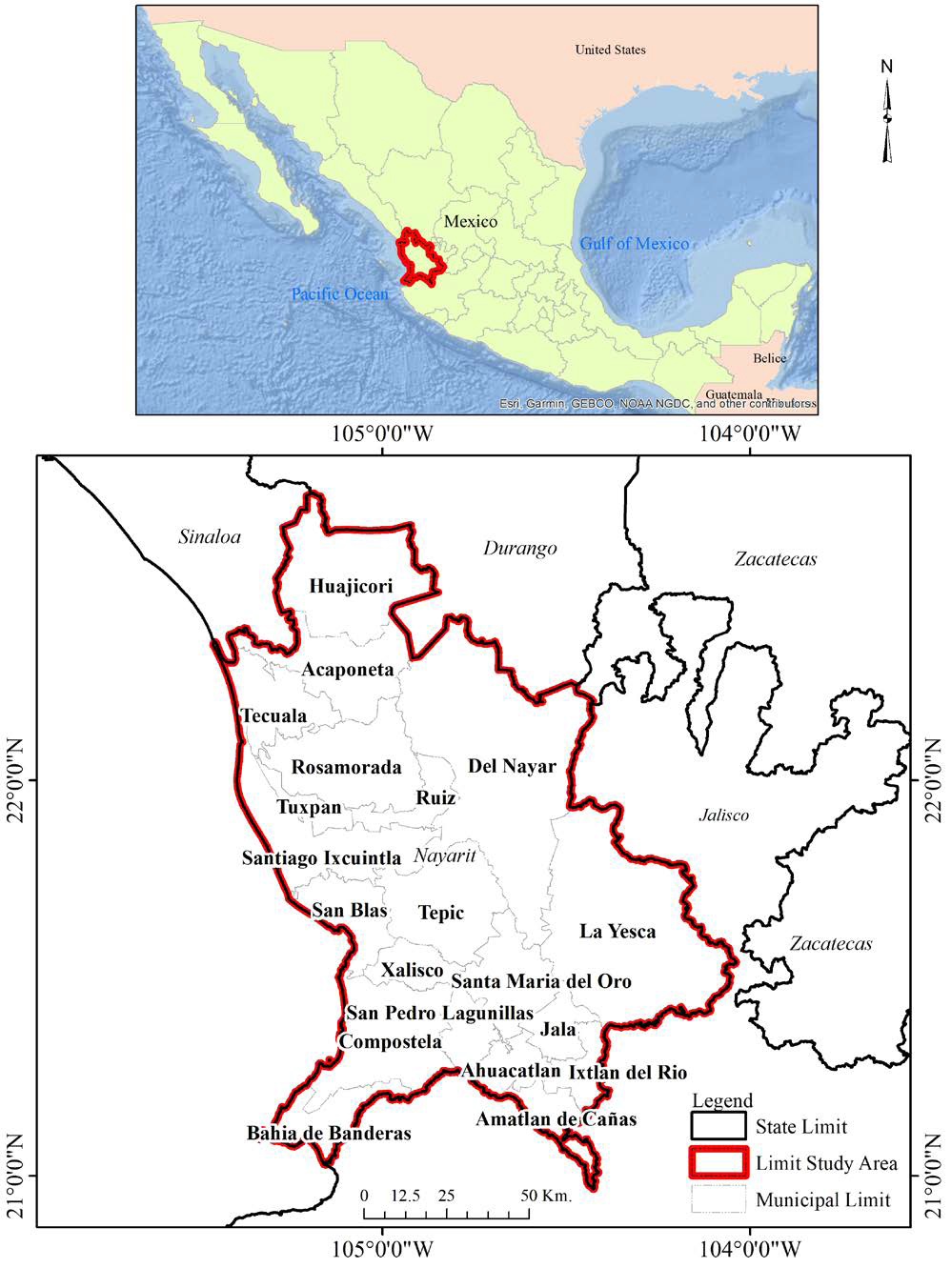[/graphic]
[label]Figure 1[/label]. [caption]Map of the state of Nayarit, Mexico.[/caption][/figgrp]

[p]Its total population is 1,235,456 persons registered in the 2020 census [xref ref-type="bibr" rid="r27"](INEGI, 2021[/xref]); 612,278 men and 623,178 women. Being one of the states with less inhabitants (place 29 out of 32) in the country. The predominant land uses are forests, oak, pine, mountain mesophyll communities, as well as associations with other types of plant cover (pine-oak, oak-pine). Considering their structures, there are medium sub deciduous forest, low deciduous forest, and low thorny shrubs, and several associations between these communities. There are also induced and cultivated grasslands growing on the coastal plains, along with mangroves, palm groves, savanna like vegetation, tular, popal, coastal dune vegetation, and halophilic and hydrophilic vegetation.[/p]
[p]This state territory is a transition area of terrestrial ecosystems and marine ecosystems, it contains tributaries of rivers and streams, producing a mixture of fresh water and water of sea in this area, making it optimal for aquaculture. Besides, in this area of the Marismas Nacionales, aquaculture is allowed in the corresponding land management plan ([xref ref-type="bibr" rid="r44"]Ponce-Palafox, 2015[/xref]).[/p]

[/subsec][subsec][sectitle]2.2 Data sources[/sectitle]

[p]As a reference base, two vectorial maps of land use and vegetation at scale 1: 250,000 in digital format (INEGI series II and series VI) were used. Series II map was elaborated from the visual interpretation of mosaics of satellite imagery obtained with the Thematic Mapper sensor (LANDSAT TM), acquired in 1993 with a spatial resolution of 50 m per-pixel. This map was modified by the National Institute of Ecology (INE), and according to [xref ref-type="bibr" rid="r51"]Velázquez et al. (2002[/xref]), has a level of precision and accuracy of 95%. Serie VI map was derived based as an update from V series map, made with photointerpretation techniques on multispectral satellite images (LANDSAT TM8) of 2014, with spatial resolution of 30 m per-pixel. Its quality was validated by the digital information standard of the National Statistical and Geographic Information System [xref ref-type="bibr" rid="r26"](INEGI, 2018[/xref]). To process these maps, the date of acquisition of the imagery is considered, instead of the publication date of the map and in both cases the layer of aquaculture use (polygons of shrimp farms) was added to have a comparable vector information. Due to the process of map generation (photo interpretation) these maps are not error free, however both maps were verified by and intense field verifications. Besides considering the area extent, the scale of the data and the level of detail of the categories analyzed, the possibility of thematic and geometric errors of the coverage is minimal.[/p]

[/subsec][subsec][sectitle]2.3 Map Processing and analysis[/sectitle]

[p]Map pre-processing included a preliminary review of previous categories in the study area. 18 land use classes were considered, and a common legend was elaborated so that the maps were comparable ([xref ref-type="bibr" rid="r36"]Moreno & Chuvieco, 2009[/xref]). Such legend reduced the differences in the definitions of class and type of vegetation, facilitating the comparison between products. Corresponding databases for each map were reclassified and homogenized. Topological vector correction was performed in order to relocate error and missing polygons and thematic standardization and filling of the database issues were solved. Both maps were reprojected to Universal Transverse Mercator coordinate system (Datum ITRF-92) and rasterized (1686 columns by 2196 rows). Star and Estes (1990) cited by [xref ref-type="bibr" rid="r10"]Bosque (1997[/xref]) suggested that the grid base size should be half the length than the smaller dimension needed to represent all the existing categories in reality. Considering this, a grid of 125 X 125 m was generated.[/p]

[/subsec][subsec][sectitle]2.4 Methodological framework[/sectitle]

[p]Location and quantification of land use changes was done by cartographic overlaid of maps corresponding to before and after maps, and the estimation of a matrix of changes, generating maps and change tables that allow identifying the magnitude and spatial distribution of the change dynamics [xref ref-type="bibr" rid="r19"](Dupuy et al., 2007[/xref]). Besides, in this study, losses, gains, net changes, total changes and exchanges between categories were calculated using the method by [xref ref-type="bibr" rid="r45"]Pontius et al. (2004[/xref]). It is important to note that the cartographic information is compatible, that is, they have the same area, scale and cartographic projection and comparable since they use the same legend or equivalence in the categories.[/p]

[/subsec][subsec][sectitle]2.5 Analysis of the dynamics of land use, vegetation and water bodies[/sectitle]

[p]The analysis of change processes within each category is based on the matrix of changes ([xref ref-type="table" rid="t1"]Table 1[/xref]). The rows of the categories show time1 (t1) and the columns show time2 (t2). Additional column on the right indicates the proportion experiencing a gross loss of category i between time1 and time2. The additional row at the bottom indicates the proportion experiencing a gross gain of category j between time1 and time2. The diagonal shows the total amount of the stable class between dates, while the transitions of the classes between time1 and time2 are outside the diagonal.[/p]

[tabwrap id="t1"][label]Table 1[/label]. [caption]Matrix of changes to compare two maps of different times.[/caption]
[table][thead][tr][th align="center"] [/th] | [th align="center"]Time 2[/th] | [th align="center"] [/th] | [th align="center"] [/th] | [th align="center"] [/th] | [th align="center"]Total time 1[/th] | [th align="center"]Losses[/th][/tr]
[tr][th align="center"] [/th] | [th align="center"]Category 1[/th] | [th align="center"]Category 2[/th] | [th align="center"]Category 3[/th] | [th align="center"]Category 4[/th] | [th align="center"] [/th] | [th align="center"] [/th][/tr]
[tr][th align="center"]Time 1[/th] | [th align="center"] [/th] | [th align="center"] [/th] | [th align="center"] [/th] | [th align="center"] [/th] | [th align="center"] [/th] | [th align="center"] [/th][/tr]
[/thead][tbody][tr][td align="center"]Category 1[/td] | [td align="center"]P11[/td] | [td align="center"]P12[/td] | [td align="center"]P13[/td] | [td align="center"]P14[/td] | [td align="center"]P1+[/td] | [td align="center"]P1+ P11[/td][/tr]
[tr][td align="center"]Category 2[/td] | [td align="center"]P21[/td] | [td align="center"]P22[/td] | [td align="center"]P23[/td] | [td align="center"]P24[/td] | [td align="center"]P2+[/td] | [td align="center"]P2+ P22[/td][/tr]
[tr][td align="center"]Category 3[/td] | [td align="center"]P31[/td] | [td align="center"]P32[/td] | [td align="center"]P33[/td] | [td align="center"]P34[/td] | [td align="center"]P3+[/td] | [td align="center"]P3+ P33[/td][/tr]
[tr][td align="center"]Category 4[/td] | [td align="center"]P 41[/td] | [td align="center"]P 42[/td] | [td align="center"]P 43[/td] | [td align="center"]P 44[/td] | [td align="center"]P4+[/td] | [td align="center"]P4+ P44[/td][/tr]
[tr][td align="center"]Total time 2[/td] | [td align="center"]P+1[/td] | [td align="center"]P+2[/td] | [td align="center"]P+3[/td] | [td align="center"]P+4[/td] | [td align="center"]1[/td] | [td align="center"] [/td][/tr]
[tr][td align="center"]Gains[/td] | [td align="center"]P+1 P11[/td] | [td align="center"]P+2 P22[/td] | [td align="center"]P+3 P33[/td] | [td align="center"]P+4 P44[/td] | [td align="center"] [/td] | [td align="center"] [/td][/tr][/tbody][/table]
[fntable id="TFN1"]Source: [xref ref-type="bibr" rid="r45"]Pontius et al., (2004[/xref]).[/fntable][/tabwrap]

[p]With the information from the change matrix, the gain (Gij) was calculated, which is the difference between the total column of time2 (P+ j) and the persistence (Pjj) (expr. 1).[/p]
[quote]Gij = P+j Pij (1)[/quote]
[p]The loss (Lij) denotes the difference between the total row of time 1 (Pj+) and the persistence (Pjj), (expr. 2).[/p]
[quote]Lij = Pj+ Pij (2)[/quote]
[p]To calculate the total change for each category (Cj) it is established as the sum of the net change (Dj) and the exchange (Sj), or, the sum of the gains and losses (expr. 3).[/p]
[quote]Cj = Dj + Sj (3)[/quote]
[p]The exchange between categories (Sj) is calculated as twice the minimum value of gains and losses (expr. 4).[/p]
[quote]Sj 2 X MIN (Pj+ Pjj, P+j Pjj) (4)[/quote]
[p]The net change is defined as the absolute value of the difference between the gains and losses of each category (expr. 5).[/p]
[quote]Dj = |Lij Gij| (5)[/quote]
[p]To calculate the losses, gains, persistence, exchange and net change for each category the results of CROSSTAB command were exported to Excel, to convert cell units to hectares multiplying by the cell size (125 m²) and to calculate percentages.[/p]

[/subsec][/sec][sec sec-type="results"][sectitle]3. Results[/sectitle]

[p]3.1 Analysis of the dynamics of land use and cover changes, vegetation and water bodies[/p]

[p]In this study, 18 land cover categories were analyzed for the year 1993 (a) and 2014 (b) ([xref ref-type="fig" rid="f2"]Figure 2[/xref]). In 1993, the low forest areas accounted for 20.82% of the total state coverage, while agriculture covered 18.17%. Similarly, the mixed forest (pine-oak forest and oak-pine) had 17.00% followed by the oak forest with the 16.98%, whereas the medium forest covered 14.85%, and water bodies occupied 1.63%. In 2014, agriculture increased its surface area and exceeded 22.14% of the state territory. The mixed forest comprised 19.13%, the medium forest occupied 15.05%, the low forest accounted for 13.76%, and the share of oak forests decreased to 12.11 %. Finally, water bodies occupied 1.91%.[/p]

[figgrp id="f2"][attrib]Source: INEGI Land use and vegetation mapping 1993 and 2014.[/attrib]
[graphic href="?a07v69n2"]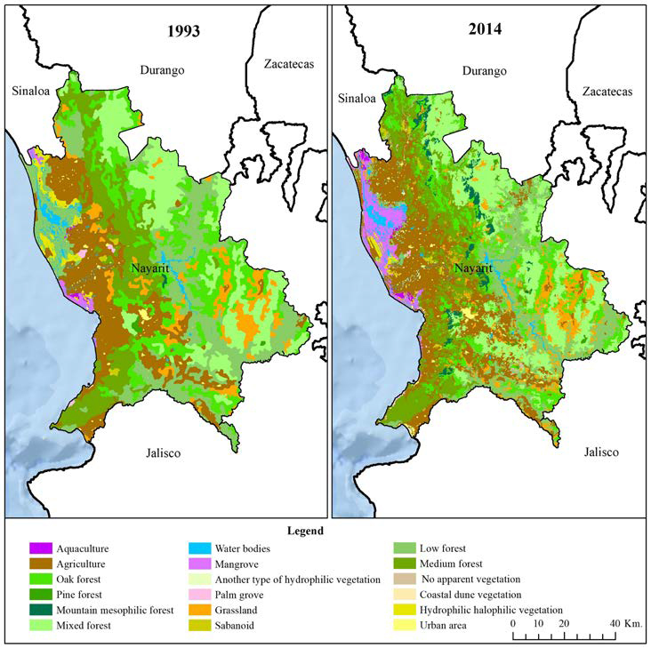[/graphic]
[label]Figure 2[/label]. [caption]Land use and cover change in 1993 (a) and 2014 (b) at the vegetation type level.[/caption][/figgrp]

[p]According to the observed patterns, changes occurring within each category at Nayarit state are described and quantified. ([xref ref-type="table" rid="t2"]Table 2[/xref]) shows a summary of the matrix of changes in hectares and in percentages of the losses, gains, net change, exchange and total change of each of the analyzed categories. This makes it possible to clearly distinguish a net change from a total change, since the latter hides the exchanges that take place between categories. During the study period and at the coverage type level, the total change affected 2,783,572.50 ha. 58.06%, did not experience any change, while 41.94% presented some change in land cover, of which 15.42% denotes exchanges between the categories and 26.52% corresponds to a net change.[/p]
[p]The real values of the change between 1993 and 2014 were obtained by means of the equation of the total change (expr. 3) that, unlike the net change (expr. 5), made possible to estimate the transitions between categories. In this regard, it should be noted that, if a category had gains and losses of the same magnitude, then net change would be equal to zero. Agriculture extended over an area of 505,767.3 ha in 1993, while for 2014, it increased to 616,147.2 ha. There was an increase of 110,380.00 ha, during a period of 21 years.[/p]
[p]The increase in the mountain mesophilic forest stands shows a gain of 58,843.25 ha, considering a “recovery” of the forest cover, mainly at the municipalities of Del Nayar (22,611 ha) and Huajicori (16,899 ha). Another coverage with significant gains is mixed forests with 194,123.50 ha, mainly in the municipalities of Del Nayar (75,784 ha), La Yesca (41,787 ha) and, to a lesser extent Santa María del Oro (20,425 ha). The recovery of the mangroves is considerable showing a gain of 86,812.75 ha, which is most evident in the municipalities of Santiago Ixcuintla (34,718 ha), Rosamorada (21,667) ha and Tecuala (18,041 ha).[/p]
[p]With regard to the loss of vegetation, low forest lost 287,422.75 ha, classified as a disturbance process. The municipality of Del Nayar has had the greatest alteration with 48,330 ha, followed by Santiago Ixcuintla with 38,081 ha and Huajicori with 30,316 ha. Oak forests lost almost half of its coverage (286,515.00 ha). This was recorded in the municipality of Del Nayar with 103,748 ha, La Yesca with 43, 784 and Huajicori with 33,073 ha. Halophilic and hydrophilic vegetation also suffered considerable losses (37,202.75 ha); this occurred more frequently in the municipality of Tecuala (15,700 ha), as well as in the municipalities of Santiago Ixcuintla (6,767) ha and Rosamorada (6,281 ha).[/p]

[tabwrap id="t2"][label]Table 2[/label]. [caption]Summary of the matrix of changes at the level of vegetation type (hectares and percentage).[/caption]
[table][thead][tr][th align="center"] [/th] | [th align="center" colspan="2"]Total 1993  [/th] |  | [th align="center" colspan="2"]Total 2014  [/th] |  | [th align="center" colspan="2"]Gains  [/th] |  | [th align="center" colspan="2"]Losses  [/th] |  | [th align="center" colspan="2"]Total change  [/th] |  | [th align="center" colspan="2"]Exchanges  [/th] |  | [th align="center" colspan="2"]Net change  [/th]
[/tr][tr][th align="center"] [/th] | [th align="center"]ha.[/th] | [th align="center"]%[/th] | [th align="center"]ha.[/th] | [th align="center"]%[/th] | [th align="center"]ha.[/th] | [th align="center"]%[/th] | [th align="center"]ha.[/th] | [th align="center"]%[/th] | [th align="center"]ha.[/th] | [th align="center"]%[/th] | [th align="center"]ha.[/th] | [th align="center"]%[/th] | [th align="center"]ha.[/th] | [th align="center"]%[/th]
[/tr][/thead][tbody][tr][td align="center"]ACUI[/td] | [td align="center"]4096.8[/td] | [td align="center"]0.15[/td] | [td align="center"]9297.25[/td] | [td align="center"]0.33[/td] | [td align="center"]5291.50[/td] | [td align="center"]0.19[/td] | [td align="center"]91.00[/td] | [td align="center"]0.00[/td] | [td align="center"]5382.50[/td] | [td align="center"]0.19[/td] | [td align="center"]5200.50[/td] | [td align="center"]0.01[/td] | [td align="center"]182.00[/td] | [td align="center"]0.19[/td]
[/tr][tr][td align="center"]AGRI[/td] | [td align="center"]505767.3[/td] | [td align="center"]18.17[/td] | [td align="center"]616147.25[/td] | [td align="center"]22.14[/td] | [td align="center"]227096.00[/td] | [td align="center"]8.16[/td] | [td align="center"]116716.00[/td] | [td align="center"]4.19[/td] | [td align="center"]343812.00[/td] | [td align="center"]12.35[/td] | [td align="center"]110380.00[/td] | [td align="center"]8.39[/td] | [td align="center"]233432.00[/td] | [td align="center"]3.97[/td]
[/tr][tr][td align="center"]BENC[/td] | [td align="center"]472724.8[/td] | [td align="center"]16.98[/td] | [td align="center"]337187.25[/td] | [td align="center"]12.11[/td] | [td align="center"]150977.50[/td] | [td align="center"]5.42[/td] | [td align="center"]286515.00[/td] | [td align="center"]10.29[/td] | [td align="center"]437492.50[/td] | [td align="center"]15.72[/td] | [td align="center"]135537.50[/td] | [td align="center"]10.85[/td] | [td align="center"]301955.00[/td] | [td align="center"]4.87[/td]
[/tr][tr][td align="center"]BPIN[/td] | [td align="center"]6708.8[/td] | [td align="center"]0.24[/td] | [td align="center"]16482.50[/td] | [td align="center"]0.59[/td] | [td align="center"]13596.75[/td] | [td align="center"]0.49[/td] | [td align="center"]3823.00[/td] | [td align="center"]0.14[/td] | [td align="center"]17419.75[/td] | [td align="center"]0.63[/td] | [td align="center"]9773.75[/td] | [td align="center"]0.27[/td] | [td align="center"]7646.00[/td] | [td align="center"]0.35[/td]
[/tr][tr][td align="center"]BMM[/td] | [td align="center"]2057.3[/td] | [td align="center"]0.07[/td] | [td align="center"]60260.50[/td] | [td align="center"]2.16[/td] | [td align="center"]58843.25[/td] | [td align="center"]2.11[/td] | [td align="center"]640.00[/td] | [td align="center"]0.02[/td] | [td align="center"]59483.25[/td] | [td align="center"]2.14[/td] | [td align="center"]58203.25[/td] | [td align="center"]0.05[/td] | [td align="center"]1280.00[/td] | [td align="center"]2.09[/td]
[/tr][tr][td align="center"]BMIX[/td] | [td align="center"]473243.3[/td] | [td align="center"]17.00[/td] | [td align="center"]532600.25[/td] | [td align="center"]19.13[/td] | [td align="center"]194123.50[/td] | [td align="center"]6.97[/td] | [td align="center"]134766.50[/td] | [td align="center"]4.84[/td] | [td align="center"]328890.00[/td] | [td align="center"]11.82[/td] | [td align="center"]59357.00[/td] | [td align="center"]9.68[/td] | [td align="center"]269533.00[/td] | [td align="center"]2.13[/td]
[/tr][tr][td align="center"]CA[/td] | [td align="center"]45289.3[/td] | [td align="center"]1.63[/td] | [td align="center"]53092.00[/td] | [td align="center"]1.91[/td] | [td align="center"]12174.50[/td] | [td align="center"]0.44[/td] | [td align="center"]4371.75[/td] | [td align="center"]0.16[/td] | [td align="center"]16546.25[/td] | [td align="center"]0.59[/td] | [td align="center"]7802.75[/td] | [td align="center"]0.31[/td] | [td align="center"]8743.50[/td] | [td align="center"]0.28[/td]
[/tr][tr][td align="center"]MAN[/td] | [td align="center"]17819.0[/td] | [td align="center"]0.64[/td] | [td align="center"]98139.25[/td] | [td align="center"]3.53[/td] | [td align="center"]86812.75[/td] | [td align="center"]3.12[/td] | [td align="center"]6492.50[/td] | [td align="center"]0.23[/td] | [td align="center"]93305.25[/td] | [td align="center"]3.35[/td] | [td align="center"]80320.25[/td] | [td align="center"]0.47[/td] | [td align="center"]12985.00[/td] | [td align="center"]2.89[/td]
[/tr][tr][td align="center"]OTV[/td] | [td align="center"]87.3[/td] | [td align="center"]0.00[/td] | [td align="center"]7907.25[/td] | [td align="center"]0.28[/td] | [td align="center"]7830.50[/td] | [td align="center"]0.28[/td] | [td align="center"]10.50[/td] | [td align="center"]0.00[/td] | [td align="center"]7841.00[/td] | [td align="center"]0.28[/td] | [td align="center"]7820.00[/td] | [td align="center"]0.00[/td] | [td align="center"]21.00[/td] | [td align="center"]0.28[/td]
[/tr][tr][td align="center"]PAL[/td] | [td align="center"]5712.5[/td] | [td align="center"]0.21[/td] | [td align="center"]3605.25[/td] | [td align="center"]0.13[/td] | [td align="center"]2081.00[/td] | [td align="center"]0.07[/td] | [td align="center"]4188.25[/td] | [td align="center"]0.15[/td] | [td align="center"]6269.25[/td] | [td align="center"]0.23[/td] | [td align="center"]2107.25[/td] | [td align="center"]0.15[/td] | [td align="center"]4162.00[/td] | [td align="center"]0.08[/td]
[/tr][tr][td align="center"]PAS[/td] | [td align="center"]188672.5[/td] | [td align="center"]6.78[/td] | [td align="center"]184483.75[/td] | [td align="center"]6.63[/td] | [td align="center"]112744.75[/td] | [td align="center"]4.05[/td] | [td align="center"]116933.50[/td] | [td align="center"]4.20[/td] | [td align="center"]229678.25[/td] | [td align="center"]8.25[/td] | [td align="center"]4188.75[/td] | [td align="center"]8.10[/td] | [td align="center"]225489.50[/td] | [td align="center"]0.15[/td]
[/tr][tr][td align="center"]SAB[/td] | [td align="center"]6742.0[/td] | [td align="center"]0.24[/td] | [td align="center"]13785.00[/td] | [td align="center"]0.50[/td] | [td align="center"]12529.50[/td] | [td align="center"]0.45[/td] | [td align="center"]5486.50[/td] | [td align="center"]0.20[/td] | [td align="center"]18016.00[/td] | [td align="center"]0.65[/td] | [td align="center"]7043.00[/td] | [td align="center"]0.39[/td] | [td align="center"]10973.00[/td] | [td align="center"]0.25[/td]
[/tr][tr][td align="center"]SB[/td] | [td align="center"]579529.8[/td] | [td align="center"]20.82[/td] | [td align="center"]382925.00[/td] | [td align="center"]13.76[/td] | [td align="center"]90818.00[/td] | [td align="center"]3.26[/td] | [td align="center"]287422.75[/td] | [td align="center"]10.33[/td] | [td align="center"]378240.75[/td] | [td align="center"]13.59[/td] | [td align="center"]196604.75[/td] | [td align="center"]6.53[/td] | [td align="center"]181636.00[/td] | [td align="center"]7.06[/td]
[/tr][tr][td align="center"]SM[/td] | [td align="center"]413236.0[/td] | [td align="center"]14.85[/td] | [td align="center"]419029.50[/td] | [td align="center"]15.05[/td] | [td align="center"]166691.00[/td] | [td align="center"]5.99[/td] | [td align="center"]160897.50[/td] | [td align="center"]5.78[/td] | [td align="center"]327588.50[/td] | [td align="center"]11.77[/td] | [td align="center"]5793.50[/td] | [td align="center"]11.56[/td] | [td align="center"]321795.00[/td] | [td align="center"]0.21[/td]
[/tr][tr][td align="center"]SINVA[/td] | [td align="center"]222.0[/td] | [td align="center"]0.01[/td] | [td align="center"]4184.75[/td] | [td align="center"]0.15[/td] | [td align="center"]4184.75[/td] | [td align="center"]0.15[/td] | [td align="center"]222.00[/td] | [td align="center"]0.01[/td] | [td align="center"]4406.75[/td] | [td align="center"]0.16[/td] | [td align="center"]3962.75[/td] | [td align="center"]0.02[/td] | [td align="center"]444.00[/td] | [td align="center"]0.14[/td]
[/tr][tr][td align="center"]VDC[/td] | [td align="center"]861.0[/td] | [td align="center"]0.03[/td] | [td align="center"]1107.00[/td] | [td align="center"]0.04[/td] | [td align="center"]392.75[/td] | [td align="center"]0.01[/td] | [td align="center"]146.75[/td] | [td align="center"]0.01[/td] | [td align="center"]539.50[/td] | [td align="center"]0.02[/td] | [td align="center"]246.00[/td] | [td align="center"]0.01[/td] | [td align="center"]293.50[/td] | [td align="center"]0.01[/td]
[/tr][tr][td align="center"]VHH[/td] | [td align="center"]45805.0[/td] | [td align="center"]1.65[/td] | [td align="center"]15122.25[/td] | [td align="center"]0.54[/td] | [td align="center"]6520.00[/td] | [td align="center"]0.23[/td] | [td align="center"]37202.75[/td] | [td align="center"]1.34[/td] | [td align="center"]43722.75[/td] | [td align="center"]1.57[/td] | [td align="center"]30682.75[/td] | [td align="center"]0.47[/td] | [td align="center"]13040.00[/td] | [td align="center"]1.10[/td]
[/tr][tr][td align="center"]ZU[/td] | [td align="center"]14998.3[/td] | [td align="center"]0.54[/td] | [td align="center"]28216.50[/td] | [td align="center"]1.01[/td] | [td align="center"]14780.75[/td] | [td align="center"]0.53[/td] | [td align="center"]1562.50[/td] | [td align="center"]0.06[/td] | [td align="center"]16343.25[/td] | [td align="center"]0.59[/td] | [td align="center"]13218.25[/td] | [td align="center"]0.11[/td] | [td align="center"]3125.00[/td] | [td align="center"]0.47[/td]
[/tr][tr][td align="center"]Total[/td] | [td align="center"]2783572.50[/td] | [td align="center"]100.00[/td] | [td align="center"]2783572.50[/td] | [td align="center"]100.00[/td] | [td align="center"]1167488.75[/td] | [td align="center"]41.94[/td] | [td align="center"]1167488.75[/td] | [td align="center"]41.94[/td] | [td align="center"]1167488.75[/td] | [td align="center"]41.94[/td] | [td align="center"]369121.00[/td] | [td align="center"]15.42[/td] | [td align="center"]798367.75[/td] | [td align="center"]26.52[/td][/tr][/tbody][/table]
[fntable id="TFN2"]Categorys: ACUI, aquaculture; AGRI, agriculture; BENC, oak forest; BPIN, pine forest; BMM, mountain mesophilic forest; BMIX, mixed forest (pine-oak and oak pine); CA, water bodies; MAN, mangrove; OTV, another type of hydrophilic vegetation; PAL, palm grove; PAS, grassland; SAB, sabanoid; SB, low forest; SM, medium forest; SINVA, no apparent vegetation; VDC, coastal dune vegetation; VHH, hydrophilic halophilic vegetation; ZU, urban área[/fntable]
[fntable id="TFN3"]Source: Author[/fntable][/tabwrap]

[p]The growth of urban areas at Tepic (state capital) reached out 2,515 ha; similarly, the urban area at Bahía de Banderas municipality gained 2,460 ha. The opening of new areas for agriculture increased in the municipalities of Rosamorada (30,571 ha), Tepic (27,754 ha) and Compostela (22,712 ha).[/p]
[p]The extension of the water bodies increased considerably in the municipalities of Tecuala with 2,021 ha and Santiago Ixcuintla with 1,118 ha, due to changes in land use and the construction of new canals and reservoirs to capture and store water. This is also remarkable at the municipalities of La Yesca (1,820 ha) and Santa María del Oro where it occupies now 1,384 ha, due to the construction of the “El Cajón” dam by the Federal Electricity Commission. The increase in areas devoted to aquaculture is particularly remarkable at the municipality of Acaponeta where it expands on 2,231 ha and San Blas on 1,037 ha.[/p]
[p]([xref ref-type="fig" rid="f3"]Figure 3 [/xref]) describes gains and losses on land use categories at Nayarit during 1993-2014. Categories that have gained the largest areas in absolute values are agriculture (227,203 ha), mixed forest (194,222 ha), medium forest (166,616 ha); oak forest (151,089 ha), grassland (112,672 ha) and water bodies (12,183 ha). Oppositely, categories that have lost the largest areas in absolute values are: low forest (287,516 ha), oak forest (286,603 ha), medium forest (160, 927 ha), mixed forest (134,723 ha), grassland (116,909 ha) and agriculture (116,716 ha).[/p]
[p]The expansion of aquaculture farms occurs at the expense of hydrophilic halophilic vegetation that lost 3,291 ha, mangroves lost 952 ha, agriculture lost 519 ha, and low forest which lost 364 ha ([xref ref-type="fig" rid="f4"]Figure 4[/xref]). Agricultural expansion has affected low forests (47,711 ha), grasslands (33,066 ha), medium forest (27,559 ha), and oak forests (10,180 ha) ([xref ref-type="fig" rid="f5"]Figure 5[/xref]). Urban expansion advanced over agriculture (8,727 ha), medium forests (1,513 ha), low forests (1,063 ha), grassland (964 ha) and oak forest (241 ha) ([xref ref-type="fig" rid="f6"]Figure 6[/xref]).[/p]
[p]Mountain mesophilic forests seem to grow due to the contributions of mixed forests (29,456 ha), medium forests (13,888 ha), oak forests (11,680 ha), and agriculture (2,147 ha). ([xref ref-type="fig" rid="f7"]Figure 7[/xref]). Water bodies growth is feed with the contributions of the low forest (4,808 ha), hydrophilic halophilic vegetation (1,623 ha), agriculture (1,478 ha), medium forests (520 ha) and the grasslands with 263 ha ([xref ref-type="fig" rid="f8"]Figure 8[/xref]).[/p]

[figgrp id="f3"][attrib]Source: Author[/attrib]
[graphic href="?a07v69n2"]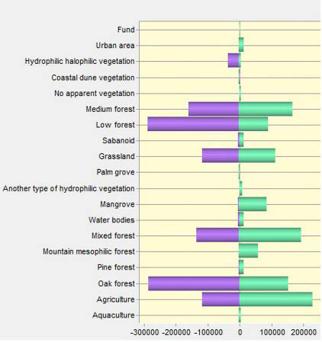[/graphic]
[label]Figure 3[/label]. [caption]Gains and losses during 1993-2014.[/caption][/figgrp]

[figgrp id="f4"][attrib]Source: Author[/attrib]
[graphic href="?a07v69n2"]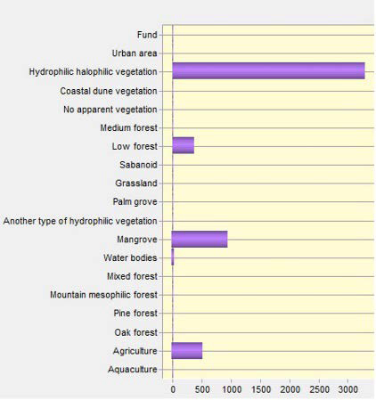[/graphic]
[label]Figure 4[/label]. [caption]Contributions to Net Change in aquaculture.[/caption][/figgrp]

[figgrp id="f5"][attrib]Source: Author[/attrib]
[graphic href="?a07v69n2"]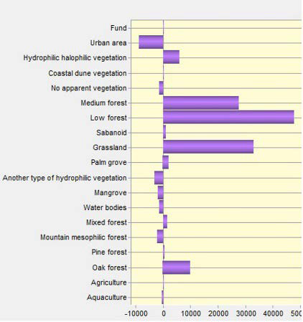[/graphic]
[label]Figure 5[/label]. [caption]Contributions to Net Change in agriculture.[/caption][/figgrp]

[figgrp id="f6"][attrib]Source: Author[/attrib]
[graphic href="?a07v69n2"]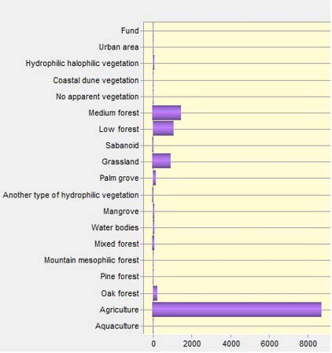[/graphic]
[label]Figure 6[/label]. [caption]Contributions to Net Change in urban area.[/caption][/figgrp]

[figgrp id="f7"][attrib]Source: Author[/attrib]
[graphic href="?a07v69n2"]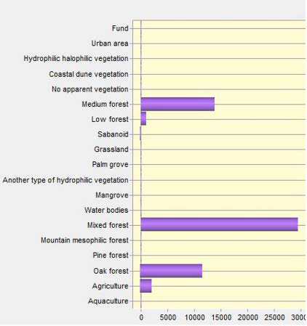[/graphic]
[label]Figure 7[/label]. [caption]Contributions to Net Change in mountain mesophilic forest.[/caption][/figgrp]

[figgrp id="f8"][attrib]Source: Author[/attrib]
[graphic href="?a07v69n2"]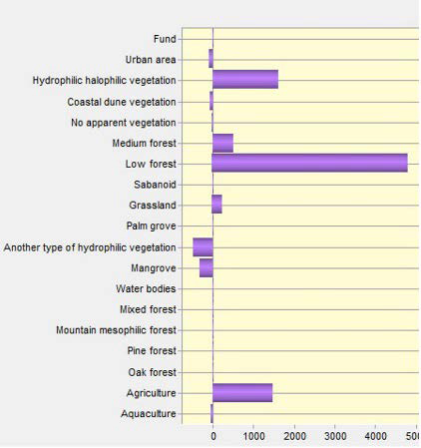[/graphic]
[label]Figure 8[/label]. [caption]Contributions to Net Change in water bodies.[/caption][/figgrp]

[p]([xref ref-type="fig" rid="f9"]Figure 9[/xref]) is the map of change between land use categories in Nayarit for the period 1993-2014. It allows locating areas where change from one category to another occurred. Mesophilic forests have expanded over mixed forests, medium forests and oak forests, particularly in the upper and middle parts of the territory, as a process of forest area recovery. In contrast, sabanoid vegetation has gained territory due to contributions from the medium and low forests, grassland and oak forests, as a deterioration process of natural vegetation. Aquaculture farms expand over hydrophilic halophilic vegetation, mangroves, agriculture and low forests; these changes occur in the lower parts of the territory and closer to water bodies. Urban sprawl has removed agriculture, medium and low forests, grasslands and oak forests, as a result of the intense demand for new spaces for settlements.[/p]

[figgrp id="f9"]Source: Author
[graphic href="?a07v69n2"]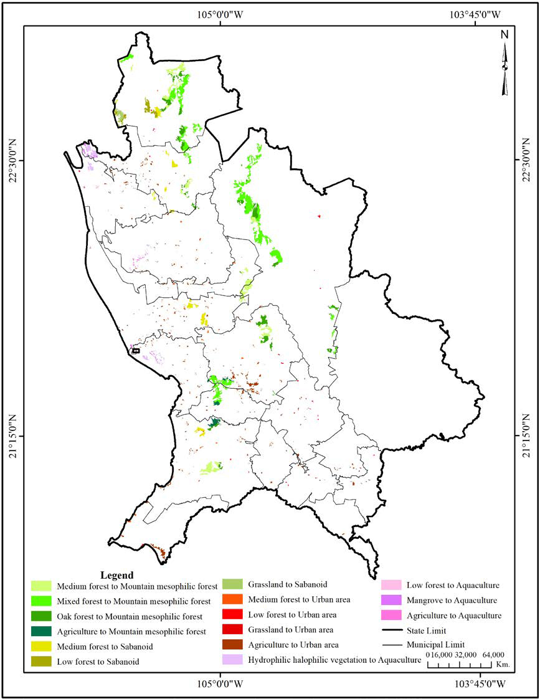[/graphic]
[label]Figure 9[/label]. [caption]Map of Land Use and Cover Change 1993-2014.[/caption][/figgrp]

[p]The map of contributions to net change in the category water bodies is shown in ([xref ref-type="fig" rid="f10"]Figure 10[/xref]). Several areas of hydrophilic halophilic vegetation were transformed into water bodies. These changes are explained by the regional dynamism, given the demand of fresh water circulation for aquaculture farms. Artificial water bodies and new channels and channel connections are constantly built to provide water for the shrimp farms. In 1993, water bodies occupied 45,289.3 ha, which in 2014 increased to 53,092.00 ha, with a gain of 12,174.50 ha and a loss of 4,371.75 ha. Total change was of 16,546.25 ha, while the exchange was 7,802.75 ha. Finally, the net change was 8,743.50 ha.[/p]

[figgrp id="f10"][attrib]Source: Author[/attrib]
[graphic href="?a07v69n2"]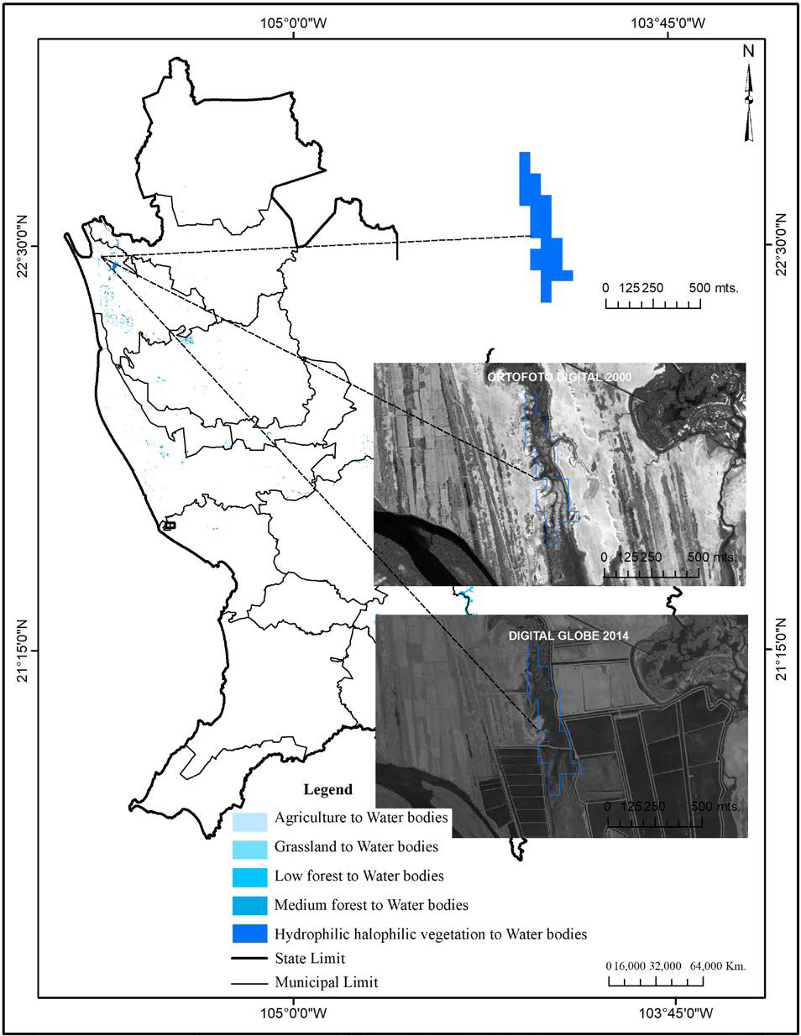[/graphic]
[label]Figure 10[/label]. [caption]Map of Contributions to Net Change in Water Bodies.[/caption][/figgrp]

[p]The contributions to the net change within the aquaculture farms are shown in ([xref ref-type="fig" rid="f11"]Figure 11[/xref]). Agricultural areas were transformed into aquaculture farms; the image shows the construction of new shrimp farms and the expansion of their infrastructure. For 1993, the aquaculture farms occupied an area of 4,096.8 ha, while for 2014, it increased to 9,297.25 ha, obtained a gain of 5,291.51 ha and a loss of 91.00 ha. The total change was 5,382.50 ha, the exchange was 5,200.50 ha, and the net change was 182 ha.[/p]

[figgrp id="f11"][attrib]Source: Author[/attrib]
[graphic href="?a07v69n2"]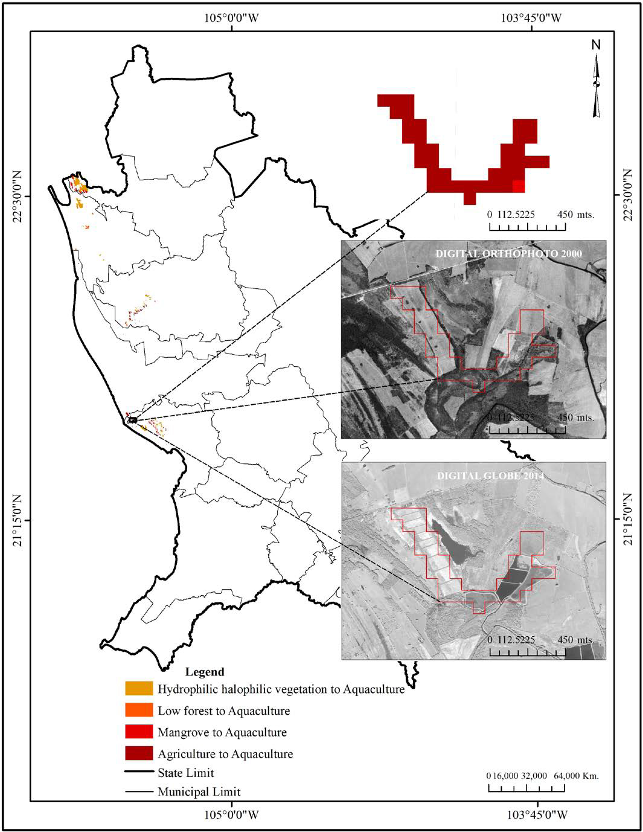[/graphic]
[label]Figure 11[/label]. [caption]Map of Contributions to the Net Change in Aquaculture Activity.[/caption][/figgrp]

[/sec][sec sec-type="discussion"][sectitle]Discussion[/sectitle]

[p]Studies of changes in land use and vegetation have been widely used to understand the dynamics of changes at the local and regional scale ([xref ref-type="bibr" rid="r11"]Calderón-Loor et al., 2021[/xref]; [xref ref-type="bibr" rid="r12"]Calzada et al., 2018[/xref]; [xref ref-type="bibr" rid="r38"]Naikoo et al., 2020[/xref]; [xref ref-type="bibr" rid="r41"]Pérez-Hoyos et al., 2020[/xref]). Change matrix indeed allow analyzing change processes into greater detail, especially regarding the contributions to net change and the exchanges occurring between categories [xref ref-type="bibr" rid="r13"](Camacho Sanabria, 2017[/xref]; [xref ref-type="bibr" rid="r43"]Pineda Jaimes & Santana Castañeda, 2019[/xref]; [xref ref-type="bibr" rid="r48"]Roldán-Aragón & Sevilla-Salcedo, 2014[/xref]). It is remarkable the growth of aquaculture farms which expands over hydrophilic halophilic vegetation; such transformation is transcendental because it is permanent. Hydrophilic halophilic vegetation surface was reduced without recovery.[/p]
[p]In general terms, there is a trend of expansion in the surface devoted to productive activities such as agriculture, aquaculture and urban spaces; while a considerable decrease occurs in areas with natural covers such as oak forests and low forest. In this sense, our results agree with those obtained by [xref ref-type="bibr" rid="r6"]Berlanga-Robles & Ruiz-Luna (2020[/xref]), [xref ref-type="bibr" rid="r7"]Berlanga Robles et al., (2009[/xref]) and [xref ref-type="bibr" rid="r47"]Ramírez-Garcı́a et al. (1998[/xref]), which show that agricultural and aquaculture farms have advanced over natural covers, being low forest and hydrophilic halophilic vegetation the most affected. Agricultural frontier expansion has an environmental impact and is expressed in the increase of grain sorghum, mango and sugar cane crops that have a greater representation of planted area according to the national agricultural survey [xref ref-type="bibr" rid="r24"](INEGI, 2014[/xref]). Traditional crops such as: white corn and beans, occupy 30,571 ha in Rosamorada, 27,754 ha in Tepic and 22,712 ha in Compostela.[/p]
[p]Agricultural fields also have been affected by urban sprawl, particularly in Tepic and Bahía de Banderas, due to the tourism and housing demand explained by the economic boom that Nayarit experienced from 1970 to 2015. Urban growth increased the pressure over natural resources in this region. Urban sprawl is also related to changes in land tenure regulations, the landowners and how they manage their lands determine the dynamics of the landscape. In Nayarit, aquaculture activity started in 1979 with a rustic system in the Estero El Conchal. In 1993 there were 4,096.8 ha devoted to aquaculture farms, which in 2014, increased to 9,297.25 ha, being hydrophilic halophilic vegetation (3,291 ha) and mangroves (952 ha) transformed into shrimp farms. Despite covering a small proportion of the landscape, such farms also represent a significant displacement of the hydrophilic halophilic vegetation. Mangroves lost is added as another factor of pressure on the surrounding natural wetlands, not only due to the possibilities of changing the land use and natural hydrological flow, but also through the contribution of nutrients and pollutants to water bodies and the spread of diseases ([xref ref-type="bibr" rid="r40"]Páez-Osuna, 2001[/xref]). Mangroves are located in low-lying coastal wetlands and are periodically submerged by incoming tides. Therefore, they are affected by the construction of roads, canals and ponds, which interfere with the surface flows of fresh and tidal water in the lagoon system ([xref ref-type="bibr" rid="r8"]Blanco et al., 2011[/xref]). The passage of Hurricane Rosa on October 14, 1994 caused a reduction in stem density and basal area in the mangroves of 31% and 51%, respectively ([xref ref-type="bibr" rid="r28"]Kovacs et al., 2001[/xref]). The loss of coverage caused directly by the meteor is estimated at approximately 600 has, and has been considered as a main disturbing event ([xref ref-type="bibr" rid="r5"]Berlanga-Robles & Ruiz-Luna, 2007[/xref]).[/p]
[p]The use of information contained in attributes of the vegetation types map as one that provides the maximum level of detail of the analyzed geographic unit according to the work scale yielded a precision and accuracy of 95% for series II and the SNIEG digital quality information standard for series VI.[/p]

[/sec][sec sec-type="conclusions"][sectitle]Conclusions[/sectitle]

[p]Detected changes in Nayarit during the study period are mainly associated with the expansion of agriculture and aquaculture farms as well as urban sprawl. Very dynamic change processes have been experienced in the State of Nayarit, fundamentally sustained by the growth of anthropic land uses (having an average growth of 4.62%) and forest shrink of 5.18%. According to the time-space dynamics of land use, 58.06% of the vegetation types and water bodies did not suffer any change while 41.94% showed some change in land cover, out of which 15.42% corresponds to exchanges between categories and 26.52% is a net change. Agriculture was the category that gained the most surface with an increase of 3.97%, while low forest lost the most surface (7.06%).[/p]
[p]There are recovery and re-vegetation processes in the state, but do not have the same intensity than the disturbances, particularly in the low forest, oak forests and hydrophilic halophilic vegetation where recovery was low. Such processes are mostly driven by productive activities, due to the expansion of agricultural and aquaculture frontiers. The constant pressure of agricultural activities coupled with urban sprawl over forest resources, drive the dynamics of land use and water bodies changes, modifying the landscape and its biodiversity. Forest loss, particularly of the hydrophilic halophilic vegetation and mangroves is reflected in the contributions to the net change, which expresses the expansion of the aquaculture farms, which due to its high profitability have strongly increased.[/p]
[p]Hopefully, this quantitative and qualitative vision of the conditions of natural resources and their spatio-temporal dynamics in Nayarit might help government agents to make better planning decisions, integrating socioeconomic development and environmental protection.[/p][/sec][/xmlbody]

[refs][sectitle]References[/sectitle]

[ref id="r1" reftype=“journal"][authors role="nd"][pauthor][surname]Abel[/surname], [fname]C.[/fname][/pauthor]; [pauthor][surname]Horion[/surname], [fname]S.[/fname][/pauthor]; [pauthor][surname]Tagesson[/surname], [fname]T.[/fname][/pauthor]; [pauthor][surname]Brandt[/surname], [fname]M.[/fname][/pauthor]; & [pauthor][surname]Fensholt[/surname], [fname]R.[/fname][/pauthor][/authors] ([date dateiso="20190000" specyear="2019"]2019[/date]). [arttitle]Towards improved remote sensing based monitoring of dryland ecosystem functioning using sequential linear regression slopes (SeRGS). [/arttitle][source]Remote Sensing of Environment[/source], [volid]224[/volid], [pages]317-332[/pages]. Obtenido de https://doi.org/[pubid idtype="doi"]10.1016/j.rse.2019.02.010[/pubid][/ref]
[ref id="r2" reftype=“journal"][authors role="nd"][pauthor][surname]Abreu[/surname], [fname]C. G.[/fname][/pauthor], & [pauthor][surname]Ralha[/surname], [fname]C. G.[/fname][/pauthor] [/authors]([date dateiso="20180000" specyear="2018"]2018[/date]). [arttitle]An empirical workflow to integrate uncertainty and sensitivity analysis to evaluate agent-based simulation outputs. [/arttitle][source]Environmental Modelling & Software[/source], [volid]107[/volid], [pages]281-297[/pages]. Obtenido de https://doi.org/[pubid idtype="doi"]10.1016/j.envsoft.2018.06.013[/pubid][/ref]
[ref id="r3" reftype=“journal"][authors role="nd"][pauthor][surname]Amadou[/surname], [fname]M. L.[/fname][/pauthor]; [pauthor][surname]Villamor[/surname], [fname]G. B.[/fname][/pauthor]; & [pauthor][surname]Kyei-Baffour[/surname], [fname]N.[/fname][/pauthor][/authors] ([date dateiso="20180000" specyear="2018"]2018[/date]). [arttitle]Simulating agricultural land-use adaptation decisions to climate change: An empirical agent-based modelling in northern Ghana. [/arttitle][source]Agricultural Systems[/source], [volid]166[/volid], [pages]196-209[/pages]. Obtenido de https://doi.org/[pubid idtype="doi"]10.1016/j.agsy.2017.10.015[/pubid][/ref]
[ref id="r4" reftype=“journal"][authors role="nd"][pauthor][surname]Bera[/surname], [fname]B.[/fname][/pauthor]; [pauthor][surname]Saha[/surname], [fname]S.[/fname][/pauthor]; & [pauthor][surname]Bhattacharjee[/surname], [fname]S.[/fname][/pauthor] [/authors]([date dateiso="20200000" specyear="2020"]2020[/date]). [arttitle]Forest cover dynamics (1998 to 2019) and prediction of deforestation probability using binary logistic regression (BLR) model of Silabati watershed, India.[/arttitle] [source]Trees, Forests and People[/source], [volid]2[/volid]([issueno]100034[/issueno]), [pages]1-10[/pages]. Obtenido de https://doi. org/[url]10.1016/j.tfp.2020.100034[/url].[/ref]
[ref id="r5" reftype="book"][authors role="nd"][pauthor][surname]Berlanga-Robles[/surname], [fname]C. A.[/fname][/pauthor]; & [pauthor][surname]Ruiz-Luna[/surname], [fname]A.[/fname][/pauthor] [/authors]([date dateiso="20070000" specyear="2007"]2007[/date]). [chptitle]Analisis de las tendencias de cambio del bosque de mangle del sistema lagunar TeacapanAgua Brava, Mexico. Una aproximacion con el uso de imagenes de satelite Landsat. [/chptitle][source]Universidad y Ciencia[/source], [volid]23[/volid]([issueno]1[/issueno]), [pages]29+[/pages].[/ref]
[ref id="r6" reftype=“journal"][authors role="nd"][pauthor][surname]Berlanga-Robles[/surname], [fname]C. A.[/fname][/pauthor], & [pauthor][surname]Ruiz-Luna[/surname], [fname]A.[/fname][/pauthor] [/authors]([date dateiso="20200000" specyear="2020"]2020[/date]). [arttitle]Assessing seasonal and long-term mangrove canopy variations in Sinaloa, northwest Mexico, based on time series of enhanced vegetation index (EVI) data. [/arttitle][source]Wetlands Ecology and Management[/source], [volid]28[/volid], [pages]229-249[/pages]. doi: https://doi. org/[pubid idtype="doi"]10.1007/s11273-020-09709-0[/pubid][/ref]
[ref id="r7" reftype=“journal"][authors role="nd"][pauthor][surname]Berlanga-Robles[/surname], [fname]C. A.[/fname][/pauthor]; [pauthor][surname]García-Campos[/surname], [fname]R. R.[/fname][/pauthor]; [pauthor][surname]López-Blanco[/surname], [fname]J.[/fname][/pauthor]; & [pauthor][surname]Ruiz-Luna[/surname], [fname]A.[/fname][/pauthor][/authors] ([date dateiso="20090000" specyear="2009"]2009[/date]). [arttitle]Patrones de cambio de coberturas y usos del suelo en la región costa norte de Nayarit (1973-2000). [/arttitle][source]Investigaciones Geográficas, Boletín del Instituto de Geografía, UNAM[/source]([issueno]72[/issueno]), [pages]7-22[/pages]. doi: [url]http://www.journals.unam.mx/index.php/rig/article/ view/19272/18272[/url][/ref]
[ref id="r8" reftype="book"][authors role="nd"][pauthor][surname]Blanco[/surname], [fname]C. M.[/fname][/pauthor]; [pauthor][surname]Flores[/surname], [fname]F.[/fname][/pauthor]; & [pauthor][surname]Ortiz[/surname], [fname]M. A.[/fname][/pauthor] [/authors]([date dateiso="20110000" specyear="2011"]2011[/date]). [source]Diagnostico funcional de Marismas Nacionales.[/source] [pubname]Universidad Autónoma de Nayarit/Comisión Nacional Forestal[/pubname], [publoc]México[/publoc].[/ref]
[ref id="r9" reftype=“journal"][authors role="nd"][pauthor][surname]Bonilla-Moheno[/surname], [fname]M.[/fname][/pauthor]; & [pauthor][surname]Aide[/surname], [fname]T. M.[/fname][/pauthor] [/authors]([date dateiso="20200000" specyear="2020"]2020[/date]). [arttitle]Beyond deforestation: Land cover transitions in Mexico.[/arttitle] [source]Agricultural Systems[/source], [volid]178[/volid]([issueno]102734[/issueno]). Obtenido de https://doi.org/[pubid idtype="doi"]10.1016/j.agsy.2019.102734[/pubid][/ref]
[ref id="r10" reftype="book"][authors role="nd"][pauthor][surname]Bosque Sendra[/surname], [fname]J.[/fname][/pauthor] [/authors]([date dateiso="19970000" specyear="1997"]1997[/date]). [source]Sistemas de Información Geográfica[/source] ([issueno]2a[/issueno] ed.). [publoc]Madrid[/publoc]: [pubname]Rialp[/pubname].[/ref]
[ref id="r11" reftype=“journal"][authors role="nd"][pauthor][surname]Calderón-Loor[/surname], [fname]M.[/fname][/pauthor]; [pauthor][surname]Hadjikakou[/surname], [fname]M.[/fname][/pauthor]; & [pauthor][surname]Bryan[/surname], [fname]B. A.[/fname][/pauthor][/authors] ([date dateiso="20210000" specyear="2021"]2021[/date]). [arttitle]High-resolution wall-to-wall land-cover mapping and land change assessment for Australia from 1985 to 2015. [/arttitle][source]Remote Sensing of Environment[/source], [pages]252[/pages]. doi: https://doi.org/[pubid idtype="doi"]10.1016/j.rse.2020.112148[/pubid][/ref]
[ref id="r12" reftype=“journal"][authors role="nd"][pauthor][surname]Calzada[/surname], L., Meave, [fname]J. A.[/fname][/pauthor]; [pauthor][surname]Bonfil[/surname], [fname]C.[/fname][/pauthor]; & [pauthor][surname]Figueroa[/surname], [fname]F.[/fname][/pauthor][/authors] ([date dateiso="20180000" specyear="2018"]2018[/date]). [arttitle]Lands at risk: Land use/land cover change in two contrasting tropical dry regions of Mexico.[/arttitle] [source]Applied Geography[/source], [volid]99[/volid], [pages]22-30[/pages]. Obtenido de https://doi.org/[pubid idtype="doi"]10.1016/j.apgeog.2018.07.021[/pubid][/ref]
[ref id="r13" reftype=“journal"][authors role="nd"][pauthor][surname]Camacho-Sanabria[/surname], [fname]R.[/fname][/pauthor]; [pauthor][surname]Camacho-Sanabria[/surname], [fname]J. M.[/fname][/pauthor]; [pauthor][surname]Balderas-Plata[/surname], [fname]M. Á.[/fname][/pauthor]; & [pauthor][surname]Sánchez-López[/surname], [fname]M.[/fname][/pauthor] [/authors]([date dateiso="20170000" specyear="2017"]2017[/date]). [arttitle]Cambios de cobertura y uso de suelo: estudio de caso en Progreso Hidalgo, Estado de México. [/arttitle][source]Madera y Bosques[/source], [volid]23[/volid]([issueno]3[/issueno]), [pages]39-60[/pages]. Obtenido de https://doi.org/[pubid idtype="doi"]10.21829/myb.2017.2331516[/pubid][/ref]
[ref id="r14" reftype=“journal"][authors role="nd"][pauthor][surname]Cao[/surname], [fname]Y.[/fname][/pauthor]; [pauthor][surname]Zhang[/surname], [fname]X.[/fname][/pauthor]; [pauthor][surname]Fu[/surname], [fname]Y.[/fname][/pauthor]; [pauthor][surname]Lu[/surname], [fname]Z.[/fname][/pauthor]; & [pauthor][surname]Shen[/surname], [fname]X.[/fname][/pauthor][/authors] ([date dateiso="20200000" specyear="2020"]2020[/date]). [arttitle]Urban spatial growth modeling using logistic regression and cellular automata: A case study of Hangzhou.[/arttitle] [source]Ecological Indicators[/source], [volid]113[/volid]([issueno]106200[/issueno]), [pages]1-12[/pages]. Obtenido de https://doi.org/[pubid idtype="doi"]10.1016/j.ecolind.2020.106200[/pubid][/ref]
[ref id="r15" reftype=“journal"][authors role="nd"][pauthor][surname]Chandra Paul[/surname], [fname]G.[/fname][/pauthor]; [pauthor][surname]Saha[/surname], [fname]S.[/fname][/pauthor]; & [pauthor][surname]Kanti Hembram[/surname], [fname]T.[/fname][/pauthor] [/authors]([date dateiso="20200000" specyear="2020"]2020[/date]). [arttitle]Application of phenology-based algorithm and linear regression model for estimating rice cultivated areas and yield using remote sensing data in Bansloi River Basin, Eastern India.[/arttitle] [source]Remote Sensing Applications: Society and Environment[/source], [volid]19[/volid]([issueno]100367[/issueno]), [pages]1-12[/pages]. Obtenido de https://doi. org/[pubid idtype="doi"]10.1016/j.rsase.2020.100367[/pubid][/ref]
[ref id="r16" reftype=“journal"][authors role="nd"][pauthor][surname]Darvishi[/surname], [fname]A.[/fname][/pauthor]; [pauthor][surname]Yousefi[/surname], [fname]M.[/fname][/pauthor]; & [pauthor][surname]Marull[/surname], [fname]J.[/fname][/pauthor] [/authors]([date dateiso="20200000" specyear="2020"]2020[/date]). [arttitle]Modelling landscape ecological assessments of land use and cover change scenarios. Application to the Bojnourd Metropolitan Area (NE Iran).[/arttitle] [source]Land Use Policy[/source], [volid]99[/volid]([issueno]105098[/issueno]). Obtenido de https://doi.org/[pubid idtype="doi"]10.1016/j.landusepol.2020.105098[/pubid][/ref]
[ref id="r17" reftype=“journal"][authors role="nd"][pauthor][surname]Deng[/surname], [fname]X.[/fname][/pauthor]; [pauthor][surname]Liu[/surname], [fname]J.[/fname][/pauthor]; [pauthor][surname]Lin[/surname], [fname]Y.[/fname][/pauthor]; & [pauthor][surname]Shi[/surname], [fname]C.[/fname][/pauthor][/authors] ([date dateiso="20130000" specyear="2013"]2013[/date]). [arttitle]A Framework for the Land Use Change Dynamics Model Compatible with RCMs. [/arttitle][source]Advances in Meteorology, 2013[/source], [pages]1-7[/pages]. Obtenido de http://dx.doi. org/[pubid idtype="doi"]10.1155/2013/658941[/pubid][/ref]
[ref id="r18" reftype=“journal"][authors role="nd"][pauthor][surname]Dhulipala[/surname], [fname]S.[/fname][/pauthor]; & [pauthor][surname]Patil[/surname], [fname]G. R.[/fname][/pauthor] [/authors]([date dateiso="20200000" specyear="2020"]2020[/date]). [arttitle]Freight production of agricultural commodities in India using multiple linear regression and generalized additive modelling.[/arttitle] [source]Transport Policy[/source], [volid]97[/volid], [pages]245-258[/pages]. Obtenido de https://doi.org/[pubid idtype="doi"]10.1016/j.tranpol.2020.06.012[/pubid][/ref]
[ref id="r19" reftype=“journal"][authors role="nd"][pauthor][surname]Dupuy Rada[/surname], [fname]J. M.[/fname][/pauthor]; [pauthor][surname]González Iturbe[/surname], [fname]J. A.[/fname][/pauthor]; [pauthor][surname]Iriarte Vivar[/surname], [fname]S.[/fname][/pauthor]; [pauthor][surname]Calvo Irabien[/surname], [fname]L.[/fname][/pauthor]; [pauthor][surname]Espadas Manrique[/surname], [fname]C.[/fname][/pauthor]; [pauthor][surname]Tun Dzul[/surname], [fname]F.,[/fname][/pauthor] & [pauthor][surname]Dorantes Euán[/surname], [fname]A.[/fname][/pauthor] [/authors]([date dateiso="20070000" specyear="2007"]2007[/date]). [arttitle]Cambio de cobertura y uso del suelo (1979-2000) en dos comunidades rurales en el noroeste de Quintana Roo.[/arttitle] [source]Investigaciones Geográficas, Boletín del Instituto de Geografía, UNAM[/source] ([issueno]62[/issueno]), [pages]104-124[/pages].[/ref]
[ref id="r20" reftype="book"][authors role="nd"][pauthor][surname]Fuenzalida[/surname], [fname]M.[/fname][/pauthor]; [pauthor][surname]Buzai[/surname], [fname]G. D.[/fname][/pauthor]; [pauthor][surname]Moreno Jiménez[/surname], [fname]A.[/fname][/pauthor]; & [pauthor][surname]García de León[/surname], [fname]A.[/fname][/pauthor] [/authors]([date dateiso="20150000" specyear="2015"]2015[/date]). [source]Geografía, geotecnología y análisis espacial: tendencias, métodos y aplicaciones. [/source][publoc]Santiago de Chile[/publoc]: [pubname]Triángulo[/pubname].[/ref]
[ref id="r21" reftype="book"][authors role="nd"][cauthor]Geografía, I. N.[/cauthor][/authors]([date dateiso="20180000" specyear="2018"]2018[/date]). [source]Norma técnica del proceso de producción de información estadística y geográfica para el Instituto Nacional de Estadística y Geografía, Comité de aseguramiento de la calidad.[/source] doi: [url]https://sc.inegi.org.mx/repositorioNormateca/O_05Sep18.pdf[/url][/ref]
[ref id="r22" reftype=“journal"][authors role="nd"][pauthor][surname]Hernández-Guzmán[/surname], [fname]R.[/fname][/pauthor]; [pauthor][surname]Ruiz-Luna[/surname], [fname]A.[/fname][/pauthor]; & [pauthor][surname]González[/surname], [fname]C.[/fname][/pauthor] [/authors]([date dateiso="20180000" specyear="2018"]2018[/date]). [arttitle]Assessing and modeling the impact of land use and changes in land cover related to carbon storage in a western basin in Mexico.[/arttitle] [source]Remote Sensing Applications: Society and Environment[/source], [volid]13[/volid], [pages]318-327[/pages]. Obtenido de https://doi.org/[pubid idtype="doi"]10.1016/j.rsase.2018.12.005[/pubid][/ref]
[ref id="r23" reftype=“journal"][authors role="nd"][pauthor][surname]Homer[/surname], [fname]C.[/fname][/pauthor]; [pauthor][surname]Dewitz[/surname], [fname]J.[/fname][/pauthor]; [pauthor][surname]Jin[/surname], [fname]S.[/fname][/pauthor]; [pauthor][surname]Xian[/surname], [fname]G.[/fname][/pauthor]; [pauthor][surname]Costello[/surname], [fname]C.[/fname][/pauthor]; [pauthor][surname]Danielson[/surname], [fname]P.[/fname][/pauthor]; [pauthor][surname]Riitters[/surname], [fname]K.[/fname][/pauthor] [/authors]([date dateiso="20200000" specyear="2020"]2020[/date]). [arttitle]Conterminous United States land cover change patterns 2001-2016 from the 2016 National Land Cover Database.[/arttitle] [source]Conterminous United States land cover change patterns 2001-2016 from the 2016 National Land Cover Database[/source], [volid]162[/volid], [pages]184-199[/pages]. Obtenido de https://doi.org/[pubid idtype="doi"]10.1016/j.isprsjprs.2020.02.019[/pubid][/ref]
[ref id="r24" reftype="book"][authors role="nd"][cauthor]Instituto Nacional de Estadística y Geografía[/cauthor].[/authors] ([date dateiso="20140000" specyear="2014"]2014[/date]). [source]Encuesta Nacional Agropecuaria[/source]. doi: [url]https://www.inegi.org.mx/programas/ena/2014/#Tabulados[/url][/ref]
[ref id="r25" reftype="book"][authors role="nd"][cauthor]Instituto Nacional de Estadística y Geografía[/cauthor].[/authors] ([date dateiso="20170000" specyear="2017"]2017[/date]). [source]Marco Geoestadístico[/source], [publoc]México[/publoc]. Obtenido de [url]https://www.inegi.org.mx/app/biblioteca/ficha.html?upc=889463142683[/url][/ref]
[ref id="r26" reftype="book"][authors role="nd"][cauthor]Instituto Nacional de Estadística y Geografía[/cauthor].[/authors] ([date dateiso="20180000" specyear="2018"]2018[/date]). [source]Norma técnica del proceso de producción de información estadística y geográfica para el Instituto Nacional de Estadística y Geografía, Comité de aseguramiento de la calidad.[/source] doi: [url]https://sc.inegi.org.mx/repositorioNormateca/O_05Sep18.pdf[/url][/ref]
[ref id="r27" reftype="book"][authors role="nd"][cauthor]Instituto Nacional de Estadística y Geografía.[/cauthor][/authors] ([date dateiso="20210000" specyear="2021"]2021[/date]). [source]Censo de Población y Vivienda 2020[/source]. doi: [url]https://www.inegi.org.mx/programas/ccpv/2020/#Tabulados[/url][/ref]
[ref id="r28" reftype=“journal"][authors role="nd"][pauthor][surname]Kovacs[/surname], [fname]J. M.[/fname][/pauthor], [pauthor][surname]Blanco-Correa[/surname], [fname]M.[/fname][/pauthor], & [pauthor][surname]Flores-Verdugo[/surname], [fname]F.[/fname][/pauthor] [/authors]([date dateiso="20010000" specyear="2001"]2001[/date]). [arttitle]A logistic regression model of hurricane impacts in a mangrove forest of Mexican Pacific[/arttitle]. [source]Journal of Coastal Resarch[/source], [volid]17[/volid]([issueno]1[/issueno]), [pages]30-37[/pages].[/ref]
[ref id="r29" reftype=“journal"][authors role="nd"][pauthor][surname]Lambin[/surname], [fname]E. F.[/fname][/pauthor], [pauthor][surname]Geist[/surname], [fname]H. J.[/fname][/pauthor], & [pauthor][surname]Lepers[/surname], [fname]E.[/fname][/pauthor][/authors] ([date dateiso="20030000" specyear="2003"]2003[/date]). [arttitle]Dynamics of land-use and land-cover change in tropical regions. [/arttitle][source]Annual Review of Environment and Resources[/source], [volid]28[/volid], [pages]205-241[/pages]. Obtenido de doi: https://doi.org/[pubid idtype="doi"]10.1146/annurev.energy.28.050302.105459[/pubid][/ref]
[ref id="r30" reftype=“journal"][authors role="nd"][pauthor][surname]Leh[/surname], [fname]M. D.[/fname][/pauthor], [pauthor][surname]Matlock[/surname], [fname]M. D.[/fname][/pauthor], [pauthor][surname]Cummings[/surname], [fname]E. C.[/fname][/pauthor], & [pauthor][surname]Nalley[/surname], [fname]L. L.[/fname][/pauthor] [/authors]([date dateiso="20130000" specyear="2013"]2013[/date]). [arttitle]Quantifying and mapping multiple ecosystem services change in West Africa.[/arttitle] [source]Agriculture, Ecosystems & Environment[/source], [volid]165[/volid], [pages]6-18[/pages]. Obtenido de https://doi.org/[pubid idtype="doi"]10.1016/j.agee.2012.12.001[/pubid][/ref]
[ref id="r31" reftype=“journal"][authors role="nd"][pauthor][surname]Li[/surname], [fname]F.[/fname][/pauthor]; [pauthor][surname]Li[/surname], [fname]Z.[/fname][/pauthor]; [pauthor][surname]Chen[/surname], [fname]H.[/fname][/pauthor]; [pauthor][surname]Chen[/surname], [fname]Z.[/fname][/pauthor]; & [pauthor][surname]Li[/surname], [fname]M.[/fname][/pauthor] [/authors]([date dateiso="20200000" specyear="2020"]2020[/date]). [arttitle]An agent-based learningembedded model (ABM-learning) for urban land use planning: A case study of residential land growth simulation in Shenzhen, China.[/arttitle] [source]Land Use Policy[/source], [volid]95[/volid]([issueno]104620[/issueno]). Obtenido de https://doi.org/[url]10.1016/j.landusepol.2020.104620[/url][/ref]
[ref id="r32" reftype=“journal"][authors role="nd"][pauthor][surname]Liu[/surname], [fname]D.[/fname][/pauthor]; [pauthor][surname]Zheng[/surname], [fname]X.[/fname][/pauthor]; & [pauthor][surname]Wang[/surname], [fname]H.[/fname][/pauthor][/authors] ([date dateiso="20200000" specyear="2020"]2020[/date]). [arttitle]Land-use Simulation and Decision-Support system (LandSDS): Seamlessly integrating system dynamics, agent-based model, and cellular automata.[/arttitle] [source]Ecological Modelling[/source], [volid]417[/volid]([issueno]108924[/issueno]). Obtenido de https://doi.org/[url]10.1016/j.ecolmodel.2019.108924[/url][/ref]
[ref id="r33" reftype=“journal"][authors role="nd"][pauthor][surname]Matsa[/surname], [fname]M.[/fname][/pauthor]; [pauthor][surname]Mupepi[/surname], [fname]O.[/fname][/pauthor]; [pauthor][surname]Musasa[/surname], [fname]T.[/fname][/pauthor]; & [pauthor][surname]Defe[/surname], [fname]R.[/fname][/pauthor][/authors] ([date dateiso="20200000" specyear="2020"]2020[/date]). [arttitle]A GIS and remote sensing aided assessment of land use/cover changes in resettlement areas; a case of ward 32 of Mazowe district, Zimbabwe. [/arttitle][source]Journal of Environmental Management[/source], [volid]276[/volid]([issueno]111312[/issueno]). Obtenido de https://doi.org/[pubid idtype="doi"]10.1016/j.jenvman.2020.111312[/pubid][/ref]
[ref id="r34" reftype=“journal"][authors role="nd"][pauthor][surname]Mendoza-Ponce[/surname], [fname]A.[/fname][/pauthor]; [pauthor][surname]Corona-Núñez[/surname], [fname]R.[/fname][/pauthor]; [pauthor][surname]Kraxner[/surname], [fname]F.[/fname][/pauthor]; [pauthor][surname]Leduc[/surname], [fname]S.[/fname][/pauthor]; & [pauthor][surname]Patrizio[/surname], [fname]P.[/fname][/pauthor] [/authors]([date dateiso="20180000" specyear="2018"]2018[/date]). [arttitle]Identifying effects of land use cover changes and climate change on terrestrial ecosystems and carbon stocks in Mexico. [/arttitle][source]Global Environmental Change[/source], [volid]53[/volid], [pages]12-23[/pages]. Obtenido de https://doi.org/[pubid idtype="doi"]10.1016/j.gloenvcha.2018.08.004[/pubid][/ref]
[ref id="r35" reftype="book"][authors role="nd"][pauthor][surname]Meyer[/surname], [fname]W. B.[/fname][/pauthor]; & [pauthor][surname]Turner[/surname], [fname]B. L.[/fname][/pauthor] [/authors]([date dateiso="19940000" specyear="1994"]1994[/date]). [source]Changes in Land Use and Land Cover: A Global Perspective.[/source] [pubname](Cambridge, Ed.) Cambridge University Press[/pubname].[/ref]
[ref id="r36" reftype=“journal"][authors role="nd"][pauthor][surname]Moreno[/surname], [fname]M. V.[/fname][/pauthor]; & [pauthor][surname]Chivieco[/surname], [fname]E.[/fname][/pauthor] [/authors]([date dateiso="20090000" specyear="2009"]2009[/date]). [arttitle]Validación de productos globales de cobertura del suelo en la España Peninsular. Validation of global land cover products for the Spanish Peninsular area.[/arttitle] [source]Revista de Teledetección[/source], [volid]31[/volid], [pages]5-22[/pages]. Obtenido de Retrieved from: [url]http://www.aet.org.es/revistas/revista31/Numero31_1.pdf[/url][/ref]
[ref id="r37" reftype=“journal"][authors role="nd"][pauthor][surname]Müller-Hansen[/surname], [fname]F.[/fname][/pauthor]; [pauthor][surname]Heitzig[/surname], [fname]J.[/fname][/pauthor]; [pauthor][surname]Donges[/surname], [fname]J. F.[/fname][/pauthor]; [pauthor][surname]Cardoso[/surname], [fname]M. F.[/fname][/pauthor]; [pauthor][surname]Dalla-Nora[/surname], [fname]E. L.[/fname][/pauthor]; [pauthor][surname]Andrade[/surname], [fname]P.[/fname][/pauthor]; [pauthor][surname]Thonicke[/surname], [fname]K.[/fname][/pauthor] [/authors]([date dateiso="20190000" specyear="2019"]2019[/date]). [arttitle]Can Intensification of Cattle Ranching Reduce Deforestation in the Amazon? Insights From an Agent-based Social-Ecological Model. [/arttitle][source]Ecological Economics[/source], [volid]159[/volid], [pages]198-211[/pages]. Obtenido de https://doi.org/[pubid idtype="doi"]10.1016/j.ecolecon.2018.12.025[/pubid][/ref]
[ref id="r38" reftype=“journal"][authors role="nd"][pauthor][surname]Naikoo[/surname], [fname]M. W.[/fname][/pauthor]; [pauthor][surname]Rihan[/surname], [fname]M.[/fname][/pauthor]; [pauthor][surname]Ishtiaque[/surname], [fname]M.[/fname][/pauthor]; & [pauthor]Shahfahad.[/pauthor][/authors] ([date dateiso="20200000" specyear="2020"]2020[/date]). [arttitle]Analyses of land use land cover (LULC) change and built-up expansion in the suburb of a metropolitan city: Spatio-temporal analysis of Delhi NCR using landsat datasets.[/arttitle] [source]Journal of Urban Management[/source], [volid]9[/volid], Issue [issueno]3[/issueno], [pages]347-359[/pages]. Obtenido de https://doi.org/[pubid idtype="doi"]10.1016/j.jum.2020.05.004[/pubid][/ref]
[ref id="r39" reftype=“journal"][authors role="nd"][pauthor][surname]Newbold[/surname], [fname]T.[/fname][/pauthor]; [pauthor][surname]Hudson[/surname], [fname]L. N.[/fname][/pauthor]; [pauthor][surname]Hill[/surname], [fname]S. L.[/fname][/pauthor]; [pauthor][surname]Contu[/surname], [fname]S.[/fname][/pauthor]; [pauthor][surname]Lysenko[/surname], [fname]I.[/fname][/pauthor]; [pauthor][surname]Senior[/surname], [fname]R. A.[/fname][/pauthor]; [pauthor][surname]Purvis[/surname], [fname]A.[/fname][/pauthor][/authors]([date dateiso="20150000" specyear="2015"]2015[/date]). [arttitle]Global effects of land use on local terrestrial biodiversity. [/arttitle][source]Nature[/source], [volid]520[/volid], [pages]45-50[/pages]. Obtenido de DOI: [pubid idtype="doi"]10.1038/nature14324[/pubid][/ref]
[ref id="r40" reftype=“journal"][authors role="nd"][pauthor][surname]Páez-Osuna[/surname], [fname]F.[/fname][/pauthor][/authors] ([date dateiso="20010000" specyear="2001"]2001[/date]). [arttitle]The environmental impact of shrimp aquaculture: Causes, effects, and mitigating alternatives.[/arttitle] [source]Environmental Management[/source], [volid]28[/volid]([issueno]1[/issueno]), [pages]131-140[/pages].[/ref]
[ref id="r41" reftype=“journal"][authors role="nd"][pauthor][surname]Pérez-Hoyos[/surname], [fname]A.[/fname][/pauthor]; [pauthor][surname]Udías[/surname], [fname]A.[/fname][/pauthor]; & [pauthor][surname]Rembold[/surname], [fname]F.[/fname][/pauthor] [/authors]([date dateiso="20200000" specyear="2020"]2020[/date]). [arttitle]Integrating multiple land cover maps through a multi-criteria analysis to improve agricultural monitoring in Africa. [/arttitle][source]International Journal of Applied Earth Observation and Geoinformation[/source], [volid]88[/volid]([issueno]102064[/issueno]). Obtenido de https://doi.org/[pubid idtype="doi"]10.1016/j.jag.2020.102064[/pubid][/ref]
[ref id="r42" reftype="book"][authors role="nd"][pauthor][surname]Pineda Jaimes[/surname], [fname]N. B.[/fname][/pauthor] [/authors]([date dateiso="20100000" specyear="2010"]2010[/date]). [source]Descripción, Análisis y Simulación de Procesos Forestales en el Estado de México Mediante Tecnologías de la Información Geográfica [/source]([moreinfo]Vols. Tesis de doctorado[/moreinfo], [pubname]Universidad de Alcalá[/pubname]). [publoc]Madrid, España[/publoc].[/ref]
[ref id="r43" reftype=“journal"][authors role="nd"][pauthor][surname]Pineda Jaimes[/surname], [fname]N. B.[/fname][/pauthor], & [pauthor][surname]Santana Castañeda[/surname], [fname]G.[/fname][/pauthor] [/authors]([date dateiso="20190000" specyear="2019"]2019[/date]). [arttitle]Cambios en la cobertura y uso del suelo en el Estado de México, en el período 2002-2014. [/arttitle] [source]Geografía y Sistemas de Información Geográfica (GEOSIG)[/source], [volid]11[/volid]([issueno]15[/issueno]), [pages]72-90[/pages]. Obtenido de [url]http://www.revistageosig. wixsite.com/geosig[/url][/ref]
[ref id="r44" reftype="book"][authors role="nd"][pauthor][surname]Ponce Palafox[/surname], [fname]J. T.[/fname][/pauthor] [/authors]([date dateiso="20150000" specyear="2015"]2015[/date]). [source]Manifestación de impacto ambiental modalidad regional, sector acuícola, operación, mantenimiento y abandono del cultivo de camarón en la unidad de manejo acuícola, Pericos Pimientillo. [/source][pubname]UAN, Gobierno del Estado de Nayarit, Comité Estatal de Sanidad del Estado de Nayarit A. C., Unión de Acuicultores del estado de Nayarit AC[/pubname].[/ref]
[ref id="r45" reftype=“journal"][authors role="nd"][pauthor][surname]Pontius[/surname], [fname]R. G.[/fname][/pauthor]; [pauthor][surname]Shusas[/surname], [fname]E.[/fname][/pauthor]; & [pauthor][surname]McEachern[/surname], [fname]M.[/fname][/pauthor] [/authors]([date dateiso="20040000" specyear="2004"]2004[/date]). [arttitle]Detecting important categorical land changes while accounting for persistence.[/arttitle] [source]Agriculture, Ecosystems & Environment[/source], [volid]101[/volid]([issueno]2-3[/issueno]), [pages]251-268[/pages]. Obtenido de https://doi.org/[pubid idtype="doi"]10.1016/j.agee.2003.09.008[/pubid][/ref]
[ref id="r46" reftype=“journal"][authors role="nd"][pauthor][surname]Prashar[/surname], [fname]S.[/fname][/pauthor]; [pauthor][surname]Shaw[/surname], [fname]R.[/fname][/pauthor]; & [pauthor][surname]Takeuchi[/surname], [fname]Y.[/fname][/pauthor] [/authors]([date dateiso="20130000" specyear="2013"]2013[/date]). [arttitle]Community action planning in East Delhi: A participatory approach to build urban disaster resilience. [/arttitle][source]Mitigation and Adaptation Strategies for Global Change[/source], [volid]18[/volid]([issueno]4[/issueno]), [pages]429-448[/pages]. Obtenido de https://doi.org/[pubid idtype="doi"]10.1007/s11027-012-9368-4[/pubid][/ref]
[ref id="r47" reftype=“journal"][authors role="nd"][pauthor][surname]Ramı́rez-Garcı́a[/surname], [fname]P.[/fname][/pauthor]; [pauthor][surname]López-Blanco[/surname], [fname]J.[/fname][/pauthor]; & [pauthor][surname]Ocaña[/surname], [fname]D.[/fname][/pauthor] [/authors]([date dateiso="19980000" specyear="1998"]1998[/date]). [arttitle]Mangrove vegetation assessment in the Santiago River Mouth, Mexico, by means of supervised classification using LandsatTM imagery. [/arttitle][source]Forest Ecology and Management[/source], [volid]105[/volid], [pages]217-229[/pages]. doi: https://doi.org/[pubid idtype="doi"]10.1016/S0378-1127(97)00289-2[/pubid][/ref]
[ref id="r48" reftype=“journal"][authors role="nd"][pauthor][surname]Roldán-Aragón[/surname], [fname]I. E.[/fname][/pauthor], & [pauthor][surname]Sevilla-Salcedo[/surname], [fname]Y.[/fname][/pauthor] [/authors]([date dateiso="20140000" specyear="2014"]2014[/date]). [arttitle]Cambios de uso del suelo y vegetación (1970-2005) en la cuenca del río Eslava, Distrito Federal, México.[/arttitle] [source]El Hombre y su Ambiente[/source], [volid]1[/volid]([issueno]5[/issueno]), [pages]1-10[/pages].[/ref]
[ref id="r49" reftype=“journal"][authors role="nd"][pauthor][surname]Saha[/surname], [fname]S.[/fname][/pauthor]; [pauthor][surname]Saha[/surname], [fname]M.[/fname][/pauthor]; [pauthor][surname]Mukherjee[/surname], [fname]K.[/fname][/pauthor]; [pauthor][surname]Arabameri[/surname], [fname]A.[/fname][/pauthor]; [pauthor][surname]Thao[/surname], [fname]N.[/fname][/pauthor]; & [pauthor][surname]Paul[/surname], [fname]G.[/fname][/pauthor] [/authors]([date dateiso="20200000" specyear="2020"]2020[/date]). [arttitle]Predicting the deforestation probability using the binary logistic regression, random forest, ensemble rotational forest, REPTree: A case study at the Gumani River Basin, India.[/arttitle] [source]Science of The Total Environment[/source], [volid]730[/volid], [pages]1-20[/pages]. Obtenido de https://doi.org/[pubid idtype="doi"]10.1016/j.scitotenv.2020.139197[/pubid][/ref]
[ref id="r50" reftype=“journal"][authors role="nd"][pauthor][surname]Schürmann[/surname], [fname]A.[/fname][/pauthor]; [pauthor][surname]Kleemann[/surname], [fname]J.[/fname][/pauthor]; [pauthor][surname]Fürst[/surname], [fname]C.[/fname][/pauthor]; & [pauthor][surname]Teucher[/surname], [fname]M.[/fname][/pauthor] [/authors]([date dateiso="20200000" specyear="2020"]2020[/date]). [arttitle]Assessing the relationship between land tenure issues and land cover changes around the Arabuko Sokoke Forest in Kenya. [/arttitle][source]Land Use Policy[/source], [volid]95[/volid]([issueno]104625[/issueno]). Obtenido de https://doi.org/[pubid idtype="doi"]10.1016/j.landusepol.2020.104625[/pubid][/ref]
[ref id="r51" reftype=“journal"][authors role="nd"][pauthor][surname]Velázquez[/surname], [fname]A.[/fname][/pauthor]; [pauthor][surname]Mas[/surname], [fname]J. F.[/fname][/pauthor]; [pauthor][surname]Díaz Gallegos[/surname], [fname]J. R.[/fname][/pauthor]; [pauthor][surname]Mayorga Saucedo[/surname], [fname]R.[/fname][/pauthor]; [pauthor][surname]Alcántara[/surname], [fname]P. C.[/fname][/pauthor]; [pauthor][surname]Castro[/surname], [fname]R.[/fname][/pauthor]; [pauthor][surname]Palacio[/surname], [fname]J. L.[/fname][/pauthor] [/authors]([date dateiso="20020000" specyear="2002"]2002[/date]). [arttitle]Patrones y tasas de cambio de uso del suelo en México. [/arttitle][source]Gaceta Ecológica [/source]([issueno]62[/issueno]), [pages]21-37[/pages]. doi: [url]http://www.redalyc.org/articulo.oa?id=53906202[/url][/ref]
[ref id="r52" reftype=“journal"][authors role="nd"][pauthor][surname]Zhang[/surname], F., Zhan, [fname]J.[/fname][/pauthor]; [pauthor][surname]Zhang[/surname], [fname]Q.[/fname][/pauthor]; [pauthor][surname]Yao[/surname], [fname]L.[/fname][/pauthor]; & [pauthor][surname]Liu[/surname], [fname]W.[/fname][/pauthor][/authors] ([date dateiso="20170000" specyear="2017"]2017[/date]). [arttitle]Impacts of land use/cover change on terrestrial carbon stocks in Uganda.[/arttitle] [source]Physics and Chemistry of the Earth, Parts A/B/C[/source], [volid]101[/volid], [pages]195-203[/pages]. Obtenido de https://doi.org/[pubid idtype="doi"]10.1016/j.pce.2017.03.005[/pubid][/ref][/refs][/doc]

