[doc sps="1.8" acron="revmar" jtitle="Revista Ciencias Marinas y Costeras" stitle="Rev. Cienc. Mar. Cost" issn="1659-455X" pissn="1659-455X" eissn="1659-407X" pubname="Universidad Nacional, Costa Rica" license="http://creativecommons.org/licenses/by-nc-nd/3.0" volid="14" issueno="2" dateiso="20221200" season="July/Dec" order="02" fpage="27" lpage="36" pagcount="10" doctopic="oa" language="en"]DOI:[doi]10.15359/revmar.14-2.2[/doi]
[toctitle]Artículo[/toctitle]

[doctitle language="en"]First record of the Fiddler Crab, Minuca osa from the Eastern Montijo Gulf, Panama[/doctitle]
[doctitle language="es"]Primer reporte del cangrejo violinista, Minuca osa en el oriente del golfo de Montijo, Panamá[/doctitle]

[author role="nd"][fname]Roberto C.[/fname] [surname]Lombardo-González[/surname] [xref ref-type="aff" rid="aff1"]¹ [/xref][authorid authidtp="orcid"]0000-0002-0279-8621[/authorid][/author]

[normaff id="aff1" ncountry="Not normalized" norgname="Not normalized" icountry="PA"][label]¹[/label] [orgname]Universidad de Panamá[/orgname], [orgdiv1]Centro Regional Universitario de Veraguas[/orgdiv1]. [orgdiv2]Centro de Capacitación, Investigación y Monitoreo de la Biodiversidad en el Parque Nacional Coiba[/orgdiv2]. [email]roberto.lombardo@up.ac.pa[/email]* ORCID: https://orcid.org/0000-0002-0279-8621[/normaff]

[xmlabstr language="en"][sectitle]ABSTRACT[/sectitle]
[p]Minuca osa had been previously thought to be endemic to Pacific Costa Rica (Golfo Dulce). However, specimens fitting the description were sampled in April 2021 and August 2022 in two sites in the Eastern Montijo Gulf, Panama. Based on the morphological character correspondence between the specimens collected and the original species description, it can be concluded that Minuca osa is also present in the Eastern Montijo Gulf.[/p][/xmlabstr]
[kwdgrp language="en"][sectitle]Keywords:[/sectitle] [kwd]tuberculate ridge[/kwd], [kwd]Uca[/kwd], [kwd]dactyl[/kwd], [kwd]chela[/kwd], [kwd]pollex[/kwd][/kwdgrp].

[xmlabstr language="es"][sectitle]RESUMEN[/sectitle]
[p]Anteriormente, se pensaba que Minuca osa era endémica del Pacífico de Costa Rica (golfo Dulce); sin embargo, en abril 2021 y agosto 2022, se colectaron especímenes que se ajustaban a la descripción de la especie en dos sitios del oriente del golfo de Montijo, Panamá. Con base en la correspondencia de caracteres morfológicos, se concluye que Minuca osa también está presente en el oriente del golfo de Montijo.[/p][/xmlabstr]
[kwdgrp language="es"][sectitle]Palabras clave:[/sectitle] [kwd]borde tuberculado[/kwd], [kwd]Uca[/kwd], [kwd]dáctilo[/kwd], [kwd]quela[/kwd], [kwd]pollex[/kwd][/kwdgrp]

[hist]Recepción: [received dateiso="20220830"]30 agosto 2022[/received]
Corregido: [revised dateiso="20221005"]05 octubre 2022[/revised]
Aceptado: [accepted dateiso="20221010"]10 octubre 2022[/accepted][/hist]

[xmlbody][sec sec-type="intro"][sectitle]INTRODUCTION[/sectitle]

[p]Fiddler crabs (Ocypodidae: Uca Leach, 1814) are distributed along most tropical and semitropical coastlines of the world ([xref ref-type="bibr" rid="r15"]Rosenberg, 2020[/xref]).[/p]
[p]Research on fiddler crabs in Panama has been published on various topics, such as, functional morphology in Petruca panamensis, Leptuca terpsichores and L. beebei ([xref ref-type="bibr" rid="r11"]Lim & Goh, 2021[/xref]), vision in L. stenodactylus (see [xref ref-type="bibr" rid="r5"]How et al. 2015[/xref]), sexual selection ([xref ref-type="bibr" rid="r4"]Dennenmoser & Christy, 2013[/xref]), construction of structures ([xref ref-type="bibr" rid="r13"]Pardo et al. 2020[/xref]) in L. terpsichores and L. beebei, and larval ecology in L. terpsichores [xref ref-type="bibr" rid="r2"](Christy, 2003[/xref]), and L. deichmanni ([xref ref-type="bibr" rid="r8"]Kerr, 2015[/xref]). Even though fiddler crabs are widely distributed in Panama, sampling in all the aforementioned studies was conducted exclusively at the Pacific entrance of the Panama Canal, whereas studies from other provinces are lacking.[/p]
[p]There are currently 35 recognized fiddler crab species in Panama. On the Atlantic coast, there are seven species, distributed into three genera: Minuca with four species, Uca with two, and a single species of Leptuca (L. thayeri). In the Pacific, there are 28 species grouped into four genera, of which sixteen are in the genus Leptuca, six within Uca, five within Minuca, and a single species of Petruca (P. panamensis) ([xref ref-type="bibr" rid="r14"]Rosenberg, 2014[/xref]).[/p]
[p]In the Ponuga River, Eastern Montijo Gulf, Veraguas Province, fiddler crabs were observed waving their claw in synchrony. The major claw, bright red-orange with a white tip, was the most striking feature of these fiddler crabs. A species fitting this morphological characteristic was described by [xref ref-type="bibr" rid="r10"]Landstorfer & Schubart (2010[/xref]) from the Golfo Dulce, Pacific coast of Costa Rica [xref ref-type="fig" rid="f1"](Fig. 1A[/xref]). The authors named the new species, Minuca osa, and suggested that it might be endemic. Based on geographical proximity of Golfo Dulce and our study area, it seemed plausible that M. osa could also be found in Panama [xref ref-type="fig" rid="f1"](Fig. 1B, C[/xref]). Therefore, the objective of this study was to identify the specimens found in the Eastern Montijo Gulf and report on the possible geographical extension of M. osa distribution range.[/p]

[/sec][sec sec-type="materials|methods"][sectitle]MATERIALS AND METHODS[/sectitle]

[p]Sampling was conducted on April 27th, 2021, and August 13th and 14th, 2022 at two sites on the Eastern Montijo Gulf ([xref ref-type="fig" rid="f1"]Fig. 1[/xref]D); the Ponuga River (07° 51ʼ 51.3756ʼʼ N,-081° 00ʼ 52.6248ʼʼ W) and Mata Oscura (07° 27ʼ 29.0124ʼʼ N, -080° 55ʼ 12.8532ʼʼ W). Fiddler crabs (n = 22) were caught by hand, rinsed, and later stored in a freezer unit. Morphological characters of interest were photographed; specimens’ carapace width and length, as well as chela height and length, were measured (mean ± SD; 0.01 mm), and taxonomical keys ([xref ref-type="bibr" rid="r10"]Landstorfer & Schubart, 2010[/xref]; Cra- ne, 2015; [xref ref-type="bibr" rid="r16"]Shih et al. 2016[/xref]; [xref ref-type="bibr" rid="r15"]Rosenberg, 2020[/xref]) were used for the identification of the collected material. Morphological characters between Golfo Dulce [xref ref-type="bibr" rid="r10"](Landstorfer & Schubart, 2010[/xref]) and the Eastern Montijo Gulf were compared with the t-test.[/p]

[figgrp id="f1"][attrib]First record of the Fiddler Crab, Minuca osa from the Eastern Montijo Gulf, Panama[/attrib]
[graphic href="?a02v14n2"]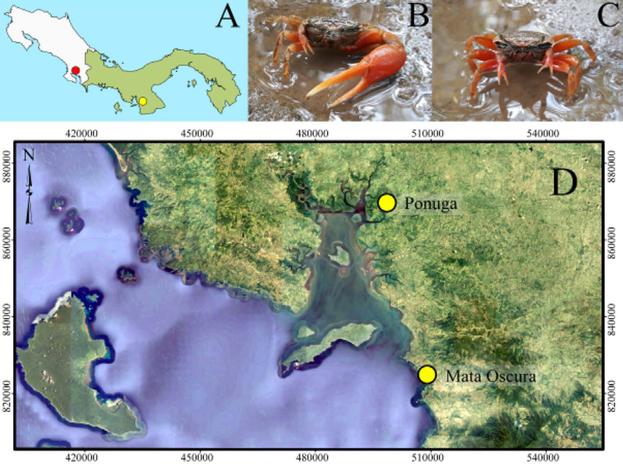[/graphic]
[label]Fig. 1[/label]. [caption]Contexto geográfico y ubicaciones de reportes de Minuca osa en el Pacífico Tropical Oriental. A: sitio de procedencia (rojo) de los especímenes en la descripción original de Minuca osa ([xref ref-type="bibr" rid="r10"]Landstorfer & Schubart, 2010[/xref]). Imágenes preliminares de Minuca osa macho (B) y hembra (C) del oriente del golfo de Montijo. D: Sitios de muestreo georeferenciados de Ponuga (norte) y Mata Oscura (sur) (amarillo); escala: 1:250,000. Proyección UTM (Universal Mercator Traverse 17 N). Datum horizontal: Sistema Geodésico Mundial 1984 (WGS-84). Datum vertical: Nivel medio del mar del geoide WGS-84[/caption][/figgrp]

[/sec][sec sec-type="results"][sectitle]RESULTS[/sectitle]

[p]Features of the genus Minuca were found in 22 individuals averaging 21.44 ± 2.96 mm and 14.60 ± 1.62 mm in carapace width and length, respectively; 14 were from Ponuga and eight from Mata Oscura. Specimens were larger than those from Golfo Dulce, except in major chela height, where no difference was detected ([xref ref-type="table" rid="t1"]Table 1[/xref]). In general, compared to other Minuca species, sampled individuals from Ponuga and Mata Oscura can be considered large within the genus [xref ref-type="table" rid="t2"](Table 2[/xref]).[/p]

[tabwrap id="t1"][label]Table 1[/label]. [caption]Morphological character comparisons (mm) between Minuca osa specimens collected in the Eastern Montijo Gulf (Panama) and those noted in the original species description by [xref ref-type="bibr" rid="r10"]Landstorfer and Schubart (2010[/xref]) at Golfo Dulce (Costa Rica). EMG: Eastern Montijo Gulf. GD: Golfo Dulce. CW: carapace width. CL: carapace length. QH: major chela height. QL: major chela length [/caption]
[table][tbody][tr][td align="left"]EMG-CW[/td] | [td align="center"]22[/td] | [td align="center"]21.44 ± 2.96[/td] | [td align="center"]12.66[/td] | [td align="center"]25.98[/td] | [td align="center"]4.21; 18[/td] | [td align="center"]0.001[/td][/tr]
[tr][td align="left"]GD-CW[/td] | [td align="center"]12[/td] | [td align="center"]16.22 ± 3.70[/td] | [td align="center"]9.28[/td] | [td align="center"]21.10[/td] | [td align="center"] [/td] | [td align="center"] [/td][/tr]
[tr][td align="left"]EMG-CL[/td] | [td align="center"]22[/td] | [td align="center"]14.60 ± 1.62[/td] | [td align="center"]11.10[/td] | [td align="center"]17.89[/td] | [td align="center"]4.01; 15[/td] | [td align="center"]0.001[/td][/tr]
[tr][td align="left"]GD-CL[/td] | [td align="center"]12[/td] | [td align="center"]11.32 ± 2.57[/td] | [td align="center"]6.12[/td] | [td align="center"]14.70[/td] | [td align="center"] [/td] | [td align="center"] [/td][/tr]
[tr][td align="left"]EMG-QH[/td] | [td align="center"]22[/td] | [td align="center"]11.04 ± 2.34[/td] | [td align="center"]4.09[/td] | [td align="center"]14.66[/td] | [td align="center"]1.55; 13[/td] | [td align="center"]0.146[/td][/tr]
[tr][td align="left"]GD-QH[/td] | [td align="center"]7[/td] | [td align="center"]9.76 ± 1.76[/td] | [td align="center"]7.83[/td] | [td align="center"]11.90[/td] | [td align="center"] [/td] | [td align="center"] [/td][/tr]
[tr][td align="left"]EMG-QL[/td] | [td align="center"]22[/td] | [td align="center"]30.27 ± 7.80[/td] | [td align="center"]7.13[/td] | [td align="center"]42.23[/td] | [td align="center"]2.31; 18[/td] | [td align="center"]0.033[/td][/tr]
[tr][td align="left"]GD-QL[/td] | [td align="center"]8[/td] | [td align="center"]24.41 ± 5.42[/td] | [td align="center"]18.32[/td] | [td align="center"]31.05[/td] | [td align="center"] [/td] | [td align="center"] [/td][/tr]
[tr][td align="left"]EMG-Front[/td] | [td align="center"]22[/td] | [td align="center"]7.47 ± 1.04[/td] | [td align="center"]4.42[/td] | [td align="center"]9.09[/td] | [td align="center"]3.85; 13[/td] | [td align="center"]0.002[/td][/tr]
[tr][td align="left"]GD-Front[/td] | [td align="center"]10[/td] | [td align="center"]5.59 ± 1.37[/td] | [td align="center"]3.11[/td] | [td align="center"]7.17[/td] | [td align="center"] [/td] | [td align="center"] [/td][/tr][/tbody][/table][/tabwrap]

[tabwrap id="t2"][label]Table 2[/label]. [caption]Carapace width differences between Minuca osa from the Eastern Montijo Gulf (mean = 21.44 mm), Golfo Dulce (Pacific Costa Rica) and other Minuca species reported in Panama[/caption]
[graphic href="?a02v14n2"]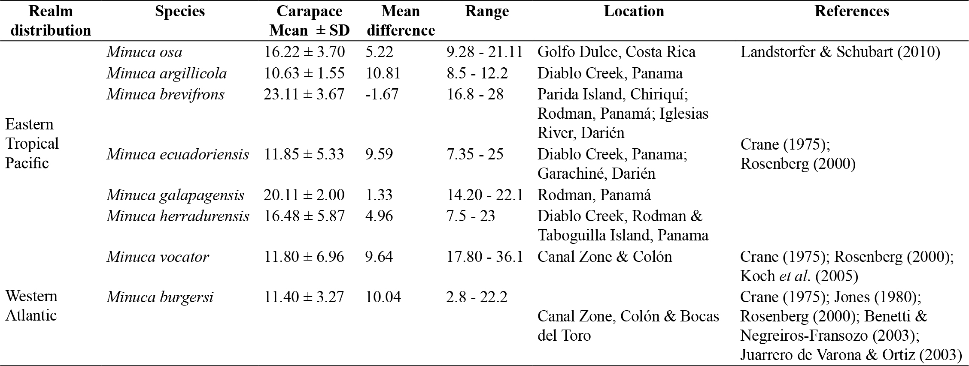[/graphic][/tabwrap]

[p]Morphological characters of the genus found in sampled specimens include: H-like depression in the cardiac-mesogastric region, carapace width to front ratio of approximately 35% (wide front; [xref ref-type="fig" rid="f2"]Fig. 2A[/xref]), with long anterolateral margins curving inwards [xref ref-type="fig" rid="f2"](Fig. 2A, D[/xref]), small suborbital crenulations increasing towards outer angle [xref ref-type="fig" rid="f2"](Fig. 2B[/xref]), narrow gape minor chelipeds with small serrations [xref ref-type="fig" rid="f2"](Fig. 2C[/xref]), and two postero-lateral striae in the carapace [xref ref-type="fig" rid="f2"](Fig. 2D[/xref]).[/p]
[p]A total of 16 males and six females exhibited traits that fit the description of Minuca osa. Specifically, segments of the pleon were not fused, carapace surface with small pits; no pubescence or setae on carapace [xref ref-type="fig" rid="f2"](Fig. 2A, D[/xref]). There was pile with few long setae in the ambulatories dorsal margin of the carpus and propodus, in agreement with that reported for M. osa [xref ref-type="fig" rid="f2"](Fig. 2E[/xref]). The dorsal margins of ambulatory meri in males had a soft dorsal tuberculate ridge [xref ref-type="fig" rid="f2"](Fig. 2F[/xref]); dactyls of ambulatory legs have three distinct rows of short setae [xref ref-type="fig" rid="f2"](Fig. 2G[/xref]). In males, the external surface and dorsal edge of the manus was tuberculate, with a minuscule hollow space, proximal to the predactylar groove. Tubers in the major chela diminished on lower manus and were minuscule on pollex and dactyl [xref ref-type="fig" rid="f2"](Fig. 2H[/xref]). The pollex was curved upwards at the tip; both, the pollex and dactyl were flattened. The dactyl was longer than the pollex and was curved at approx. 90° downward at tip [xref ref-type="fig" rid="f2"](Fig. 2H, K, M[/xref]). The pollex showed three rows of tubercles, and one large carina beyond the midpoint [xref ref-type="fig" rid="f2"](Fig. 2I[/xref]). There was one large subdistal tooth at the gape midrow of the pollex, forming three distinct tubercles (white) on the tip [xref ref-type="fig" rid="f2"](Fig. 2J, K, M[/xref]). The dactyl had three to four larger tubercles (Fig. 2K, M). The inner surface of the manus had a ridge of dense tubercles lining the margin of the carpal cavity, warping in direction to the palm with tubercles growing in size and ending in a patch in the central section of the manus, almost connecting to the oblique tuberculate edge [xref ref-type="fig" rid="f2"](Fig. 2L[/xref]). The ventral manus tuberculate ridge was oblique with a high apex, sloping into pollex ventral surface. This ridge had distinctive tubercles decreasing in size towards the pollex with increased irregularity. The pollex and manus articulation had a deep sulcus which ran between the pollex ventral margin and two predactylar tuberculate ridges; the nearest was divergent and curled into the inner dorsal tuberculate ridge of the pollex [xref ref-type="fig" rid="f2"](Fig. 2L, M[/xref]). The carpal surface (dorsal) of major chelipeds bearded four to five sharp tubers, and the merus showed numerous sharp tubercles on the dorsal edge [xref ref-type="fig" rid="f2"](Fig. 2N[/xref]). The gonopod had two flanges and a thumb; the posterior flange was longer than the anterior. The genital pore and flanges were covered by extension of the shaft. Setae were on the opposite side of the flanges, on thumb and tip of gonopod [xref ref-type="fig" rid="f2"](Fig. 2O[/xref]).[/p]

[figgrp id="f2"][graphic href="?a02v14n2"]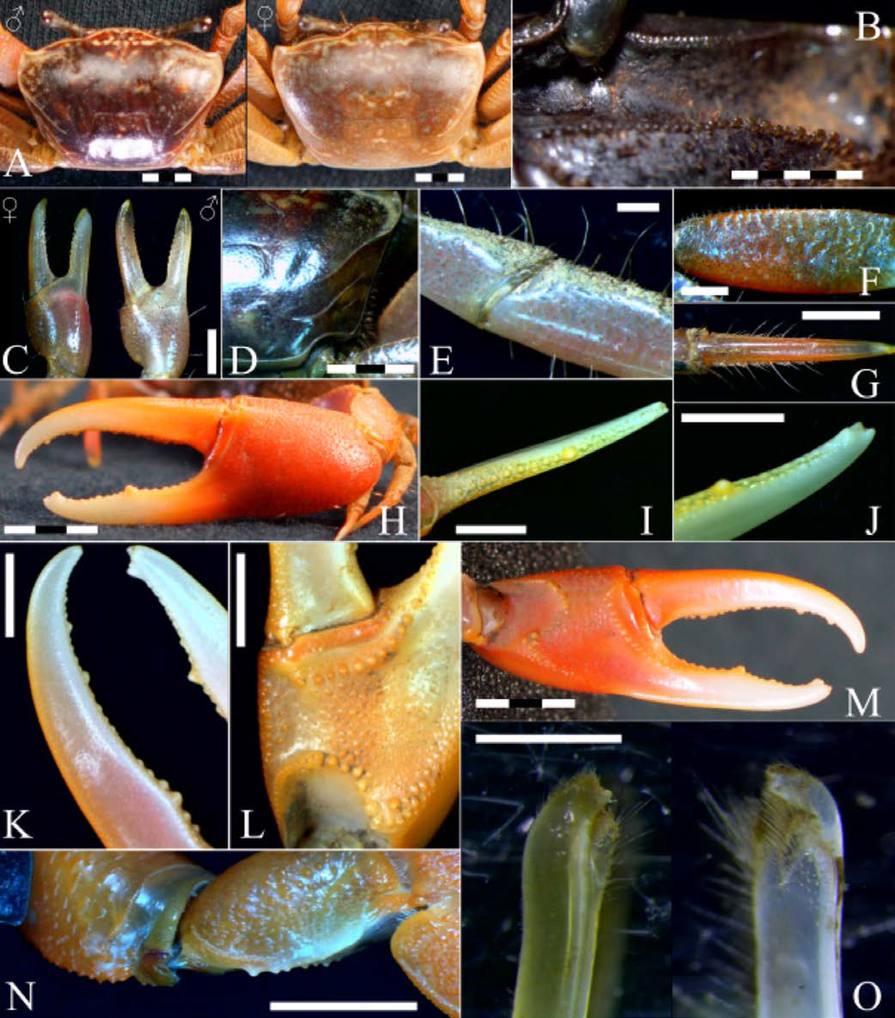[/graphic]
[label]Fig. 2[/label]. [caption]Minuca osa diagnostic features from the Eastern Montijo Gulf, Veraguas, Panama. A: carapace. B: orbital cavity. C: minor chelipeds, left female (outer side); right male (inner surface). D: carapace striae. E: pubescence in carpus and propodus of ambulatories. F: ambulatory merus tuberculate ridge. G: ambulatories dactylus setae rows. H: major chela. I: pollex tubercle rows and large carina beyond midpoint. J: large tubercles at pollex tip. K: dactyl edge tubercles. L-M: manus, palm, and pollex tubercular ridges. N: large chela carpus and merus tubercles. O: right gonopod, anterolateral (left) and posteromesial (right). (Scale bar: A, D, I-L, N = 5 mm; B, C, F, G = 2 mm; H, M = 10 mm; E = 0.5 mm; O = 0.2 mm)[/caption][/figgrp]

[/sec][sec sec-type="discussion"][sectitle]DISCUSSION[/sectitle]

[p]Minuca burgersi, M. vocator, and M. ecuadoriensis are morphologically similar to M. osa ([xref ref-type="bibr" rid="r10"]Landstorfer & Schubart, 2010[/xref]; [xref ref-type="bibr" rid="r15"]Rosenberg, 2020[/xref]); however, M. burgersi and M. vocator are only distributed in the Western Atlantic, while M. ecuadoriensis is only found in the Eastern Pacific ([xref ref-type="bibr" rid="r12"]Masunari et al. 2020[/xref]; [xref ref-type="bibr" rid="r15"]Rosenberg, 2020[/xref]). Furthermore, M. burgersi also differs from our specimens in that the oblique tuberculate ridge on the major palm has small tubercles (not a single row); tubercle ridge does not diminish distally on outer pollex [xref ref-type="bibr" rid="r3"](Crane, 2015[/xref]; [xref ref-type="bibr" rid="r16"]Shih et al. 2016[/xref]). In Minuca vocator and M. ecuadoriensis, the carapace as well as the ambulatories on all segments have a profuse pile (except dactyls) in an irregular pattern (see [xref ref-type="bibr" rid="r12"]Masunari et al. 2020[/xref]), while our specimens had no such pile. In M. ecuadoriensis, the oblique ridge in the major palm has a very low apex; tubercles are small and irregular, sometimes vestigial or absent. In contrast, the apex in M. osa is high and tubercles are large ([xref ref-type="bibr" rid="r10"]Landstorfer & Schubart, 2010[/xref]; [xref ref-type="bibr" rid="r3"]Crane, 2015[/xref]); all of our specimens showed the latter. Considering its behavior and coloration, M. osa is a conspicuous fiddler crab species; thus, it is unclear why it was not been identified other than in Golfo Dulce [xref ref-type="bibr" rid="r10"](Landstorfer & Schubart, 2010[/xref]) prior to this report. Based on the morphological differences between M. osa, M. burgersi, M. vocator, and M. ecuadoriensis, it can be concluded that M. osa is also present in the Eastern Montijo Gulf, Panama[/p][/sec][/xmlbody].

[ack][sectitle]ACKNOWLEDGEMENTS[/sectitle]
[p]Our gratitude goes to the anonymous reviewers for their comments to improve the manuscript and to John Christy and Fumio Takeshita for their preliminary discussions. We would also like to thank Jaime Rivera for his cartographic assistance, as well as Jacinto Rodríguez and the Cantarana Hotel staff for their hospitality[/p][/ack].

[refs][sectitle]REFERENCES[/sectitle]

[ref id="r1" reftype=“journal"][authors role="nd"][pauthor][surname]Benetti[/surname], [fname]A. S.[/fname][/pauthor]; & [pauthor][surname]Negreiros-Fransozo[/surname], [fname]M. L.[/fname][/pauthor] [/authors]([date dateiso="20030000" specyear="2003"]2003[/date]). [arttitle]Symmetric chelipeds in males of the fiddler crab Uca burgersi Holthuis, 1967 (Decapoda, Brachyura, Ocypodidae). [/arttitle][source]Nauplius[/source], [volid]11[/volid]([issueno]2[/issueno]), [pages]141-144[/pages].[/ref]
[ref id="r2" reftype=“journal"][authors role="nd"][pauthor][surname]Christy[/surname], [fname]J. H.[/fname][/pauthor] [/authors]([date dateiso="20030000" specyear="2003"]2003[/date]). [arttitle]Reproductive timing and larval dispersal of intertidal crabs: the predator avoidance hypothesis[/arttitle]. [source]Rev. Chil. Hist. Nat.[/source], [volid]76[/volid]([issueno]2[/issueno]), [pages]177-185[/pages]. https://doi.org/[pubid idtype="doi"]10.4067/S0716-078X2003000200005[/pubid][/ref]
[ref id="r3" reftype="book"][authors role="nd"][pauthor][surname]Crane[/surname], [fname]J.[/fname][/pauthor] [/authors]([date dateiso="19750000" specyear="1975"]1975[/date]). [source]Fiddler Crabs of the World: Ocypididae: Genus Uca [/source]([edition]1st [/edition]ed.). [publoc]USA, Princeton[/publoc]: [pubname]Princeton University Press[/pubname]. https://doi.org/10.1515/9781400867936[/ref]
[ref id="r4" reftype=“journal"][authors role="nd"][pauthor][surname]Dennenmoser[/surname], [fname]S.[/fname][/pauthor] & [pauthor][surname]Christy[/surname], [fname]J. H.[/fname][/pauthor][/authors] ([date dateiso="20130000" specyear="2013"]2013[/date]). [arttitle]The design of a beautiful weapon: Compensation for opposing sexual selection on a trait with two functions[/arttitle]. [source]Evolution[/source], [volid]67[/volid]([issueno]4[/issueno]), [pages]1181-1188[/pages]. https://doi.org/[pubid idtype="doi"]10.1111/evo.12018[/pubid][/ref]
[ref id="r5" reftype=“journal"][authors role="nd"][pauthor][surname]How[/surname], [fname]M. J.[/fname][/pauthor]; [pauthor][surname]Christy[/surname], [fname]J. H.[/fname][/pauthor]; [pauthor][surname]Temple[/surname], [fname]S. E.[/fname][/pauthor]; [pauthor][surname]Hemmi[/surname], [fname]J. M.[/fname][/pauthor]; [pauthor][surname]Marshall[/surname], [fname]J. N.[/fname][/pauthor]; & [pauthor][surname]Roberts[/surname], [fname]N. W.[/fname][/pauthor][/authors] ([date dateiso="20150000" specyear="2015"]2015[/date]). [arttitle]Target detection is enhanced by polarization vision in a fiddler crab[/arttitle]. [source]Curr. Biol.[/source], [volid]25[/volid]([issueno]23[/issueno]), [pages]3069-3073[/pages]. https://doi.org/[pubid idtype="doi"]10.1016/j.cub.2015.09.073[/pubid][/ref]
[ref id="r6" reftype=“journal"][authors role="nd"][pauthor][surname]Jones[/surname], [fname]A. R.[/fname][/pauthor] [/authors]([date dateiso="19800000" specyear="1980"]1980[/date]). [arttitle]Chela injuries in the fiddler crab, Uca burgersi holthuis[/arttitle]. [source]Mar. Behav. Physiol.[/source], [volid]7[/volid]([issueno]1[/issueno]), [pages]47-56[/pages]. https://doi.org/[pubid idtype="doi"]10.1080/10236248009386970[/pubid][/ref]
[ref id="r7" reftype=“journal"][authors role="nd"][pauthor][surname]Juarrero de Varona[/surname], [fname]A.[/fname][/pauthor] & [pauthor][surname]Ortiz[/surname], [fname]M.[/fname][/pauthor][/authors] ([date dateiso="20030000" specyear="2003"]2003[/date]). [arttitle]Los cangrejos del género Uca (Crustacea: Brachyura: Ocypodidae) en Cuba. Apuntes taxonómicos[/arttitle]. [source]Cocuyo[/source], [volid]13[/volid], [pages]7-10[/pages].[/ref]
[ref id="r8" reftype=“journal"][authors role="nd"][pauthor][surname]Kerr[/surname], [fname]K. A.[/fname][/pauthor] [/authors]([date dateiso="20150000" specyear="2015"]2015[/date]). [arttitle]Decreased temperature results in daytime larval release by the fiddler crab Uca deichmanni Rathbun, 1935[/arttitle]. [source]J. Crustac. Biol.[/source], [volid]35[/volid]([issueno]2[/issueno]), [pages]185-190[/pages]. https://doi.org/[pubid idtype="doi"]10.1163/1937240X-00002334[/pubid][/ref]
[ref id="r9" reftype=“journal"][authors role="nd"][pauthor][surname]Koch[/surname], [fname]V.[/fname][/pauthor]; [pauthor][surname]Wolff[/surname], [fname]M.[/fname][/pauthor]; & [pauthor][surname]Diele[/surname], [fname]K.[/fname][/pauthor][/authors] ([date dateiso="20050000" specyear="2005"]2005[/date]). [arttitle]Comparative population dynamics of four fiddler crabs (Ocypodidae, genus Uca) from a North Brazilian mangrove ecosystem[/arttitle]. [source]Mar. Ecol. Prog. Ser.[/source], [volid]291[/volid], [pages]177-188[/pages]. https://doi.org/[pubid idtype="doi"]10.3354/meps291177[/pubid][/ref]
[ref id="r10" reftype=“journal"][authors role="nd"][pauthor][surname]Landstorfer[/surname], [fname]R. B.[/fname][/pauthor] & [pauthor][surname]Schubart[/surname], [fname]C. D.[/fname][/pauthor] [/authors]([date dateiso="20100000" specyear="2010"]2010[/date]). [arttitle]A phylogeny of Pacific fiddler crabs of the subgenus Minuca (Crustacea, Brachyura, Ocypodidae: Uca) with the description of a new species from a tropical gulf in Pacific Costa Rica[/arttitle]. [source]J. Zool. Syst. Evol. Res.[/source], [volid]48[/volid]([issueno]3[/issueno]), [pages]213-218[/pages]. https://doi.org/[pubid idtype="doi"]10.1111/j.1439-0469.2009.00554.x[/pubid][/ref]
[ref id="r11" reftype=“journal"][authors role="nd"][pauthor][surname]Lim[/surname], [fname]S. S. L.[/fname][/pauthor] & [pauthor][surname]Goh[/surname], [fname]S. J. A.[/fname][/pauthor][/authors] ([date dateiso="20210000" specyear="2021"]2021[/date]). [arttitle]Ecomorphological adaptations of second maxilliped-setation: Insights from three species of fiddler crabs from Panama. [/arttitle][source]Zool. Stud.[/source], [volid]60[/volid], [pages]1-10[/pages]. https://doi. org/[pubid idtype="doi"]10.6620/ZS.2021.60-48[/pubid][/ref]
[ref id="r12" reftype=“journal"][authors role="nd"][pauthor][surname]Masunari[/surname], [fname]S.[/fname][/pauthor]; [pauthor][surname]Martins[/surname], [fname]S. B.[/fname][/pauthor]; & [pauthor][surname]Anacleto[/surname], [fname]A. F. M.[/fname][/pauthor][/authors] ([date dateiso="20200000" specyear="2020"]2020[/date]). [arttitle]An illustrated key to the fiddler crabs (Crustacea, Decapoda, Ocypodidae) from the Atlantic coast of Brazil. [/arttitle][source]ZooKeys[/source], [volid]943[/volid], [issueno]1-20[/issueno]. https://doi. org/[pubid idtype="doi"]10.3897/zookeys.943.52773[/pubid][/ref]
[ref id="r13" reftype=“journal"][authors role="nd"][pauthor][surname]Pardo[/surname], [fname]J. C. F.[/fname][/pauthor]; [pauthor][surname]Stefanelli-Silva[/surname], [fname]G.[/fname][/pauthor]; [pauthor][surname]Christy[/surname], [fname]J. H.[/fname][/pauthor]; & [pauthor][surname]Costa[/surname], [fname]T. M.[/fname][/pauthor] [/authors]([date dateiso="20200000" specyear="2020"]2020[/date]). [arttitle]Fiddler crabs and their above-ground sedimentary structures: a review[/arttitle]. [source]J. Ethol.[/source], [volid]38[/volid]([issueno]2[/issueno]), [pages]137-154[/pages]. https://doi.org/[pubid idtype="doi"]10.1007/s10164-020-00647-1[/pubid][/ref]
[ref id="r14" reftype=“journal"][authors role="nd"][pauthor][surname]Rosenberg[/surname], [fname]M. S.[/fname][/pauthor] [/authors]([date dateiso="20140000" specyear="2014"]2014[/date]). [arttitle]Contextual cross-referencing of species names for Fiddler Crabs (Genus Uca): an experiment in cyber-taxonomy[/arttitle]. [source]PLoS ONE[/source], [volid]9[/volid]([issueno]7[/issueno]), [edition]e101704[/edition]. https://doi.org/[pubid idtype="doi"]10.1371/journal.pone.0101704[/pubid][/ref]
[ref id="r15" reftype=“journal"][authors role="nd"][pauthor][surname]Rosenberg[/surname], [fname]M. S.[/fname][/pauthor][/authors] ([date dateiso="20200000" specyear="2020"]2020[/date]). [arttitle]A fresh look at the biodiversity lexicon for fiddler crabs (Decapoda: Brachyura: Ocypodidae). Part 2: Biogeography[/arttitle]. [source]J. Crust. Biol.[/source], [volid]40[/volid]([issueno]4[/issueno]), [pages]364-383[/pages]. https://doi.org/[pubid idtype="doi"]10.1093/jcbiol/ruaa029[/pubid][/ref]
[ref id="r16" reftype=“journal"][authors role="nd"][pauthor][surname]Shih[/surname], [fname]H.[/fname][/pauthor], [pauthor][surname]Ng[/surname], [fname]P.[/fname][/pauthor], [pauthor][surname]Davie[/surname], [fname]P.[/fname][/pauthor], [pauthor][surname]Schubart[/surname], [fname]C.[/fname][/pauthor], [pauthor][surname]Türkay[/surname], [fname]M.[/fname][/pauthor], [pauthor][surname]Naderloo[/surname], [fname]R.[/fname][/pauthor], & [pauthor][surname]Liu[/surname], [fname]M.[/fname][/pauthor] [/authors]([date dateiso="20160000" specyear="2016"]2016[/date]). [arttitle]Systematics of the family Ocypodidae Rafinesque, 1815 (Crustacea: Brachyura), based on phylogenetic relationships, with a reorganization of subfamily rankings and a review of the taxonomic status of Uca Leach, 1814, sensu lato and its subgenera[/arttitle]. [source]Raffles Bull. Zool.[/source], [volid]64[/volid], [pages]139-175[/pages][/ref][/refs].[/doc]

