[doc sps="1.8" acron="uniciencia" jtitle="Uniciencia" stitle="Uniciencia" issn="2215-3470" pissn="2215-3470" eissn="1011-0275" pubname="Universidad Nacional, Costa Rica" license="http://creativecommons.org/licenses/by-nc-nd/3.0" volid="35" issueno="2" dateiso="20211200" season="July/Dec" order="13" fpage="197" lpage="209" pagcount="13" doctopic="oa" language="es"]DOI:[doi]10.15359/ru.35-2.13[/doi]
[toctitle]Artículo[/toctitle]

[doctitle language="en"]Nesting of arboreal ants (Hymenoptera: Formicidae) in artificial substrates in coffee plantations in the Colombian Andes[/doctitle]
[doctitle language="es"]Anidación por hormigas arbóreas (Hymenoptera: Formicidae) en sustratos artificiales en plantaciones de café en los Andes Colombianos.[/doctitle]
[doctitle language="pt"]Aninhamento feito por formigas arbóreas (Hymenoptera: Formicidae) em substratos artificiais em cafezais nos Andes Colombianos.[/doctitle]

[author role="nd"][fname]Andrés Jireh[/fname] [surname]López-Dávila[/surname] [xref ref-type="aff" rid="aff1"]¹[/xref] [authorid authidtp="orcid"]0000-0003-2868-3547[/authorid][/author]
[author role="nd"][fname]Selene[/fname] [surname]Escobar-Ramírez[/surname][xref ref-type="aff" rid="aff2"]²[/xref] [authorid authidtp="orcid"]0000-0002-1603-4710[/authorid][/author]
[author role="nd"][fname]Inge[/fname] [surname]Armbrecht[/surname] [xref ref-type="aff" rid="aff3"]³[/xref] [authorid authidtp="orcid"]0000-0003-0574-2559[/authorid][/author]

[normaff id="aff1" ncountry="Not normalized" norgname="Not normalized" icountry="CO"][label]¹[/label] [orgdiv1]Department of Biology[/orgdiv1], [orgname]Universidad del Valle[/orgname], [city]Cali[/city], [country]Colombia[/country]. [email]andresjlopez25@gmail.com[/email] [/normaff]
[normaff id="aff2" ncountry="Not normalized" norgname="Not normalized" icountry="EC"][label]²[/label] [orgdiv1]Colegio de Ciencias Biológicas y Ambientales[/orgdiv1], [orgdiv2]Herbario de Botánica Económica del Ecuador[/orgdiv2], [orgname]Universidad San Francisco de Quito[/orgname], [city]Quito[/city], [country]Ecuador [/country][email]sescobar@usfq.edu.ec[/email] [/normaff]
[normaff id="aff3" ncountry="Not normalized" norgname="Not normalized" icountry="CO"][label]³[/label] [orgdiv1]Department of Biology[/orgdiv1], [orgname]Universidad del Valle[/orgname], [city]Cali[/city], [country]Colombia[/country][email]inge.armbrecht@correounivalle.edu.co[/email][/normaff]

[xmlabstr language="en"][sectitle]Abstract[/sectitle]
[p]Ants can provide pest biocontrol for coffee crops; however, this ecosystem service may decline in intensively managed plantations due to the loss of nesting resources. Considering how to increase the number of ants, we studied if they nest in different types of artificial substrates attached to coffee bushes both in shade-grown and sun-grown coffee plantations. Three independent tests were conducted at some coffee plantations in southwestern Colombia with the purpose of answering the following questions: 1) Do ants nest in artificial substrates made from recyclable materials? 2) Do the types of substrate (materials and configuration) and coffee management (shade-grown vs. sun-grown coffee) affect colonization rates, richness, and identity of colonizing ants? 3) Does time affect substrate colonization rates? Each experiment independently compared different substrate materials and designs, in both shade and sun-grown coffee. Results showed preference of one of the substrates offered and higher nesting rates in shade-grown plantations. Eight ant species were found nesting in artificial substrates, most of them being arboreal generalists. A higher number of ant species colonized substrates in shade-grown plantations; however, the effect was not statistically significant. Nesomyrmex asper and Crematogaster spp. were always found nesting in both types of plantation. There was a trend to increase nesting activity with time in shade-grown coffee but not in sun-grown coffee. Evidence supports that offering artificial substrates enhances arboreal ant nesting in coffee plantations.[/p][/xmlabstr]
[kwdgrp language="en"][sectitle]Keywords:[/sectitle] [kwd]Crematogaster[/kwd]; [kwd]Management of beneficial ants[/kwd]; [kwd]Management of coffee agroecosystems[/kwd]; [kwd]Nesting resources[/kwd]; [kwd]Nesomyrmex[/kwd][/kwdgrp]

[xmlabstr language="es"][sectitle]Resumen[/sectitle]
[p]Las hormigas pueden ejercer biocontrol del cultivo de café, pero este servicio puede declinar en plantaciones manejadas intensivamente debido a que se pierden recursos de nidificación. Considerando cómo incrementar las hormigas, estudiamos si estas anidan en diferentes tipos de sustratos artificiales adheridos sobre arbustos de café tanto en cafetales de sombra como de sol. Se realizaron tres exámenes independientes en cafetales del suroccidente colombiano para responder: 1) ¿Anidan las hormigas en sustratos artificiales hechos de materiales reciclables? 2) ¿El tipo de sustrato (material y configuración) y el tipo de manejo del cafetal (sombra vs. sol) afectan la colonización, riqueza e identidad de hormigas? 3) ¿Afecta el tiempo las tasas de colonización de sustratos artificiales? Cada experimento comparó diferentes materiales y diseños, tanto en cafetales de sombra como de sol. Las hormigas anidaron más en uno de los sustratos ofrecidos y hubo mayor nidificación en cafetales de sombra. Ocho especies anidaron en los sustratos artificiales, la mayoría generalistas arbóreas. Un mayor número de especies de hormigas colonizó sustratos en cafetales de sombra, aunque no fue estadísticamente significativo. Nesomyrmex asper y Crematogaster spp. siempre se encontraron anidando en ambos tipos de plantación. La evidencia soporta que se puede ofrecer sustratos artificiales favorece la anidación por hormigas arbóreas en plantaciones de café.[/p][/xmlabstr]
[kwdgrp language="es"][sectitle]Palabras Clave:[/sectitle] [kwd]Crematogaster[/kwd]; [kwd]Manejo hormigas benéficas[/kwd]; [kwd]Manejo agroecosistemas cafeteros[/kwd]; [kwd]Recursos de nidificación[/kwd]; [kwd]Nesomyrmex[/kwd][/kwdgrp]

[xmlabstr language="pt"][sectitle]Resumo[/sectitle]
[p]As formigas podem exercer controle biológico no cultivo do café, porém essa função pode reduzir em plantações manejadas intensivamente, já que os recursos de aninhamento são perdidos. Considerando o aumento das formigas, foi estudado se o aninhamento se dá em diferentes tipos de substratos artificiais aderidos sobre arbustos de café tanto em cafezais sombreados quanto ensolarados. Foram realizadas três provas independentes em cafezais do sul ocidental colombiano para responder: 1) As formigas se aninham em substratos artificiais feitos de materiais recicláveis? 2) O tipo de substrato (material e configuração) e o tipo de manejo do cafezal (sombra vs. sol) afetam a colonização, riqueza e identidade das formigas? 3) O tempo afeta as taxas de colonização de substratos artificiais? Cada experimento comparou diferentes materiais e desenhos, tanto em cafezais sombreados quanto ensolarados. As formigas se aninharam mais em um dos substratos oferecidos e houve maior aninhamento em cafezais sombreados. Oito espécies aninharam-se nos substratos artificiais, a maioria generalistas arbóreas. Um maior número de espécies de formigas colonizou substratos em cafezais sombreados, ainda que não tenha sido estatisticamente significativo. Nesomyrmex asper e Crematogaster spp. sempre foram encontrados se aninhando em ambos os tipos de plantação. A evidência propõe que é possível oferecer substratos artificiais para favorecer o aninhamento de formigas arbóreas em plantações de café.[/p][/xmlabstr]
[kwdgrp language="pt"][sectitle]Palavras-chave:[/sectitle] [kwd]Crematogaster[/kwd]; [kwd]Manejo de formigas benéficas[/kwd]; [kwd]Manejo agroecossistemas cafeeiros[/kwd]; [kwd]Recursos de aninhamento[/kwd]; [kwd]Nesomyrmex[/kwd][/kwdgrp]

[hist]Received: [received dateiso="20201101"]Nov/1/2020[/received]
Accepted: [accepted dateiso="20210228"]Feb/28/2021[/accepted]
Published: Jul/31/2021[/hist]

[xmlbody][sec sec-type="intro"][sectitle]Introduction[/sectitle]

[p]Coffee crop intensification often involves elimination of associated trees and high agrochemical use, practices which negatively affect the natural diversity associated to the plantations ([xref ref-type="bibr" rid="r2"]Armbrecht & Perfecto, 2003[/xref]). Traditionally, coffee was planted under a canopy of native trees which protected the plants and soil, and provided habitat for wild fauna such as birds, mammals, and insects. However, some decades ago, a fast conversion and intensive production system was implemented with no tree cover and was highly dependent on agricultural inputs [xref ref-type="bibr" rid="r21"](Perfecto et al., 1996[/xref]). In Colombia, more than half of the coffee agroecosystems have no shade trees ([xref ref-type="bibr" rid="r13"]Jha et al., 2014[/xref]; [xref ref-type="bibr" rid="r20"]Ocampo-Lopez & Alvarez-Herrera, 2017[/xref]). This reduction of shade affects the structural complexity of the coffee agroecosystem with negative consequences for the associated biodiversity and its ecosystem services [xref ref-type="bibr" rid="r6"](De La Mora et al., 2015[/xref]; [xref ref-type="bibr" rid="r23"]Philpott & Armbrecht, 2006[/xref]).[/p]
[p]The lack of shade trees limits the amount of available resources that ants need for nesting (less leaf litter, twigs and trunks) ([xref ref-type="bibr" rid="r3"]Armbrecht et al., 2006[/xref]), thus probably reducing their impact on biological pest control ([xref ref-type="bibr" rid="r23"]Philpott & Armbrecht, 2006[/xref]). As an alternative, the provision of artificial nesting sites could contribute to an increase in abundance of ants that nest in twigs on shrubs and, therefore, promote both the abundance and diversity of ants, and a more effective biological control of pests on the sites where the artificial nests are located ([xref ref-type="bibr" rid="r10"]Guzman et al., 1997[/xref]; [xref ref-type="bibr" rid="r27"]Vidal-Hernández & Armbrecht, 2009[/xref]; [xref ref-type="bibr" rid="r11"]Hosang et al., 2010[/xref]; [xref ref-type="bibr" rid="r6"]De la Mora et al., 2015[/xref]). For instance, [xref ref-type="bibr" rid="r10"]Guzman et al. (1997[/xref]) found 98% control by ants of a pest in oil palms whereas Crematogaster sp. was promoted while [xref ref-type="bibr" rid="r27"]Vidal-Hernandez and Armbrecht (2009[/xref]) found increased ant diversity when bamboo twigs were added to Colombian coffee plantations. [xref ref-type="bibr" rid="r11"]Hosang et al. (2010[/xref]) managed to enhance the predator ant Dolichoderus thoracicus using artificial nesting substrates while [xref ref-type="bibr" rid="r6"]De la Mora et al. (2015[/xref]) found that prey removal by ants on coffee plantations was positively correlated with hollow coffee twigs. Further, heterogeneous nesting resources (substrates) could be important in promoting ant diversity and abundance [xref ref-type="bibr" rid="r4"](Armbrecht et al. 2004[/xref]; [xref ref-type="bibr" rid="r19"]Mottl et al., 2019[/xref]) Given these studies and the potential of ants as biocontrol agents, an assessment is needed for the type of substrates or the appropriate configurations required to favour ant colonization in a given agroecosystem.[/p]
[p]In this study, a total of three field tests were performed in order to assess nesting ability, preferences and colonization rates of ant species in both shaded-grown and sun-grown coffee crops, when artificial nesting resources were provided in plantations in southwestern Colombia. First, we tested ant colonization in two different designs of artificial substrate. Based on the best traits of those designs, a third nesting substrate was designed and monitored for ant colonization over time. We hypothesized that the presence of trees in coffee plantations fosters the colonization of artificial substrates by generalist ants, and that a higher percentage of substrates will be colonized by ants over time.[/p]

[/sec][sec sec-type="methods"][sectitle]Methods[/sectitle]

[subsec][sectitle]Study area[/sectitle]

[p]The sampling site was located in the village of La Venta, Municipality of Cajibio, Cauca Department, Colombia (2°37′24″N; 76°34′23″W). The site was located in the Alto Cauca Valley at 1,760 m.a.s.l. with annual temperatures between 23.8-27.1°C (IDEAM 2015). Three sun-grown and three shade-grown coffee plantations were selected, approximately 1.5 ha each, with ∼3-year-old coffee shrubs planted 1.5-2.0 m from each other (Table S1). To differentiate shade-grown from sun-grown coffee plantations, the canopy cover was calculated by means of a GRS Densitometer^{(TM)} at 400 observation points. Canopy cover was 6.2% (±9.5; n=3) in sun-grown coffee vs. 42.3% (±6.5; n=3) in shade-grown coffee. Three independent tests were performed between 24 March and 18 December 2015 on all six plots at different moments. During the sampling period, monthly temperature and average precipitation data were recorded ([xref ref-type="fig" rid="f1"]Figure 1[/xref]) [xref ref-type="bibr" rid="r12"](IDEAM, 2015[/xref]). The first test matched a decrease in precipitation, the second was made throughout the dry period, and the third during a transition to the next rainy season. Each of the three tests carried out in the field is described below.[/p]

[/subsec][subsec][sectitle]Sampling period[/sectitle]

[figgrp id="f1"][graphic href="?a13v35n2"]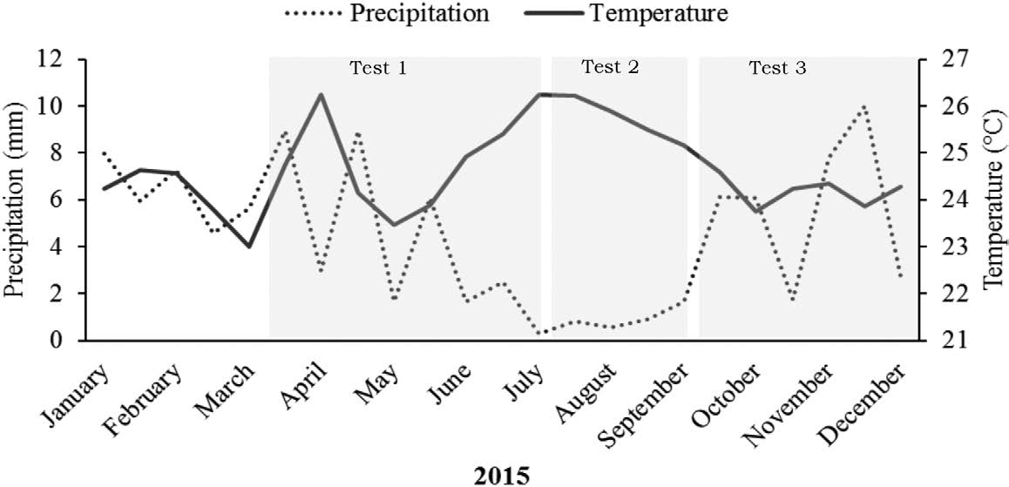[/graphic]
[label]Figure 1[/label]. [caption]Monthly temperature in °C (black line) and monthly precipitation in mm (dotted line) recorded during 2015, the year when the three independent experiments were performed (Source: IDEAM Colombia).[/caption][/figgrp]

[subsec][sectitle]Test 1: PVC covers filled with corrugated cardboard (CC) vs. cardboard tubes (CT)[/sectitle]

[p]Ant nesting was compared in two types of artificial substrates: polyvinylchloride tubes filled with corrugated cardboard (CC) vs. polyvinylchloride tubes filled with cardboard tubes (CT), on sun-grown and shade-grown coffee plantations ([xref ref-type="fig" rid="f2"]Figure 2a[/xref]). The CC resembles the cavities found in tree bark where ants forage and nest, and CT resembles hollow twigs. The PVC cover was a tube 6 cm in diameter and 30 cm in length. The CC substrate filling consisted of a 30 × 46 cm sheet of a tightly rolled CC, forming internal cavities of 0.3cm in diameter and 0.4 cm in height (Packing S.A., Colombia). The CT substrate consisted of five firmly packed CT (diameter = 1 cm, length = 30 cm, thickness = 3-4 mm) ([xref ref-type="fig" rid="f2"]Figure 2a[/xref]). On each of the six coffee plantations, 20 focal units of trees with high ant activity were identified. Then, two CC substrates and two CT substrates were placed on four coffee plants surrounding the tree ([xref ref-type="fig" rid="f2"]Figure 2a[/xref]). Overall, 120 artificial substrates were provided: 60 on shade-grown coffee plots and 60 on sun-grown coffee plots. Substrates were installed from March 21st to 24th, 2015 (flowering cycle), and collected between June 28th and July 3rd (fruiting cycle) after three months for inspection to assess colonization.[/p]

[/subsec][subsec][sectitle]Test 2: Cover comparison (PVC vs. CC)[/sectitle]

[p]Given the possibility of a ‘greenhouse effect’ on the interior of the substrates caused by a polyvinylchloride cover, a second test was performed in sun-grown and shade-grown coffee to establish whether this type of cover affected substrate colonization. For this test, we compared ant nesting in substrates with two different covers: polyvinylchloride tube vs. CC covered with a transparent plastic film ([xref ref-type="fig" rid="f2"]Figure 2b[/xref]). Both covers were filled with the same substrate consisting of CT filled with CC. The same six coffee plots in Test 1 were used for Test 2. In each coffee plot, 13 pairs of contiguous coffee trees with high ant activity were selected, and the two types of substrates were randomly assigned to each coffee tree. A total of 156 artificial substrates were used in this test: 78 on shade-grown coffee plots and 78 on sun-grown coffee plots. Inner substrate temperature was estimated for sun-grown and shade-grown coffee from a total of 30 substrates of each type. The substrates were installed between June 28th and July 3rd, 2015 during the fruiting cycle and were collected, uncovered, and inspected between September 12th and 15th, 2015 (flowering cycle) to assess ant colonization after two months.[/p]

[/subsec][subsec][sectitle]Test 3. Single type of a full cardboard substrate: colonization over time[/sectitle]

[p]In this test, a single substrate type was monitored for ant colonization over time in sun-grown and shade-grown coffee. Based on previous experience with Tests 1 and 2, we designed a substrate covered by CC (to avoid an increase in internal temperature) and filled it with a combination of CT and CC (to allow nesting by ants of different sizes) ([xref ref-type="fig" rid="f2"]Figure 2c[/xref]). Specifically, the filling of each substrate consisted of five flattened and tightly packaged CT (diameter = 3 mm; length = 30 cm), protected by a CC cover (30 × 36 cm) and wrapped in a transparent plastic film ([xref ref-type="fig" rid="f2"]Figure 2c[/xref]). At each coffee plot, 40 artificial substrates were fixed (one substrate per coffee plant) and spatially distributed into five rows, each of them containing eight substrates separated from each other by ten coffee plants. A total of 240 substrates were provided: 120 in sun-grown coffee and 120 in shade-grown coffee. Substrates were checked once a month for three months for ant colonization. Substrates were installed between September 12th and 15th, 2015 (flowering cycle), collected between December 15th and 18th, 2015 (fruiting period). Identification of the ants nesting in the substrates was performed using available guides on Neotropical ants: [xref ref-type="bibr" rid="r8"]Fernández and Palacio (2003[/xref]), [xref ref-type="bibr" rid="r1"]Antweb (2014[/xref]), and [xref ref-type="bibr" rid="r16"]Longino (2003[/xref]). Cephalic capsules were measured for twenty individuals from each nesting species using a SMZ 645 model Nikon stereoscope with magnifying binocular lenses up to 8.0 × (4.0 × 2.0).[/p]

[figgrp id="f2"][graphic href="?a13v35n2"]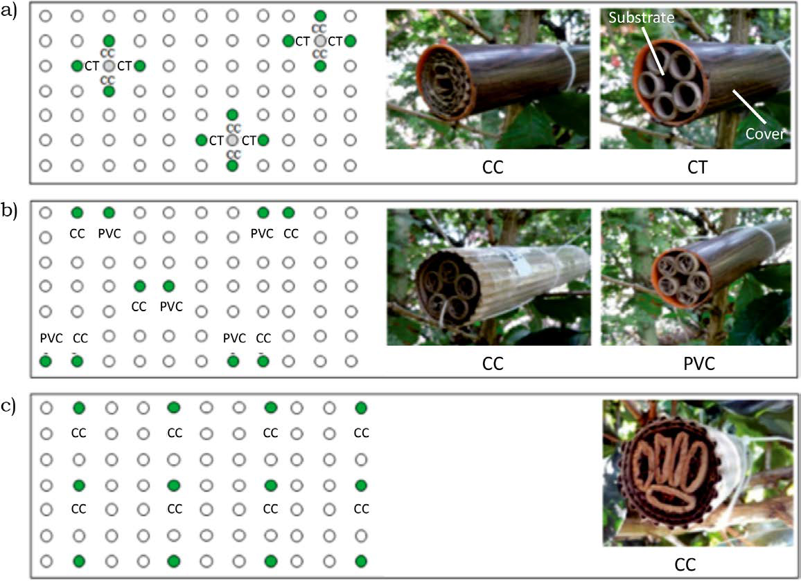[/graphic]
[label]Figure 2[/label]. [caption]Types of artificial substrates offered and their allocation within the coffee plantation: a) In Test 1, a PVC cover with two types of filling substrate (CC and CT) was placed around trees with high ant activity; b) for Test 2, two different types of covers (PVC vs. CC) for the same substrate filling (CT filled with CC) were compared; c) in Test 3, a single type of substrate made of CC was evenly distributed in the plantations.[/caption][/figgrp]

[/subsec][/subsec][subsec][sectitle]Data analyses[/sectitle]

[p]For the three tests, colonization percentages were estimated as number of colonized substrates over the total of recovered substrates (missing substrates were not considered) and analysed in relation to substrate type and tree cover on the coffee plots.[/p]
[p]In Test 1, a generalized linear mixed model (GLMM) was used to assess the effect of substrate type, coffee plot, tree cover type (fixed factors) and focal unit (random factor) on the colonization percentage by ants. The response variable was binary. Only those focal units where at least one substrate of each type was recovered were used. Through this model, we assessed possible interactions between type of substrate and type of arboreal cover.[/p]
[p]In Test 2, no statistical analysis was carried out because the independence of the sample units could not be clearly established. Therefore, a descriptive comparison of the treatments was made. The inner substrate temperatures on sun-grown and shade-grown coffee plantations were compared using a t-student test.[/p]
[p]For Test 3, a chi-square test ([xref ref-type="bibr" rid="r29"]Zar, 1999[/xref]) was used to determine if differences existed in the proportion of colonized substrates between sun-grown and shade-grown coffee during the months of substrate monitoring. For the GLMM and chi-square tests, we used the glmer package from the Ime4 library and R Studio software [xref ref-type="bibr" rid="r25"](R Core Team, 2013[/xref]). For this test, each coffee plantation was considered a sample unit. Colonization preferences by ant species on the different tests were also analysed[/p]

[/subsec][subsec][sectitle]Analyses and results[/sectitle]

[subsec][sectitle]Test 1: Substrate comparison (CC vs. CT)[/sectitle]

[p]General colonization in the first test was 28.9%. Substrate colonization was not significantly affected by the presence of tree cover on the coffee plantation (F _{(1.52)} = 0.47; p = 0.49). No interaction between type of tree cover and type of substrate was found, indicating that tree cover had no influence on the success of substrate colonization (F _{(4.52)} = 1.4162; p = 0.7081). However, ants showed a nesting preference for the substrate filled with CC compared to CT on both sun-grown and shade-grown coffee plantations (F _{(1.52)} = 6.45; p = 0.014) ([xref ref-type="fig" rid="f3"]Figure 3[/xref]). The species with the highest number of colonization events were Nesomyrmex asper (52.6% in shade-grown coffee and 36.4% in sun-grown coffee) and Crematogaster crinosa (54.5% in sun-grown coffee but only 10.5% in shade-grown coffee). Both species nested exclusively inside substrates filled with CC (Supplementary material, [xref ref-type="fig" rid="f1"]Figure S1[/xref]) and had the smallest cephalic capsules among all the ants found in this experiment ([xref ref-type="table" rid="t1"]Table 1[/xref]). Larger Camponotus species were found nesting exclusively inside the CT. The reason for including a measurement of cephalic capsules was because a trend for smaller species nesting in corrugated cardboard was detected. However, there was not enough data to test for differences in ant traits according to substrate features. [xref ref-type="bibr" rid="r5"]Barroso et al. (2020[/xref]), in Brazil, found that different species of Pheidole colonized twigs with different wood anatomy and structure, which suggests that wood structure determines preference for twig occupation.[/p]

[tabwrap id="t1"][label]Table 1[/label]. [caption]Size of cephalic capsule of ants nesting in Test 1 substrates, and size of entrance to their respective substrate. Average values ±SD are presented in this table. N = 20 workers for all species listed.[/caption]

[table][thead][tr][th align="center"]Species[/th] | [th align="center"]Approx. size of head (mm)[/th] | [th align="center"]Size of entrance to substrate (mm)[/th][/tr]
[/thead][tbody][tr][td align="center"]Crematogaster crinosa[/td] | [td align="center"]0.8 (± 0.07)[/td] | [td align="center"]4[/td][/tr]
[tr][td align="center"]Cr. montezumia[/td] | [td align="center"]0.74 (± 0.09)[/td] | [td align="center"]4[/td][/tr]
[tr][td align="center"]Nesomyrmex asper[/td] | [td align="center"]1.16 (± 0.11)[/td] | [td align="center"]4[/td][/tr]
[tr][td align="center"]Camponotus sp. 1[/td] | [td align="center"]2.5 (± 0.29)[/td] | [td align="center"]10[/td][/tr]
[tr][td align="center"]Camponotus sp. 2[/td] | [td align="center"]2.38 (± 0.47)[/td] | [td align="center"]10[/td][/tr]
[tr][td align="center"]Camponotus cf. indianus[/td] | [td align="center"]5.1 (± 1.58)[/td] | [td align="center"]10[/td][/tr][/tbody][/table][/tabwrap]

[p]Test 1[/p]
[figgrp id="f3"][graphic href="?a13v35n2"]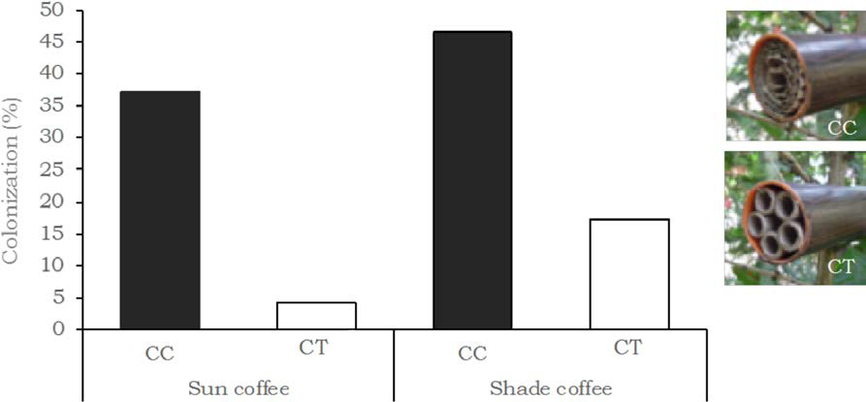[/graphic]

[label]Figure 3[/label]. [caption]Nesting preferences by ants in Test 1. Percentage of colonization by ants in substrates made using a PVC cover and filled with two different types of filling substrates: CC and CT on sun-grown and shade-grown coffee plots.[/caption][/figgrp]

[/subsec][subsec][sectitle]Test 2: Cover comparison (corrugated cover vs. PVC cover)[/sectitle]

[p]A general colonization of 9.9% was found, the lowest among all the tests ([xref ref-type="fig" rid="f4"]Figure 4[/xref]), which coincided with the driest/hottest period in the study ([xref ref-type="fig" rid="f1"]Figure 1[/xref]). However, this coincidence does not necessarily explain the observed nesting preferences. Ant colonization was 7.5% in sun-grown coffee and 12.5% in shade-grown coffee. In sun-grown coffee, a higher colonization percentage was found in CC (12.5% for CC vs 2.9% for PVC), while in shade-grown coffee a similar colonization by ants was found in both substrates (12.1% in CC and 12.9% in PVC). In general, average inner temperature was 2.3-2.7°C higher in sun-grown coffee than in shade-grown coffee. In sun-grown coffee, temperature inside substrates covered with PVC (27.0°C) was higher than substrates covered by CC (26.6°C) (t ₍₁₄₎ = -2.28; p = 0.0298); in contrast, substrates on shade-grown plantations showed no differences (t ₍₁₄₎ = 0.183; p = 0.855). Due to the low number of colonized substrates, the colonization preferences by ants are difficult to detect. Again, N. asper colonized more substrates in sun-grown and shade-grown coffee (Figure S2). Temperatures inside PVC substrates were only significantly higher than those inside CC substrates on sun-grown coffee plantations (Table S2) in contrast to shade-grown coffee where no differences were detected. In shade-grown coffee, the different ant species indistinctively colonized substrates with both cover types. However, in sun-grown coffee, N. asper never colonized substrates covered with PVC, suggesting a species-specific thermal response to the increased inner temperature due to the PVC cover on plots with low tree cover.[/p]

[p]Test 2[/p]
[figgrp id="f4"][graphic href="?a13v35n2"]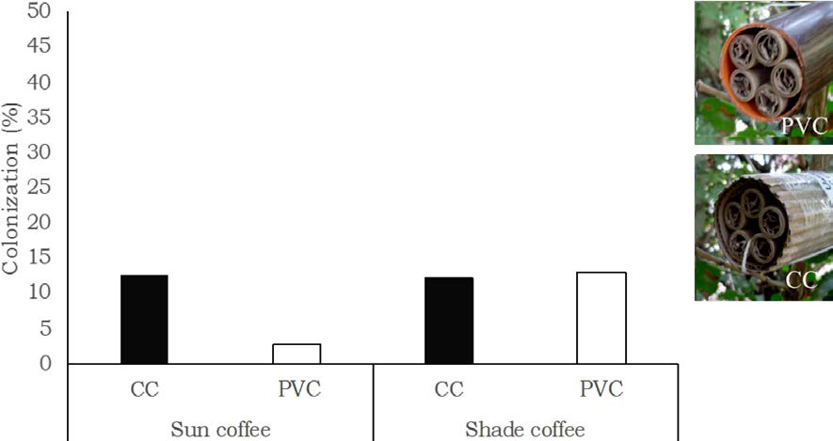[/graphic]
[label]Figure 4[/label]. [caption]For Test 2, percentage of ant colonization in CC substrates with two types of cover, CC cover and polyvinylchloride cover (PVC) on shade-grown and sun-grown coffee plantations.[/caption][/figgrp]

[/subsec][subsec][sectitle]Test 3. Monitoring of a type of artificial substrate over time[/sectitle]

[p]General colonization showed no significant variation over time (χ²₍₁₎ = 0.14; p = 0.71). Colonization percentages per month were 13.6%, 14.1%, and 17.5% for the first, second, and third month, respectively ([xref ref-type="fig" rid="f5"]Figure 5[/xref]). Colonization was higher in shade-grown coffee (χ²₍₁₎ = 32.85; p = 0.95*e⁻⁹) and a trend towards an increase in colonization was observed as time passed (from 18% to 25%). On sun-grown coffee plantations, colonization remained relatively stable over time (6% to 8%). Species N. asper, C. crinosa and Camponotus sp.1 were found in both sun-grown and shade-grown coffee (Figure S3). N. asper colonized a higher number of substrates in this test, showing the highest colonization percentage in shade-grown coffee, followed by C. crinosa.[/p]

[p]Test 3[/p]
[figgrp id="f5"][graphic href="?a13v35n2"]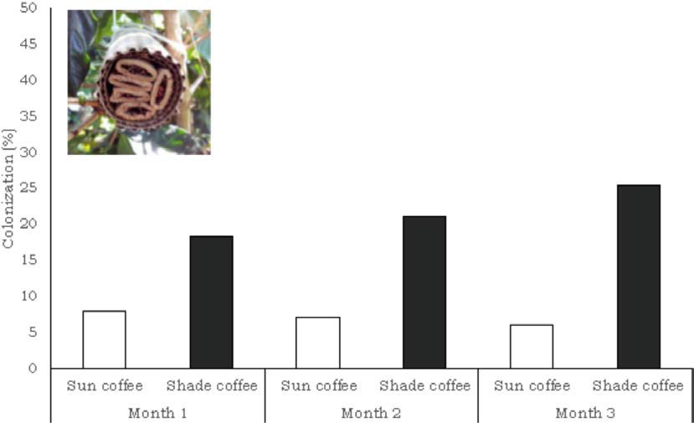[/graphic]
[label]Figure 5[/label]. [caption]Percentage of ant colonization on shade-grown and sun-grown coffee plantations over a three-month period in Test 3. The substrate was mainly made of corrugated cardboard (CC). An increase in the colonization of shade-grown coffee plantations was observed over time, whereas colonization remained stable on the sun-grown coffee plantations.[/caption][/figgrp]

[/subsec][/subsec][/sec][sec sec-type="discussion"][sectitle]Discussion[/sectitle]

[p]In general, this research project shows that arboreal generalist ants do use artificial substrates mainly made of recyclable cardboard as an alternative nesting resource on both sun-grown and shade-grown coffee plantations. Low colonization percentages also occurred in the same region where [xref ref-type="bibr" rid="r27"]Vidal-Hernandez and Armbrecht (2009[/xref]) found colonization values of 13.24% and 6.03% in artificially added bamboo twigs both in shade-grown and sun-grown coffee, respectively. The percentage of colonization was low compared to other studies ([xref ref-type="bibr" rid="r11"]Hosang et al., 2010[/xref]; [xref ref-type="bibr" rid="r19"]Mottl et al. 2019[/xref]), possibly due to a reduction in ant diversity and abundance with elevation ([xref ref-type="bibr" rid="r15"]Lach et al., 2010[/xref]). Although ants are found on almost all continents (except Antarctica), they are mainly found at low latitudes and, in general, there is a monotonal reduction of ant richness with altitude ([xref ref-type="bibr" rid="r9"]Fisher, 2010[/xref]). Ants are also sensitive to environmental conditions [xref ref-type="bibr" rid="r9"](Fisher, 2010[/xref]). The general low ant nesting activity may also be explained by the extraordinarily dry conditions during the test period which coincided with the lowest colonization rates experienced in Test 2. This test occurred during the driest season of the year, from July to September, when higher temperatures and lower precipitation were recorded. Such environmental conditions may have affected the ants, since they are sensitive to microhabitat conditions ([xref ref-type="bibr" rid="r22"]Perfecto and Vandermeer, 1996[/xref]) Furthermore, the noteworthy colonization by other arthropods (mainly Araneae, Hymenoptera; Crabronidae, and Blattodea. See Table S3) during the dry season may have fostered interspecific competition for the artificial substrates.[/p]
[p]Substrate materials and their configuration affected colonization by ants. Although we could not prove a relationship between ant size and substrate configuration, it is possible that the smaller entrances in CC filtered certain ant species; therefore, smaller ants like N. asper and C. crinosa were more capable of nesting in this substrate, while larger ant Camponotus species preferred CT with larger entrances. Possibly, arboreal ants such as N. asper and C. crinosa preferred CC because they closely resembled their natural nesting habitats in cavities in branches and bark ([xref ref-type="bibr" rid="r26"]Tschinkel, 2002[/xref]; [xref ref-type="bibr" rid="r16"]Longino, 2003[/xref]), while Camponotus are found nesting in hollow twigs from living and dead tree branches ([xref ref-type="bibr" rid="r17"]Longino, 2006[/xref]; [xref ref-type="bibr" rid="r28"]Yamamoto & Del Claro, 2008[/xref]). Therefore, providing more heterogeneous substrates may allow for greater diversity due to niche differentiation in the ant community colonizing the artificial substrates, as suggested by [xref ref-type="bibr" rid="r14"]Jimenez-Soto and Philpott (2015[/xref]).[/p]
[p]Despite a trend towards increasing species richness among ants nesting in shade-grown coffee in Test 1 and 2, no solid evidence was found that crop management type influenced substrate colonization or the number of ant species that colonized. One would expect colonization of artificial substrates to be higher in sun-grown coffee, where nesting resources for ants are scarce, as suggested by [xref ref-type="bibr" rid="r3"]Armbrecht et al. (2006[/xref]) and [xref ref-type="bibr" rid="r24"]Philpott and Foster (2005[/xref]). However, in this study, the most abundant and frequent species present in both sun-grown and shade-grown coffee (also found by [xref ref-type="bibr" rid="r7"]Escobar et al., 2020[/xref], using tuna bait at the same study site) did not necessarily colonize the substrates, suggesting that colonization was more related to idiosyncratic preferences of a small-sized ant species present on both types of coffee plantations. Thus, the dominance of N. asper, Crematogaster crinosa and Camponotus sp. 1 colonizing substrates in both types of coffee plantations explained the lack of differences between sun-grown and shade-grown coffee. [xref ref-type="bibr" rid="r24"]Philpott and Foster (2005[/xref]) found that Nesomyrmex sp. showed the greatest colonization (219 colonization events) of artificial substrates on shade-grown coffee plantations in Mexico.[/p]
[p]No differences in internal temperatures were found between substrate types in shade-grown coffee (in Test 2) while statistical differences were actually detected between substrates in sun-grown coffee. This suggests that the temperature in PVC substrates in sun-grown coffee could be limiting the ability of ants to colonize, since ants in sun-grown coffee mainly colonized substrates with no PVC cover. The presence of tree cover may have buffered the effects of hot days and low precipitation, sustaining microclimatic conditions suitable for ant nesting in any type of substrate.[/p]
[p]Results from Test 3 showed an increase in substrate colonization over time in shade-grown, but not sun-grown, coffee. This suggests that the positive effects from adding artificial substrates is better in shade-grown coffee and is consistent with [xref ref-type="bibr" rid="r3"]Armbrecht et al. (2006[/xref]) and [xref ref-type="bibr" rid="r24"]Philpott and Foster (2005[/xref]), who found greater limitation for twig-nesting ants on sun-grown coffee plantations in Colombia and Mexico, respectively.[/p]

[/sec][sec sec-type="conclusions"][sectitle]Conclusions[/sectitle]

[p]The three questions initially asked were answered in this study. Ants nested in artificial substrates; their nesting was slightly higher in corrugated cardboard (CC) and in shade-grown coffee, and increased over time. The provision of artificial substrates made with cardboard might help increase the number of colonization events, and possibly enhance biocontrol of the coffee berry borer bug (Hypothenemus hampei, Coleoptera: Curculionidae) by ants, as nesting ants of the genera Nesomyrmex and Crematogaster have been reported as natural enemies of this important pest. In order to increase nesting activity and potential pest control services on coffee plantation, we suggest combining CC with materials that provide diverse entrance sizes and configurational heterogeneity. Carefully choosing a protecting wrap for the substrates will be important on sun-grown coffee plantations during the dry season as microclimatic conditions cannot be buffered by the presence of a shade trees. Therefore, the use of PVC as a substrate cover should be avoided on sun-grown coffee plantations. Installation of artificial substrates during the rainy season is highly recommended.[/p]

[/sec][sec][sectitle]Conflict of interest[/sectitle]

[p]The authors declare no competing interests.[/p]

[/sec][sec][sectitle]Author contribution statement[/sectitle]

[p]The total contribution percentage for the conceptualization, preparation, and correction of this paper was as follows: A.J.L.D. 34 %., S.E.R. 33 % and I.A. 33 %.[/p]

[/sec][sec][sectitle]Data availability statement[/sectitle]

[p]The data supporting the results of this study will be made available by the corresponding author, [xref ref-type="bibr" rid="r18"]Armbrecht, I.[/xref], upon reasonable request.[/p][/sec][/xmlbody]

[supplmat id="suppl1" href="a13v35n2-s1"]a13v35n2-s1[/supplmat]

[ack][sectitle]Acknowledgements[/sectitle]
[p]Maria Cristina Gallego, Ramon Velez and SUPRACAFE for logistic support.[/p]

[p]Funding[/p]
[p]COLCIENCIAS, National Basic Sciences Programme (Code 110656933821, RC Contract o. 0648-2013) and Universidad del Valle (VRI, code CI 7951) funded this study.[/p][/ack]

[refs][sectitle]References[/sectitle]

[ref id="r1" reftype="book"][authors role="nd"][cauthor]Antweb[/cauthor][/authors]. ([date dateiso="20140000" specyear="2014"]2014[/date]). [source]Antweb (Webpage).[/source] [pubname]California Academy of Sciences[/pubname]. Available at [pubid idtype="doi"]www.antweb.org/[/pubid][/ref]
[ref id="r2" reftype=“journal"][authors role="nd"][pauthor][surname]Armbrecht[/surname], [fname]I.[/fname][/pauthor]; & [pauthor][surname]Perfecto[/surname], [fname]I.[/fname][/pauthor][/authors] ([date dateiso="20030000" specyear="2003"]2003[/date]). [arttitle]Litter-twig dwelling ant species richness and predation potential within a forest fragment and neighboring coffee plantations of contrasting habitat quality in Mexico. [/arttitle][source]Agriculture, Ecosystems and Environment[/source], [volid]97[/volid]([issueno]1-3[/issueno]), [pages]107-115[/pages]. doi: [url]https://doi.org/10.1016/S0167-8809(03)00128-2[/url][/ref]
[ref id="r3" reftype=“journal"][authors role="nd"][pauthor][surname]Armbrecht[/surname], [fname]I.[/fname][/pauthor]; [pauthor][surname]Perfecto[/surname], [fname]I.[/fname][/pauthor]; & [pauthor][surname]Silverman[/surname], [fname]E.[/fname][/pauthor][/authors] ([date dateiso="20060000" specyear="2006"]2006[/date]). [arttitle]Limitation of nesting resources for ants in Colombian forests and coffee plantations. [/arttitle][source]Ecological Entomology[/source], [volid]31[/volid]([issueno]5[/issueno]), [pages]403-410[/pages]. doi: [url]https://doi.org/10.1111/j.1365-2311.2006.00802.x[/url][/ref]
[ref id="r4" reftype=“journal"][authors role="nd"][pauthor][surname]Armbrecht[/surname], [fname]I.[/fname][/pauthor]; [pauthor][surname]Vandermeer[/surname], [fname]J.[/fname][/pauthor]; & [pauthor][surname]Perfecto[/surname], [fname]I.[/fname][/pauthor][/authors] ([date dateiso="20040000" specyear="2004"]2004[/date]). [arttitle]Enigmatic biodiversity correlations: leaf litter ant biodiversity respond to biodiverse resources. [/arttitle][source]Science[/source], [volid]304[/volid], [pages]284-286[/pages]. doi: [pubid idtype="doi"]10.1126/science.1094981[/pubid][/ref]
[ref id="r5" reftype=“journal"][authors role="nd"][pauthor][surname]Barroso[/surname], [fname]S. C.[/fname][/pauthor]; [pauthor][surname]Longui[/surname], [fname]E. L.[/fname][/pauthor]; [pauthor][surname]Fernandes[/surname], [fname]T. T.[/fname][/pauthor]; [pauthor][surname]Oliveira[/surname], [fname]C. M.[/fname][/pauthor]; [pauthor][surname]Ferreira[/surname], [fname]A. C.[/fname][/pauthor]; [pauthor][surname]Silva[/surname], [fname]R. R.[/fname][/pauthor]; & [pauthor][surname]Morini[/surname], [fname]M. S. C.[/fname][/pauthor] [/authors]([date dateiso="20200000" specyear="2020"]2020[/date]). [arttitle]Twigs occupied by Pheidole Westwood, 1839: Is there a difference between species?[/arttitle] [source]Biota Neotropica[/source], [volid]20[/volid]([issueno]2[/issueno]), [edition]e20190897[/edition]. Doi: [url]http://dx.doi.org/10.1590/1676-0611-bn-2019-0897[/url][/ref]
[ref id="r6" reftype=“journal"][authors role="nd"][pauthor][surname]De la Mora[/surname], [fname]A.[/fname][/pauthor]; [pauthor][surname]García-Ballinas[/surname], [fname]J. A.[/fname][/pauthor]; & [pauthor][surname]Philpott[/surname], [fname]S.[/fname][/pauthor] [/authors]([date dateiso="20150000" specyear="2015"]2015[/date]). [arttitle]Local, landscape, and diversity drivers of predation services provided by ants in a coffee landscape in Chiapas, Mexico.[/arttitle] [source]Agriculture, Ecosystems & Environment[/source], [volid]201[/volid], [pages]83-91[/pages]. doi: [url]https://doi.org/10.1016/j.agee.2014.11.006[/url][/ref]
[ref id="r7" reftype=“journal"][authors role="nd"][pauthor][surname]Escobar-Ramírez[/surname], [fname]S.[/fname][/pauthor]; [pauthor][surname]Tscharntke[/surname], [fname]T.[/fname][/pauthor]; [pauthor][surname]Armbrecht[/surname], I., Torres, [fname]W.[/fname][/pauthor]; & [pauthor][surname]Grass[/surname], [fname]I.[/fname][/pauthor][/authors] ([date dateiso="20200000" specyear="2020"]2020[/date]). [arttitle]Decrease of β-diversity, but not α-diversity of ants in intensively managed coffee plantations.[/arttitle] [source]Insect Conservation and Diversity[/source], [volid]13[/volid]([issueno]5[/issueno]), [pages]445-455[/pages]. doi: [url]https://doi.org/10.1111/icad.12417[/url][/ref]
[ref id="r8" reftype="book"][authors role="nd"][pauthor][surname]Fernández[/surname], [fname]F.[/fname][/pauthor]; & [pauthor][surname]Palacio[/surname], [fname]E.[/fname][/pauthor][/authors] ([date dateiso="20030000" specyear="2003"]2003[/date]). [chptitle]Sistemática y filogenia de las hormigas: breve repaso a propuestas. [/chptitle]In [authors role="ed"][pauthor][fname]F.[/fname] [surname]Fernández[/surname][/pauthor][/authors]. [source]Introducción a las hormigas de la región Neotropical. [/source](pp. [pages]29-44[/pages]). [publoc]Bogota, Colombia[/publoc]. doi: [url]http://dx.doi.org/10.13140/2.1.1790.6248[/url][/ref]
[ref id="r9" reftype="book"][authors role="nd"][pauthor][surname]Fisher[/surname], [fname]B. L.[/fname][/pauthor] [/authors]([date dateiso="20100000" specyear="2010"]2010[/date]). [chptitle]Chapter 2. Biogeography.[/chptitle] In [authors role="nd"][pauthor][fname]C.[/fname] [surname]Lach[/surname][/pauthor]; [pauthor][fname]C.[/fname] [surname]Parr[/surname],[/pauthor] & [pauthor][fname]K. L[/fname] [surname]Abbott[/surname][/pauthor][/authors] (Eds.). [source]Ant Ecology [/source] (pp. [pages]18-37[/pages]). [pubname]Oxford University Press[/pubname]. [publoc]New York[/publoc]. [moreinfo]402p[/moreinfo].[/ref]
[ref id="r10" reftype=“journal"][authors role="nd"][pauthor][surname]Guzman[/surname], [fname]L.[/fname][/pauthor]; [pauthor][surname]Calvache[/surname], [fname]H.[/fname][/pauthor]; [pauthor][surname]Aldana[/surname], [fname]J.[/fname][/pauthor]; & [pauthor][surname]Méndez[/surname], [fname]A.[/fname][/pauthor] [/authors]([date dateiso="19970000" specyear="1997"]1997[/date]). [arttitle]Manejo de Leptopharsa gibbicarina Froeschner (Hemiptera: Tingidae) con la hormiga Crematogaster sp. en una plantación de palma de aceite. [/arttitle][source]PALMAS[/source], [volid]18[/volid]([issueno]4[/issueno]), [pages]19-26[/pages].[/ref]
[ref id="r11" reftype=“journal"][authors role="nd"][pauthor][surname]Hosang[/surname], [fname]M. L. A.[/fname][/pauthor]; [pauthor][surname]Schulze[/surname], [fname]C. H.[/fname][/pauthor]; [pauthor][surname]Tscharntke[/surname], [fname]T.[/fname][/pauthor]; & [pauthor][surname]Buchori[/surname], [fname]D.[/fname][/pauthor][/authors] ([date dateiso="20100000" specyear="2010"]2010[/date]). [arttitle]The potential of artificial nesting sites for increasing the population density of the black cacao ants. [/arttitle][source]Indonesian Journal of Agriculture[/source], [volid]3[/volid]([issueno]1[/issueno]), [pages]45-50[/pages].[/ref]
[ref id="r12" reftype="book"][authors role="nd"][cauthor]IDEAM[/cauthor][/authors]. ([date dateiso="20150000" specyear="2015"]2015[/date]). [source]Instituto de Hidrología, Meteorología y Estudios Ambientales (Webpage).[/source] [pubname]Ministerio de Ambiente y Desarrollo Sostenible de Colombia[/pubname]. Available at [pubid idtype="doi"]www.ideam.gov.co/[/pubid][/ref]
[ref id="r13" reftype=“journal"][authors role="nd"][pauthor][surname]Jha[/surname], [fname]S.[/fname][/pauthor]; [pauthor][surname]Bacon[/surname], [fname]C. M.[/fname][/pauthor]; [pauthor][surname]Philpott.[/surname] [fname]S. M.[/fname][/pauthor]; [pauthor][surname]Méndez[/surname], [fname]V. E.[/fname][/pauthor]; [pauthor][surname]Läderach[/surname], [fname]P.[/fname][/pauthor]; & [pauthor][surname]Rice[/surname], [fname]R. A.[/fname][/pauthor][/authors] ([date dateiso="20140000" specyear="2014"]2014[/date]). [arttitle]Shade coffee: update on a disappearing refuge for biodiversity. [/arttitle][source]Bioscience[/source], [volid]64[/volid]([issueno]5[/issueno]), [pages]416-428[/pages]. [pubid idtype="doi"]https://doi.org/10.1093/biosci/biu038[/pubid][/ref]
[ref id="r14" reftype=“journal"][authors role="nd"][pauthor][surname]Jiménez-Soto[/surname], [fname]E.[/fname][/pauthor] & [pauthor][surname]Philpott[/surname], [fname]S. M.[/fname][/pauthor] [/authors]([date dateiso="20150000" specyear="2015"]2015[/date]). [arttitle]Size matters: nest colonization patterns for twig-nesting ants.[/arttitle] [source]Ecology and Evolution[/source], [volid]5[/volid]([issueno]16[/issueno]), [pages]3288-3298[/pages]. doi: [url]https://doi.org/10.1002/ece3.1555.[/url][/ref]
[ref id="r15" reftype="book"][authors role="ed"][pauthor][surname]Lach[/surname], [fname]C.[/fname][/pauthor]; [pauthor][surname]Parr[/surname], [fname]C.[/fname][/pauthor]; & [pauthor][surname]Abbott[/surname], [fname]K. L.[/fname][/pauthor][/authors] (Eds.). ([date dateiso="20100000" specyear="2010"]2010[/date]). [source]Ant Ecology[/source]. [pubname]Oxford University Press. New York[/pubname]. [pages]402p[/pages]. [url]https://doi.org/10.1093/acprof:oso/9780199544639.001.0001[/url][/ref]
[ref id="r16" reftype=“journal"][authors role="nd"][pauthor][surname]Longino[/surname], [fname]J. T.[/fname][/pauthor] [/authors]([date dateiso="20030000" specyear="2003"]2003[/date]). [arttitle]The Crematogaster (Hymenoptera, Formicidae, Myrmicinae) of Costa Rica.[/arttitle] [source]Zootaxa[/source], [volid]151[/volid], [pages]1-150[/pages]. [url]https://doi.org/10.11646/zootaxa.151.1.1[/url][/ref]
[ref id="r17" reftype=“journal"][authors role="nd"][pauthor][surname]Longino[/surname], [fname]J. T.[/fname][/pauthor] [/authors]([date dateiso="20060000" specyear="2006"]2006[/date]). [arttitle]New species and nomenclatural changes for the Costa Rican ant fauna (Hymenoptera: Formicidae). [/arttitle][source]Myrmecologische Nachrichten[/source], [volid]8[/volid], [pages]131-143[/pages]. [url]https://archive.org/details/ants_21107[/url][/ref]
[ref id="r18" reftype=“journal"][authors role="nd"][pauthor][surname]Meneses R[/surname], [fname]O. E.[/fname][/pauthor] & [pauthor][surname]Armbrecht[/surname], [fname]I.[/fname][/pauthor][/authors] ([date dateiso="20180000" specyear="2018"]2018[/date]). [arttitle]Índice de intensificación agrícola y conservación vegetal en bosques y cafetales colombianos con diferentes estrategias de manejo.[/arttitle] [source]Caldasia[/source], [volid]40[/volid]([issueno]1[/issueno]), [pages]161-176[/pages]. [url]https://doi.org/10.15446/caldasia.v40n1.61284[/url][/ref]
[ref id="r19" reftype=“journal"][authors role="nd"][pauthor][surname]Mottl[/surname], [fname]O.[/fname][/pauthor]; [pauthor][surname]Yombai[/surname], [fname]J.[/fname][/pauthor]; [pauthor][surname]Fayle[/surname], [fname]T. M.[/fname][/pauthor]; [pauthor][surname]Novotny[/surname], [fname]V.[/fname][/pauthor]; & [pauthor][surname]Klimes[/surname], [fname]P.[/fname][/pauthor] [/authors]([date dateiso="20190000" specyear="2019"]2019[/date]). [arttitle]Experiments with artificial nests provide evidence for ant community stratification and nest site limitation in a tropical forest.[/arttitle] [source]Biotropica[/source], [volid]52[/volid]([issueno]2[/issueno]), [pages]277-287[/pages]. [url]https://doi.org/10.1111/btp.12684[/url][/ref]
[ref id="r20" reftype=“journal"][authors role="nd"][pauthor][surname]Ocampo-López[/surname], [fname]O. L.[/fname][/pauthor] & [pauthor][surname]Alvarez-Herrera[/surname], [fname]L. M.[/fname][/pauthor] [/authors]([date dateiso="20170000" specyear="2017"]2017[/date]). [arttitle]Tendencia de la producción y el consumo de café en Colombia.[/arttitle] [source]Apuntes del CENES[/source], [volid]36[/volid]([issueno]64[/issueno]), [pages]139-165[/pages]. doi [url]http://dx.doi.org/10.19053/01203053.v36.n64.2017.5419[/url][/ref]
[ref id="r21" reftype=“journal"][authors role="nd"][pauthor][surname]Perfecto[/surname], [fname]I.[/fname][/pauthor] & [pauthor][surname]Vandermeer[/surname], [fname]J.[/fname][/pauthor] [/authors]([date dateiso="19960000" specyear="1996"]1996[/date]). [arttitle]Microclimatic changes and the indirect loss of ant diversity in a tropical agroecosystem.[/arttitle] [source]Oecologia[/source], [volid]108[/volid], [pages]577-582[/pages]. [url]https://doi.org/10.1007/BF00333736[/url][/ref]
[ref id="r22" reftype=“journal"][authors role="nd"][pauthor][surname]Perfecto[/surname], [fname]I.[/fname][/pauthor]; [pauthor][surname]Rice[/surname], [fname]R. A.[/fname][/pauthor]; [pauthor][surname]Greenberg[/surname], [fname]R.[/fname][/pauthor]; & [pauthor][surname]Van der Voort[/surname], [fname]M. E.[/fname][/pauthor] [/authors]([date dateiso="19960000" specyear="1996"]1996[/date]). [arttitle]Shade coffee: a disappearing refuge for biodiversity.[/arttitle] [source]Bioscience[/source], [volid]46[/volid], [pages]598-608[/pages]. doi: [url]https://doi.org/10.2307/1312989.[/url][/ref]
[ref id="r23" reftype=“journal"][authors role="nd"][pauthor][surname]Philpott[/surname], [fname]S. M.[/fname][/pauthor] & [pauthor][surname]Armbrecht[/surname], [fname]I.[/fname][/pauthor][/authors] ([date dateiso="20060000" specyear="2006"]2006[/date]). [arttitle]Biodiversity in tropical agroforests and the ecological role of ants and ant diversity in predatory function. [/arttitle][source]Ecological Entomology[/source], [volid]31[/volid], [pages]369-377[/pages]. [url]https://doi.org/10.1111/j.1365-2311.2006.00793.x[/url][/ref]
[ref id="r24" reftype=“journal"][authors role="nd"][pauthor][surname]Philpott[/surname], [fname]S. M.[/fname][/pauthor], & [pauthor][surname]Foster[/surname], [fname]P. F.[/fname][/pauthor][/authors] ([date dateiso="20050000" specyear="2005"]2005[/date]). [arttitle]Nest-site limitation in coffee agroecosystems: Artificial nests maintain diversity of arboreal ants.[/arttitle] [source]Ecological Applications[/source], [volid]15[/volid]([issueno]4[/issueno]), [pages]1478-1485[/pages]. [url]https://doi.org/10.1890/04-1496[/url][/ref]
[ref id="r25" reftype="book"][authors role="nd"][cauthor]R Development Core Team.[/cauthor] [/authors]([date dateiso="20130000" specyear="2013"]2013[/date]). [source]R: A language and environment for statistical computing. [/source][pubname]R Foundation for Statistical Computing[/pubname], [publoc]Vienna, Austria[/publoc]. Available from: [pubid idtype="doi"]www.R-project.org/[/pubid].[/ref]
[ref id="r26" reftype=“journal"][authors role="nd"][pauthor][surname]Tschinkel[/surname], [fname]W. R.[/fname][/pauthor] [/authors]([date dateiso="20020000" specyear="2002"]2002[/date]). [arttitle]The natural history of the arboreal ant, Crematogaster ashmeadi.[/arttitle] [source]Journal of Insect Science[/source] , [volid]2[/volid]([issueno]12[/issueno]), [pages]1-15[/pages]. [url]https://doi.org/10.1673/031.002.1201[/url][/ref]
[ref id="r27" reftype=“journal"][authors role="nd"][pauthor][surname]Vidal-Hernández[/surname], [fname]W. J.[/fname][/pauthor], & [pauthor][surname]Armbrecht[/surname], [fname]I.[/fname][/pauthor][/authors] ([date dateiso="20090000" specyear="2009"]2009[/date]). [arttitle]Impacto de la adición de ramitas de bambú y de la exclusión de hormigas sobre la herbivoría de cafetales de sol y sombra en el Cauca (Colombia).[/arttitle] [source]Rev. Brasil. Agroecol[/source], [volid]4[/volid]([issueno]2[/issueno]), [pages]877-881[/pages].[/ref]
[ref id="r28" reftype=“journal"][authors role="nd"][pauthor][surname]Yamamoto[/surname], [fname]M.[/fname][/pauthor] & [pauthor][surname]Del-claro[/surname], [fname]K.[/fname][/pauthor] [/authors]([date dateiso="20080000" specyear="2008"]2008[/date]). [arttitle]Natural history and foraging behavior of the carpenter ant Camponotus sericeiventris Guërin, 1838 (Formicinae, Campotonini) in the Brazilian tropical savanna. [/arttitle][source]Acta Ethologica[/source], [volid]11[/volid]([issueno]2[/issueno]), [pages]55-65[/pages]. [url]https://doi.org/10.1007/s10211-008-0041-6[/url][/ref]
[ref id="r29" reftype="book"][authors role="nd"][pauthor][surname]Zar[/surname], [fname]J. H.[/fname][/pauthor] [/authors]([date dateiso="19990000" specyear="1999"]1999[/date]). [source]Biostatistical Analysis[/source]. [edition]4th [/edition]edition. [publoc]Prentice Hall[/publoc], [pubname]New Jersey[/pubname].[/ref][/refs] [/doc]

