[doc sps="1.8" acron="uniciencia" jtitle="Uniciencia" stitle="Uniciencia" issn="2215-3470" pissn="2215-3470" eissn="1011-0275" pubname="Universidad Nacional, Costa Rica" license="http://creativecommons.org/licenses/by-nc-nd/3.0" volid="36" issueno="1" dateiso="20221200" season="Jan/Dec" order="21" fpage="332" lpage="346" pagcount="15" doctopic="oa" language="en"]Doi:[doi]10.15359/ru.36-1.21[/doi]
[toctitle]Artículo[/toctitle]

[doctitle language="en"]Tooth whitening in conventional orthodontic patients: a systematic review[/doctitle]
[doctitle language="es"]Blanqueamiento dental en pacientes con tratamiento ortodóncico: Revisión sistemática[/doctitle]
[doctitle language="pt"]Clareamento dental em pacientes com tratamento ortodôntico: revisão sistemática[/doctitle]

[author role="nd"][fname]Stefanía[/fname] [surname]Hernández-Viana[/surname] [xref ref-type="aff" rid="aff1"]¹[/xref], [authorid authidtp="orcid"]0000-0002-5268-557X[/authorid][/author]
[author role="nd"][fname]Miguel Fernando[/fname] [surname]Niño[/surname] [xref ref-type="aff" rid="aff2"]²[/xref] [authorid authidtp="orcid"]0000-0002-9846-2152[/authorid][/author]
[author role="nd"][fname]Felipe Augusto[/fname] [surname]Restrepo[/surname] [xref ref-type="aff" rid="aff3"]³[/xref] [authorid authidtp="orcid"]0000-0001-9954-5876[/authorid][/author]
[author role="nd"][fname]Javier Enrique[/fname] [surname]Botero[/surname] [xref ref-type="aff" rid="aff4"]⁴[/xref] [authorid authidtp="orcid"]0000-0001-7572-7384[/authorid][/author]

[normaff id="aff1" ncountry="Colombia" norgname="Universidad de Antioquia" icountry="CO"][label]¹[/label] [orgdiv1]Facultad de Odontología[/orgdiv1], [orgname]Universidad de Antioquia[/orgname], [city]Medellín[/city], [country]Colombia[/country]. [email]stefania.hernandez@udea.edu.co[/email], https://orcid.org/0000-0002-5268-557X[/normaff]
[normaff id="aff2" ncountry="Colombia" norgname="Universidad de Antioquia" icountry="CO"][label]²[/label] [orgdiv1]Facultad de Odontología[/orgdiv1], [orgname]Universidad de Antioquia[/orgname], [city]Medellín[/city], [country]Colombia[/country], [email]fernando.nino@udea.edu.co[/email], https://orcid.org/0000-0002-9846-2152[/normaff]
[normaff id="aff3" ncountry="Colombia" norgname="Universidad de Antioquia" icountry="CO"][label]³[/label] [orgdiv1]Facultad de Odontología[/orgdiv1], [orgname]Universidad de Antioquia[/orgname], [city]Medellín[/city], [country]Colombia[/country]. [email]felipe.restrepo@udea.edu.co[/email], https://orcid.org/0000-0001-9954-5876[/normaff]
[normaff id="aff4" ncountry="Colombia" norgname="Universidad de Antioquia" icountry="CO"][label]⁴[/label] [orgdiv1]Facultad de Odontología[/orgdiv1], [orgname]Universidad de Antioquia[/orgname], [city]Medellín[/city], [country]Colombia[/country]. [email]javier.botero@udea.edu.co[/email], https://orcid.org/0000-0001-7572-7384[/normaff]

[xmlabstr language="en"][sectitle]Abstract[/sectitle]
[p]This systematic review aimed to identify and critically evaluate the available evidence of the appropriate moment to perform tooth whitening in conventional orthodontic patients. A systematic review in MEDLINE and SciELO databases from inception to February 2021 was carried out by two independent reviewers. Randomized clinical trials, non-randomized clinical trials, case-control, cohort, cross-sectional, case-series and reviews that focused on the application of tooth whitening during or after orthodontic treatment were considered for inclusion. The primary outcome was defined as tooth whitening during/after orthodontic treatment. The secondary outcome included the time in days after bracket debonding in which tooth whitening was performed. Risk of bias analysis was performed for each study and the findings were synthesized in a narrative summary. A total of 4 randomized clinical trials, 1 non-randomized clinical trial and 3 reviews were included in the qualitative synthesis. One study performed tooth whitening during, and three studies after orthodontic treatment. One study compared tooth whitening during and after orthodontic treatment. The time after which tooth whitening was applied following bracket debonding ranged from 7 to 90 days with a mean value of 40.2 days. All studies reported satisfactory improvements in tooth color shade during or after orthodontic treatment independent of the protocol. Low quality evidence suggests that the appropriate moment to perform tooth whitening in conventional orthodontic patients is after brackets removal with a waiting period of at least 30 days. There is not adequate evidence to support tooth whitening during conventional orthodontic treatment.[/p][/xmlabstr]
[kwdgrp language="en"][sectitle]Keywords:[/sectitle] [kwd]tooth whitening[/kwd]; [kwd]tooth bleaching[/kwd]; [kwd]orthodontic patients[/kwd]; [kwd]systematic review.[/kwd][/kwdgrp]

[xmlabstr language="es"][sectitle]Resumen[/sectitle]
[p]Esta revisión sistemática tuvo como objetivo identificar y evaluar críticamente la evidencia disponible del momento adecuado para realizar el blanqueamiento dental en pacientes de ortodoncia convencional. Dos revisores independientes llevaron a cabo la revisión sistemática en las bases de datos MEDLINE y SciELO desde el inicio hasta febrero de 2021. Se consideraron para su inclusión ensayos clínicos aleatorizados, ensayos clínicos no aleatorizados, de casos y controles, de cohortes, transversales, de series de casos y revisiones que se centraran en la aplicación del blanqueamiento dental durante o después del tratamiento de ortodoncia. El resultado primario se definió como blanqueamiento dental durante/después del tratamiento de ortodoncia. El resultado secundario incluyó el tiempo en días después del desprendimiento del soporte en el que se realizó el blanqueamiento dental. Se realizó un análisis de riesgo de sesgo para cada estudio y los hallazgos se sintetizaron en un resumen narrativo. En la síntesis cualitativa se incluyeron un total de 4 ensayos clínicos aleatorizados, 1 ensayo clínico no aleatorizado y 3 revisiones. Un estudio realizó el blanqueamiento dental durante y tres estudios después del tratamiento de ortodoncia. Un estudio comparó el blanqueamiento dental durante y después del tratamiento de ortodoncia. El tiempo después del cual se aplicó el blanqueamiento dental después del desprendimiento de los brackets osciló entre 7 y 90 días con un valor medio de 40,2 días. Todos los estudios informaron mejoras satisfactorias en el tono del color de los dientes durante o después del tratamiento de ortodoncia, independientemente del protocolo. La evidencia de baja calidad sugiere que el momento adecuado para realizar el blanqueamiento dental en pacientes con ortodoncia convencional es después de la extracción de los brackets con un período de espera de al menos 30 días. No hay evidencia adecuada para respaldar el blanqueamiento dental durante el tratamiento de ortodoncia convencional.[/p][/xmlabstr]
[kwdgrp language="es"][sectitle]Palabras clave:[/sectitle] [kwd]Blanqueamiento dental[/kwd]; [kwd]aclaramiento dental[/kwd]; [kwd]pacientes ortodóncicos[/kwd]; [kwd]revisión sistemática.[/kwd][/kwdgrp]

[xmlabstr language="pt"][sectitle]Resumo[/sectitle]
[p]Esta revisão sistemática teve como objetivo identificar e avaliar criticamente as evidências disponíveis do tempo adequado para a realização do clareamento dental em pacientes de ortodontia convencional. Dois revisores independentes realizaram a revisão sistemática nas bases de dados MEDLINE e SciELO desde o início até fevereiro de 2021. Foram considerados ensaios clínicos randomizados, não randomizados, de casos e controles, de coorte, transversais, de séries de casos e ensaios clínicos de revisão com foco na aplicação do clareamento dental durante ou após o tratamento ortodôntico. O resultado primário foi definido como clareamento dental durante/após o tratamento ortodôntico. O resultado secundário incluiu o tempo em dias após o desprendimento do suporte no qual o clareamento dos dentes foi realizado. Foi realizada uma análise de risco de viés para cada estudo e os achados foram sintetizados em um resumo narrativo. Um total de 4 ensaios clínicos randomizados, 1 ensaio clínico não randomizado e 3 revisões foram incluídos na síntese qualitativa. Um estudo realizou clareamento dental durante e três estudos após o tratamento ortodôntico. Um estudo comparou o clareamento dental durante e após o tratamento ortodôntico. O tempo depois do qual o clareamento dos dentes foi aplicado após o desprendimento do aparelho variou de 7 a 90 dias com um valor médio de 40,2 dias. Todos os estudos relataram melhorias satisfatórias no tom da cor dos dentes durante ou após o tratamento ortodôntico, independentemente do protocolo. Evidências de baixa qualidade sugerem que o tempo apropriado para realizar o clareamento dental em pessoas com ortodontia convencional é após a remoção do aparelho com um período de espera de pelo menos 30 dias. Não há evidências pertinentes para respaldar o clareamento dental durante o tratamento de ortodontia convencional.[/p][/xmlabstr]
[kwdgrp language="pt"][sectitle]Palavras-chave:[/sectitle] [kwd]Clareamento dental[/kwd]; [kwd]branqueamento dental[/kwd]; [kwd]pacientes ortodônticos[/kwd]; [kwd]revisão sistemática.[/kwd][/kwdgrp]

[hist]Received: [received dateiso="20210604"]06/4/2021[/received]
Accepted: [accepted dateiso="20211211"]12/11/2021[/accepted]
Published: 02/14/2022[/hist]

[xmlbody][sec sec-type="intro"][sectitle]Introduction[/sectitle]

[p]External tooth whitening (TW) is nowadays a common cosmetic procedure which is designed to reduce the body color of the tooth ([xref ref-type="bibr" rid="r32"]Tredwin et al. 2006[/xref]). TW can be applied as in-office or at-home procedures with effective and satisfactory results in color improvement for patients. While both strategies have been considered safe, the effectiveness of at-home whitening protocols is uncertain and several adverse effects have been reported such as cervical resorption, soft tissue burns, increased dental porosity, dental hypersensitivity, pulp inflammation and even necrosis ([xref ref-type="bibr" rid="r9"]Eachempati et al., 2018[/xref]; [xref ref-type="bibr" rid="r3"]Alqahtani et al., 2014[/xref]; [xref ref-type="bibr" rid="r6"]Costa et al., 2010[/xref]; [xref ref-type="bibr" rid="r26"]Rodrigues et al. 2018[/xref]).[/p]
[p]An increased concern for whiter teeth in patients has also been reported by orthodontists. A survey in 1182 orthodontists reported that 88.8% of orthodontists had patients who requested tooth whitening, and 76.2% of orthodontists recommended whitening procedures ([xref ref-type="bibr" rid="r29"]Slack et al., 2013[/xref]). The most frequent reason for the recommendation for in-office TW in orthodontic patients is the presence of white-spot lesions adjacent to brackets or after the debonding of brackets (Guzmán-Armstraog et al., 2010). In addition, tooth color changes around brackets are frequent, resulting in a non-uniform tooth shade after bracket debonding ([xref ref-type="bibr" rid="r18"]Kamber et al., 2018[/xref]). Hence, color changes during or after orthodontic treatment (OT) affects the aesthetic result. However, most suggestions for TW in orthodontic patients have been extrapolated from in vitro and few in vivo studies on the debonding effect on brackets after the application of whitening agents ([xref ref-type="bibr" rid="r16"]Imani et al., 2020[/xref]; [xref ref-type="bibr" rid="r24"]Mullins et al., 2009[/xref]). [xref ref-type="bibr" rid="r5"]Consolaro et al. (2013[/xref]) in a critical review suggested that TW procedures should be best performed after brackets are removed to allow for the balance in the oral environment after orthodontic treatment. In addition, the authors recommended against TW during orthodontic treatment due to the limited penetration of the whitening agent under bracket surface. Nevertheless, there is no clear evidence-based recommendation for the use of TW during or after orthodontic treatment. Therefore, the objective of this systematic review was to identify and critically evaluate the available evidence of the appropriate moment to perform tooth whitening in conventional orthodontic patients.[/p]

[/sec][sec sec-type="methods"][sectitle]Methodology[/sectitle]

[p]The protocol for this systematic review is in fulfillment with the Preferred Reporting Items for Systematic Reviews and Meta-Analyses (PRISMA) statement guidelines.[/p]

[p]Research question[/p]

[p]What is the appropriate moment to perform tooth whitening in conventional orthodontic patients?[/p]

[p]Search strategy and limits[/p]

[p]Two calibrated independent reviewers (SH, MFN) searched MEDLINE via PubMed and SciELO (gray literature) from inception to February 2021 using the medical subject heading (MeSH) terms and keywords: (dental bleaching (Title/Abstract)) OR dental whitening (Title/Abstract) OR tooth bleaching (Title/Abstract)) OR tooth whitening (Title/Abstract) AND orthodontic treatment (Title/Abstract). The reference list of potential articles was manually searched for additional results.[/p]
[p]Articles written in Spanish, English and Portuguese corresponding to randomized clinical trials (RCT), non-randomized clinical trials (non-RCT), case control, cohort, cross-sectional, case series and previous systematic and critical reviews that focused on the application of tooth whitening during or after orthodontic treatment were considered for inclusion. Case reports, in vitro, and animal studies were not considered in this systematic review.[/p]

[p]Population, intervention, and comparator[/p]

[p]Target population included patients under orthodontic treatment with no restriction of age.[/p]
[p]The intervention considered for analysis was defined as external tooth whitening performed in-office by a clinician during or after conventional orthodontic treatment. In-office interventions may have been continued by the patients with at-home whitening agents as instructed by the clinician. Non-vital tooth whitening was not considered for analysis. Clinical studies which evaluated debonding force resistance of brackets after tooth whitening and tooth whitening during clear aligner orthodontics were also not considered.[/p]
[p]This review examined interventions with comparators groups which included no intervention or intervention performed at different time intervals or with different whitening agent during or after orthodontic treatment.[/p]

[p]Outcomes[/p]

[p]This review aimed to identify, and critically assess the findings related to the most appropriate moment to perform tooth whitening in conventional orthodontics patients.[/p]
[p]Therefore, the primary outcome was the application of tooth whitening during/after orthodontic treatment as a dichotomic result. A secondary outcome included the time in days after bracket debonding in which tooth whitening was performed.[/p]

[p]Data extraction[/p]

[p]Two independent reviewers (SH, MFN) extracted the information from studies that met the inclusion criteria in a predetermined form which comprised: study identification, objective, age of participants, sex, number of participants, number of participants in intervention group, number of participants in comparison group, time (days) after bracket debonding in which tooth whitening was performed, tooth whitening during orthodontic treatment (yes/ no), time of tooth whitening after bracket installation and conclusions. Any disagreement between the reviewers was discussed and resolved with a third reviewer (JEB).[/p]

[p]Risk of bias (quality) assessment[/p]

[p]RCTs were assessed using the Cochrane Risk of Bias version 2 (RoB 2). Each study was assessed, and each domain was judged as low risk of bias, some concerns or high risk of bias. An overall judgment of the study was determined as low risk of bias if all domains were low risk; some concerns if at least one domain raised some concerns but not be high risk; and high risk of bias if at least one domain was high risk.[/p]
[p]Non-RCTs were assessed using the Cochrane Risk of Bias In Non-Randomized Studies of Interventions (ROBINS-I) tool. Each study was analyzed using the critical domains and judged as low, moderate, serious, and critical risk of bias. A study was judged as low risk of bias if all domains[/p]
[p] were low risk; moderate risk of bias if all domains were low or moderate risk; serious risk of bias if at least one domain was at serious risk; critical risk of bias if at least one domain was at critical risk. Critical reviews were not quality assessed.[/p]

[p]Data synthesis and analysis[/p]

[p]Meta-analysis was not attempted since outcomes were recorded in a qualitative style. Consequently, the findings were synthesized with tabulation and figures, in addition to a narrative summary.[/p]

[/sec][sec sec-type="results"][sectitle]Results[/sectitle]

[p]A systematic search in MEDLINE and SciELO yielded 41 potential results after duplicates were removed. The results were screened for the inclusion criteria and 11 were excluded. A total of 30 full-text articles were assessed for eligibility and 22 were further excluded, resulting in 8 articles included in the qualitative synthesis ([xref ref-type="fig" rid="f1"]Figure 1[/xref]). Excluded records with reasons are presented in the supplementary material 1.[/p]

[figgrp id="f1"][graphic href="?a21v36n1"]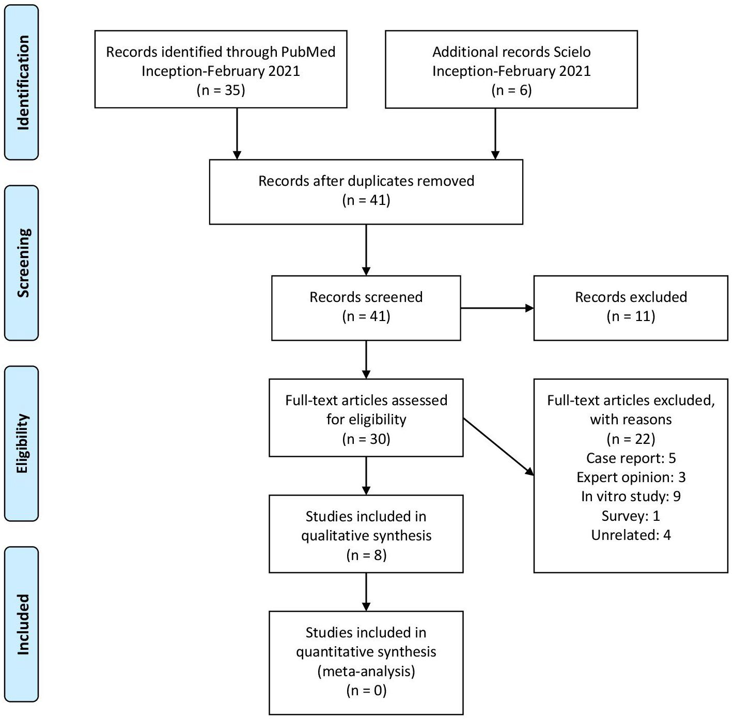[/graphic]
[label]Figure 1[/label]. [caption]Flowchart of study selection.[/caption][/figgrp]

[p][xref ref-type="table" rid="t1"]Tables 1[/xref], [xref ref-type="table" rid="t2"]2 [/xref]and [xref ref-type="table" rid="t3"]3[/xref] depict the characteristics and variables of the 8 included studies and reviews. Four studies were RCTs ([xref ref-type="bibr" rid="r19"]Knösel et al., 2007[/xref]; [xref ref-type="bibr" rid="r20"]Krug and Green, 2008[/xref]; [xref ref-type="bibr" rid="r23"]Montenegro-Arana et al., 2016[/xref]; [xref ref-type="bibr" rid="r2"]Ahrari et al., 2020[/xref]) and one a non-RCT ([xref ref-type="bibr" rid="r17"]Jadad et al., 2011[/xref]). Three results were critical reviews ([xref ref-type="bibr" rid="r5"]Consolaro et al., 2013[/xref]; [xref ref-type="bibr" rid="r22"]Márquez et al., 2012[/xref]; [xref ref-type="bibr" rid="r11"]Freire et al., 2018[/xref]). The age of participants ranged from 14 to 40 years old and were mostly women ([xref ref-type="table" rid="t1"]table 1[/xref]).[/p]
[p]All clinical studies were small-sample size which comprised 19-71 participants and only one study ([xref ref-type="bibr" rid="r23"]Montenegro-Arana et al., 2016[/xref]) provided information about sample size calculation ([xref ref-type="table" rid="t2"]table 2[/xref]). Three studies ([xref ref-type="bibr" rid="r19"]Knösel et al., 2007[/xref]; [xref ref-type="bibr" rid="r20"]Krug and Green, 2008[/xref]; [xref ref-type="bibr" rid="r2"]Ahrari et al., 2020[/xref]) performed tooth[/p]

[tabwrap id="t1"][label]Table 1[/label]. [caption]Characteristics of the included clinical studies[/caption]
[graphic href="?a21v36n1"]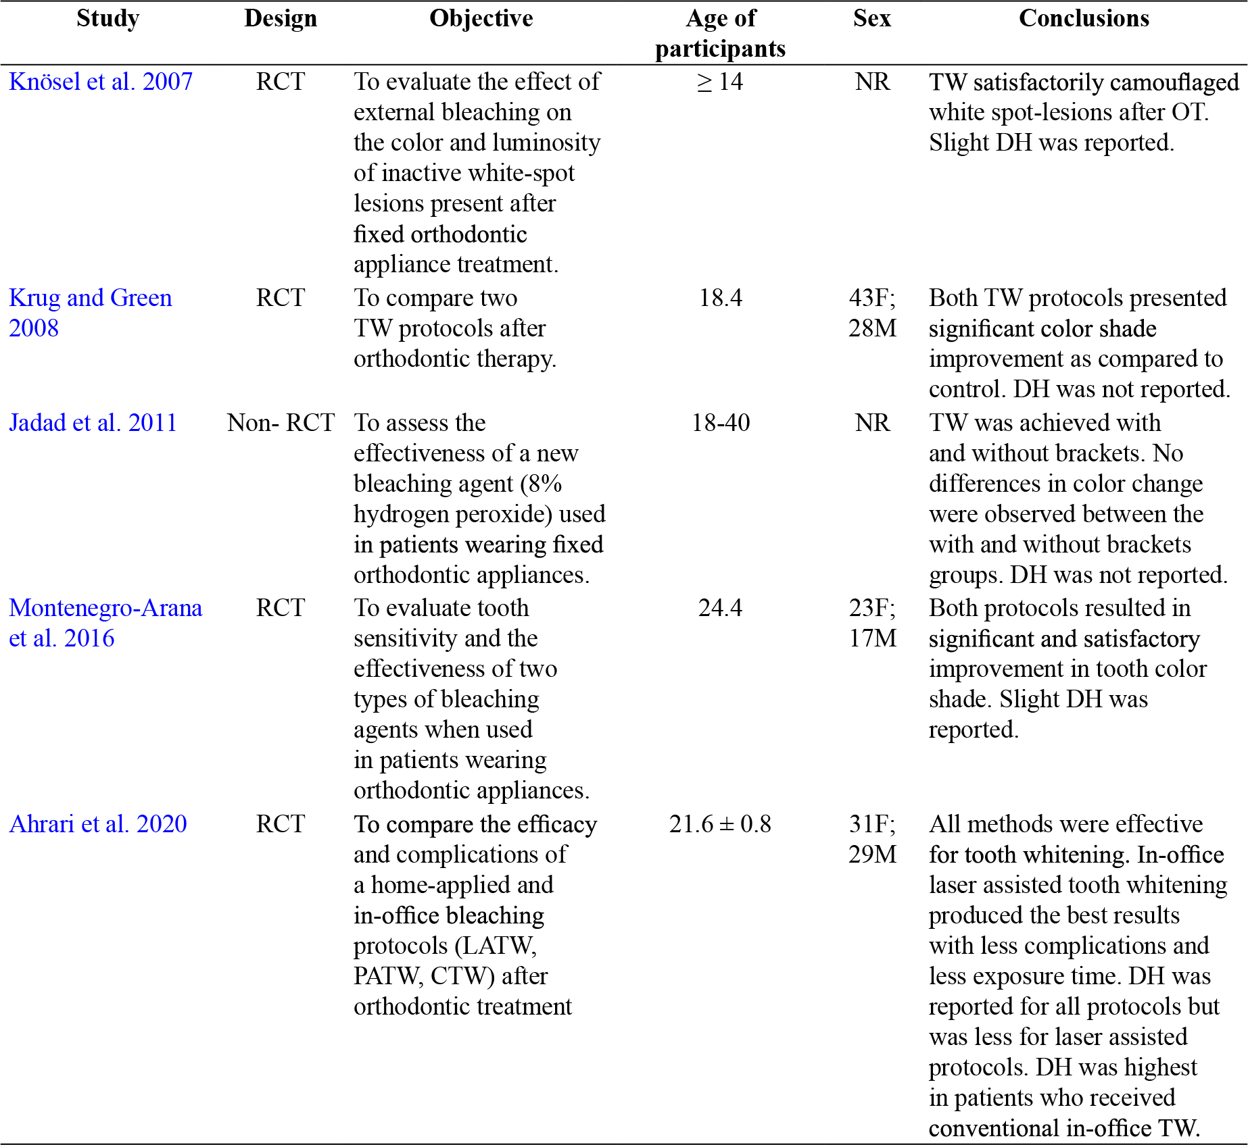[/graphic]
[fntable id="TFN1"]Note: Derived from research. RCT: randomized clinical trial. Non-RCT: non-randomized clinical trial. NR: not reported. F: female. M: male. TW: tooth whitening. OT: orthodontic treatment. DH: dental hypersensitivity. LATW: laser assisted tooth whitening. PATW: plasma arc tooth whitening. CTW: conventional tooth whitening.[/fntable][/tabwrap]

[p]whitening (TW) after orthodontic treatment (OT) was finalized ([xref ref-type="table" rid="t2"]table 2[/xref]). One study ([xref ref-type="bibr" rid="r23"]Montenegro-Arana et al., 2016[/xref]) performed TW during OT immediately after bracket installation. One study ([xref ref-type="bibr" rid="r17"]Jadad et al., 2011[/xref]) compared TW during OT immediately after bracket installation and TW after brackets debonding ([xref ref-type="table" rid="t2"]table 2[/xref]). The time in days after which TW was applied following bracket debonding ranged from 7 to 90 days with a mean value of 40.2 days ([xref ref-type="bibr" rid="r19"]Knösel et al., 2007[/xref]; [xref ref-type="bibr" rid="r20"]Krug and Green, 2008[/xref]; [xref ref-type="bibr" rid="r2"]Ahrari et al. 2020[/xref]) and one study (Jadad et al., 2011) performed TW immediately after bracket debonding ([xref ref-type="table" rid="t2"]table 2[/xref]). Studies that applied TW during or immediately (Montenegro-Arana et al., 2016; Jadad et al., 2011) after bracket debonding used lower whitening agent concentration (8-10%). In contrast, studies that performed TW 90 days after bracket debonding (Knösel et al., 2007; Ahrari et al. 2020) used concentrations between 30-46% of the whitening agent [xref ref-type="table" rid="t2"](table 2[/xref]).[/p]

[tabwrap id="t2"][label]Table 2[/label]. [caption]Variables of the included clinical studies[/caption]
[graphic href="?a21v36n1"][/graphic]
[fntable id="TFN2"]Note: Derived from research. NA: not applicable. TW: tooth whitening. OT: orthodontic treatment. LATW: laser assisted tooth whitening. PATW: plasma arc tooth whitening. CTW: conventional tooth whitening. *Days after brackets removal. **Days after brackets installation.[/fntable][/tabwrap]

[p]All studies reported satisfactory improvements in tooth color shade during or after OT independent of the protocol used with no significant differences among them ([xref ref-type="bibr" rid="r19"]Knösel et al., 2007[/xref]; [xref ref-type="bibr" rid="r20"]Krug and Green, 2008[/xref]; [xref ref-type="bibr" rid="r23"]Montenegro-Arana et al., 2016[/xref]; [xref ref-type="bibr" rid="r2"]Ahrari et al., 2020[/xref]; [xref ref-type="bibr" rid="r17"]Jadad et al., 2011[/xref]) However, the two studies [xref ref-type="bibr" rid="r23"](Montenegro-Arana et al., 2016[/xref]; [xref ref-type="bibr" rid="r17"]Jadad et al., 2011[/xref]) that performed TW during OT are from the same group of researchers with the same protocol and therefore the external validity remains inconclusive.[/p]
[p]Risk of bias for clinical studies is presented in [xref ref-type="fig" rid="f2"]figures 2[/xref] and [xref ref-type="fig" rid="f3"]3[/xref]. Three studies were judged to have high risk of bias ([xref ref-type="bibr" rid="r19"]Knösel et al., 2007[/xref]; [xref ref-type="bibr" rid="r20"]Krug and Green, 2008[/xref]; [xref ref-type="bibr" rid="r17"]Jadad et al., 2011[/xref]), one study ([xref ref-type="bibr" rid="r23"]Montenegro-Arana et al., 2016[/xref]) had some concerns that may have introduced bias and one study presented low risk of bias ([xref ref-type="bibr" rid="r2"]Ahrari et al., 2020[/xref]). Concerns about introducing bias in the studies were due to inadequate sample calculation, unclear randomization and concealment and not sufficient description about blinding. In general, the evidence was judged low quality due to the inclusion of RCTs with great uncertainty and methodological issues.[/p]
[p]Observations from the included reviews are presented in [xref ref-type="table" rid="t3"]table 3[/xref]. Two reviews ([xref ref-type="bibr" rid="r5"]Consolaro et al., 2013[/xref]; [xref ref-type="bibr" rid="r22"]Márquez et al., 2013[/xref]) considered TW during and after OT and one review ([xref ref-type="bibr" rid="r11"]Freire et al., 2018[/xref]) during OT. Regarding the time after bracket debonding in which TW can be applied, the authors recommend a 14-30-day period [xref ref-type="bibr" rid="r5"](Consolaro et al., 2013[/xref]; [xref ref-type="bibr" rid="r22"]Márquez et al., 2012[/xref]). All three reviews [xref ref-type="bibr" rid="r5"](Consolaro et al., 2013[/xref]; [xref ref-type="bibr" rid="r22"]Márquez et al., 2012[/xref]; [xref ref-type="bibr" rid="r11" label="."]Freire et al., 2018[/xref]) did not recommend TW during conventional OT. The lack of diffusion of the whitening agent under the brackets which may result in non-uniform color changes and possible enamel cracks during debonding are variables to consider [xref ref-type="bibr" rid="r5"](Consolaro et al., 2013[/xref]).[/p]

[figgrp id="f2"][graphic href="?a21v36n1"]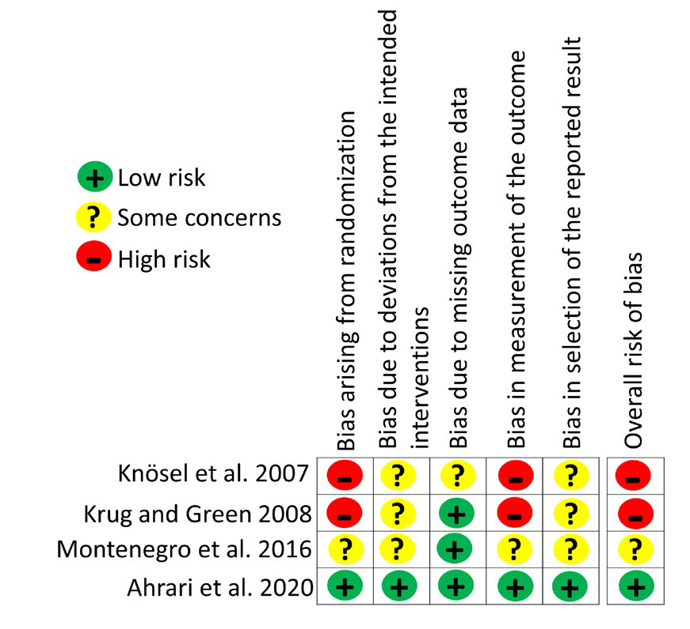[/graphic]
[label]Figure 2[/label]. [caption]Risk of bias of randomized clinical trials.[/caption][/figgrp]

[figgrp id="f3"][graphic href="?a21v36n1"]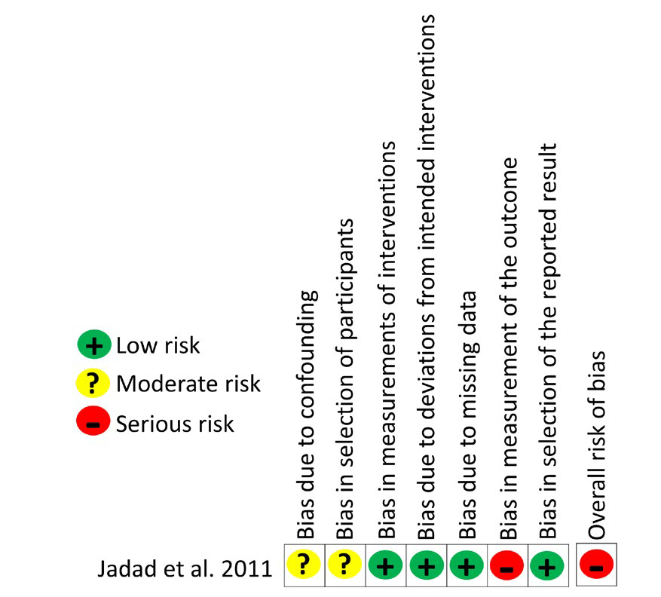[/graphic]
[label]Figure 3[/label]. [caption]Risk of bias of non-randomized clinical trials.[/caption][/figgrp]

[tabwrap id="t3"][label]Table 3[/label]. [caption]Data from reviews included in the analysis[/caption]
[graphic href="?a21v36n1"]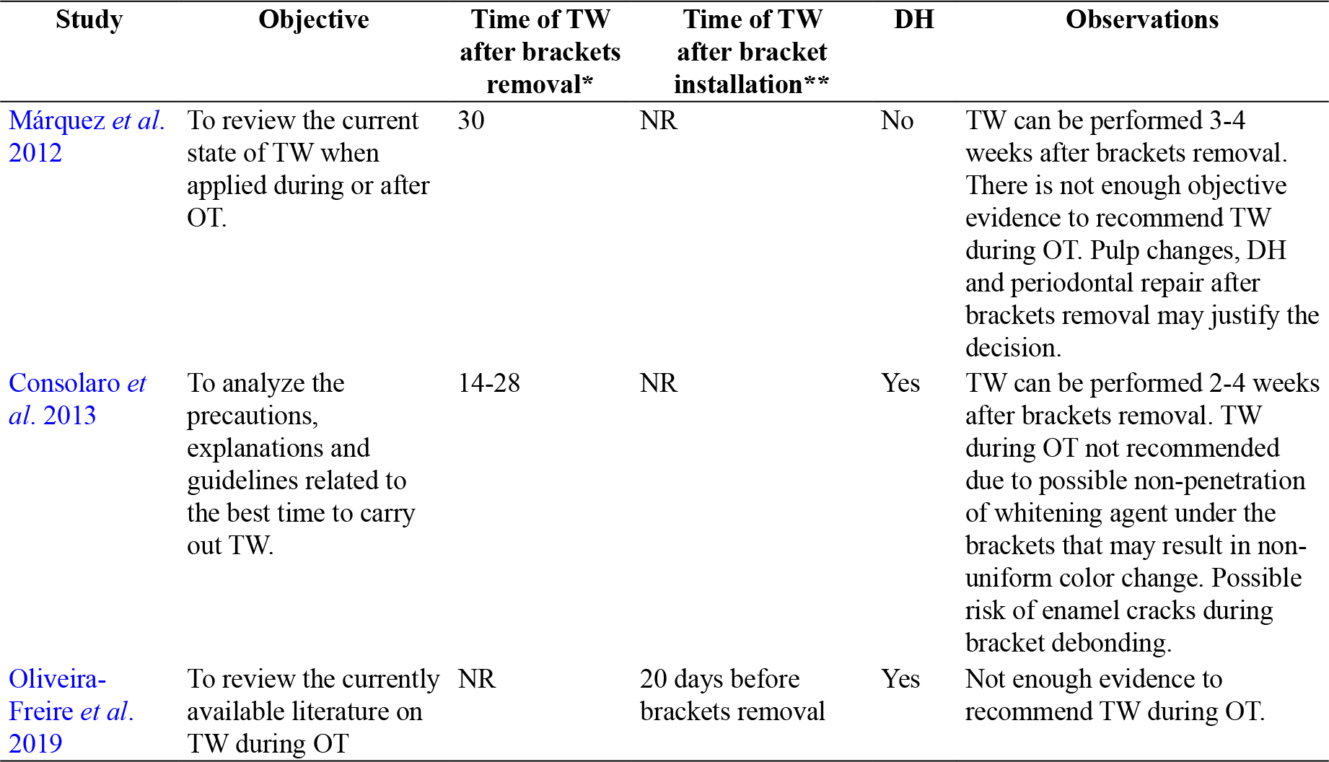[/graphic]
[fntable id="TFN3"]Note: Derived from research. NR: not reported. TW: tooth whitening. OT: orthodontic treatment. DH: dental hypersensitivity. *Days after brackets removal. **Days after brackets installation.[/fntable][/tabwrap]

[/sec][sec sec-type="discussion"][sectitle]Discussion[/sectitle]

[p]General issues[/p]

[p]Results from this systematic review were limited and meta-analysis was not attempted due to the nature of the data collected. In general, the clinical studies found were low quality with important methodological issues such as small-sample and no calculation of sample size. The inclusion of previous critical reviews offered some points of views based mainly on data from in vitro studies which need to be considered with caution when deciding about TW during or after OT. This narrative review synthesized the findings of quantitative studies which used diverse methodologies or with different conceptualizations to identify the appropriate moment to perform TW in conventional orthodontic patients. It is important to note that all studies that were assessed reported satisfactory improvements in color, independent of the protocol used and therefore will not be subjected to discussion.[/p]

[p]Tooth whitening during orthodontic treatment[/p]

[p]This systematic review found two studies from the same research group ([xref ref-type="bibr" rid="r23"]Montenegro-Arana et al., 2016[/xref]; [xref ref-type="bibr" rid="r17"]Jadad et al., 2011[/xref]) which performed TW during OT with satisfactory results in color shade. However, the evidence is low quality and there seems to be a lack of rationality for this procedure with no external validity. Color changes of the tooth around brackets is a possible outcome but there is the concern that applying TW procedures with brackets in place would produce a non-uniform color change. Two in vitro studies using bovine teeth demonstrated that the diffusion of the TW agent is impaired under the bracket resulting in significant difference in color between the center (area under bracket) and marginal areas of the tooth ([xref ref-type="bibr" rid="r21"]Lunardi et al., 2014[/xref]; [xref ref-type="bibr" rid="r7" label="."] De Melo Oliveira et al., 2021[/xref]). In contrast, few case reports have obtained satisfactory results of TW used during clear aligner OT suggesting its feasibility with this technique in areas without bonded resin attachments ([xref ref-type="bibr" rid="r25"]Oliverio et al., 2019[/xref]; [xref ref-type="bibr" rid="r30"]Sword and Haywood, 2020[/xref]). Nonetheless, controlled clinical studies are necessary to recommend this last strategy. The decision of TW during conventional OT appears to be based on clinical preference rather than on an evidence-based approach. Therefore, it is not possible to recommend TW during OT.[/p]

[p]Tooth whitening after orthodontic treatment[/p]

[p]One of the main reasons for TW after OT is the development of white-spot lesions. However, the intervention that has shown moderate effectivity in treating these lesions is fluoride varnish application ([xref ref-type="bibr" rid="r15"]Höchli et al., 2017[/xref]). In addition, the available evidence from a recent systematic review found no support for TW for the management of whitespot lesions after OT ([xref ref-type="bibr" rid="r12"]Gizani et al., 2020[/xref]). On the other hand, extrinsic stains developed during OT can be successfully managed with TW strategies ([xref ref-type="bibr" rid="r27"]Rodríguez-Martinez et al., 2019[/xref]). But the question is: ¿what is the appropriate time in days in which tooth whitening can be performed after bracket debonding? Several aspects are discussed based on the available evidence.[/p]
[p]Important changes in pulp tissues occur during OT depending on the magnitude of the force and the type of movement. Pulp vitality is affected with moderate to severe intrusion forces due to vascular congestión ([xref ref-type="bibr" rid="r14"]Han et al., 2013[/xref]). Other researchers found in clinical studies that pulp volume and pulp blood flow are significantly decreased with orthodontic forces ([xref ref-type="bibr" rid="r35"]Venkatesh et al., 2014[/xref]; [xref ref-type="bibr" rid="r1"]Abu Alhaija et al., 2019[/xref]). Pulp blood flow was found to return to baseline values after one month, suggesting that waiting this time would be advisable after bracket removal to perform TW [xref ref-type="bibr" rid="r1"](Abu Alhaija et al., 2019[/xref]).[/p]
[p]Debonding of brackets results in damage to the enamel, resin tags and increased sensitivity ([xref ref-type="bibr" rid="r37"]Zaher et al., 2012[/xref]; [xref ref-type="bibr" rid="r8"]Dumbryte et al., 2017[/xref]). A study found that sensitivity is higher immediately after bracket debonding and shows a decreased but still positive response after 7 days [xref ref-type="bibr" rid="r8"](Dumbryte et al., 2017[/xref]). Dental hypersensitivity was a frequent finding in this systematic review. In addition, polishing of the tooth surface with burs and discs after bracket debonding may also affect the enamel quality and result in damage ([xref ref-type="bibr" rid="r10"]Faria-Júnior et al., 2015[/xref]; [xref ref-type="bibr" rid="r36"]Vidor et al., 2015[/xref]). A recent experimental study showed that a remineralization layer can be formed 14 days after debonding when a toothpaste containing calcium sodium phosphosilicate (CSPS) was applied daily ([xref ref-type="bibr" rid="r33"]Triwardhani et al., 2019[/xref]). Therefore, all these variables and possible consequences should be carefully assessed before deciding on performing TW after OT.[/p]
[p]Periodontal changes are also associated with OT. Increased plaque accumulation and gingivitis is common in conventional orthodontic patients ([xref ref-type="bibr" rid="r34"]Van Gastel et al., 2007[/xref]). Oral hygiene during OT is a major factor which influence the periodontal condition and successful achievement of treatment objectives ([xref ref-type="bibr" rid="r31"]Talic, 2011[/xref]). Additionally, it has been reported that the levels of plaque, bleeding on probing and gingivitis are significantly reduced 30 days after bracket debonding accompanied by prophylaxis and oral hygiene instructions ([xref ref-type="bibr" rid="r17"]Jadad et al., 2011[/xref]; [xref ref-type="bibr" rid="r28"]Sallum et al., 2004[/xref]). Therefore, any TW procedure after OT would be best applied under proper oral hygiene and healthy periodontal conditions.[/p]
[p]A final consideration is the concentration of the whitening agent. Tooth whitening agents, depending on the protocol used, must remained in contact with the tooth surface for extensive periods of time to produce its effects. Home whitening protocols used concentrations between 8-15% for 45 minutes to 1 hour. In contrast, in-office protocols used higher concentrations of the whitening agent (30-46%) for a short exposure time. It has been observed that patients overuse the at-home TW protocols that may result in important complications ([xref ref-type="bibr" rid="r3"]Alqahtani et al., 2014[/xref]). An in vitro study showed that higher concentrations of carbamide peroxide (>10%) caused a reduction in the enamel microhardness. Furthermore, after a post-whitening recovery period in artificial saliva, the microhardness improved but did not reach baseline values ([xref ref-type="bibr" rid="r4"]Basting et al., 2003[/xref]). This may indicate that the changes in the mineral composition and surface of the enamel produced by high concentration of whitening agents are permanent and therefore, could affect the previously altered tooth structure by the mechanical debonding of brackets.[/p]
[p]Remineralization of the enamel is possible after orthodontic treatment and this phenomenon occurs naturally by saliva and with the use of fluorides or casein phosphopeptide-amorphous calcium phosphate products. [xref ref-type="bibr" rid="r13"]Guzmán-Armstrong et al. (2010[/xref]) reported that remineralization of white spot lesion is possible after bracket removal, but it depends on the severity of the lesions. Nonetheless, remineralization could take up to 6 months and therefore any treatment for white spot lesion or stains should be delayed until the enamel has recovered. Therefore, TW after bracket debonding should be carefully considered as remineralization of the enamel is occurring and whitening agents could induce further damage to the tooth surface. In all cases, TW after OT must be closely monitored by the clinician in order to control the desired tooth color change and possible adverse effects.[/p]
[p]Since no consensus regarding the number of days after bracket debonding in which TW can be safely applied and based on the available data, it seems rational to wait at least 30 days to avoid complications and to allow for the enamel, pulp and periodontal tissues to recover after OT. However, there may be cases in which an extended waiting period is appropriate depending on the clinical appearance of extrinsic stains, white spot lesions and quality of the enamel.[/p]

[/sec][sec sec-type="conclusions"][sectitle]Conclusions[/sectitle]

[p]Low quality evidence suggests that the appropriate moment to perform tooth whitening in conventional orthodontic patients is after brackets removal with a waiting period of at least 30 days. There is not adequate evidence to support tooth whitening during conventional orthodontic treatment.[/p]

[subsec][sectitle]Conflict of Interest[/sectitle]

[p]The authors declare no competing interests.[/p]

[/subsec][subsec][sectitle]Author contribution statement[/sectitle]

[p]All the authors declare that the final version of this paper was read and approved. The total contribution percentage for the conceptualization, preparation, and correction of this paper was as follows: S.H.V. 25%, M.F.N. 25%, J.E.B. 25% and F.A.R. 25%.[/p]

[/subsec][subsec][sectitle]Data availability statement[/sectitle]

[p]The data supporting the results of this study is available as “supplementary files” on the Uniciencia website.[/p]

[supplmat id="suppl1" href="a21v36n1-s1"]Ver anexo en PDF a21v36n1-s1[/supplmat][/subsec][/sec][/xmlbody]

[refs][sectitle]References[/sectitle]

[ref id="r1" reftype=“journal"][authors role="nd"][pauthor][surname]Abu Alhaija[/surname], [fname]E.[/fname][/pauthor]; [pauthor][surname]Al-Abdallah[/surname], [fname]S. Y.[/fname][/pauthor]; & [pauthor][surname]Taha[/surname], [fname]N. A.[/fname][/pauthor][/authors] ([date dateiso="20190000" specyear="2019"]2019[/date]). [arttitle]A comparative study of initial changes in pulpal blood flow between clear aligners and fixed orthodontic appliances.[/arttitle] [source]American Journal of Orthodontics and Dentofacial[/source], [volid]156[/volid]([issueno]5[/issueno]), [pages]603-610[/pages]. https://doi.org/[pubid idtype="doi"]10.1016/j.ajodo.2018.11.013[/pubid][/ref]
[ref id="r2" reftype=“journal"][authors role="nd"][pauthor][surname]Ahrari[/surname], [fname]F.[/fname][/pauthor]; [pauthor][surname]Akbari[/surname], [fname]M.[/fname][/pauthor]; [pauthor][surname]Mohammadipour[/surname], [fname]H. S.[/fname][/pauthor]; [pauthor][surname]Fallahrastegar[/surname], [fname]A.[/fname][/pauthor]; & [pauthor][surname]Sekandari[/surname], [fname]S.[/fname][/pauthor][/authors] ([date dateiso="20200000" specyear="2020"]2020[/date]). [arttitle]The efficacy and complications of several bleaching techniques in patients after fixed orthodontic therapy.[/arttitle] [source]A randomized clinical trial. [/source][pubname]Swiss dental journal[/pubname], [volid]130[/volid]([issueno]6[/issueno]), [pages]493-501[/pages].[/ref]
[ref id="r3" reftype=“journal"][authors role="nd"][pauthor][surname]Alqahtani[/surname] [fname]M. Q.[/fname][/pauthor] [/authors]([date dateiso="20140000" specyear="2014"]2014[/date]). [arttitle]Tooth-bleaching procedures and their controversial effects: A literature review.[/arttitle] [source]The Saudi Dental Journal[/source], [volid]26[/volid]([issueno]2[/issueno]), [pages]33-46[/pages]. https://doi.org/[pubid idtype="doi"]10.1016/j.sdentj.2014.02.002[/pubid][/ref]
[ref id="r4" reftype=“journal"][authors role="nd"][pauthor][surname]Basting[/surname], [fname]R. T.[/fname][/pauthor]; [pauthor][surname]Rodrigues[/surname], [fname]A. L.[/fname][/pauthor]; & [pauthor][surname]Serra[/surname], [fname]M. C.[/fname][/pauthor][/authors] ([date dateiso="20030000" specyear="2003"]2003[/date]). [arttitle]The effects of seven carbamide peroxide bleaching agents on enamel microhardness over time. [/arttitle][source]Journal of the American Dental Association,[/source] [volid]134[/volid]([issueno]10[/issueno]), [pages]1335-1342[/pages]. https://doi.org/[pubid idtype="doi"]10.14219/jada.archive.2003.0047[/pubid][/ref]
[ref id="r5" reftype=“journal"][authors role="nd"][pauthor][surname]Consolaro[/surname], [fname]A.[/fname][/pauthor]; [pauthor][surname]Consolaro[/surname], [fname]R. B.[/fname][/pauthor]; & [pauthor][surname]Francischone[/surname], [fname]L.[/fname][/pauthor] [/authors]([date dateiso="20130000" specyear="2013"]2013[/date]). [arttitle]Clarifications, guidelines, and questions about the dental bleaching "associated" with orthodontic treatment. [/arttitle][source]Dental Press Journal of Orthodontics[/source], [volid]18[/volid]([issueno]5[/issueno]), 4-10. https://doi.org/[pubid idtype="doi"]10.1590/s2176-94512013000500002[/pubid][/ref]
[ref id="r6" reftype=“journal"][authors role="nd"][pauthor][surname]Costa[/surname], [fname]C. A.[/fname][/pauthor]; [pauthor][surname]Riehl[/surname], [fname]H.[/fname][/pauthor]; [pauthor][surname]Kina[/surname], [fname]J. F.[/fname][/pauthor]; [pauthor][surname]Sacono[/surname], [fname]N. T.[/fname][/pauthor]; & [pauthor][surname]Hebling[/surname], [fname]J.[/fname][/pauthor][/authors] ([date dateiso="20100000" specyear="2010"]2010[/date]). [arttitle]Human pulp responses to in-office tooth bleaching.[/arttitle] [source]Oral Surgery, Oral Medicine, Oral Pathology, Oral Radiology, and Endodontics,[/source] [volid]109[/volid]([issueno]4[/issueno]), [edition]e59-e64[/edition]. https://doi.org/[pubid idtype="doi"]10.1016/j.tripleo.2009.12.002[/pubid][/ref]
[ref id="r7" reftype=“journal"][authors role="nd"][pauthor][surname]De Melo Oliveira[/surname], [fname]I.[/fname][/pauthor]; [pauthor][surname]Santana[/surname], [fname]T. R.[/fname][/pauthor]; [pauthor][surname]Correia[/surname], [fname]A.[/fname][/pauthor]; [pauthor][surname]Fontes[/surname], [fname]L. S.[/fname][/pauthor]; [pauthor][surname]Griza[/surname], [fname]S.[/fname][/pauthor]; & [pauthor][surname]Faria-E-Silva[/surname], [fname]A. L.[/fname][/pauthor][/authors] ([date dateiso="20210000" specyear="2021"]2021[/date]). [arttitle]Color heterogeneity and individual color changes in dentin and enamel bleached in the presence of a metallic orthodontic bracket. [/arttitle][source]Journal of Esthetic and Restorative Dentistry[/source], [volid]33[/volid]([issueno]2[/issueno]), [pages]262-268[/pages]. https://doi.org/[pubid idtype="doi"]10.1111/jerd.12660[/pubid][/ref]
[ref id="r8" reftype=“journal"][authors role="nd"][pauthor][surname]Dumbryte[/surname], [fname]I.[/fname][/pauthor]; [pauthor][surname]Linkeviciene[/surname], [fname]L.[/fname][/pauthor]; [pauthor][surname]Linkevicius[/surname], [fname]T.[/fname][/pauthor]; & [pauthor][surname]Malinauskas[/surname], [fname]M.[/fname][/pauthor][/authors] ([date dateiso="20170000" specyear="2017"]2017[/date]). [arttitle]Does orthodontic debonding lead to tooth sensitivity? Comparison of teeth with and without visible enamel microcracks.[/arttitle] [source]American Journal of Orthodontics and Dentofacial Orthopedics[/source], [volid]151[/volid]([issueno]2[/issueno]), [pages]284-291[/pages]. https://doi.org/[pubid idtype="doi"]10.1016/j.ajodo.2016.06.036[/pubid][/ref]
[ref id="r9" reftype=“journal"][authors role="nd"][pauthor][surname]Eachempati[/surname], [fname]P.[/fname][/pauthor]; [pauthor][surname]Kumbargere Nagraj[/surname], [fname]S.[/fname][/pauthor]; [pauthor][surname]Kiran Kumar Krishanappa[/surname], [fname]S.[/fname][/pauthor]; [pauthor][surname]Gupta[/surname], [fname]P.[/fname][/pauthor]; & [pauthor][surname]Yaylali[/surname], [fname]I. E.[/fname][/pauthor][/authors] ([date dateiso="20180000" specyear="2018"]2018[/date]). [arttitle]Home-based chemically-induced whitening (bleaching) of teeth in adults.[/arttitle] [source]The Cochrane Database of Systematic Reviews[/source], [volid]12[/volid]([issueno]12[/issueno]), [edition]CD006202[/edition]. https://doi. org/[pubid idtype="doi"]10.1002/14651858.CD006202.pub2[/pubid][/ref]
[ref id="r10" reftype="journal"][authors role="nd"][pauthor][surname]Faria-Júnior[/surname], [fname]É. M.[/fname][/pauthor]; [pauthor][surname]Guiraldo[/surname], [fname]R. D.[/fname][/pauthor]; [pauthor][surname]Berger[/surname], [fname]S. B.[/fname][/pauthor]; [pauthor][surname]Correr[/surname], [fname]A. B.[/fname][/pauthor]; [pauthor][surname]Correr-Sobrinho[/surname], [fname]L.[/fname][/pauthor]; [pauthor][surname]Contreras[/surname], [fname]E. F.,[/fname][/pauthor] & [pauthor][surname]Lopes[/surname], [fname]M. B.[/fname][/pauthor][/authors] ([date dateiso="20150000" specyear="2015"]2015[/date]). [arttitle]In-vivo evaluation of the surface roughness and morphology of enamel after bracket removal and polishing by different techniques.[/arttitle] [source]American Journal of Orthodontics and Dentofacial Orthopedics [/source], [volid]147[/volid]([issueno]3[/issueno]), [pages]324-329[/pages]. https://doi.org/[pubid idtype="doi"]10.1016/j.ajodo.2014.10.033[/pubid][/ref]
[ref id="r11" reftype=“journal"][authors role="nd"][pauthor][surname]Freire[/surname], [fname]A.[/fname][/pauthor], [pauthor][surname]Pedrosa[/surname], [fname]M.[/fname][/pauthor], [pauthor][surname]Vasconselos[/surname], [fname]M.[/fname][/pauthor], [pauthor][surname]Lopes[/surname], [fname]M.[/fname][/pauthor], [pauthor][surname]Lopes[/surname], [fname]R.[/fname][/pauthor], & [pauthor][surname]Carvalho[/surname], [fname]M.[/fname][/pauthor][/authors] ([date dateiso="20180000" specyear="2018"]2018[/date]). [arttitle]Clareamento dentário durante tratamento ortodôntico.[/arttitle] [source]Revista Da Faculdade De Odontología UPF[/source], [volid]22[/volid]([issueno]3[/issueno]). https://doi.org/[pubid idtype="doi"]10.5335/rfo.v22i3.7647[/pubid][/ref]
[ref id="r12" reftype=“journal"][authors role="nd"][pauthor][surname]Gizani[/surname], [fname]S.[/fname][/pauthor]; [pauthor][surname]Kloukos[/surname], [fname]D.[/fname][/pauthor]; [pauthor][surname]Papadimitriou[/surname], [fname]A.[/fname][/pauthor]; [pauthor][surname]Roumani[/surname], [fname]T.,[/fname][/pauthor] & [pauthor][surname]Twetman[/surname], [fname]S.[/fname][/pauthor] [/authors]([date dateiso="20200000" specyear="2020"]2020[/date]). [arttitle]Is Bleaching Effective in Managing Post-orthodontic Whitespot Lesions? [/arttitle][source]A Systematic Review. Oral Health & Preventive Dentistry[/source], [volid]18[/volid]([issueno]1[/issueno]), [pages]2-10[/pages]. https://doi.org/[pubid idtype="doi"]10.3290/j.ohpd.a44113[/pubid][/ref]
[ref id="r13" reftype=“journal"][authors role="nd"][pauthor][surname]Guzmán-Armstrong[/surname], [fname]S.[/fname][/pauthor], [pauthor][surname]Chalmers[/surname], [fname]J.[/fname][/pauthor], & [pauthor][surname]Warren[/surname], [fname]J. J.[/fname][/pauthor][/authors] ([date dateiso="20100000" specyear="2010"]2010[/date]). [arttitle]Ask us. White spot lesions: prevention and treatment.[/arttitle] [source]American Journal of Orthodontics and Dentofacial Orthopedics [/source], [volid]138[/volid]([issueno]6[/issueno]), [pages]690-696[/pages]. https://doi.org/[url]10.1016/j. ajodo.2010.07.007[/url][/ref]
[ref id="r14" reftype=“journal"][authors role="nd"][pauthor][surname]Han[/surname], [fname]G.[/fname][/pauthor]; [pauthor][surname]Hu[/surname], [fname]M.[/fname][/pauthor]; [pauthor][surname]Zhang[/surname], [fname]Y.[/fname][/pauthor]; & [pauthor][surname]Jiang[/surname], [fname]H.[/fname][/pauthor][/authors] ([date dateiso="20130000" specyear="2013"]2013[/date]). [arttitle]Pulp vitality and histologic changes in human dental pulp after the application of moderate and severe intrusive orthodontic forces.[/arttitle] [source]American Journal of Orthodontics and Dentofacial[/source], [volid]144[/volid]([issueno]4[/issueno]), [pages]518-522[/pages]. https://doi.org/[pubid idtype="doi"]10.1016/j.ajodo.2013.05.005[/pubid][/ref]
[ref id="r15" reftype=“journal"][authors role="nd"][pauthor][surname]Höchli[/surname], [fname]D.[/fname][/pauthor]; [pauthor][surname]Hersberger-Zurfluh[/surname], [fname]M.[/fname][/pauthor]; [pauthor][surname]Papageorgiou[/surname], [fname]S. N.[/fname][/pauthor]; & [pauthor][surname]Eliades[/surname], [fname]T.[/fname][/pauthor][/authors] ([date dateiso="20170000" specyear="2017"]2017[/date]). [arttitle]Interventions for orthodontically induced white spot lesions: a systematic review and meta-analysis.[/arttitle] [source]European Journal of Orthodontics[/source], [volid]39[/volid]([issueno]2[/issueno]), [pages]122-133[/pages]. https://doi.org/[pubid idtype="doi"]10.1093/ejo/cjw065[/pubid][/ref]
[ref id="r16" reftype=“journal"][authors role="nd"][pauthor][surname]Imani[/surname], [fname]M. M.[/fname][/pauthor]; [pauthor][surname]Azizi[/surname], [fname]F.[/fname][/pauthor]; [pauthor][surname]Bahrami[/surname], [fname]K.[/fname][/pauthor]; [pauthor][surname]Golshah[/surname], [fname]A.[/fname][/pauthor]; & [pauthor][surname]Safari-Faramani[/surname], [fname]R.[/fname][/pauthor][/authors] ([date dateiso="20200000" specyear="2020"]2020[/date]). [arttitle]In vitro bleaching effect of hydrogen peroxide with different time of exposition and concentration on shear bond strength of orthodontic brackets to human enamel: A meta-analysis of in vitro studies.[/arttitle] [source]International Orthodontics[/source], [volid]18[/volid]([issueno]1[/issueno]), [pages]22-31[/pages]. https://doi.org/[pubid idtype="doi"]10.1016/j.ortho.2019.09.001[/pubid][/ref]
[ref id="r17" reftype=“journal"][authors role="nd"][pauthor][surname]Jadad[/surname], [fname]E.[/fname][/pauthor]; [pauthor][surname]Montoya[/surname], [fname]J.[/fname][/pauthor]; [pauthor][surname]Arana[/surname], [fname]G.[/fname][/pauthor]; [pauthor][surname]Gordillo[/surname], [fname]L. A.[/fname][/pauthor]; [pauthor][surname]Palo[/surname], [fname]R. M.[/fname][/pauthor]; & [pauthor][surname]Loguercio[/surname], [fname]A. D.[/fname][/pauthor][/authors] ([date dateiso="20110000" specyear="2011"]2011[/date]). [arttitle]Spectrophotometric evaluation of color alterations with a new dental bleaching product in patients wearing orthodontic appliances. [/arttitle][source]American Journal of Orthodontics and Dentofacial Orthopedics[/source], [volid]140[/volid]([issueno]1[/issueno]), [edition]e43-e47[/edition]. https://doi.org/[pubid idtype="doi"]10.1016/j.ajodo.2010.11.021[/pubid][/ref]
[ref id="r18" reftype=“journal"][authors role="nd"][pauthor][surname]Kamber[/surname], [fname]R.[/fname][/pauthor]; [pauthor][surname]Papageorgiou[/surname], [fname]S. N.[/fname][/pauthor]; & [pauthor][surname]Eliades[/surname], [fname]T.[/fname][/pauthor][/authors] ([date dateiso="20180000" specyear="2018"]2018[/date]). [arttitle]Does orthodontic treatment have a permanent effect on tooth color? A systematic review and meta-analysis. [/arttitle][source]Journal of Orofacial Orthopedics[/source], [volid]79[/volid]([issueno]2[/issueno]), [pages]73-82[/pages]. https://doi.org/[pubid idtype="doi"]10.1007/s00056-018-0123-7[/pubid][/ref]
[ref id="r19" reftype=“journal"][authors role="nd"][pauthor][surname]Knösel[/surname], [fname]M.[/fname][/pauthor]; [pauthor][surname]Attin[/surname], [fname]R.[/fname][/pauthor]; [pauthor][surname]Becker[/surname], [fname]K.[/fname][/pauthor]; & [pauthor][surname]Attin[/surname], [fname]T.[/fname][/pauthor][/authors] ([date dateiso="20070000" specyear="2007"]2007[/date]). [arttitle]External bleaching effect on the color and luminosity of inactive white-spot lesions after fixed orthodontic appliances.[/arttitle] [source]The Angle Orthodontist[/source], [volid]77[/volid]([issueno]4[/issueno]), [pages]646-652[/pages]. https://doi. org/[pubid idtype="doi"]10.2319/060106-224[/pubid][/ref]
[ref id="r20" reftype=“journal"][authors role="nd"][pauthor][surname]Krug[/surname], [fname]A. Y.[/fname][/pauthor], & [pauthor][surname]Green[/surname], [fname]C.[/fname][/pauthor] [/authors]([date dateiso="20080000" specyear="2008"]2008[/date]). [arttitle]Changes in patient evaluation of completed orthodontic esthetics after dental bleaching.[/arttitle] [source]Journal of Esthetic and Restorative Dentistry[/source], [volid]20[/volid]([issueno]5[/issueno]), [pages]313-321[/pages]. https://doi.org/[pubid idtype="doi"]10.1111/j.1708-8240.2008.00200.x[/pubid][/ref]
[ref id="r21" reftype=“journal"][authors role="nd"][pauthor][surname]Lunardi[/surname], [fname]N.[/fname][/pauthor]; [pauthor][surname]Correr[/surname], [fname]A. B.[/fname][/pauthor]; [pauthor][surname]Rastelli[/surname], [fname]A. N.[/fname][/pauthor]; [pauthor][surname]Lima[/surname], [fname]D. A.[/fname][/pauthor]; & [pauthor][surname]Consani[/surname], [fname]R. L.[/fname][/pauthor][/authors] ([date dateiso="20140000" specyear="2014"]2014[/date]). [arttitle]Spectrophotometric evaluation of dental bleaching under orthodontic bracket in enamel and dentin. [/arttitle][source]Journal of Clinical and Experimental Dentistry[/source], [volid]6[/volid]([issueno]4[/issueno]), [edition]e321-e326[/edition]. https://doi.org/[pubid idtype="doi"]10.4317/jced.51168[/pubid][/ref]
[ref id="r22" reftype=“journal"][authors role="nd"][pauthor][surname]Márquez[/surname], [fname]J.F.[/fname][/pauthor]; [pauthor][surname]Pedroza-Garcés[/surname], [fname]A.[/fname][/pauthor]; & [pauthor][surname]Villada-Castro[/surname], [fname]M.[/fname][/pauthor][/authors] ([date dateiso="20120000" specyear="2012"]2012[/date]). [arttitle]Aclaramiento dental, durante y después de ortodoncia.[/arttitle] [source]CES Odontología[/source], [volid]25[/volid]([issueno]2[/issueno]), [pages]54-62[/pages]. [url]http://www.scielo.org.co/scielo.php?script=sci_arttext&pid=S0120-971X2012000200005&l-ng=en&tlng=es[/url][/ref]
[ref id="r23" reftype=“journal"][authors role="nd"][pauthor][surname]Montenegro-Arana[/surname], [fname]A.[/fname][/pauthor]; [pauthor][surname]Arana-Gordillo[/surname], [fname]L. A.[/fname][/pauthor]; [pauthor][surname]Farana[/surname], [fname]D.[/fname][/pauthor]; [pauthor][surname]Davila-Sanchez[/surname], [fname]A.[/fname][/pauthor]; [pauthor][surname]Jadad[/surname], [fname]E.[/fname][/pauthor]; [pauthor][surname]Coelho[/surname], [fname]U.[/fname][/pauthor]; [pauthor][surname]Gomes[/surname], [fname]O.[/fname][/pauthor]; & [pauthor][surname]Loguercio[/surname], [fname]A. D.[/fname][/pauthor][/authors] ([date dateiso="20160000" specyear="2016"]2016[/date]). [arttitle]Randomized Double-blind Clinical Trial of Bleaching Products in Patients Wearing Orthodontic Devices. [/arttitle][source]Operative Dentistry[/source], [volid]41[/volid]([issueno]4[/issueno]), [pages]379-387[/pages]. https://doi. org/[pubid idtype="doi"]10.2341/15-240-C[/pubid][/ref]
[ref id="r24" reftype=“journal"][authors role="nd"][pauthor][surname]Mullins[/surname], [fname]J. M.[/fname][/pauthor]; [pauthor][surname]Kao[/surname], [fname]E. C.[/fname][/pauthor]; [pauthor][surname]Martin[/surname], [fname]C. A.[/fname][/pauthor]; [pauthor][surname]Gunel[/surname], [fname]E.[/fname][/pauthor]; & [pauthor][surname]Ngan[/surname], [fname]P.[/fname][/pauthor][/authors] ([date dateiso="20090000" specyear="2009"]2009[/date]). [arttitle]Tooth whitening effects on bracket bond strength in vivo.[/arttitle] [source]The Angle Orthodontist[/source], [volid]79[/volid]([issueno]4[/issueno]), [pages]777-783[/pages]. https://doi.org/[pubid idtype="doi"]10.2319/042308-226.1[/pubid][/ref]
[ref id="r25" reftype=“journal"][authors role="nd"][pauthor][surname]Oliverio[/surname], [fname]T.[/fname][/pauthor]; [pauthor][surname]Cremonini[/surname], [fname]F.[/fname][/pauthor]; [pauthor][surname]Lombardo[/surname], [fname]L.[/fname][/pauthor]; & [pauthor][surname]Siciliani[/surname], [fname]G.[/fname][/pauthor][/authors] ([date dateiso="20190000" specyear="2019"]2019[/date]). [arttitle]Tooth Whitening in Association with Clear Aligner Treatment.[/arttitle] [source]Journal of Clinical Orthodontics[/source], [volid]53[/volid]([issueno]9[/issueno]), [pages]508-517[/pages].[/ref]
[ref id="r26" reftype=“journal"][authors role="nd"][pauthor][surname]Rodrigues[/surname], [fname]J. L.[/fname][/pauthor]; [pauthor][surname]Rocha[/surname], [fname]P. S.[/fname][/pauthor]; [pauthor][surname]Pardim[/surname], [fname]S.[/fname][/pauthor]; [pauthor][surname]Machado[/surname], [fname]A.[/fname][/pauthor]; [pauthor][surname]Faria-E-Silva[/surname], [fname]A. L.[/fname][/pauthor]; & [pauthor][surname]Seraidarian[/surname], [fname]P. I.[/fname][/pauthor][/authors] ([date dateiso="20180000" specyear="2018"]2018[/date]). [arttitle]Association Between In-Office and At-Home Tooth Bleaching: A Single Blind Randomized Clinical Trial.[/arttitle] [source]Brazilian Dental Journal[/source], [volid]29[/volid]([issueno]2[/issueno]), [pages]133-139[/pages]. https://doi. org/[pubid idtype="doi"]10.1590/0103-6440201801726[/pubid][/ref]
[ref id="r27" reftype=“journal"][authors role="nd"][pauthor][surname]Rodríguez-Martínez[/surname], [fname]J.[/fname][/pauthor]; [pauthor][surname]Valiente[/surname], [fname]M.[/fname][/pauthor]; & [pauthor][surname]Sánchez Martín[/surname], [fname]M. J.[/fname][/pauthor][/authors] ([date dateiso="20190000" specyear="2019"]2019[/date]). [arttitle]Tooth whitening: From the established treatments to novel approaches to prevent side effects. [/arttitle][source]Journal of Esthetic and Restorative Dentistry[/source], [volid]31[/volid]([issueno]5[/issueno]), [pages]431-440[/pages]. https://doi.org/[pubid idtype="doi"]10.1111/jerd.12519[/pubid][/ref]
[ref id="r28" reftype=“journal"][authors role="nd"][pauthor][surname]Sallum[/surname], [fname]E. J.[/fname][/pauthor]; [pauthor][surname]Nouer[/surname], [fname]D. F.[/fname][/pauthor]; [pauthor][surname]Klein[/surname], [fname]M. I.[/fname][/pauthor]; [pauthor][surname]Gonçalves[/surname], [fname]R. B.[/fname][/pauthor]; [pauthor][surname]Machion[/surname], [fname]L.[/fname][/pauthor]; [pauthor][surname]Wilson Sallum[/surname], [fname]A.[/fname][/pauthor]; & [pauthor][surname]Sallum[/surname], [fname]E. A.[/fname][/pauthor][/authors] ([date dateiso="20040000" specyear="2004"]2004[/date]). [arttitle]Clinical and microbiologic changes after removal of orthodontic appliances.[/arttitle] [source]American Journal of Orthodontics and Dentofacial Orthopedics [/source], [volid]126[/volid]([issueno]3[/issueno]), [pages]363-366[/pages]. https://doi.org/[pubid idtype="doi"]10.1016/j.ajodo.2004.04.017[/pubid][/ref]
[ref id="r29" reftype=“journal"][authors role="nd"][pauthor][surname]Slack[/surname], [fname]M. E.[/fname][/pauthor]; [pauthor][surname]Swift[/surname], [fname]E. J.[/fname] [suffix]Jr[/suffix][/pauthor]; [pauthor][surname]Rossouw[/surname], [fname]P. E.[/fname][/pauthor]; & [pauthor][surname]Phillips[/surname], [fname]C.[/fname][/pauthor] [/authors]([date dateiso="20130000" specyear="2013"]2013[/date]). [arttitle]Tooth whitening in the orthodontic practice: a survey of orthodontists.[/arttitle] [source]American Journal of Orthodontics and Dentofacial Orthopedics [/source], [volid]143[/volid]([issueno]4[/issueno]), [pages]S64-S71[/pages]. https://doi.org/[pubid idtype="doi"]10.1016/j.ajodo.2012.06.017[/pubid][/ref]
[ref id="r30" reftype=“journal"][authors role="nd"][pauthor][surname]Sword[/surname] [fname]R. J.[/fname][/pauthor]; [pauthor][surname]Haywood[/surname] [fname]V.B.[/fname][/pauthor][/authors] ([date dateiso="20200000" specyear="2020"]2020[/date]). [arttitle]Teeth Bleaching Efficacy During Clear Aligner Orthodontic Treatment.[/arttitle] [source]Compend Contin Educ Dent[/source], [volid]41[/volid]([issueno]5[/issueno]), [edition]e11-e16[/edition]. [moreinfo]PMID: 32369381[/moreinfo].[/ref]
[ref id="r31" reftype="journal"][authors role="nd"][pauthor][surname]Talic[/surname] [fname]N. F.[/fname][/pauthor] [/authors]([date dateiso="20110000" specyear="2011"]2011[/date]). [arttitle]Adverse effects of orthodontic treatment: A clinical perspective[/arttitle]. [source]The Saudi Dental Journal[/source], [volid]23[/volid]([issueno]2[/issueno]), [pages]55-59[/pages]. https://doi.org/[pubid idtype="doi"]10.1016/j.sdentj.2011.01.003[/pubid][/ref]
[ref id="r32" reftype=“journal"][authors role="nd"][pauthor][surname]Tredwin[/surname], [fname]C. J.[/fname][/pauthor]; [pauthor][surname]Naik[/surname], [fname]S.[/fname][/pauthor]; [pauthor][surname]Lewis[/surname], [fname]N. J.[/fname][/pauthor]; & [pauthor][surname]Scully[/surname], [fname]C.[/fname][/pauthor][/authors] ([date dateiso="20060000" specyear="2006"]2006[/date]). [arttitle]Hydrogen peroxide tooth-whitening (bleaching) products: review of adverse effects and safety issues.[/arttitle] [source]British Dental Journal[/source], [volid]200[/volid]([issueno]7[/issueno]), [pages]371-376[/pages]. https://doi.org/[pubid idtype="doi"]10.1038/sj.bdj.4813423[/pubid][/ref]
[ref id="r33" reftype=“journal"][authors role="nd"][pauthor][surname]Triwardhani[/surname], [fname]A.[/fname][/pauthor]; [pauthor][surname]Djaharu'ddin[/surname], [fname]I.[/fname][/pauthor]; & [pauthor][surname]Herawan[/surname], [fname]P. A.[/fname][/pauthor][/authors] ([date dateiso="20190000" specyear="2019"]2019[/date]). [arttitle]Effectivity comparison between three different enamel remineralizing agent postfix orthodontic treatment. [/arttitle][source]Journal of Clinical and Experimental Dentistry[/source], [volid]11[/volid]([issueno]10[/issueno]), [edition]e906e912[/edition]. https://doi.org/[pubid idtype="doi"]10.4317/jced.55933[/pubid][/ref]
[ref id="r34" reftype=“journal"][authors role="nd"][pauthor][surname]Van Gastel[/surname], [fname]J.[/fname][/pauthor]; [pauthor][surname]Quirynen[/surname], [fname]M.[/fname][/pauthor]; [pauthor][surname]Teughels[/surname], [fname]W.[/fname][/pauthor]; & [pauthor][surname]Carels[/surname], [fname]C.[/fname][/pauthor][/authors] ([date dateiso="20070000" specyear="2007"]2007[/date]). [arttitle]The relationships between malocclusion, fixed orthodontic appliances and periodontal disease. A review of the literature.[/arttitle] [source]Australian Orthodontic Journal[/source], [volid]23[/volid]([issueno]2[/issueno]), [pages]121-129[/pages].[/ref]
[ref id="r35" reftype=“journal"][authors role="nd"][pauthor][surname]Venkatesh[/surname], [fname]S.[/fname][/pauthor]; [pauthor][surname]Ajmera[/surname], [fname]S.[/fname][/pauthor]; & [pauthor][surname]Ganeshkar[/surname], [fname]S. V.[/fname][/pauthor][/authors] ([date dateiso="20140000" specyear="2014"]2014[/date]). [arttitle]Volumetric pulp changes after orthodontic treatment determined by cone-beam computed tomography.[/arttitle] [source]Journal of Endodontics[/source], [volid]40[/volid]([issueno]11[/issueno]), [pages]1758-1763[/pages]. https://doi.org/[pubid idtype="doi"]10.1016/j.joen.2014.07.029[/pubid][/ref]
[ref id="r36" reftype=“journal"][authors role="nd"][pauthor][surname]Vidor[/surname], [fname]M. M.[/fname][/pauthor]; [pauthor][surname]Felix[/surname], [fname]R. P.[/fname][/pauthor]; [pauthor][surname]Marchioro[/surname], [fname]E. M.[/fname][/pauthor]; & [pauthor][surname]Hahn[/surname], [fname]L.[/fname][/pauthor] [/authors]([date dateiso="20150000" specyear="2015"]2015[/date]). [arttitle]Enamel surface evaluation after bracket debonding and different resin removal methods. [/arttitle][source]Dental Press Journal of Orthodontics[/source], [volid]20[/volid]([issueno]2[/issueno]), [pages]61-67[/pages]. https://doi.org/[pubid idtype="doi"]10.1590/2176-9451.20.2.061-067.oar[/pubid][/ref]
[ref id="r37" reftype=“journal"][authors role="nd"][pauthor][surname]Zaher[/surname], [fname]A. R.[/fname][/pauthor]; [pauthor][surname]Abdalla[/surname], [fname]E. M.[/fname][/pauthor]; [pauthor][surname]Abdel Motie[/surname], [fname]M. A.[/fname][/pauthor]; [pauthor][surname]Rehman[/surname], [fname]N. A.[/fname][/pauthor]; [pauthor][surname]Kassem[/surname], [fname]H.[/fname][/pauthor]; & [pauthor][surname]Athanasiou[/surname], [fname]A. E.[/fname][/pauthor][/authors] ([date dateiso="20120000" specyear="2012"]2012[/date]). [arttitle]Enamel colour changes after debonding using various bonding systems.[/arttitle] [source]Journal of Orthodontics[/source], [volid]39[/volid]([issueno]2[/issueno]), [pages]82-88[/pages]. https://doi.org/[pubid idtype="doi"]10.1179/1465312512Z.0000000009[/pubid][/ref][/refs][/doc]

