[doc sps="1.8" acron="uniciencia" jtitle="Uniciencia" stitle="Uniciencia" issn="2215-3470" pissn="2215-3470" eissn="1011-0275" pubname="Universidad Nacional, Costa Rica" license="http://creativecommons.org/licenses/by-nc-nd/3.0" volid="36" issueno="1" dateiso="20221200" season="Jan/Dec" order="44" fpage="687" lpage="701" pagcount="15" doctopic="oa" language="es"] Doi:[doi]10.15359/ru.36-1.44[/doi]
[toctitle]Artículo[/toctitle]

[doctitle language="en"]Sphingolipid pathway as a biosensor of cancer chemosensitivity: a proof of principle[/doctitle]
[doctitle language="es"]La vía de los esfingolípidos como biosensor de la quimiosensibilidad al cáncer: Una prueba de principio[/doctitle]
[doctitle language="pt"]A via dos esfingolipídeos como biossensor da quimiossensibilidade do câncer: Uma prova de princípio[/doctitle]

[author role="nd"][fname]José Arturo[/fname] [surname]Molina-Mora[/surname] [xref ref-type="aff" rid="aff1"]¹[/xref][authorid authidtp="orcid"]0000-0001-9764-4192[/authorid][/author]
[author role="nd"][fname]Susana[/fname] [surname]Mesen-Porras[/surname] [xref ref-type="aff" rid="aff2"]²[/xref] [authorid authidtp="orcid"]0000-0001-9449-4918[/authorid][/author]
[author role="nd"][fname]Isaac[/fname] [surname]Quirós-Fernández[/surname] [xref ref-type="aff" rid="aff3"]³[/xref] [authorid authidtp="orcid"]0000-0002-3974-6171[/authorid][/author]
[author role="nd"][fname]Mariana[/fname] [surname]Kop-Montero[/surname] [xref ref-type="aff" rid="aff4"]⁴[/xref] [authorid authidtp="orcid"]0000-0003-0959-7985[/authorid][/author]
[author role="nd"][fname]Andrea[/fname] [surname]Rojas-Céspedes[/surname] [xref ref-type="aff" rid="aff5"]⁵[/xref] [authorid authidtp="orcid"]0000-0002-4572-0963[/authorid][/author]
[author role="nd"][fname]Steve[/fname] [surname]Quirós[/surname] [xref ref-type="aff" rid="aff6"]⁶[/xref] [authorid authidtp="orcid"]0000-0002-9377-0199[/authorid][/author]
[author role="nd"][fname]Francisco[/fname] [surname]Siles[/surname] [xref ref-type="aff" rid="aff7"]⁷[/xref] [authorid authidtp="orcid"]0000-0002-6704-0600[/authorid][/author]
[author role="nd"][fname]Rodrigo[/fname] [surname]Mora[/surname] [xref ref-type="aff" rid="aff8"]⁸[/xref] [authorid authidtp="orcid"]0000-0001-7964-3575[/authorid][/author]

[normaff id="aff1" ncountry="Costa Rica" norgname="Universidad de Costa Rica" icountry="CR"][label]¹[/label] [orgdiv2]Research Center on Tropical Diseases (CIET)[/orgdiv2], [orgdiv1]Faculty of Microbiology[/orgdiv1], [orgname]University of Costa Rica[/orgname], [city]San José[/city], [country]Costa Rica[/country]. [email]jose.molinamora@ucr.ac.cr[/email], https://orcid.org/0000-0001-9764-4192[/normaff]
[normaff id="aff2" ncountry="Costa Rica" norgname="Universidad de Costa Rica" icountry="CR"][label]²[/label] [orgdiv2]Research Center on Tropical Diseases (CIET)[/orgdiv2], [orgdiv1]Faculty of Microbiology[/orgdiv1], [orgname]University of Costa Rica[/orgname], [city]San José[/city], [country]Costa Rica[/country]. [email]susana.mesen@ucr.ac.cr[/email], https://orcid.org/0000-0001-9449-4918[/normaff]
[normaff id="aff3" ncountry="Costa Rica" norgname="Universidad de Costa Rica" icountry="CR"][label]³[/label] [orgdiv2]Research Center on Tropical Diseases (CIET)[/orgdiv2], [orgdiv1]Faculty of Microbiology[/orgdiv1], [orgname]University of Costa Rica[/orgname], [city]San José[/city], [country]Costa Rica[/country]. [email]isaac.quirosfernandez@ucr.ac.cr[/email], https://orcid.org/0000-0002-3974-6171[/normaff]
[normaff id="aff4" ncountry="Costa Rica" norgname="Universidad de Costa Rica" icountry="CR"][label]⁴[/label] [orgdiv2]Research Center on Tropical Diseases (CIET)[/orgdiv2], [orgdiv1]Faculty of Microbiology[/orgdiv1], [orgname]University of Costa Rica[/orgname], [city]San José[/city], [country]Costa Rica[/country]. [email]marikm26@hotmail.com[/email], https://orcid.org/0000-0003-0959-7985[/normaff]
[normaff id="aff5" ncountry="Costa Rica" norgname="Universidad de Costa Rica" icountry="CR"][label]⁵[/label] [orgdiv2]Research Center on Tropical Diseases (CIET)[/orgdiv2], [orgdiv1]Faculty of Microbiology[/orgdiv1], [orgname]University of Costa Rica[/orgname], [city]San José[/city], [country]Costa Rica[/country]. [email]andrea.rojascespedes@ucr.ac.cr[/email], https://orcid.org/0000-0002-4572-0963[/normaff]
[normaff id="aff6" ncountry="Costa Rica" norgname="Universidad de Costa Rica" icountry="CR"][label]⁶[/label] [orgdiv2]Research Center on Tropical Diseases (CIET)[/orgdiv2], [orgdiv1]Faculty of Microbiology[/orgdiv1], [orgname]University of Costa Rica[/orgname], [city]San José[/city], [country]Costa Rica[/country]. [email]steve.quiros@ucr.ac.cr[/email], https://orcid.org/0000-0002-9377-0199[/normaff]
[normaff id="aff7" ncountry="Costa Rica" norgname="Universidad de Costa Rica" icountry="CR"][label]⁷[/label] [orgdiv2]PRIS-LAB School of Electrical Engineering[/orgdiv2], [orgdiv1]Faculty of Engineering[/orgdiv1], [orgname]University of Costa Rica[/orgname], [city]San José[/city], [country]Costa Rica[/country]. [email]francisco.siles@ucr.ac.cr[/email], https://orcid.org/0000-0002-6704-0600[/normaff]
[normaff id="aff8" ncountry="Costa Rica" norgname="Universidad de Costa Rica" icountry="CR"][label]⁸[/label] [orgdiv2]Research Center on Tropical Diseases (CIET)[/orgdiv2], [orgdiv1]Faculty of Microbiology[/orgdiv1], [orgname]University of Costa Rica[/orgname], [city]San José[/city], [country]Costa Rica[/country]. * Corresponding author [email]rodrigo.morarodriguez@ucr.ac.cr[/email], https://orcid.org/0000-0001-7964-3575[/normaff]

[xmlabstr language="en"][sectitle]Abstract[/sectitle]
[p]Cancer is a complex genetic disease with reduced treatment alternatives due to tumor heterogeneity and drug multiresistance emergence. The sphingolipid (SL) metabolic pathway integrates different responses of cellular stress signals and defines cell survival. Therefore, we suggest studying the perturbations on the sphingolipid pathway (SLP) caused by chemotherapeutic drugs using a systems biology approach to evaluate its functionality as a drug response sensor. We used a sphingomyelin-BODIPY (SM-BOD) sensor to study SL metabolism by flow cytometry and live cell imaging in different cancer models. To decode pathway complexity, we implemented Gussian mixture models, ordinary differential equations models, unsupervised classification algorithms and a fuzzy logic approach to assess its utility as a chemotherapy response sensor. Our results show that chemotherapeutic drugs perturb the SLP in different ways in a cell line-specific manner. In addition, we found that few SM-BOD fluorescence features predict chemosensitivity with high accuracy. Finally, we found that the relative species composition of SL appears to contribute to the resulting cytotoxicity of many treatments. This report offers a conceptual and mathematical framework for developing personalized mathematical models to predict and improve cancer therapy. [/p][/xmlabstr]
[kwdgrp language="en"][sectitle]Keywords:[/sectitle] [kwd]cancer[/kwd]; [kwd]tumor chemosensitivity[/kwd]; [kwd]sphingolipids[/kwd]; [kwd]systems biology[/kwd]; [kwd]chemotherapy[/kwd]; [kwd]fuzzy logic.[/kwd][/kwdgrp]

[xmlabstr language="es"][sectitle]Resumen[/sectitle]
[p]El cáncer es una enfermedad genética compleja con opciones terapéuticas limitadas, debido a la heterogeneidad tumoral y a la aparición de multirresistencia a los fármacos. La vía metabólica de los esfingolípidos (SL) se caracteriza por ser capaz de integrar diferentes tipos de señales de estrés celular y definir la supervivencia celular. Por lo tanto, sugerimos estudiar las perturbaciones en la vía de los esfingolípidos (SLP) causadas por fármacos quimioterapéuticos utilizando un enfoque de biología de sistemas y evaluar su funcionalidad como sensor de respuesta a fármacos. Usamos un sensor de esfingomielina-BODIPY (SMBOD) para estudiar el metabolismo de SL mediante citometría de flujo e imágenes de células vivas en diferentes modelos de cáncer. Para decodificar la complejidad de la ruta, implementamos modelos de mezcla gaussianos, modelos de ecuaciones diferenciales ordinarias, algoritmos de clasificación no supervisados y un modelo de lógica difusa para evaluar su utilidad como sensor de respuesta a la quimioterapia. Nuestros resultados muestran que los fármacos quimioterapéuticos perturban la SLP de diferentes formas y de una manera específica de la línea celular. Además, encontramos que pocas características de fluorescencia de SM-BOD predicen la quimiosensibilidad con alta precisión. Finalmente, encontramos que la composición relativa de especies de SL parece contribuir a la citotoxicidad resultante de muchos tratamientos. Este informe ofrece un marco conceptual y matemático para desarrollar modelos matemáticos personalizados para predecir y mejorar la terapia del cáncer.[/p][/xmlabstr]
[kwdgrp language="es"][sectitle]Palabras clave:[/sectitle] [kwd]Cáncer[/kwd]; [kwd]quimiosensibilidad tumoral[/kwd]; [kwd]esfingolípidos[/kwd]; [kwd]biología de sistemas[/kwd]; [kwd]quimioterapia[/kwd]; [kwd]lógica difusa.[/kwd][/kwdgrp]

[xmlabstr language="pt"][sectitle]Resumo[/sectitle]
[p]O câncer é uma doença genética complexa com opções terapêuticas limitadas, devido à heterogeneidade tumoral e ao aparecimento de multirresistência aos fármacos. A via metabólica dos esfingolipídeos (SP) é caracterizada por ser capaz de integrar diferentes tipos de sinais de estresse celular e definir a sobrevivência celular. Portanto, sugerimos estudar as perturbações na rota dos esfingolipídeos (SP) causadas por fármacos quimioterápicos usando uma abordagem de biologia de sistemas e avaliar sua funcionalidade como sensor de resposta a fármacos. Usamos um sensor de esfingomielina-BODIPY (SM-BOD) para estudar o metabolismo do SP por citometria de fluxo e imagens de células vivas em diferentes modelos de câncer. Para decodificar a complexidade do caminho, implementamos modelos de mistura gaussiana, modelos de equações diferenciais ordinárias, algoritmos de classificação não supervisionados e um modelo de lógica difusa para avaliar sua utilidade como sensor de resposta à quimioterapia. Nossos resultados mostram que os fármacos quimioterápicos perturbam a rota dos SP de diferentes maneiras e de maneira específica da linhagem celular. Além disso, descobrimos que poucas características de fluorescência do SM-BOD predizem a quimiossensibilidade com alta precisão. Finalmente, descobrimos que a composição relativa de espécies de SP parece contribuir para a citotoxicidade resultante de muitos tratamentos. Este relatório oferece uma estrutura conceitual e matemática para o desenvolvimento de modelos matemáticos personalizados para prever e melhorar a terapia do câncer.[/p][/xmlabstr]
[kwdgrp language="pt"][sectitle]Palavras-chave:[/sectitle] [kwd]Câncer[/kwd]; [kwd]quimiossensibilidade do tumor[/kwd]; [kwd]esfingolipídeos[/kwd]; [kwd]biologia de sistemas[/kwd]; [kwd]quimioterapia[/kwd]; [kwd]lógica difusa[/kwd][/kwdgrp].

[hist]Received: [received dateiso="20210914"]Sep/14/2021[/received]
Accepted: [accepted dateiso="20220318"]Mar/18/2022 [/accepted]
Published: Nov/1/2022[/hist]

[xmlbody][sec sec-type="intro"][sectitle]Introduction[/sectitle]

[p]Cancer refers to a group of diseases characterized by uncontrolled cell growth ([xref ref-type="bibr" rid="r11"]Fernandis & Wenk, 2009[/xref]; [xref ref-type="bibr" rid="r16"]Kenchegowda et al., 2022[/xref]). The intratumoral heterogeneity promotes cancer genomic instability due to variability in drug resistance pattern at the single cells level which ensures tumor robustness ([xref ref-type="bibr" rid="r22"]Lukow & Sheltzer, 2021[/xref]; [xref ref-type="bibr" rid="r17"]Kitano, 2004[/xref]). To address this level of complexity, is necessary to identify biosensors able to report chemosensitivity with single cell resolution ([xref ref-type="bibr" rid="r2"]Barteneva, Fasler-Kan, & Vorobjev, 2012[/xref]; [xref ref-type="bibr" rid="r7"]Chuan Yang, Caibo Yang, Yosef Yarden, K.W.To & Liwu Fu, 2021[/xref]).[/p]
[p]The sphingolipid pathway (SLP) has a significant role in sensing the activity of different chemotherapeutic agents which could afford to overcome drug resistance ([xref ref-type="bibr" rid="r8"]Dupre et al., 2017[/xref]; [xref ref-type="bibr" rid="r31"]Ogretmen, 2017[/xref]; [xref ref-type="bibr" rid="r40"]Van Meer, Wolthoorn & Degroote, 2003[/xref]), thus, we suggest to study the behavior of this signaling pathway as sensor of cellular stress induced by chemotherapeutic treatments.[/p]
[p]The SLP is a complex biological system integrating different responses of cell stress and kinetic phenotypes in order to induce death of cells ([xref ref-type="bibr" rid="r24"]Molina-Mora et al., 2018[/xref]; [xref ref-type="bibr" rid="r29"]Morales, Lee, Goñi, Kolesnick & Fernandez-Checa, 2007[/xref]). The balance within sphingolipids (SL) determines cell fate ([xref ref-type="bibr" rid="r15"]Iessi et al., 2020[/xref]; [xref ref-type="bibr" rid="r37"]Tepper et al., 2000[/xref]). Concentration ratios among ceramide, sphingosine and sphingosine-1-phosphate, which are convertible metabolites, are determinant in defining cell fate. The balance between pro-death and pro-survival metabolites is termed sphingolipid rheostat [xref ref-type="bibr" rid="r28"](Mora et al., 2010[/xref]).[/p]
[p]In this way, previous studies indicate that understanding SL dynamics allows the manipulation of cell fate for improving the response to chemotherapy (Dyatlovitskaya,[/p]
[p] [xref ref-type="bibr" rid="r9"]Kandyba, Kozlov & Somova, 2001[/xref]; [xref ref-type="bibr" rid="r19"]Kroll, Cho & Kang, 2020[/xref]; [xref ref-type="bibr" rid="r30"]Ogretmen, 2006[/xref]). In order to predict chemotherapy response and infer how drugs disturb the SLP, we propose to evaluate SL dynamics in single cells using fluorescent sphingolipid analogues as a biosensor.[/p]
[p]Notwithstanding the fact that the SLP has been extensively studied in SL transport and metabolism ([xref ref-type="bibr" rid="r15"]Iessi et al., 2020[/xref]; [xref ref-type="bibr" rid="r34"]Singh, Marks & Pagano, 2007[/xref]), the effects of the perturbations on the SL signaling pathway and the sphingolipid rheostat mechanisms remain unclear. Thus, the connections between chemotherapy and cell fate should be considered for the comprehension of the SLP complexity.[/p]
[p]In this context, we have studied the complexity of the SL metabolic pathway and its relationship with cell viability using different approaches associated to mathematical models, cancer cell lines and perturbations. Our previous work was focused on the study of a BODIPY-FL fluorescent-sphingomyelin analog (SM-BOD) to decode the effect of known perturbations in SL-metabolism in a cancer cell line ([xref ref-type="bibr" rid="r28"]Mora et al., 2010[/xref]).[/p]
[p]We have established three approaches to evaluate the hypothesis of the use of the SLP as a predictor of tumor chemosensitivity using cell lines of three different types of cancer. The development of those approaches has been achieved with three major mathematical models and complemented with two machine learning strategies (with regards to dimensionality reduction and classification).[/p]
[p]First, the complexity of the SLP is related to the multiple inputs and outputs and it is regulated spatially, therefore we developed a systems approach to deconvolve SLP complexity and determine the differences associated to drug resistance. Thus, cells were exposed to SM-BOD and we assessed the kinetic changes in total cell fluorescence using imaging flow cytometry or fluorescent microscopy and an ordinary differential equation (ODE) model.[/p]
[p]Second, with the aim of characterizing the heterogeneous response to perturbations, we implemented a Gaussian mixture model (GMM). This approach allowed to identify cell subpopulations based on different drugs sensitivities and patterns of heterogeneity signals ([xref ref-type="bibr" rid="r33"]Singh et al., 2010[/xref]).[/p]
[p]Third, we implemented a fuzzy logic model (FLM) to relate SL composition and cell viability using fuzzy rules.[/p]
[p]With our mathematical models, we have evaluated three cell lines of three different types of cancer.[/p]
[p]Pancreatic cancer: previous studies reported that differences between gemcitabine (GMZ) resistant and sensitive cell lines were dependent on the SLP ([xref ref-type="bibr" rid="r13"]Guillermet-Guibert et al., 2009[/xref]; [xref ref-type="bibr" rid="r27"]Mora-Rodriguez & Molina-Mora, 2017[/xref]). ODE and GMM results demonstrate that fluorescent SM-BOD can present changes according to the sensitivity profile to chemotherapy in cancer cells and validate the pathway dynamics at the subpopulation level.[/p]
[p]Breast cancer: we implemented two machine learning analyses to identify features related to SM-BOD metabolism as predictor of chemosensitivity in the MCF7 human breast cancer cell line. SM-BOD was then tracked over time to monitor fluorescence intensity and features with single cell resolution. Also, we tested chemotherapeutic drugs in the same cell line. Using a feature selection algorithm, the system complexity was reduced to less than 10% of features. To implement a classification analysis for recognizing sensitivity or resistant conditions, features were also evaluated with a decision tree algorithm. ODE and GMM were implemented to analyze the type of sensor response in this cell line.[/p]
[p]Leukemia: we identified different patterns of chemosensitivity using a leukemia cell line. Double perturbations were tested using chemotherapy combinations, making possible the identification of semi-quantitative patterns between SL composition and cell fate.[/p]
[p]Taken together, these approaches suggest a potential application of fluorescent SL analogues as biosensors of perturbation-response patterns to perform in vitro chemosensitivity assays capable of considering tumor heterogeneity to quantify the signaling dynamics of this pathway to overcome drug resistance.[/p]

[/sec][sec sec-type="methods"][sectitle]Methodology[/sectitle]

[subsec][sectitle]2.1 Cell culture, SM-BOD metabolism and cell viability assay[/sectitle]

[p]In order to evaluate SL composition and its relationship to chemosensitivity, three cancer cell lines were used: pancreatic cancer (a sensitive cell line called BxPC-3, and two resistant cell lines called MIAPaCa-2 and PANC-1), MCF-7 breast cancer and CCRF-CEM leukemic cell lines. Cell lines were cultured in RPMI medium (for leukemic cell line) or DMEM (others) containing 10% of fetal bovine serum and under standard conditions in 96well plates. The general strategy implied that cells were treated with a SM-BOD fluorescent probe analogous to sphingomyelin, which was incorporated into the metabolism by the respective cellular machinery, and then exposed to chemotherapies. In the 96 well plates, culture medium was removed and replaced with medium containing the respective chemotherapeutic agents, as detailed for each cell line.[/p]
[p]In the case of the pancreatic cancer cell lines, assays were done with different concentrations of gemcitabine (GMZ). For the other cell lines, the employed concentrations were according to ([xref ref-type="bibr" rid="r12"]Glaysher & Cree, 2011[/xref]). For the breast cancer cell line, the selected chemotherapies were: vincristine (Vin), paclitaxel (Pac), gemcitabine (GMZ), cisplatin (Cis), etoposide (Eto), methotrexate (Met), 5-fluorouracil (5-fl), epirubicin (Epi) and mafosfamide (Maf). Combinations of these chemotherapeutic drugs were used in the treatment of breast cancer. For the leukemic cell line, the same drugs were evaluated but also included temozolomide (Tem).[/p]
[p]The same cell lines from the previous section were used to evaluate the metabolism of the SM-BODIPY sensor (sphingomyelin analogue, SM-BOD). SL inhibitors and chemotherapies were added to the cell lines for 24 hours, as described above. Next, the cells were loaded with the fluorescent sensor (0.25 μM of SM-BOD) and incubated for a specific period of time. For all cell lines, the same inhibitors of the SLP enzymes were evaluated: SKI, PDMP, CKI, Des, DMAPP-M-NCI, D609, GW, FB1 and Myr. More details of the experimental conditions are presented in ([xref ref-type="bibr" rid="r10"]Erlich et al., 1999[/xref]; [xref ref-type="bibr" rid="r21"]Lippert, Ruoff & Volm, 2008[/xref]; [xref ref-type="bibr" rid="r36"]Solomonov, Rumyantsev, Kochergin & Antina, 2014[/xref]).[/p]
[p]After the fluorescence images were acquired using a Cytation™ 3 automated microscope (Biotek), automatic image analysis with CellProfiler™ (Broad Institute) was implemented to obtain fluorescence features (green channel for SM-BOD) with single cell resolution and including intensity, texture and morphological features. These measurements served as input for the machine learning algorithms and mathematical models.[/p]
[p]To evaluate chemosensitivity, cell viability and cell death assays were performed using Hoechst 33342 and propidium iodide (PI) stain assays. In 96 well plates, cells were grown and incubated for 24h. Subsequently, upon completion of incubation time, propidium iodide (PI) and Hoechst 33342 stains were added. Images were captured in the red (PI, dead cells) and blue (Hoescht 33342, all nuclei of all cells) channels of the fluorescence microscope. Cell viability was determined by the number of living cells for each condition with respect to the number of alive cells of the untreated control. Each condition was evaluated in triplicate. More details of the experimental conditions are presented in ([xref ref-type="bibr" rid="r10"]Erlich et al., 1999[/xref]; [xref ref-type="bibr" rid="r21"]Lippert et al., 2008[/xref]; [xref ref-type="bibr" rid="r36"]Solomonov et al., 2014[/xref]).[/p]

[/subsec][subsec][sectitle]2.2 Machine learning algorithms[/sectitle]

[p]We implemented a classification analysis to assess the predictive value of different features in each cell after exposure to SM-BOD. C4.5 (J48) decision tree algorithm was implemented. Evaluation included analysis of subsets of features which were selected by a support-vector machine (SVM) algorithm to reduce dimensionality.[/p]
[p]On the other hand, image analysis data obtained from flow cytometry and fluorescence microscopy were subjected to GMM analysis to identify heterogeneity profiles and identify equivalences between chemotherapies and inhibitors. See details in ([xref ref-type="bibr" rid="r36"]Solomonov et al., 2014[/xref]). The validation of the performance was based on the ability of the algorithms to keep the control conditions in a same cluster.[/p]

[/subsec][subsec][sectitle]2.3 ODE and FLM models[/sectitle]

[p]In order to simulate the transit of SMBOD in cancer cells, an ordinary differential equations (ODE) model was implemented using the fluorescence intensity data obtained from the fluorescence features based on the SM-BOD dynamics acquired in the green channel. Different kinetics such as the law of mass action, Michaelis-Menten or Hill coefficient were used to model each reaction. The composition of SL was inferred using the adjusted model, and that composition was then used in a new model using fuzzy logic (FLM) to create rules that correlate SL contents and cell viability. Rules were generated using the ANFIS (Adaptative Neuro-Fuzzy Inference System) algorithm in MATLAB.[/p]

[figgrp id="f1"][attrib]Note: derived from research.[/attrib]
[graphic href="?a44v36n1"]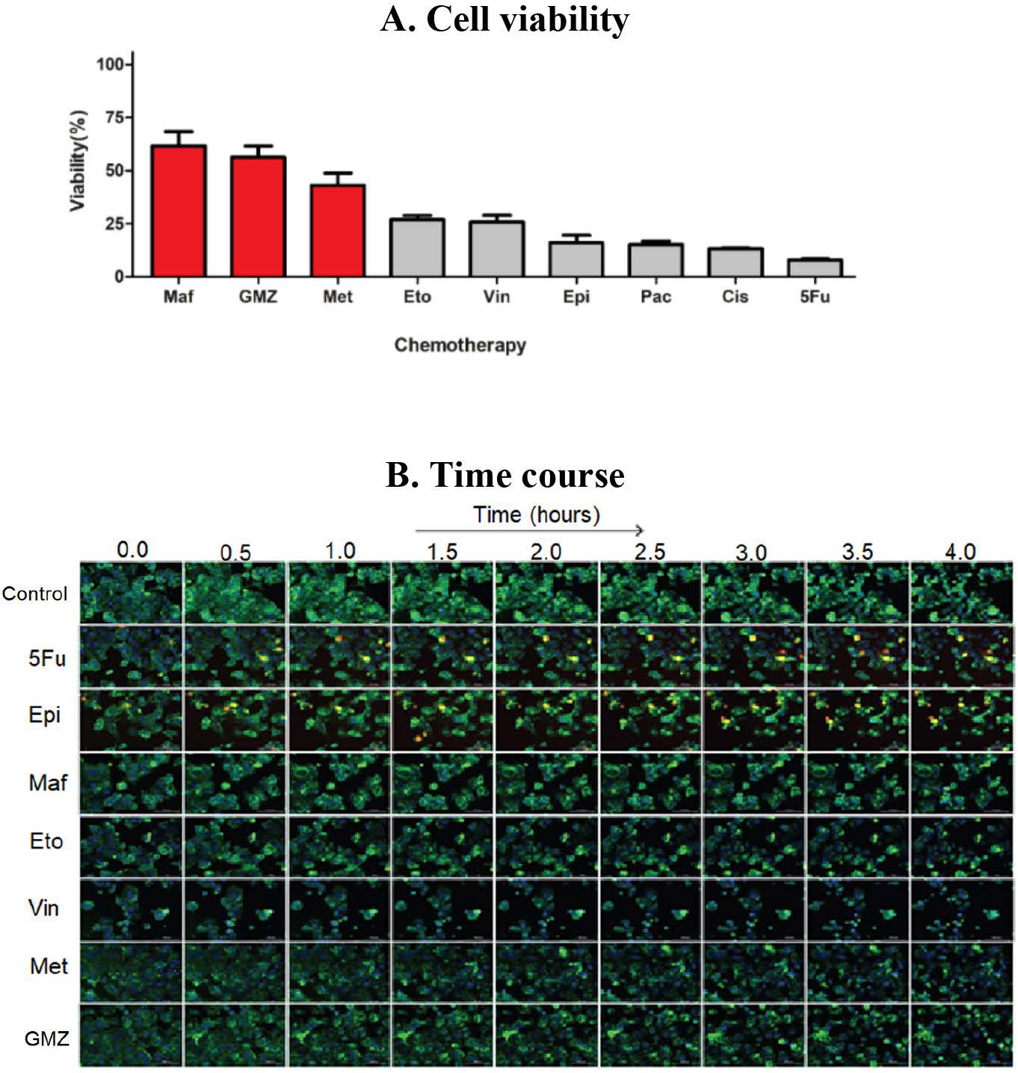[/graphic]
[label]Figure 1[/label]. [caption](A) Cell viability and (B) SM-BOD kinetics (after exposure to chemotherapies) of a breast cancer model of chemosensitivity/ chemoresistance as a proof of principle to evaluate a fluorescent sphingolipid analogue as predictor.[/caption][/figgrp]

[figgrp id="f2"][attrib]Note: derived from research.[/attrib]
[graphic href="?a44v36n1"]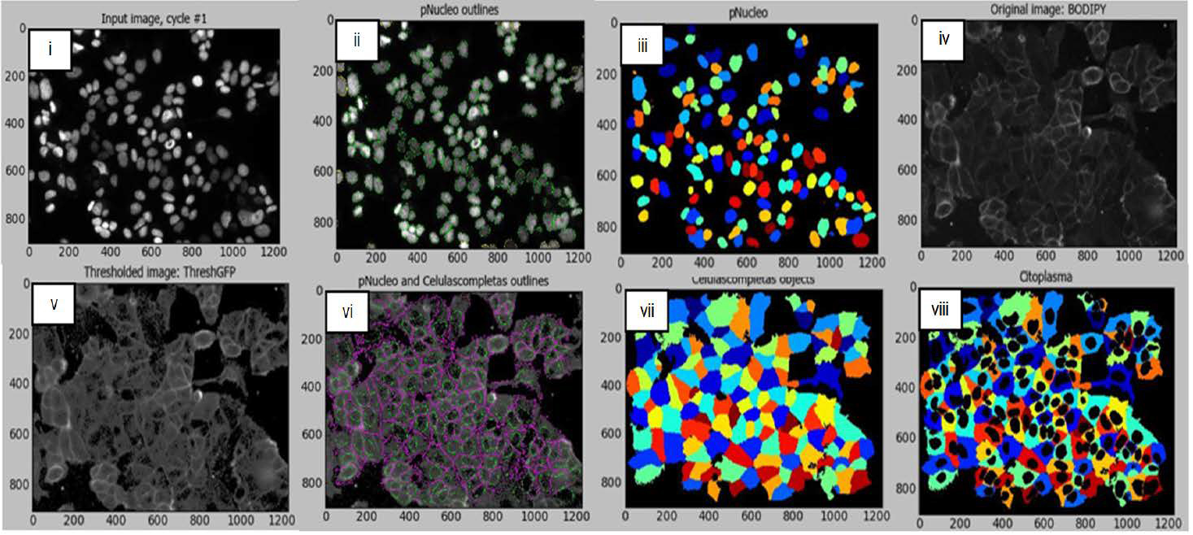[/graphic]
[label]Figure 2[/label]. [caption]Microscopy-based image analysis pipeline for the subcellular segmentation (nuclei/cytoplasm) with the breast cancer cell model.[/caption][/figgrp]

[/subsec][subsec][sectitle]2.4 Simulations and validation assays[/sectitle]

[p]For MCF-7 breast cancer and CCRFCEM leukemic cell lines, we compared the inferred SL composition of double perturbations including inhibitor/chemotherapy with the experimentally obtained cell viability for those treatments. The validation of the variations in SL composition was performed for the pancreatic cancer cell line using thin layer chromatography (TLC), in which cell lines were compared for the content of several SL included also as standard controls. See details in ([xref ref-type="bibr" rid="r21"]Lippert et al., 2008[/xref]).[/p]

[/subsec][/sec][sec sec-type="results"][sectitle]Analysis and results[/sectitle]

[p]Cell viability and SM-BOD kinetics: In order to identify the effect of different chemotherapies on cell fate of cancer cell lines, a viability assay was standardized.[/p]
[p]For pancreatic cancer, BxPC-3 cells were considerably impacted after 72h with a reduced viability (down to 30% compared to control conditions) with GMZ. Contrarily, a dose-dependent reduction in cell viability was determined for both PANC-1 and MIAPaCa-2 cells, which suggest that GMZ induces an important cytostatic effect on the resistant cell lines. The evaluation of the MCF-7 human breast cancer cell line showed resistance to 3 chemotherapeutic drugs (mafosfamide, gemcitabine and methotrexate) but was sensitive to the other treatments ([xref ref-type="fig" rid="f1"]Figure 1-A[/xref]). In addition, the CCRF-CEM leukemia cell line was sensitive to paclitaxel and vincristine, but this cell line was resistant to the remaining six chemotherapeutic agents.[/p]
[p]SM-BOD was added to cell lines to assess changes in cellular fluorescence (e.g. [xref ref-type="fig" rid="f1"]Figure 1[/xref]-B for the breast cancer cell line). Intensity and distribution features were obtained from the time-resolved images. We then implemented an image analysis protocol/pipeline in CellProfiler™ for the image segmentation of both breast cancer and leukemic cell lines (shown in [xref ref-type="fig" rid="f2"]Figure 2[/xref] for breast cancer cell line) in order to automate features extraction for each cell.[/p]
[p]Machine learning approaches: In order to identify how different dynamical fluorescence features of the SM-BOD can be associated to chemosensitivity, we evaluated a classification technique using C4.5 (J48) decision tree algorithm. For this, feature reduction was performed to select features associated to categories of resistant or sensitive ([xref ref-type="fig" rid="f3"]Figure 3[/xref]-A for breast cancer cell line). Temporal changes were evident (left) and reduction to 51 features enabled to classify cells with greater than 95% precision (tree not shown), but interestingly only three features could classify with a precision of 73% using the decision tree ([xref ref-type="fig" rid="f3"]Figure 3[/xref]-A right). For the CCRF-CEM leukemia cell line, a similar reduction was done from 401 to 41 features and again with greater than 95% precision (tree not shown).[/p]

[figgrp id="f3"][attrib]Note: derived from research.[/attrib]
[graphic href="?a44v36n1"]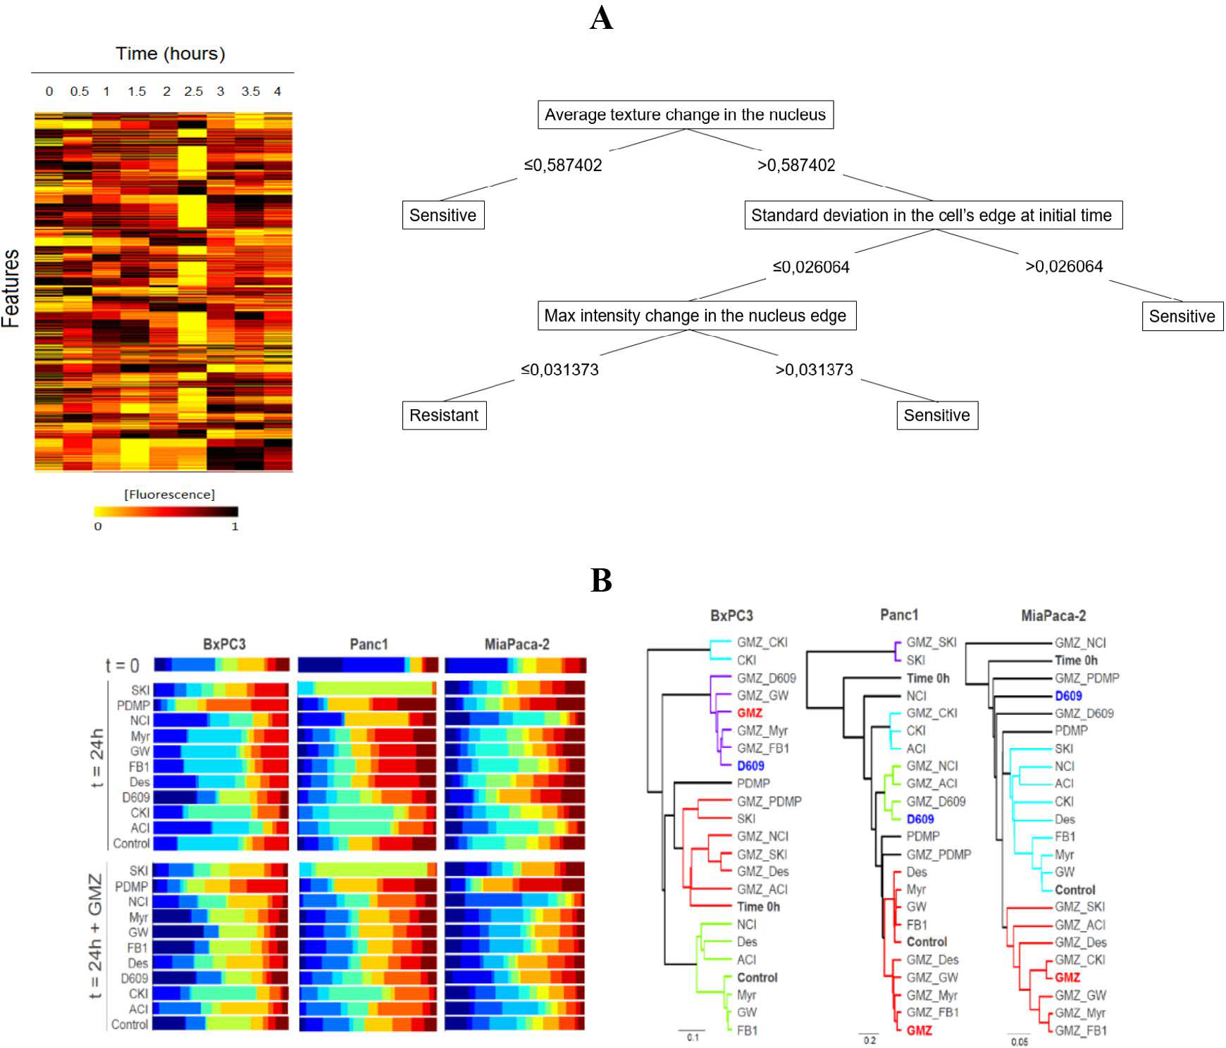[/graphic]
[label]Figure 3[/label]. [caption]The use of a fluorescent SL sensor enables population-based data mining to predict chemosensitivity and inference on how the chemotherapy perturbs the SLP. (A) Data of intensity/distribution features on the breast cancer model allows the construction of decision trees for the prediction of chemosensitivity. (B) Gaussian mixture modeling (GMM) of the population of pancreatic cancer cells leads to the inference on how gemcitabine (GMZ) perturbs the SLP by the similarity of the population-based heterogeneity profiles to known inhibitors of the SLP.[/caption][/figgrp]

[p]Furthermore, a GMM model was developed to predict the effect of chemotherapies on the SLP and to establish a heterogeneity profile for each perturbation as a fingerprint pattern (e.g. [xref ref-type="fig" rid="f3"]Figure 3-B [/xref]for pancreatic cancer). Finally, a clustering analysis was performed, using Euler distance and statistical significance of 0.05 for the evaluation of the similarities of such fingerprints. According to the GMM analysis, the GMZ sensitive pancreatic cancer cell line (BxPC-3) showed that D609 inhibitor and GMZ produced comparable heterogeneity profiles, which suggest that the modification upon the SLP of both treatments induce a similar response. For the breast cancer cell line, the GMM suggested pairs of clusters composed of chemotherapy/inhibitor between FEC/myriocin, methotrexate/myriocin, epirrubicin/PDMP, gemcitabin/SKI, vincristine/SKI, mafosfamide/NCI and finally EC/desipramine, suggesting a large number of chemotherapeutic drugs sensed in the SLP. In the case of the leukemic cell line, clusters obtained were FB-Tem, NCIMet, SKI-Pac, and D609-Doxorubicin (Doxo). All these relationships suggest that those respective paired perturbations were sensed similarly by the SLP.[/p]
[p]ODE-models: We built a SL metabolic pathway topology based on available data and literature. The model was fitted to imaging to estimate parameters and SL-composition per condition. For pancreatic cancer cell lines, the same network topology was established ([xref ref-type="fig" rid="f4"]Figure 4[/xref]-A); nonetheless, the SL profile was different for each cell model ([xref ref-type="fig" rid="f4"]Figure 4[/xref]-B). Similar results were obtained with leukemia and breast cancer cell lines.[/p]

[figgrp id="f4"][attrib]Note: derived from research.[/attrib]
[graphic href="?a44v36n1"]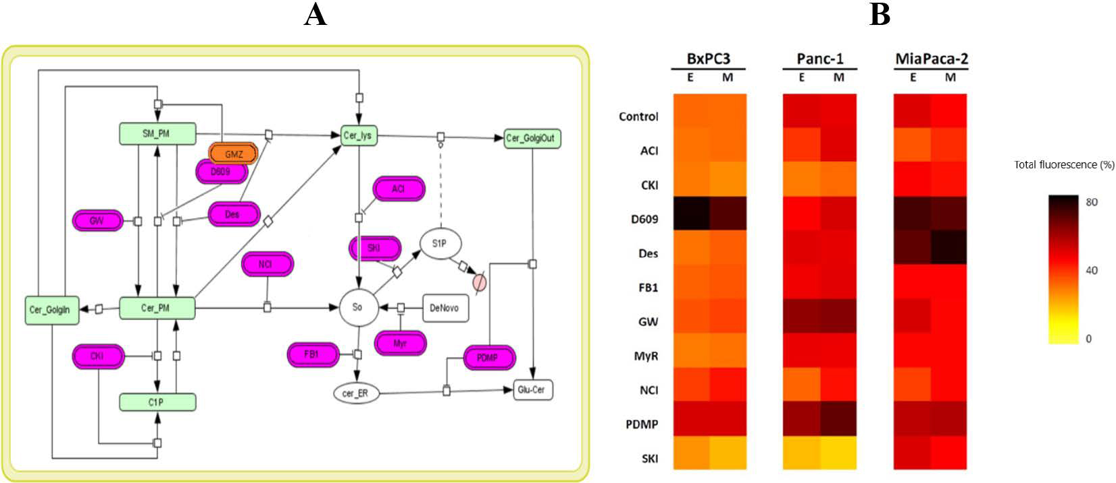[/graphic]
[label]Figure 4[/label]. [caption]The use of fluorescent SL sensor enables the construction of ordinary differential equation (ODE) models (topology in A) to estimate the rates of the reactions involved in the metabolism of this SL analogue and changes in the relative composition of SL species upon perturbations (B). E: experiment, M: model.[/caption][/figgrp]

[p]Hybrid model and experimental validation: The study of the fluorescent-SL composition allowed to validate the changes in fluorescence intensities between sensitive and resistant cells obtained from the SL-sensor metabolism upon chemotherapies.[/p]
[p]SL were inferred using the hybrid model with differential equations and the Gaussian model. For pancreatic cancer cell lines, prediction of the increment in ceramide (Cer) and glucosylceramide (Glu-Cer) content after exposure to GMZ was validated using TLC, as shown in [xref ref-type="fig" rid="f5"]Figure 5-A[/xref].[/p]
[p] In the next step we tested MCF7 and CCRF-CEM cell lines to evaluate the robustness of our approach with more chemotherapeutic drugs. For the MCF-7 breast cancer cell line, cell viability was experimentally obtained for single and double perturbations of inhibitor and chemotherapy. However, the cell lines were sensitive to the majority of the single perturbations. In order to have a better scenario for studying resistance, we developed another approach using the CCRF-CEM cell line, which showed resistance to 6 of the 8 evaluated chemotherapies.[/p]

[figgrp id="f5"][attrib]Note: derived from research.[/attrib]
[graphic href="?a44v36n1"]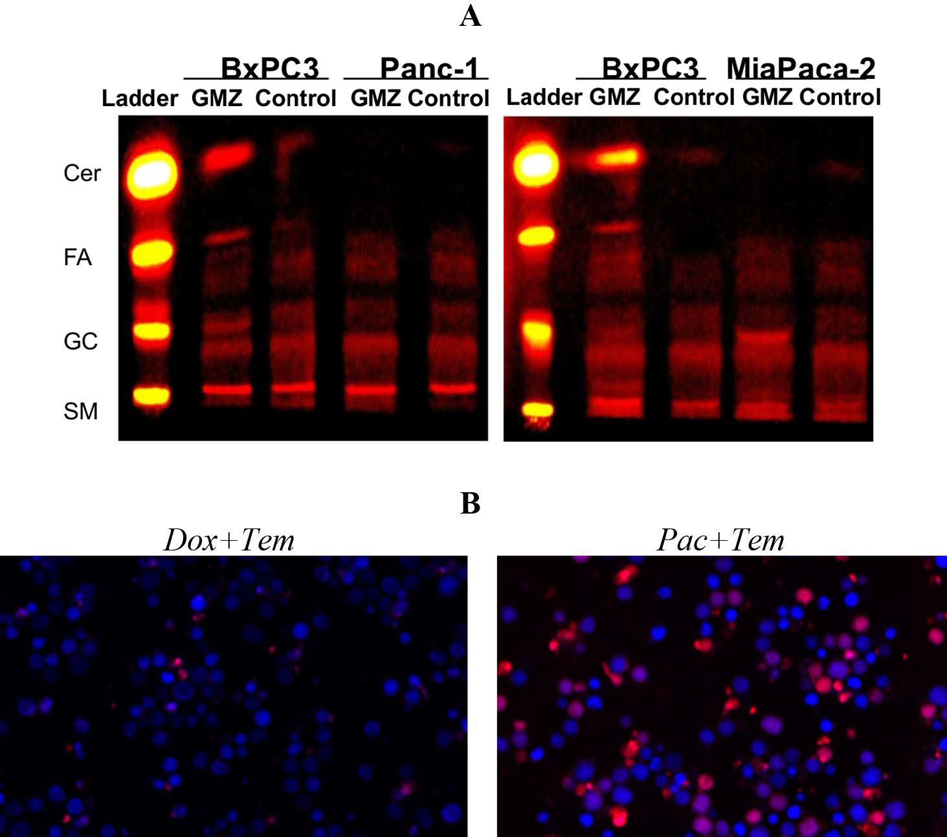[/graphic]
[label]Figure 5[/label]. [caption]Validation assays for the hybrid mathematical modeling approach of the SL sensor as predictor of chemosensitivity allows the formulation of experimentally-testable hypothesis. (A) Pancreatic cancer cell line using TLC, in which the prediction of changes in SL composition was validated. (B) Predictions of cell viability on a leukemia cell line after double chemotherapeutic treatments were validated experimentally.[/caption][/figgrp]

[p]Finally, the FLM was used to correlate SL composition to cell viability. Double perturbations were evaluated to predict cell viability (six combinations). Predictions showed an outstanding performance when results were compared to the experimental validation assay ([xref ref-type="fig" rid="f5"]Figure 5[/xref]-B). Taken together, these findings indicate that the fluorescent sphingolipid analogues can be used as biosensors of chemosensitivity to identify chemotherapeutic regimes overcoming drug resistance.[/p]

[/sec][sec sec-type="discussion"][sectitle]Discussion[/sectitle]

[p]Considering the highlight functions of the SLP in cell processes related to signaling, metabolism and cell death/survival, the use of SL sensors in cancer can be used to measure chemosensitivity ([xref ref-type="bibr" rid="r21"]Lippert et al., 2008[/xref]; Quirós-Fernandez, I; [xref ref-type="bibr" rid="r32"]Molina-Mora, JA, Kop-Monteo, M; Salas-Hidalgo. E; Mora-Rodriguez, 2018[/xref]). In this context, targeting of the SLP is a potential approach to overcome chemotherapy resistance ([xref ref-type="bibr" rid="r39"]Truman, García-Barros, Obeid & Hannun, 2014[/xref]; [xref ref-type="bibr" rid="r40"]Van Meer et al., 2003[/xref]). In this context, SM-BOD has been widely used in several reports to measure SL metabolism in cells ([xref ref-type="bibr" rid="r10"]Erlich et al., 1999[/xref]; [xref ref-type="bibr" rid="r28"]Mora et al., 2010[/xref]; [xref ref-type="bibr" rid="r36"]Solomonov et al., 2014[/xref]).[/p]
[p]Here we employed different experiments and mathematical models for describing the effects of chemotherapy on SLP and cell fate. We performed a perturbation-specific profile of cell heterogeneity for clustering the studied perturbations. GMM analysis led to discriminate different classes of perturbations based on possible relationships chemotherapy-inhibitor which can modulate the effects on the SLP ([xref ref-type="bibr" rid="r24"]Molina-Mora et al., 2018[/xref]; [xref ref-type="bibr" rid="r25"]Molina-Mora & Mora-Rodriguez, 2016[/xref]; [xref ref-type="bibr" rid="r35"]Slack, Martinez, Wu & Altschuler, 2008[/xref]). In the case of the pancreatic cancer cell lines, according to clustering analysis, the GMM indicates that gemcitabine and D609 have similar effects on the SLP. Clustering analysis of the breast cancer cell line data found 7 chemotherapies which were mapped to known perturbations in the SLP, meanwhile for the leukemic cell line, 4 chemotherapies were sensed in the SLP. All these relationships suggest that those chemotherapies perturb the SLP in a similar way. This is particularly important in cancer biology, since these results can identify specific responses to drugs, in part due to the heterogeneity.[/p]
[p]Remarkably, these results have not been reported before. Indeed, there are a limited amount of scientific studies related to how perturbations can affect SLP ([xref ref-type="bibr" rid="r4"]Bonhoure et al., 2006[/xref]; [xref ref-type="bibr" rid="r14"]Hannun & Obeid, 2008[/xref]; [xref ref-type="bibr" rid="r20"]Lacour et al., 2004[/xref]; [xref ref-type="bibr" rid="r23"]Machala et al., 2019[/xref]). This information indicates that the chemotherapy response is dependent on the cancer type (tumor or cell line) and specific analyses are required.[/p]
[p]Furthermore, some chemotherapies were not sensed in the SLP for neither breast cancer nor leukemia cell lines, which may not be related to any of the SL inhibitors ([xref ref-type="bibr" rid="r3"]Bensimon, Heck & Aebersold, 2012[/xref]).[/p]
[p]To describe the metabolism of SMBOD in cell lines, total fluorescence data of perturbations were used for fitting an ODE model on a systems biology approach. In this model, we assumed that the addition of SM-BOD promotes the internalization and remains mostly in the plasma membrane ([xref ref-type="bibr" rid="r18"]Koval & Pagano, 1991[/xref]). The transit of SM-BOD for each cell line is simulated with the mathematical approach. The model was built using ODEs and it describes the SL composition for each cell line, inhibitory perturbations and single or double perturbations with chemotherapeutic treatments.[/p]
[p]For pancreatic cancer cell lines, predictions of the mathematical model were validated by TLC, showing an increment in the ceramide content in the BxPC-3 sensitive cell line when exposed to gemcitabine. For the MCF-7 breast cancer cell line, double perturbations (inhibitor and chemotherapy) were tested. More chemotherapeutic treatments were included, and the SL composition was inferred by ODE/ GMM models. Different SL compositions were achieved for different chemosensitivity levels. To correlate the SL profile to cell viability and to infer rules, we implemented the FLM as is common for data analysis in biological studies ([xref ref-type="bibr" rid="r1"]Al Daoud & Al-Daoud, 2010[/xref]; [xref ref-type="bibr" rid="r5"]Bosl, 2007[/xref]; [xref ref-type="bibr" rid="r38"]Torshabi, Riboldi, Fooladi, Mosalla & Baroni, 2013[/xref]). Thus, the prediction of viability for double perturbations with chemotherapy were inferred from ODE/GMM/FLM models. A viability assay confirmed that the hybrid approach is able to predict cell viability when cells are exposed to double perturbations.[/p]
[p]The hybrid models inferred that different chemotherapies triggered different mechanisms of cellular stress on the SLP, and the subsequent signaling is responsible for a specific SL balance which finally decides cell fate, as has been previously demonstrated by others ([xref ref-type="bibr" rid="r6"]Chai et al., 2011[/xref]; [xref ref-type="bibr" rid="r26"]Molino, Tate, McKillop & Medin, 2017[/xref]; [xref ref-type="bibr" rid="r37"]Tepper et al., 2000[/xref]).[/p]

[/sec][sec sec-type="conclusions"][sectitle]Conclusions[/sectitle]

[p]Taking all together, our complex approach to study SL using SM-BOD was able to recognize particular features in cells, which can be useful to study cancer. As it was demonstrated, the balance in the SLP can be used as a biosensor of cancer chemosensitivity. This proof of principle was demonstrated using not only different experimental data derived from fluorescence microscopy, imaging and mathematical modeling, but also including an experimental validation (TLC and cell viability assays). At the clinical setting, these findings are interesting because they can be potentially implemented in personalized strategies to model chemosensitivity and to enhance therapeutic decisions in benefit of the patients. Further analyses are required to make this possible, but the results presented here pave the way for a translational research on SL-based chemosensitivy in cancer patients.[/p]

[subsec][sectitle]Conflict of interest[/sectitle]

[p]The authors declare no competing interests.[/p]

[/subsec][subsec][sectitle]Author contribution statement[/sectitle]

[p]All the authors declare that the final version of this paper was read and approved. The total contribution percentage for the conceptualization, preparation, and correction of this paper was as follows: J.A.M.M 30%., S.M.P. 10%, I.Q.F. 10%, M.K.F. 5%, A.R.C. 5%, S.Q.5 %, F.S. 5% and R.M. 30%.[/p]

[/subsec][subsec][sectitle]Data availability statement[/sectitle]

[p]The data supporting the results of this study will be made available by the corresponding author, R.M., upon reasonable request.[/p][/subsec][/sec][/xmlbody]

[refs][sectitle]References[/sectitle]

[ref id="r1" reftype=“journal"][authors role="nd"][pauthor][surname]Al Daoud[/surname], [fname]E.[/fname][/pauthor], & [pauthor][surname]Al-Daoud[/surname], [fname]E.[/fname][/pauthor] [/authors]([date dateiso="20100000" specyear="2010"]2010[/date]). [arttitle]Cancer Diagnosis Using Modified Fuzzy Network. [/arttitle][source]Universal Journal of Computer Science and Engineering Technology[/source], [volid]1[/volid]([issueno]2[/issueno]), [pages]73-78[/pages]. [url]https://www.researchgate.net/publication/49582994[/url][/ref]
[ref id="r2" reftype=“journal"][authors role="nd"][pauthor][surname]Barteneva[/surname], [fname]N. S.[/fname][/pauthor]; [pauthor][surname]Fasler-Kan[/surname], [fname]E.[/fname][/pauthor]; & [pauthor][surname]Vorobjev[/surname], [fname]I. A.[/fname][/pauthor][/authors] ([date dateiso="20120000" specyear="2012"]2012[/date]). [arttitle]Imaging flow cytometry: coping with heterogeneity in biological systems.[/arttitle] [source]The Journal of Histochemistry and Cytochemistry: Official Journal of the Histochemistry Society[/source], [volid]60[/volid]([issueno]10[/issueno]), [pages]723-733[/pages]. https://doi.org/[pubid idtype="doi"]10.1369/0022155412453052[/pubid][/ref]
[ref id="r3" reftype=“journal"][authors role="nd"][pauthor][surname]Bensimon[/surname], [fname]A.[/fname][/pauthor], [pauthor][surname]Heck[/surname], [fname]A. J. R.[/fname][/pauthor], & [pauthor][surname]Aebersold[/surname], [fname]R.[/fname][/pauthor][/authors] ([date dateiso="20120000" specyear="2012"]2012[/date]). [arttitle]Mass spectrometry-based proteomics and network biology.[/arttitle] [source]Annual Review of Biochemistry[/source], [volid]81[/volid], [pages]379-405[/pages]. https://doi.org/[pubid idtype="doi"]10.1146/annurev-biochem-072909-100424[/pubid][/ref]
[ref id="r4" reftype=“journal"][authors role="nd"][pauthor][surname]Bonhoure[/surname], [fname]E.[/fname][/pauthor]; [pauthor][surname]Pchejetski[/surname], [fname]D.[/fname][/pauthor]; [pauthor][surname]Aouali[/surname], [fname]N.[/fname][/pauthor]; [pauthor][surname]Morjani[/surname], [fname]H.[/fname][/pauthor]; [pauthor][surname]Levade[/surname], [fname]T.[/fname][/pauthor]; [pauthor][surname]Kohama[/surname], [fname]T.[/fname][/pauthor]; & [pauthor][surname]Cuvillier[/surname], [fname]O.[/fname][/pauthor][/authors] ([date dateiso="20060000" specyear="2006"]2006[/date]). [arttitle]Overcoming MDR-associated chemoresistance in HL-60 acute myeloid leukemia cells by targeting sphingosine kinase-1. [/arttitle][source]Leukemia[/source], [volid]20[/volid]([issueno]1[/issueno]), [pages]95-102[/pages]. https://doi. org/[pubid idtype="doi"]10.1038/sj.leu.2404023[/pubid][/ref]
[ref id="r5" reftype=“journal"][authors role="nd"][pauthor][surname]Bosl[/surname], [fname]W. J.[/fname][/pauthor][/authors] ([date dateiso="20070000" specyear="2007"]2007[/date]). [arttitle]Systems biology by the rules: hybrid intelligent systems for pathway modeling and discovery.[/arttitle] [source]BMC Systems Biology[/source], [volid]1[/volid], [pages]13[/pages]. https://doi.org/[pubid idtype="doi"]10.1186/1752-0509-1-13[/pubid][/ref]
[ref id="r6" reftype=“journal"][authors role="nd"][pauthor][surname]Chai[/surname], [fname]L.[/fname][/pauthor]; [pauthor][surname]McLaren[/surname], [fname]R. P.[/fname][/pauthor]; [pauthor][surname]Byrne[/surname], [fname]A.[/fname][/pauthor]; [pauthor][surname]Chuang[/surname], [fname]W. L.[/fname][/pauthor]; [pauthor][surname]Huang[/surname], [fname]Y.[/fname][/pauthor]; [pauthor][surname]Dufault[/surname], [fname]M. R.[/fname][/pauthor]; [pauthor][surname]Jiang[/surname], [fname]Y. A.[/fname][/pauthor][/authors] ([date dateiso="20110000" specyear="2011"]2011[/date]). [arttitle]The chemosensitizing activity of inhibitors of glucosylceramide synthase is mediated primarily through modulation of P-gp function.[/arttitle] [source]International Journal of Oncology[/source], [volid]38[/volid]([issueno]3[/issueno]), [pages]701-711[/pages]. https://doi.org/[pubid idtype="doi"]10.3892/ijo.2010.888[/pubid][/ref]
[ref id="r7" reftype=“journal"][authors role="nd"][pauthor][fname]Chuan[/fname] [surname]Yang[/surname][/pauthor]; [pauthor][fname]Caibo[/fname] [surname]Yang[/surname][/pauthor]; [pauthor][fname]Yosef[/fname] [surname]Yarden[/surname][/pauthor]; [pauthor][surname]K.W.To[/surname], [fname]K.[/fname][/pauthor] & [pauthor][fname]Liwu[/fname] [surname]Fu.[/surname][/pauthor][/authors] ([date dateiso="20210000" specyear="2021"]2021[/date]). [arttitle]The prospects of tumor chemosensitivity testing at the single-cell level. [/arttitle][source]Drug Resistance Updates[/source], [volid]54[/volid]. https://doi.org/[pubid idtype="doi"]10.1016/j.drup.2020.100741[/pubid][/ref]
[ref id="r8" reftype=“journal"][authors role="nd"][pauthor][surname]Dupre[/surname], [fname]T. V.[/fname][/pauthor]; [pauthor][surname]Doll[/surname], [fname]M. A.[/fname][/pauthor]; [pauthor][surname]Shah[/surname], [fname]P. P.[/fname][/pauthor]; [pauthor][surname]Sharp[/surname], [fname]C. N.[/fname][/pauthor]; [pauthor][surname]Siow[/surname], [fname]D.[/fname][/pauthor]; [pauthor][surname]Megyesi[/surname], [fname]J.[/fname][/pauthor]; [pauthor][surname]Siskind[/surname], [fname]L. J.[/fname][/pauthor][/authors] ([date dateiso="20170000" specyear="2017"]2017[/date]). [arttitle]Inhibiting glucosylceramide synthase exacerbates cisplatin-induced acute kidney injury.[/arttitle] [source]Journal of Lipid Research[/source], [volid]58[/volid]([issueno]7[/issueno]), [pages]1439-1452[/pages]. https://doi.org/[pubid idtype="doi"]10.1194/jlr.M076745[/pubid][/ref]
[ref id="r9" reftype=“journal"][authors role="nd"][pauthor][surname]Dyatlovitskaya[/surname], [fname]E. V.[/fname][/pauthor]; [pauthor][surname]Kandyba[/surname], [fname]A. G.[/fname][/pauthor]; [pauthor][surname]Kozlov[/surname], [fname]A. M.[/fname][/pauthor]; & [pauthor][surname]Somova[/surname], [fname]O. G.[/fname][/pauthor][/authors] ([date dateiso="20010000" specyear="2001"]2001[/date]). [arttitle]Sphinganine in sphingomyelins of tumors and mouse regenerating liver.[/arttitle] [source]Biochemistry (Moscow)[/source], [volid]66[/volid]([issueno]5[/issueno]), [pages]502-504[/pages]. https://doi.org/[pubid idtype="doi"]10.1023/A:1010250600604[/pubid][/ref]
[ref id="r10" reftype=“journal"][authors role="nd"][pauthor][surname]Erlich[/surname], [fname]S.[/fname][/pauthor]; [pauthor][surname]Miranda[/surname], [fname]S. R.[/fname][/pauthor]; [pauthor][surname]Visser[/surname], [fname]J. W.[/fname][/pauthor]; [pauthor][surname]Dagan[/surname], [fname]A.[/fname][/pauthor]; [pauthor][surname]Gatt[/surname], [fname]S.[/fname][/pauthor]; & [pauthor][surname]Schuchman[/surname], [fname]E. H.[/fname][/pauthor][/authors] ([date dateiso="19990000" specyear="1999"]1999[/date]). [arttitle]Fluorescence-based selection of gene-corrected hematopoietic stem and progenitor cells from acid sphingomyelinase-deficient mice: implications for Niemann-Pick disease gene therapy and the development of improved stem cell gene transfer procedures. [/arttitle][source]Blood[/source], [volid]93[/volid]([issueno]1[/issueno]), [pages]80-86[/pages]. https://doi.org/[pubid idtype="doi"]10.1182/blood.v93.1.80[/pubid][/ref]
[ref id="r11" reftype=“journal"][authors role="nd"][pauthor][surname]Fernandis[/surname], [fname]A. Z.[/fname][/pauthor], & [pauthor][surname]Wenk[/surname], [fname]M. R.[/fname][/pauthor] [/authors]([date dateiso="20090000" specyear="2009"]2009[/date]). [arttitle]Lipid-based biomarkers for cancer. [/arttitle][source]Journal of Chromatography B[/source], [volid]877[/volid]([issueno]26[/issueno]), [pages]2830-2835[/pages]. https://doi.org/[pubid idtype="doi"]10.1016/j.jchromb.2009.06.015[/pubid][/ref]
[ref id="r12" reftype="book"][authors role="nd"][pauthor][surname]Glaysher[/surname], [fname]S.[/fname][/pauthor], & [pauthor][surname]Cree[/surname], [fname]I. A.[/fname][/pauthor] [/authors]([date dateiso="20110000" specyear="2011"]2011[/date]). [chptitle]Cell Sensitivity Assays: The ATP-based Tumor Chemosensitivity Assay.[/chptitle] In [source]Methods in molecular biology [/source]([publoc]Clifton, N.J[/publoc].), [volid]731[/volid], [pages]247-257[/pages]. https://doi.org/[pubid idtype="doi"]10.1007/978-1-61779-080-5_21[/pubid][/ref]
[ref id="r13" reftype=“journal"][authors role="nd"][pauthor][surname]Guillermet-Guibert[/surname], [fname]J.[/fname][/pauthor]; [pauthor][surname]Davenne[/surname], [fname]L.[/fname][/pauthor]; [pauthor][surname]Pchejetski[/surname], [fname]D.[/fname][/pauthor]; [pauthor][surname]Saint-Laurent[/surname], [fname]N.[/fname][/pauthor]; [pauthor][surname]Brizuela[/surname], [fname]L.[/fname][/pauthor]; [pauthor][surname]Guilbeau-Frugier[/surname], [fname]C.[/fname], Bousquet, C.[/pauthor][/authors] ([date dateiso="20090000" specyear="2009"]2009[/date]). [arttitle]Targeting the sphingolipid metabolism to defeat pancreatic cancer cell resistance to the chemotherapeutic gemcitabine drug.[/arttitle] [source]Molecular Cancer Therapeutics[/source], [volid]8[/volid]([issueno]4[/issueno]), [pages]809-820[/pages]. https://doi.org/[pubid idtype="doi"]10.1158/1535-7163.MCT-08-1096[/pubid][/ref]
[ref id="r14" reftype=“journal"][authors role="nd"][pauthor][surname]Hannun[/surname], [fname]Y. A.[/fname][/pauthor], & [pauthor][surname]Obeid[/surname], [fname]L. M.[/fname][/pauthor] [/authors]([date dateiso="20080000" specyear="2008"]2008[/date]). [arttitle]Principles of bioactive lipid signalling: Lessons from sphingolipids.[/arttitle] [source]Nature Reviews Molecular Cell Biology[/source], [volid]9[/volid]([issueno]2[/issueno]), [pages]139-150[/pages]. https://doi.org/[pubid idtype="doi"]10.1038/nrm2329[/pubid][/ref]
[ref id="r15" reftype=“journal"][authors role="nd"][pauthor][surname]Iessi[/surname], [fname]E.[/fname][/pauthor]; [pauthor][surname]Marconi[/surname], [fname]M.[/fname][/pauthor]; [pauthor][surname]Manganelli[/surname], [fname]V.[/fname][/pauthor]; [pauthor][surname]Sorice[/surname], [fname]M.[/fname][/pauthor]; [pauthor][surname]Malorni[/surname], [fname]W.[/fname][/pauthor]; [pauthor][surname]Garofalo[/surname], [fname]T.[/fname][/pauthor]; & [pauthor][surname]Matarrese[/surname], [fname]P.[/fname][/pauthor][/authors] ([date dateiso="20200000" specyear="2020"]2020[/date]). [arttitle]On the role of sphingolipids in cell survival and death. [/arttitle]In [source]International Review of Cell and Molecular Biology[/source] [volid]1[/volid]([issueno]351[/issueno]). https://doi.org/[pubid idtype="doi"]10.1016/bs.ircmb.2020.02.004[/pubid][/ref]
[ref id="r16" reftype=“journal"][authors role="nd"][pauthor][surname]Kenchegowda[/surname], [fname]M.[/fname][/pauthor]; [pauthor][surname]Rahamathulla[/surname], [fname]M.[/fname][/pauthor]; [pauthor][surname]Hani[/surname], [fname]U.[/fname][/pauthor]; [pauthor][surname]Begum[/surname], [fname]M. Y.[/fname][/pauthor]; [pauthor][surname]Guruswamy[/surname], [fname]S.[/fname][/pauthor]; [pauthor][surname]Osmani[/surname], [fname]R. A. M.[/fname][/pauthor]; [pauthor][surname]Gowda[/surname], [fname]D. V.[/fname][/pauthor][/authors] ([date dateiso="20220000" specyear="2022"]2022[/date]). [arttitle]Smart Nanocarriers as an Emerging Platform for Cancer Therapy: A Review. [/arttitle][source]Molecules[/source], [volid]27[/volid]([issueno]1[/issueno]). https://doi.org/[pubid idtype="doi"]10.3390/molecules27010146[/pubid][/ref]
[ref id="r17" reftype=“journal"][authors role="nd"][pauthor][surname]Kitano[/surname], [fname]H.[/fname][/pauthor] [/authors]([date dateiso="20040000" specyear="2004"]2004[/date]). [arttitle]Cáncer as a robust system: Implications for anticancer therapy. [/arttitle][source]Nature Reviews Cáncer[/source], [volid]4[/volid]([issueno]3[/issueno]), [pages]227-235[/pages]. https://doi.org/[pubid idtype="doi"]10.1038/nrc1300[/pubid][/ref]
[ref id="r18" reftype=“journal"][authors role="nd"][pauthor][surname]Koval[/surname], [fname]M.[/fname][/pauthor], & [pauthor][surname]Pagano[/surname], [fname]R. E.[/fname][/pauthor][/authors] ([date dateiso="19910000" specyear="1991"]1991[/date]). [arttitle]Intracellular transport and metabolism of sphingomyelin.[/arttitle] [source]Biochimica et Biophysica Acta[/source], [volid]1082[/volid]([issueno]2[/issueno]), [pages]113-125[/pages]. https://doi.org/[pubid idtype="doi"]10.1016/0005-2760(91)90184-j[/pubid][/ref]
[ref id="r19" reftype=“journal"][authors role="nd"][pauthor][surname]Kroll[/surname], [fname]A.[/fname][/pauthor]; [pauthor][surname]Cho[/surname], [fname]H. E.[/fname][/pauthor]; & [pauthor][surname]Kang[/surname], [fname]M. H.[/fname][/pauthor][/authors] ([date dateiso="20200000" specyear="2020"]2020[/date]). [arttitle]Antineoplastic Agents Targeting Sphingolipid Pathways.[/arttitle] [source]Frontiers in Oncology[/source], [volid]10[/volid], [pages]833[/pages]. https://doi.org/[pubid idtype="doi"]10.3389/fonc.2020.00833[/pubid][/ref]
[ref id="r20" reftype=“journal"][authors role="nd"][pauthor][surname]Lacour[/surname], [fname]S.[/fname][/pauthor]; [pauthor][surname]Hammann[/surname], [fname]A.[/fname][/pauthor]; [pauthor][surname]Grazide[/surname], [fname]S.[/fname][/pauthor]; [pauthor][surname]Lagadic-Gossmann[/surname], [fname]D.[/fname][/pauthor]; [pauthor][surname]Athias[/surname], [fname]A.[/fname][/pauthor]; [pauthor][surname]Sergent[/surname], [fname]O.[/fname][/pauthor]; [pauthor][surname]Dimanche-Boitrel[/surname], [fname]M. T.[/fname][/pauthor][/authors] ([date dateiso="20040000" specyear="2004"]2004[/date]). [arttitle]Cisplatin-induced CD95 redistribution into membrane lipid rafts of HT29 human colon cancer cells.[/arttitle] [source]Cancer Research[/source], [volid]64[/volid]([issueno]10[/issueno]), [pages]3593-3598[/pages]. https://doi.org/[pubid idtype="doi"]10.1158/0008-5472.CAN-03-2787[/pubid][/ref]
[ref id="r21" reftype=“journal"][authors role="nd"][pauthor][surname]Lippert[/surname], [fname]T. H.[/fname][/pauthor], [pauthor][surname]Ruoff[/surname], [fname]H. J.[/fname][/pauthor], & [pauthor][surname]Volm[/surname], [fname]M.[/fname][/pauthor] [/authors]([date dateiso="20080000" specyear="2008"]2008[/date]). [arttitle]Intrinsic and acquired drug resistance in malignant tumors.[/arttitle] [source]The main reason for therapeutic failure[/source]. [pubname]Arzneimittel-Forschung[/pubname], [volid]58[/volid]([issueno]6[/issueno]), [pages]261-264[/pages]. https://doi.org/[pubid idtype="doi"]10.1055/s-0031-1296504[/pubid][/ref]
[ref id="r22" reftype=“journal"][authors role="nd"][pauthor][surname]Lukow[/surname], [fname]D. A.[/fname][/pauthor], & [pauthor][surname]Sheltzer[/surname], [fname]J. M.[/fname][/pauthor] [/authors]([date dateiso="20210000" specyear="2021"]2021[/date]). [arttitle]Chromosomal instability and aneuploidy as causes of cancer drug resistance.[/arttitle] [source]Trends in Cancer[/source], [volid]8[/volid]([issueno]1[/issueno]), [pages]43-53[/pages]. https://doi.org/[pubid idtype="doi"]10.1016/j.trecan.2021.09.002[/pubid][/ref]
[ref id="r23" reftype=“journal"][authors role="nd"][pauthor][surname]Machala[/surname], [fname]M.[/fname][/pauthor]; [pauthor][surname]Procházková[/surname], [fname]J.[/fname][/pauthor]; [pauthor][surname]Hofmanová[/surname], [fname]J.[/fname][/pauthor]; [pauthor][surname]Králiková[/surname], [fname]L.[/fname][/pauthor]; [pauthor][surname]Slavík[/surname], [fname]J.[/fname][/pauthor]; [pauthor][surname]Tylichová[/surname], [fname]Z.[/fname][/pauthor]; [pauthor][surname]Vondráček[/surname], [fname]J.[/fname][/pauthor][/authors] ([date dateiso="20190000" specyear="2019"]2019[/date]). [arttitle]Colon cancer and perturbations of the sphingolipid metabolism.[/arttitle] [source]International Journal of Molecular Sciences[/source], [volid]20[/volid]([issueno]23[/issueno]). https://doi.org/[pubid idtype="doi"]10.3390/ijms20236051[/pubid][/ref]
[ref id="r24" reftype=“journal"][authors role="nd"][pauthor][surname]Molina-Mora[/surname], [fname]J. A.[/fname][/pauthor]; [pauthor][surname]Kop-Montero[/surname], [fname]M.[/fname][/pauthor]; [pauthor][surname]Quirós-Fernández[/surname], [fname]I.[/fname][/pauthor]; [pauthor][surname]Quirós[/surname], [fname]S.[/fname][/pauthor]; [pauthor][surname]Crespo-Mariño[/surname], [fname]J. L.[/fname][/pauthor] & [pauthor][surname]Mora-Rodríguez[/surname], [fname]R. A.[/fname][/pauthor][/authors] ([date dateiso="20180000" specyear="2018"]2018[/date]). [arttitle]A hybrid mathematical modeling approach of the metabolic fate of a fluorescent sphingolipid analogue to predict cancer chemosensitivity. [/arttitle][source]Computers in Biology and Medicine[/source], [volid]97[/volid](April), [pages]8-20[/pages]. https://doi.org/[pubid idtype="doi"]10.1016/j.compbiomed.2018.04.008[/pubid][/ref]
[ref id="r25" reftype=“confproc"][authors role="nd"][pauthor][surname]Molina-Mora[/surname], [fname]J. A.[/fname][/pauthor], & [pauthor][surname]Mora-Rodríguez[/surname], [fname]R. A.[/fname][/pauthor] [/authors]([date dateiso="20160000" specyear="2016"]2016[/date]). [source]Identification of cancer chemosensitivity by ODE and GMM modeling of heterogeneous cellular response to perturbations in fluorescent sphingolipid metabolism. 2016[/source], [confgrp][confname]IEEE 36th Central American and Panama Convention[/confname], [sponsor]CONCAPAN 2016[/sponsor][/confgrp]. https://doi. org/[pubid idtype="doi"]10.1109/CONCAPAN.2016.7942347[/pubid][/ref]
[ref id="r26" reftype=“journal"][authors role="nd"][pauthor][surname]Molino[/surname], [fname]S.[/fname][/pauthor]; [pauthor][surname]Tate[/surname], [fname]E.[/fname][/pauthor]; [pauthor][surname]McKillop[/surname], [fname]W.[/fname][/pauthor]; & [pauthor][surname]Medin[/surname], [fname]J. A.[/fname][/pauthor][/authors] ([date dateiso="20170000" specyear="2017"]2017[/date]). [arttitle]Sphingolipid pathway enzymes modulate cell fate and immune responses.[/arttitle] [source]Immunotherapy[/source], [volid]9[/volid]([issueno]14[/issueno]), [pages]1185-1198[/pages]. https://doi. org/[pubid idtype="doi"]10.2217/imt-2017-0089[/pubid][/ref]
[ref id="r27" reftype=“confproc"][authors role="nd"][pauthor][surname]Mora-Rodríguez[/surname], [fname]R. A.[/fname][/pauthor]; & [pauthor][surname]Molina-Mora[/surname], [fname]J. A.[/fname][/pauthor][/authors] ([date dateiso="20170000" specyear="2017"]2017[/date]). [source]Characterization of heterogeneous response to chemotherapy by perturbation-based modeling of fluorescent sphingolipid metabolism in cancer cell subpopulations.[/source] [confgrp][date dateiso="20160000" specyear="2016"]2016 [/date][confname]IEEE 36th Central American and Panama Convention[/confname], [sponsor]CONCAPAN 2016[/sponsor]. [/confgrp]https://doi.org/[pubid idtype="doi"]10.1109/CONCAPAN.2016.7942346[/pubid][/ref]
[ref id="r28" reftype=“journal"][authors role="nd"][pauthor][surname]Mora[/surname], [fname]R.[/fname][/pauthor]; [pauthor][surname]Dokic[/surname], [fname]I.[/fname][/pauthor]; [pauthor][surname]Kees[/surname], [fname]T.[/fname][/pauthor]; [pauthor][surname]Hüber[/surname], [fname]C. M.[/fname][/pauthor]; [pauthor][surname]Keitel[/surname], [fname]D.[/fname][/pauthor]; [pauthor][surname]Geibig[/surname], [fname]R.[/fname][/pauthor]; [pauthor][surname]Régnier-Vigouroux[/surname], [fname]A.[/fname][/pauthor] [/authors]([date dateiso="20100000" specyear="2010"]2010[/date]). [arttitle]Sphingolipid rheostat alterations related to transformation can be exploited for specific induction of lysosomal cell death in murine and human glioma. [/arttitle][source]Glia[/source], [volid]58[/volid]([issueno]11[/issueno]), [pages]1364-1383[/pages]. https://doi.org/[pubid idtype="doi"]10.1002/glia.21013[/pubid][/ref]
[ref id="r29" reftype="book"][authors role="nd"][pauthor][surname]Morales[/surname], [fname]A.[/fname][/pauthor]; [pauthor][surname]Lee[/surname], [fname]H.[/fname][/pauthor]; [pauthor][surname]Goñi[/surname], [fname]F. M.[/fname][/pauthor]; [pauthor][surname]Kolesnick[/surname], [fname]R.[/fname][/pauthor]; & [pauthor][surname]Fernández-Checa[/surname], [fname]J. C.[/fname][/pauthor][/authors] ([date dateiso="20070000" specyear="2007"]2007[/date]). [source]Sphingolipids and cell death[/source]. [pubname]Apoptosis[/pubname], [volid]12[/volid]([issueno]5[/issueno]), [pages]923-939[/pages]. https://doi.org/[pubid idtype="doi"]10.1007/s10495-007-0721-0[/pubid][/ref]
[ref id="r30" reftype=“journal"][authors role="nd"][pauthor][surname]Ogretmen[/surname], [fname]B.[/fname][/pauthor] [/authors]([date dateiso="20060000" specyear="2006"]2006[/date]). [arttitle]Sphingolipids in cancer: Regulation of pathogenesis and therapy.[/arttitle] [source]FEBS Letters[/source], [volid]580[/volid]([issueno]23[/issueno]), [pages]5467-5476[/pages]. https://doi.org/[pubid idtype="doi"]10.1016/j.febslet.2006.08.052[/pubid][/ref]
[ref id="r31" reftype=“journal"][authors role="nd"][pauthor][surname]Ogretmen[/surname], [fname]B.[/fname][/pauthor] [/authors]([date dateiso="20170000" specyear="2017"]2017[/date]). [arttitle]Sphingolipid metabolism in cancer signalling and therapy.[/arttitle] [source]Nature Reviews Cancer[/source], [volid]18[/volid]([issueno]1[/issueno]), [pages]33-50[/pages]. https://doi.org/[pubid idtype="doi"]10.1038/nrc.2017.96[/pubid][/ref]
[ref id="r32" reftype="confproc"][authors role="nd"][pauthor][surname]Quirós-Fernández[/surname], [fname]I.[/fname][/pauthor], [pauthor][surname]Molina-Mora[/surname], [fname]J. A.[/fname][/pauthor], [pauthor][surname]Kop-Monteo[/surname], [fname]M.[/fname][/pauthor], [pauthor][surname]Salas-Hidalgo[/surname], [fname]E.[/fname][/pauthor]; & [pauthor][surname]Mora-Rodríguez[/surname], [fname]R.[/fname] [/pauthor][/authors]([date dateiso="20180000" specyear="2018"]2018[/date]). [source]Predicting cancer chemosensitivity based on intensity/distribution profiles of cells loaded with a fluorescent sphingolipid analogue. [/source][confgrp][date dateiso="20180000" specyear="2018"]2018 [/date][confname]IEEE International Work Conference on Bioinspired Intelligence (IWOBI)[/confname][/confgrp], [pages]1-8[/pages]. https://doi.org/[pubid idtype="doi"]10.1109/iwobi.2018.8464199[/pubid][/ref]
[ref id="r33" reftype=“journal"][authors role="nd"][pauthor][surname]Singh[/surname], [fname]D. K.[/fname][/pauthor]; [pauthor][surname]Ku[/surname], [fname]C. J.[/fname][/pauthor]; [pauthor][surname]Wichaidit[/surname], [fname]C.[/fname][/pauthor]; [pauthor][surname]Steininger[/surname], [fname]R. J.[/fname][/pauthor]; [pauthor][surname]Wu[/surname], [fname]L. F.[/fname][/pauthor]; & [pauthor][surname]Altschuler[/surname], [fname]S. J.[/fname][/pauthor][/authors] ([date dateiso="20100000" specyear="2010"]2010[/date]). [arttitle]Patterns of basal signaling heterogeneity can distinguish cellular populations with different drug sensitivities. [/arttitle][source]Molecular Systems Biology[/source], [volid]6[/volid]([issueno]369[/issueno]), [pages]1-10[/pages]. https://doi.org/[pubid idtype="doi"]10.1038/msb.2010.22[/pubid][/ref]
[ref id="r34" reftype=“journal"][authors role="nd"][pauthor][surname]Singh[/surname], [fname]R. D.[/fname][/pauthor]; [pauthor][surname]Marks[/surname], [fname]D. L.[/fname][/pauthor]; & [pauthor][surname]Pagano[/surname], [fname]R. E.[/fname][/pauthor][/authors] ([date dateiso="20070000" specyear="2007"]2007[/date]). [arttitle]Using fluorescent sphingolipid analogs to study intracellular lipid trafficking.[/arttitle] [source]Current Protocols in Cell Biology. Board [/source]https://doi. org/[pubid idtype="doi"]10.1002/0471143030.cb2401s35[/pubid][/ref]
[ref id="r35" reftype=“journal"][authors role="nd"][pauthor][surname]Slack[/surname], [fname]M. D.[/fname][/pauthor]; [pauthor][surname]Martinez[/surname], [fname]E. D.[/fname][/pauthor]; [pauthor][surname]Wu[/surname], [fname]L. F.[/fname][/pauthor]; & [pauthor][surname]Altschuler[/surname], [fname]S. J.[/fname][/pauthor][/authors] ([date dateiso="20080000" specyear="2008"]2008[/date]). [arttitle]Characterizing heterogeneous cellular responses to perturbations. [/arttitle][source]Proceedings of the National Academy of Sciences of the United States of America[/source], [volid]105[/volid]([issueno]49[/issueno]), [pages]19306-19311[/pages]. https://doi.org/[pubid idtype="doi"]10.1073/pnas.0807038105[/pubid][/ref]
[ref id="r36" reftype=“journal"][authors role="nd"][pauthor][surname]Solomonov[/surname], [fname]A. V.[/fname][/pauthor]; [pauthor][surname]Rumyantsev[/surname], [fname]E. V.[/fname][/pauthor]; [pauthor][surname]Kochergin[/surname], [fname]B. A.[/fname][/pauthor]; & [pauthor][surname]Antina[/surname], [fname]E. V.[/fname][/pauthor][/authors] ([date dateiso="20140000" specyear="2014"]2014[/date]). [arttitle]The Interaction of BODIPY with bovine serum albumin and its bilirubin complex.[/arttitle] [source]Biophysics[/source], [volid]59[/volid]([issueno]1[/issueno]), [pages]35-42[/pages]. https://doi.org/[pubid idtype="doi"]10.1134/S0006350914010217[/pubid][/ref]
[ref id="r37" reftype=“journal"][authors role="nd"][pauthor][surname]Tepper[/surname], [fname]A.[/fname][/pauthor]; [pauthor][surname]Ruurs[/surname], [fname]P.[/fname][/pauthor]; [pauthor][surname]Wiedmer[/surname], [fname]T.[/fname][/pauthor]; [pauthor][surname]Sims[/surname], [fname]P. J.[/fname][/pauthor]; [pauthor][surname]Borst[/surname], [fname]J.[/fname][/pauthor]; & [pauthor][surname]Van Blitterswijk[/surname], [fname]W. J.[/fname][/pauthor][/authors] ([date dateiso="20000000" specyear="2000"]2000[/date]). [arttitle]Sphingomyelin hydrolysis to ceramide during the execution phase of apoptosis results from phospholipid scrambling and alters cell-surface morphology.[/arttitle] [source]Journal of Cell Biology[/source], [volid]150[/volid]([issueno]1[/issueno]), [pages]155-164[/pages]. https://doi.org/[pubid idtype="doi"]10.1083/jcb.150.1.155[/pubid][/ref]
[ref id="r38" reftype=“journal"][authors role="nd"][pauthor][surname]Torshabi[/surname], [fname]A. E.[/fname][/pauthor]; [pauthor][surname]Riboldi[/surname], [fname]M.[/fname][/pauthor]; [pauthor][surname]Fooladi[/surname], [fname]A. A. I.[/fname][/pauthor]; [pauthor][surname]Mosalla[/surname], [fname]S. M. M.[/fname][/pauthor]; & [pauthor][surname]Baroni[/surname], [fname]G.[/fname][/pauthor][/authors] ([date dateiso="20130000" specyear="2013"]2013[/date]). [arttitle]An adaptive fuzzy prediction model for real time tumor tracking in radiotherapy via external surrogates.[/arttitle] [source]Journal of Applied Clinical Medical Physics[/source], [volid]14[/volid]([issueno]1[/issueno]), [pages]102-114[/pages]. https://doi.org/[pubid idtype="doi"]10.1120/jacmp.v14i1.4008[/pubid][/ref]
[ref id="r39" reftype=“journal"][authors role="nd"][pauthor][surname]Truman[/surname], [fname]J. P.[/fname][/pauthor]; [pauthor][surname]García-Barros[/surname], [fname]M.[/fname][/pauthor]; [pauthor][surname]Obeid[/surname], [fname]L. M.[/fname][/pauthor]; & [pauthor][surname]Hannun[/surname], [fname]Y. A.[/fname][/pauthor][/authors] ([date dateiso="20140000" specyear="2014"]2014[/date]). [arttitle]Evolving concepts in cancer therapy through targeting sphingolipid metabolism.[/arttitle] [source]Biochimica et Biophysica Acta Molecular and Cell Biology of Lipids, [/source][volid]1841[/volid]([issueno]8[/issueno]), [pages]1174-1188[/pages]. https://doi.org/[pubid idtype="doi"]10.1016/j.bbalip.2013.12.013[/pubid][/ref]
[ref id="r40" reftype=“journal"][authors role="nd"][pauthor][surname]Van Meer[/surname], [fname]G.[/fname][/pauthor]; [pauthor][surname]Wolthoorn[/surname], [fname]J.[/fname][/pauthor]; & [pauthor][surname]Degroote[/surname], [fname]S.[/fname][/pauthor][/authors] ([date dateiso="20030000" specyear="2003"]2003[/date]). [arttitle]The fate and function of glycosphingolipid glucosylceramide. [/arttitle][source]Philosophical Transactions of the Royal Society B: Biological Sciences[/source], [volid]358[/volid]([issueno]1433[/issueno]), [pages]869-873[/pages]. https://doi.org/[pubid idtype="doi"]10.1098/rstb.2003.1266[/pubid][/ref][/refs][/doc]

