[doc sps="1.8" acron="uniciencia" jtitle="Uniciencia" stitle="Uniciencia" issn="2215-3470" pissn="1011-0275" eissn="2215-3470" pubname="Universidad Nacional, Costa Rica" license="http://creativecommons.org/licenses/by-nc-nd/3.0" volid="37" issueno="1" dateiso="20231200" season="Jan/Dec" order="08" fpage="139" lpage="153" pagcount="15" doctopic="oa" language="en"]DOI:[doi]10.15359/ru.37-1.8[/doi]
[toctitle]Artículo[/toctitle]

[doctitle language="en"]Student Camps to Promote Scientific Vocations in STEM: The Quimi Camp Case[/doctitle]
[doctitle language="es"]Campamento de estudiantes para la promoción de vocaciones científicas en STEM: Quimi Camp[/doctitle]
[doctitle language="pt"]Acampamento estudantil para a promoção de vocações científicas em STEM: Quimi Camp[/doctitle]

[author role="nd"][fname]Manuel[/fname] [surname]Sandoval-Barrantes[/surname] [xref ref-type="aff" rid="aff1"]¹[/xref] [authorid authidtp="orcid"]0000-0002-2946-8016[/authorid][/author]
[author role="nd"][fname]José Roberto[/fname] [surname]Vega-Baudrit[/surname] [xref ref-type="aff" rid="aff2"]²[/xref] [authorid authidtp="orcid"]0000-0002-2002-1744[/authorid][/author]
[author role="nd"][fname]Gilberto[/fname] [surname]Piedra-Marín[/surname] [xref ref-type="aff" rid="aff3"]³[/xref] [authorid authidtp="orcid"]0000-0003-1332-236X[/authorid][/author]
[author role="nd"][fname]Randall[/fname] [surname]Syedd-León[/surname] [xref ref-type="aff" rid="aff4"]⁴[/xref] [authorid authidtp="orcid"]0000-0002-6746-9298[/authorid][/author]
[author role="nd"][fname]Andrea[/fname] [surname]Rivera-Álvarez[/surname] [xref ref-type="aff" rid="aff5"]⁵[/xref] [authorid authidtp="orcid"]0000-0001-8740-4988[/authorid][/author]
[author role="nd"][fname]Katya Bermúdez[/fname] [surname]Campos[/surname] [xref ref-type="aff" rid="aff6"]⁶[/xref] [authorid authidtp="orcid"]0000-0002-9876-5372[/authorid][/author]
[author role="nd"][fname]Ricardo Coy[/fname] [surname]Herrera[/surname] [xref ref-type="aff" rid="aff7"]⁷[/xref] [authorid authidtp="orcid"]0000-0003-0440-0020[/authorid][/author]

[normaff id="aff1" ncountry="Costa Rica" norgname="Universidad Nacional" icountry="CR"][label]¹[/label] [orgdiv1]School of Chemistry[/orgdiv1], [orgname]Universidad Nacional[/orgname]. [city]Heredia[/city], [country]Costa Rica[/country]. [email]manuel.sandoval.barrantes@una.ac.cr[/email], https://orcid.org/0000-0002-2946-8016[/normaff]
[normaff id="aff2" ncountry="Costa Rica" norgname="Universidad Nacional" icountry="CR"][label]² [/label][orgdiv1]School of Chemistry[/orgdiv1], [orgname]Universidad Nacional[/orgname]. [country]Heredia[/country], [country]Costa Rica[/country]. National Nanotechnology Laboratory LANOTEC, National Center for Advanced Technology CENAT, San José, Costa Rica Corresponding author [email]jvegab@gmail.com[/email], https://orcid.org/0000-0002-2002-1744[/normaff]
[normaff id="aff3" ncountry="Costa Rica" norgname="Universidad Nacional" icountry="CR"][label]³ [/label][orgdiv1]School of Chemistry[/orgdiv1], [orgname]Universidad Nacional[/orgname]. [city]Heredia[/city], [country]Costa Rica [/country][email]gilberto.piedra.marin@una.ac.cr[/email], https://orcid.org/0000-0003-1332-236X[/normaff]
[normaff id="aff4" ncountry="Costa Rica" norgname="Universidad Nacional" icountry="CR"][label]⁴ [/label][orgdiv1]School of Chemistry[/orgdiv1], [orgname]Universidad Nacional[/orgname]. [city]Heredia[/city], [country]Costa Rica [/country][email]rsleon20@gmail.com[/email], https://orcid.org/0000-0002-6746-9298[/normaff]
[normaff id="aff5" ncountry="Not normalized" norgname="Not normalized" icountry="CR"][label]⁵ [/label][orgdiv1]National Nanotechnology Laboratory LANOTEC[/orgdiv1], [orgname]National Center for Advanced Technology CENAT[/orgname], [city]San José[/city], [country]Costa Rica [/country][email]arivera@cenat.ac.cr[/email], https://orcid.org/0000-0001-8740-4988[/normaff]
[normaff id="aff6" ncountry="Not normalized" norgname="Not normalized" icountry="CR"][label]⁶ [/label][orgdiv1]School of Natural and Exact Sciences[/orgdiv1], [orgname]Distance State University[/orgname], [city]Montes de Oca[/city], [country]Costa Rica [/country][email]kbermudezc@uned.ac.cr[/email], https://orcid.org/0000-0002-9876-5372[/normaff]
[normaff id="aff7" ncountry="Costa Rica" norgname="Instituto Tecnológico de Costa Rica" icountry="CR"][label]⁷[/label] [orgdiv1]School of Chemistry[/orgdiv1], [orgname]Technological Institute of Costa Rica[/orgname]. [city]Campus Cartago[/city], [country]Costa Rica[/country]. [email]rcoy@itcr.ac.cr[/email], https://orcid.org/0000-0003-0440-0020[/normaff]

[xmlabstr language="es"][sectitle]Resumen [/sectitle]
[sec][sectitle](Objetivo)[/sectitle][p] Desde el año 1988 y hasta el año 2018, el estudiantado de secundaria en Costa Rica debía aprobar un examen final para graduarse de la escuela secundaria, y ser elegible para una educación universitaria pública. En ese contexto, cada estudiante debía elegir una prueba nacional de ciencias entre las áreas de física, química y biología. Históricamente, la química fue la menos elegida (4-6 %), entre esas ciencias. Por otro lado, existe la necesidad -a nivel nacional- de aumentar el interés en las carreras relacionadas con STEM (sciences, technology, engineering and mathematics).[/p]
[/sec][sec][sectitle](Metodología) [/sectitle][p]Desde ambas premisas, en el año 2016 se realizó el primer campamento nacional de promoción de vocaciones científicas en Costa Rica (denominado Quimi Camp) para promover la química entre estudiantes de secundaria. Quimi Camp es un evento amparado en las Olimpiadas Nacionales de Química OLCOQUIM y en las Olimpiadas Nacionales de Ciencias OLCOCI; los cuales son, a su vez, organizados por las 5 universidades estatales costarricenses y el Laboratorio Nacional de Nanotecnología LANOTEC del Centro Nacional de Alta Tecnología CENAT, con la venia de los entes de gobierno. El estudiantado participante realizó la evaluación final de este evento. [/p]
[/sec][sec][sectitle](Resultados)[/sectitle][p] Los resultados mostraron una excelente percepción del evento en cuanto a su organización y contenido.[/p]
[/sec][sec][sectitle](Conclusiones)[/sectitle][p] Quimi Camp impulsó la vocación de estudiantes por las ciencias y la ingeniería e influyó positivamente en la selección de una carrera universitaria en STEM.[/p][/sec][/xmlabstr]
[kwdgrp language="es"][sectitle]Palabras clave:[/sectitle] [kwd]Estudiantes de bachillerato[/kwd]; [kwd]campamento de ciencias[/kwd]; [kwd]campamentos de química[/kwd]; [kwd]campamento de Quimi[/kwd]; [kwd]vocaciones científicas[/kwd]; [kwd]selección universitaria significativa[/kwd]; [kwd]STEM[/kwd][/kwdgrp]

[xmlabstr language="en"][sectitle]Abstract[/sectitle]
[sec][sectitle](Objective)[/sectitle][p] From 1988 to 2018, high school students in Costa Rica had to pass a final exam to graduate from high school and be eligible for public university education. In this context, students had to choose a national science test from the areas of physics, chemistry, and biology. Historically, chemistry was the least chosen (4-6 %) of those sciences. On the other hand, there is a need -at the national levelto increase interest in careers related to STEM (Sciences, technology, engineering, and mathematics).[/p]
[/sec][sec][sectitle](Methodology) [/sectitle][p]Under both premises, in 2016, the first national camp (called Quimi Camp) to promote scientific vocations was held to encourage high school students in Costa Rica to choose chemistry. Quimi Camp is an event supported by the OLCOQUIM National Chemistry Olympiad and the OLCOCI National Science Olympiad, which are in turn organized by the five Costa Rican State universities and the LANOTEC CENAT National Nanotechnology Laboratory at the National Center of High Technology, with the consent of the Ministry of Education (MEP) and the Ministry of Science, Innovation, Technology and Telecommunication (MICITT). The participating students made the final evaluation of this event.[/p]
[/sec][sec][sectitle](Results)[/sectitle][p] The results showed an excellent perception of the event regarding its organization and content.[/p]
[/sec][sec][sectitle](Conclusions) [/sectitle][p]Quimi Camp promoted students’ vocation for science and engineering and positively influenced the selection of a University Career in STEM.[/p][/sec][/xmlabstr]
[kwdgrp language="en"][sectitle]Keywords:[/sectitle] [kwd]high school students[/kwd], [kwd]science camp[/kwd], [kwd]chemistry camps[/kwd], [kwd]quimi camp[/kwd], [kwd]scientific vocations[/kwd], [kwd]significant university selection[/kwd], [kwd]STEM[/kwd][/kwdgrp]

[xmlabstr language="pt"][sectitle]Resumo[/sectitle]
[sec][sectitle](Objetivo) [/sectitle][p]De 1988 a 2018, os alunos do ensino médio na Costa Rica deviam passar em uma prova final para se formar no ensino médio e se qualificar para uma educação universitária pública. Nesse contexto, cada aluno tinha de escolher um teste nacional de ciências das áreas da física, química e biologia. Historicamente, a química foi a menos escolhida (4-6%), entre essas ciências. Por outro lado, existe a necessidade em âmbito nacional de aumentar o interesse por carreiras relacionadas com STEM (ciências, tecnologia, engenharia e matemática).[/p]
[/sec][sec][sectitle](Metodologia)[/sectitle][p] Sob ambas as premissas, em 2016 foi realizado o primeiro acampamento nacional de promoção de vocações científicas na Costa Rica (denominado Quimi Camp) para promover a química entre alunos do ensino médio. O Quimi Camp é um evento contemplado pelas Olimpíadas Nacionais de Química da OLCOQUIM e Olimpíadas Nacionais de Ciências da OLCOCI; que por sua vez são organizados pelas 5 universidades estaduais da Costa Rica e pelo Laboratório Nacional de Nanotecnologia LANOTEC do Centro Nacional de Alta Tecnologia CENAT, com a permissão das entidades governamentais. Os alunos participantes fizeram a avaliação final deste evento. [/p]
[/sec][sec][sectitle](Resultados)[/sectitle][p] Os resultados mostraram uma excelente percepção do evento em termos de organização e conteúdo.[/p]
[/sec][sec][sectitle](Conclusões)[/sectitle][p] O Quimi Camp impulsionou a vocação dos alunos para ciências e engenharias e influenciou positivamente a escolha de uma Carreira Universitária em STEM.[/p][/sec][/xmlabstr]
[kwdgrp language="pt"][sectitle]Palavras-chave:[/sectitle] [kwd]alunos do ensino médio[/kwd]; [kwd]acampamento de ciências[/kwd]; [kwd]acampamentos de química[/kwd]; [kwd]acampamento de Quimi[/kwd]; [kwd]vocações científicas[/kwd]; [kwd]seleção significativa da universidade[/kwd]; [kwd]STEM[/kwd][/kwdgrp]

[hist]Received: [received dateiso="20220610"]Jun/10/2022[/received]
Accepted: [accepted dateiso="20220905"]Sep/5/2022[/accepted]
Published: Jun/1/2023[/hist]

[xmlbody][sec sec-type="intro"][sectitle]Introduction[/sectitle]

[p]The current educational policy of the Organization for Economic Cooperation and Development (OECD) considers scientific knowledge to create new opportunities and solutions that can enrich our lives. However, at the same time, it might cause vast inequities, exacerbate social fragmentation and accelerate resource depletion. In this sense, the involvement of students in science, technology, engineering, and mathematics (STEM) is necessary for the equitable development of society.[/p]
[p]To encourage students to select a career in a STEM-related area, educators and officials promote out-of-school time (OST) science activities ([xref ref-type="bibr" rid="r7"]Dabney et al., 2012[/xref]). The primary emphasis of STEM interest is not precisely the achievement but the curiosity and the enjoyment of learning a STEM-related topic or field ([xref ref-type="bibr" rid="r10"]Krapp et al., 1992[/xref]). Young students who participated in OST science clubs/competitions showed odds of selecting a STEM-related career 1.5 times higher than those who did not participate in such activities. It also suggests that participation in OST science activities has a strong positive association with selecting a STEM-related university career [xref ref-type="bibr" rid="r7"](Dabney et al., 2012[/xref]).[/p]
[p]Science summer camps are OST activities that have been shown to influence students’ learning potential and their future enrollment in science and engineering; they also seem to play an essential role in middle-school students’ long-term career interests ([xref ref-type="bibr" rid="r11"]Kong et al., 2014[/xref]). For instance, [xref ref-type="bibr" rid="r20"]Robbins y Schoenfisch (2005[/xref]) found that such an activity encouraged most analytical chemistry summer camp participants to take more science classes in the future. Similar results were found for Physics majors ([xref ref-type="bibr" rid="r4"]Bischoff et al., 2008[/xref]).[/p]
[p]Many researchers are currently conducting projects to evaluate the effect of science summer camps/programs on the participants’ long-term careers. In general, such studies may be divided into two groups. The first focuses on the camps themselves and whether camp participants benefit directly from them. The second one examines how the camps influence participants in terms of their interest in STEM fields in the future. ([xref ref-type="bibr" rid="r11"]Kong et al., 2014[/xref])[/p]
[p]Summer camps have been developed in the United States, Canada, Europe, and some other countries. There is a wide variety of subjects that these summer camps focus on, such as biology, chemistry, mathematics, and computer science, among others. On the other hand, scientific inquiry and vocational effects of these camps have been proved ([xref ref-type="bibr" rid="r9"]Fields, 2009[/xref]; [xref ref-type="bibr" rid="r1"]Antink-Meyer et al., 2016[/xref]; [xref ref-type="bibr" rid="r12"]Leblebicioglu et al., 2017[/xref]; [xref ref-type="bibr" rid="r13"]Lindner y Kubat, 2014[/xref]). In Costa Rica, out-of-school activities are becoming popular among young people. There is an increasing array of OST subjects for children to choose from, such as science, language, sports, music, history, and environment. In particular, science camps aim to encourage participants to enjoy doing science and, eventually, pursue a STEM-related career. [xref ref-type="bibr" rid="r6"]Cohen et al. (2006[/xref]) showed that encouraging students to connect science course material and their lives promoted both interest and performance for students with low success expectancies.[/p]

[subsec][sectitle]How Vital Might a Science Camp Be for the Participants?[/sectitle]

[p][xref ref-type="bibr" rid="r9"]Fields (2009[/xref]), in an astronomy-oriented science camp, identified four themes that campers found valuable about it: a) the importance of peer relationships, where campers spoke about the positive atmosphere created by their peers, how they learned from other campers, and a sense of commonality with their peers; b) the personal autonomy they had in choosing their research projects and using the professional equipment and technology; c) the approachability and knowledge of the staff members and how well they explained things, and d) gaining new knowledge about astronomy, practical constraints of doing research and developing an understanding of science.[/p]
[p]It is essential to note what [xref ref-type="bibr" rid="r16"]Pérez, A. (2012[/xref]) affirms about the variable of gender, masculine and feminine, especially for its relevance when separating the volume of vocations to different scientific-technological careers. This perception has also been (on the part of children and young people), which has been commonly associated with certain scientific-technological professions, which has functioned as a disabling bias when it comes to the career choice of scientific-technological careers.[/p]

[/subsec][subsec][sectitle]The Costa Rican Case[/sectitle]

[p]Costa Rica’s educational system consists of elementary school (7-12 years old) and secondary school (13-19 years old). Regardless of the specializations (academic, scientific, artistic, agricultural, and technical) in secondary school, the students, have to pass national exams, collectively known in Spanish as bachillerato, to graduate. Such exams include Social Studies, Primary Language (Spanish), Second Language (English, French), Science, Mathematics, and Civil Studies. Regarding the science exam, students have to choose from three options: physics, chemistry, or biology. Results from the Costa Rican Ministry of Education showed that 85% of the student population chose biology, whereas 9% selected physics, and only 6% picked chemistry [xref ref-type="bibr" rid="r15"](Ministry of Public Education of Costa Rica, 2018[/xref]). Such results indicate that promoting chemistry among high-school students has not been successful so far. [xref ref-type="bibr" rid="r21"]Sadler et al. (2010[/xref]) found that, despite efforts to incorporate laboratory exercises and other inquiry-based learning strategies, in most science classes, the students still receive their knowledge through direct transmission from their teachers or carefully orchestrated learning activities. In Costa Rica, most secondary education institutions do not have lab facilities, or chemical reagents, for the instructor to utilize as an alternative way to teach chemistry. As a result, teaching chemistry is a learning activity carried out in the classroom, developing topics on the class board. Little promotion of chemistry may be done under such circumstances, and hence OST activities may be suitable alternatives to promote chemistry among high scholars. According to the State of Education Report (2017), one of the challenges in Costa Rica for education in science and technology is to improve science teaching as a strategy to promote scientific-technological vocations. According to this report, scientific education at the pre-university level must satisfy two demands in apparent conflict.[/p]
[p]One is to motivate the interest in this field, transmit the necessary scientific-technological knowledge and educate the students in the values and skills that accompany the scientific thought, skills, and knowledge that should be part of the credit of all citizens. The other is to provide the training required by the potential professionals of the scientific-technological disciplines. While the first demand implies a more participatory approach and focuses on interest, the second entails ensuring the understanding of deeper concepts related to the sciences processes and stimulating scientific vocations [xref ref-type="bibr" rid="r17"](The State of Education, 2017[/xref]).[/p]
[p]As indicated by [xref ref-type="bibr" rid="r18"]Retana et al. (2018[/xref]), the promotion of scientific vocations through inquiry as a didactic model and the implementation of events such as scientific and technological fairs, the Olympics, the scientific camps, among other activities, manage to promote the scientific culture among primary and secondary students in our country.[/p]
[p]It can be affirmed, supported by [xref ref-type="bibr" rid="r2"]Araújo (2015[/xref]), that the participation of students in scientific fairs, science Olympics, and scientific camps fosters their ideas of scientific projects that have a practical and social quota, seek to solve problems, meet, and respond to any demand from the community in which they live, an attitude that contributes to scientific literacy and the promotion of scientific vocations.[/p]

[/subsec][subsec][sectitle]What Is the Problem?[/sectitle]

[p]According to [xref ref-type="bibr" rid="r19"]Rivas (2007[/xref]), students’ behavior, their development, and vocational counseling are solved through teaching/ learning processes, which involve constructive activities of knowledge and experiences that are activated in the school context and in the environment in which the adolescent lives, mediated by specialized professionals that are part of school education, this has significant repercussions.[/p]
[p]Many educational institutions (secondary schools and universities in other countries) have an organizational structure to develop annual scientific camps. These institutions collaborate with different ministries such as Education and Vocational Training, Science, Innovation, and other foundations dedicated to promoting science and technology.[/p]
[p]For example, the EscueLab [xref ref-type="bibr" rid="r8"](Aquae Foundation, 2017[/xref]) is a Spanish project developed since 2013. This social project democratizes access to practical and interactive scientific education, fosters research vocations, and develops tools for the future among schoolchildren. The EscueLab encourages scientific rigor in developing the scientific workshops designed for this activity and guarantees accessibility for all country’s social sectors.[/p]
[p]As stated by the [xref ref-type="bibr" rid="r8"]Aquae Foundation (2017[/xref]), the vision that high school students have about professions related to science and technology and the qualifications necessary to perform these jobs is minimal and restricts their ability to visualize themselves exercising such professions ([xref ref-type="bibr" rid="r3"]Archer et al., 2012[/xref]). The EscueLab project puts young people with advanced scientific education and children in direct contact to establish a relationship of dialogue and trust between them, allowing them to identify with scientific and technological careers.[/p]
[p]In the case of Costa Rica, the annual chemistry camp (Quimi Camp) is organized by the National Commission of Chemistry Olympiads, which is collaboratively integrated by officials of the National University (UNA), the Distance State University (UNED), the Technological Institute of Costa Rica (TEC), the Ministry of Education (MEP), the Ministry of Science, Technology, and Telecommunications (MICITT), and the National Nanotechnology Laboratory of the National High Technology Center (LANOTEC-CeNAT-CONARE).[/p]

[/subsec][subsec][sectitle]What is Quimi Camp? Influence on Chemistry Vocations[/sectitle]

[p]The Quimi Camp is an event that promotes scientific vocations in young students. It allows direct contact with researchers from a university or research center in a multicultural environment and with peers of their age from different parts of Costa Rica.[/p]
[p]This relationship could define their future scientific vocation.[/p]
[p]The camp includes recreational, scientific-cultural activities, where university academics and accompanying teachers collaborate, develop, and participate in these activities. According to this scenario, it is of great importance to promote the learning of chemistry in secondary schools in Costa Rica. From this perspective, the organization of the Costa Rican Chemistry Olympiad has decided to encourage the study of this science through a national contest, in which it rewards students who pass the elimination phase, allowing them to be eligible to attend the first national camp to promote scientific vocations in chemistry (also called Quimi-Camp). This article shows the results of the first Quimi Camp in promoting chemistry learning in Costa Rica as an outdoor recreational experience for STEM learning, mainly in chemistry.[/p]

[/subsec][/sec][sec sec-type="methods"][sectitle]Methodology[/sectitle]

[p]This study is descriptive and interpretive ([xref ref-type="bibr" rid="r5"]Bogdan and Biklen, 1998[/xref]) and focused on the participants. Participants completed a questionnaire about their perception of this camp, the quality of the event, and the vocational effect of this camp on significant university selection. The observation was made during the whole camp, and a final open discussion with students was organized to improve information on qualitative aspects of camp evaluation.[/p]

[subsec][sectitle]Participants[/sectitle]

[p]Forty-two participants (n=15 female and n=27 male) attended this first national camp to promote scientific vocations in chemistry (also called Quimi-Camp).[/p]

[p]The students from all over the Costa Rican territory were encouraged to participate: North Pacific Region (Guanacaste, n=8), Caribbean Region (Limon, n=4), South Valley (Valley of El General, n=2), North Plains (San Carlos, n= 4) and the Grand Metropolitan Area (Central Valley, n= 24).[/p]
[p]Also, there were students from three categories in this competition: beginners category for students between 13 and 15 years of age (n=14), intermediate category for students approximately 14-16 years old (n=12), and advanced category for students between 15 and 18 years old (n=16). Yet only those who qualified for the final stages of the Costa Rica Chemistry Olympiad were eventually accepted.[/p]
[p]Preferential treatment was given to those awarded medals or recognitions in the national competitions and those from peripheral areas of Costa Rica to encourage participation from all regions, even those with a low historical participation index in the Olympiad.[/p]

[/subsec][subsec][sectitle]Camp Design and Registration[/sectitle]

[p]Quimi Camp was designed during th nine previous months of the event by five people staff appointed to organize it. The camp was developed and supervised by 12 scholars and staff members of the National University (UNA), the Distance State University (UNED), the Technological Institute of Costa Rica (TEC), and the National Nanotechnology Laboratory of the National High Technology Center (LANOTEC-CeNAT-CONARE). Quimi Camp had a 58hour duration (three days and two nights).[/p]
[p]Quimi Camp was held at the “Estación Nacional de Ciencias Marino Costeras (ECMAR)” facilities in Punta Morales, Puntarenas, Costa Rica, in November, to avoid the rainy season and the end of high school classes.[/p]
[p]All students and their parents (or legal guardians) were requested to sign a specific authorization form allowing the students to participate in all the camp activities and accept the rules of the event. Additionally, they were asked to sign a data student form related to emergency contacts, allergic and medical conditions, emergency procedures in case of urgency, and provide a student health care insurance for accidents before participating in the event. As one of the event’s activities, students were surveyed by a questionnaire. The questionnaire’s general instructions presented previously informed consent to the students.[/p]

[/subsec][subsec][sectitle]Description of Instructional Activities[/sectitle]

[p]Various indoor and outdoor activities were programmed, such as science competitions and rallies at ECMAR facilities, a bird-watching trip to Monteverde cloud forest, and beach activities at Playa Blanca.[/p]
[p]In contrast, night outdoor activities included moon watching using telescopes and a closing camp and farewell barbecue. There were also scheduled indoor activities such as five lectures (Costa Rican reptiles, astronomy, Monteverde ecology, importance of chemistry career and nanotechnology), two workshops (chemistry and nanotechnology), and one video projection (women in astronomy). Efforts were made to program motivational and scientific recreational activities to promote science appreciation with no summative evaluation. As a result, several recreational activities were offered: rally, ice breaking, Monteverde forest tour, talent night, and Playa Blanca beach tour. Detailed activities and their relation to scientific vocations are shown in [xref ref-type="table" rid="t1"]Table 1[/xref]. Some additions of extra time and schedule changes were made not to affect the development of recreational and promotions of scientific vocations. The program presented in [xref ref-type="table" rid="t1"]Table 1[/xref] is the final record of activities after these changes.[/p]

[tabwrap id="t1"][label]Table 1[/label]. [caption]Description of instructional activities developed during the first Costa Rican Quimi Camp and their purpose for scientific vocations[/caption]
[table][thead][tr][th align="center"]Day[/th] | [th align="center"]Instructional activities [/th] | [th align="center"]Aspects of scientific vocations[/th][/tr]
[/thead][tbody][tr][td align="center"]1[/td] | [td align="left"]Ice breaking[/td] | [td align="left"]Socializing with students from other institutions and ages. Outdoor activity.[/td][/tr]
[tr][td align="center"] [/td] | [td align="left"]Snakes and reptiles lecture [/td] | [td align="left"]Appreciating the biochemistry of the snake’s venom and safety rules. Indoor activity.[/td][/tr]
[tr][td align="center"] [/td] | [td align="left"]Chemical rally [/td] | [td align="left"]Enjoying chemistry in an outdoor group activity (sports and knowledge).[/td][/tr]
[tr][td align="center"] [/td] | [td align="left"]Video projection: “The sisters of the sun” (Cosmos, 2014. NatGeo) and open motivational discussion. [/td] | [td align="left"]Outdoor activity.[/td][/tr]
[tr][td align="center"] [/td] | [td align="left"] [/td] | [td align="left"]Tearing down genre inequities in STEM majors. The specific case of astronomy at the beginning of the 20th century. Indoor activity.[/td][/tr]
[tr][td align="center"] [/td] | [td align="left"]Telescope and celestial corps observation[/td] | [td align="left"]Appreciation of the night sky. Outdoor activity.[/td][/tr]
[tr][td align="center"]2[/td] | [td align="left"]Monteverde tour[/td] | [td align="left"]Appreciation of ecological relationships in the Monteverde cloud forest. [/td][/tr]
[tr][td align="center"] [/td] | [td align="left"]Chemistry motivational lecture[/td] | [td align="left"]Outdoor activity.[/td][/tr]
[tr][td align="center"] [/td] | [td align="left"]Talent night show[/td] | [td align="left"]Promotion of the importance of studying a science major in chemistry for the country’s development.[/td][/tr]
[tr][td align="center"] [/td] | [td align="left"]Denaturalization of animal and vegetable proteins due to heat exchange from carbon combustion (farewell barbecue). [/td] | [td align="left"]Recreational time to share with students to promote soft skills.[/td][/tr]
[tr][td align="center"] [/td] | [td align="left"] [/td] | [td align="left"]Enjoying a farewell barbecue.[/td][/tr]
[tr][td align="center"] [/td] | [td align="left"] [/td] | [td align="left"]Leisure activity to share with students to promote soft skills.[/td][/tr]
[tr][td align="center"] [/td] | [td align="left"] [/td] | [td align="left"]Chemistry in daily life.[/td][/tr]
[tr][td align="center"]3[/td] | [td align="left"]Chemistry workshop[/td] | [td align="left"]Enjoying chemistry reactions. Most of the youngster’s students were not in a lab before this activity.[/td][/tr]
[tr][td align="center"] [/td] | [td align="left"]Nanotechnology workshop[/td] | [td align="left"]Chemistry from emergent fields. Introduction to the fundamentals of nanotechnology in daily life.[/td][/tr]
[tr][td align="center"] [/td] | [td align="left"]Playa Blanca Beach Tour[/td] | [td align="left"]Recreational time to share with students to promote soft skills [/td][/tr]
[tr][td align="center"] [/td] | [td align="left"]Questionnaire survey[/td] | [td align="left"] Assessment of scientific vocations and quality of the event[/td][/tr][/tbody][/table]
[fntable id="TFN1"]Note: Derived from research.[/fntable][/tabwrap]

[/subsec][subsec][sectitle]Instrument Validation[/sectitle]

[p]An anonymized survey was developed during the previous nine months. It was validated by five revisions made by university professors with more than five years of experience, with knowledge of university chemical education, chemistry teaching at the high school level in Costa Rica, and the organization of events for the Costa Rican Chemistry Olympiad. The survey included prior informed consent as part of the instrument.[/p]

[/subsec][subsec][sectitle]Assessment of the Promotion of Scientific Vocations[/sectitle]

[p]The organizers observed classroom activities to improve every aspect of promoting scientific vocations. The validated survey was handed out to all participants during the event’s last day to evaluate the impact of the Costa Rican Chemistry Olympiad and the Quimi Camp on promoting scientific vocations (36 instruments were completed and returned, 85,7% of the total students).[/p]
[p]This survey included both open and closed questions, as they were related to the participant’s experience in both the Costa Rican Chemistry Olympiad and Quimi Camp, as well as to their expectations of these events, the importance of Quimi Camp in the choice of a science major, and suggestions they may have regarding the activity. The open questions were tabulated and categorized according to their answers to analyze the main findings. The closed questions were tabulated and statistically analyzed. Finally, an open roundtable with oral questions from the participants was performed to measure the qualitative vision of the group about this first Quimi Camp.[/p]

[/subsec][subsec][sectitle]Data Analysis[/sectitle]

[p]Participants’ responses to the questionnaire (n=36) were coded according to their region of origin and category of competition in the Costa Rican Chemistry Olympiad (age range). Closed questions were quantified by basic arithmetic methods (addition and percentage), and open question answers were categorized in several analysis statements to interpret data in the most appropriate objective form. Some relations with the geographical origin of the category of students’ competition and their responses were established, in some cases with negative results.[/p]

[/subsec][/sec][sec sec-type="results"][sectitle]Analysis and Results[/sectitle]

[subsec][sectitle]Characterization of Participants and Camp Quality According to Student’s Perception[/sectitle]

[p]Forty-two students were enrolled and selected from the three categories of the Costa Rican Chemistry Olympiad: 14 from the initial category, 12 from the intermediate one, and 16 from the advanced category. Eighteen students came from places outside the metropolitan area of Costa Rica (Central Valley), representing 43% of peripheral areas in this event. The details of their regions of origin are as follows: eight from Guanacaste (Pacific Plains), four from Limón (Caribbean Plains), two from the Valley of El General (Southeast Region), and three from San Carlos (North Plains), and the rest of the 25 students came from the Central Valley (Costa Rican Greater Metropolitan Area). This result shows that the Quimi Camp was a national event because it received students from across the country.[/p]
[p]Students of different country regions had an excellent perception of the event quality. [xref ref-type="table" rid="t2"]Table 2[/xref] shows a grade between 9.0 to 9.5 on a scale of 0.0 to 10.0. [xref ref-type="table" rid="t2"]Table 2[/xref] shows the participants’ perceptions categorized by region. It includes event organization, the topics covered and their level, and expectations fulfillment of the event. The general results are 9.0, which is interpreted as an excellent impression of the event regardless of the students’ region of origin.[/p]
[p][xref ref-type="table" rid="t3"]Table 3[/xref] evaluates the same subjects, but the students participated in the Costa Rican Chemistry Olympiad according to the category. In this sense, the results are very similar to the previous table. Participants’ grade for the event was about 9.0.[/p]

[tabwrap id="t2"][label]Table 2[/label]. [caption]General perceptions of participants (questionnaire n=36) from the activities developed during the 1st Costa Rican Quimi Camp[/caption]
[table][tbody][tr][td align="left"]Region[/td] | [td align="left"]Total participants[/td] | [td align="left"]Perception of organization[/td] | [td align="left"]Importance of topics developed[/td] | [td align="left"]Depth of topics covered[/td] | [td align="left"]Fulfillment of expectations (Yes/No)[/td][/tr]
[tr][td align="center"]Scale[/td] | [td align="center"] [/td] | [td align="center"] [/td] | [td align="center"]0 to 10[/td] | [td align="center"] [/td] | [td align="center"] [/td][/tr]
[tr][td align="left"]Guanacaste[/td] | [td align="center"]8[/td] | [td align="center"]9.0[/td] | [td align="center"]9.2[/td] | [td align="center"]9.2[/td] | [td align="center"]Yes[/td][/tr]
[tr][td align="left"](North Pacific)[/td] | [td align="center"] [/td] | [td align="center"]Very good[/td] | [td align="center"]Very good[/td] | [td align="center"]Very good[/td] | [td align="center"] [/td][/tr]
[tr][td align="left"]Limon[/td] | [td align="center"]4[/td] | [td align="center"]9.5[/td] | [td align="center"]10[/td] | [td align="center"]9.5[/td] | [td align="center"]Yes[/td][/tr]
[tr][td align="left"](Caribbean)[/td] | [td align="left"] [/td] | [td align="center"]Very good[/td] | [td align="center"]Excellent[/td] | [td align="center"]Very good[/td] | [td align="left"] [/td][/tr]
[tr][td align="left"]Valley of the El[/td] | [td align="center"]2[/td] | [td align="center"]9.5[/td] | [td align="center"]10[/td] | [td align="center"]9.5[/td] | [td align="center"]Yes[/td][/tr]
[tr][td align="left"]General (South)[/td] | [td align="center"] [/td] | [td align="center"]Very good[/td] | [td align="center"]Excellent[/td] | [td align="center"]Very good[/td] | [td align="center"] [/td][/tr]
[tr][td align="left"]Grand Metropolitan[/td] | [td align="center"]24[/td] | [td align="center"]9.4[/td] | [td align="center"]9.4[/td] | [td align="center"]9.2[/td] | [td align="center"]Yes[/td][/tr]
[tr][td align="left"]Area (Central Valley)[/td] | [td align="center"] [/td] | [td align="center"]Very good[/td] | [td align="center"]Very good[/td] | [td align="center"]Very good[/td] | [td align="center"] [/td][/tr]
[tr][td align="left"]San Carlos (North)[/td] | [td align="center"]4[/td] | [td align="center"]8.7[/td] | [td align="center"]9.3[/td] | [td align="center"]7.3[/td] | [td align="center"]Yes[/td][/tr]
[tr][td align="left"] [/td] | [td align="left"] [/td] | [td align="center"]Good[/td] | [td align="center"]Very good[/td] | [td align="center"]Regular[/td] | [td align="center"] [/td][/tr]
[tr][td align="left"]Total[/td] | [td align="center"]42[/td] | [td align="center"]9.2[/td] | [td align="center"]9.4[/td] | [td align="center"]8.8[/td] | [td align="center"]Yes[/td][/tr]
[tr][td align="left"] [/td] | [td align="center"] [/td] | [td align="center"]Very good[/td] | [td align="center"]Very good[/td] | [td align="center"]Good[/td] | [td align="center"] [/td][/tr][/tbody][/table]
[fntable id="TFN2"]Note: Derived from research.[/fntable][/tabwrap]

[tabwrap id="t3"][label]Table 3[/label]. [caption]General perceptions of participants (questionnaire n=36) from the activities developed during the Quimi Camp. Source: own research[/caption]
[table][thead][tr][th align="center"]Category of competition[/th] | [th align="center"]Total participants[/th] | [th align="center"]Perception of organization (scale from 0 to 10)[/th] | [th align="center"]Importance of topics developed in Quimi Camp[/th] | [th align="center"]Depth of topics covered[/th] | [th align="center"]Fulfillment of expectations (Yes/No)[/th][/tr]
[/thead][tbody][tr][td align="left"]Scale[/td] | [td align="center"] [/td] | [td align="center"] [/td] | [td align="center"]0 to 10[/td] | [td align="center"] [/td] | [td align="center"] [/td][/tr]
[tr][td align="left"]Initial[/td] | [td align="center"]14[/td] | [td align="center"]9.4[/td] | [td align="center"]9.3[/td] | [td align="center"]9.5[/td] | [td align="center"]Yes[/td][/tr]
[tr][td align="left"](13-15 years old)[/td] | [td align="left"] [/td] | [td align="center"]Very good[/td] | [td align="center"]Very good[/td] | [td align="center"]Very good[/td] | [td align="left"] [/td][/tr]
[tr][td align="left"]Intermediate[/td] | [td align="center"]12[/td] | [td align="center"]9.0[/td] | [td align="center"]9.6[/td] | [td align="center"]8.0[/td] | [td align="center"]Yes[/td][/tr]
[tr][td align="left"](14-16 years old)[/td] | [td align="left"] [/td] | [td align="center"]Very good[/td] | [td align="center"]Very good[/td] | [td align="center"]Good[/td] | [td align="left"] [/td][/tr]
[tr][td align="left"]Advanced[/td] | [td align="center"]16[/td] | [td align="center"]9.4 [/td] | [td align="center"]9.4 [/td] | [td align="center"]8.9 [/td] | [td align="center"]Yes[/td][/tr]
[tr][td align="left"](15-18 years old)[/td] | [td align="left"] [/td] | [td align="center"]Very good[/td] | [td align="center"]Very good[/td] | [td align="center"]Good[/td] | [td align="left"] [/td][/tr]
[tr][td align="left"]Total[/td] | [td align="center"]42[/td] | [td align="center"]9.2 [/td] | [td align="center"]9.4 [/td] | [td align="center"]8.8 [/td] | [td align="center"]Yes[/td][/tr]
[tr][td align="left"] [/td] | [td align="left"] [/td] | [td align="center"]Very good[/td] | [td align="center"]Very good[/td] | [td align="center"]Good[/td] | [td align="left"] [/td][/tr][/tbody][/table]
[fntable id="TFN3"]Note: Derived from research.[/fntable][/tabwrap]

[/subsec][subsec][sectitle]University Significant Interests for the Surveyed Students[/sectitle]

[p][xref ref-type="fig" rid="f1"]Figure 1[/xref] shows the students’ vocational interests in university majors. Results showed a clear tendency for science and engineering (95.7% of total students). Most participants are interested in sciences (55.3%), while another critical group is very interested in engineering (40.4%).[/p]
[p]If we look up the sciences selected by the students who chose this primary field, the results are shifted to chemistry (53.8%) (see [xref ref-type="fig" rid="f2"]figure 2[/xref]). This result is probably highly related to the origin of the population of students who participated in this study since they were selected for their performance in the 16th Costa Rican Chemistry Olympiad. They have a clear interest in this subject.[/p]
[p]The same analysis was done for the students who selected engineering majors. Similar to science majors, students are shifted to the chemistry field. In this case, the greater interest in engineering is focused on chemical engineering, with 39% of the surveyed sample. In this, there is no other clear trend in the engineering majors offered (See [xref ref-type="fig" rid="f3"]figure 3[/xref]).[/p]
[p]To determine which vocational factors are related to this university selection, students were questioned about their reasons for choosing the major they pointed[/p]

[figgrp id="f1"][attrib]Note: Derived from research[/attrib].
[graphic href="?a08v37n1"]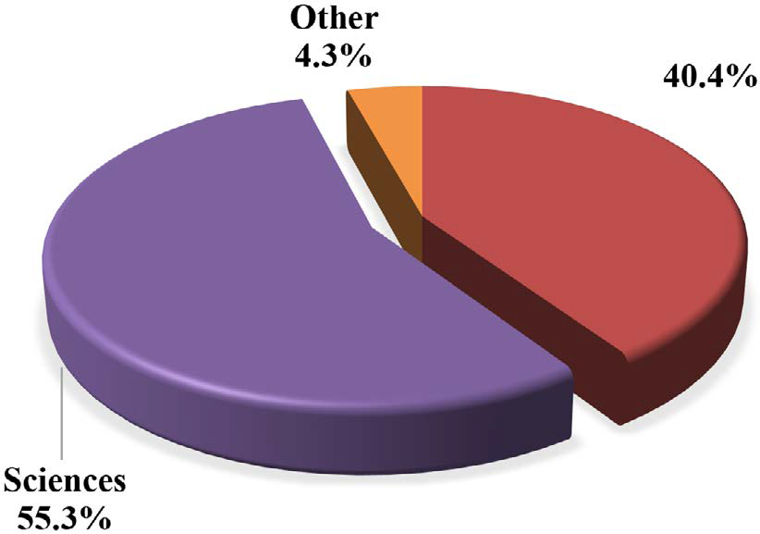[/graphic]
[label]Figure 1[/label]. [caption]University major interests for the surveyed students (n=36).[/caption][/figgrp]

[figgrp id="f2"][attrib]Note: Derived from research.[/attrib]
[graphic href="?a08v37n1"]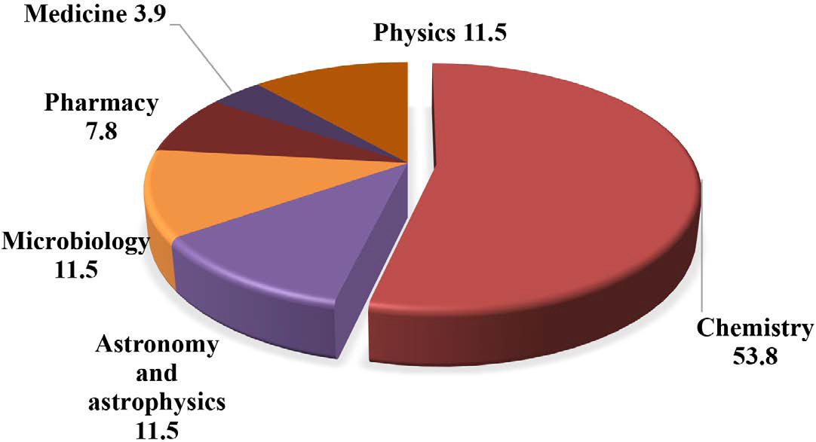[/graphic]
[label]Figure 2[/label]. [caption]Vocational interest for the surveyed students who choose sciences as a university major.[/caption][/figgrp]

[figgrp id="f3"][attrib]Note: Derived from research[/attrib].
[graphic href="?a08v37n1"]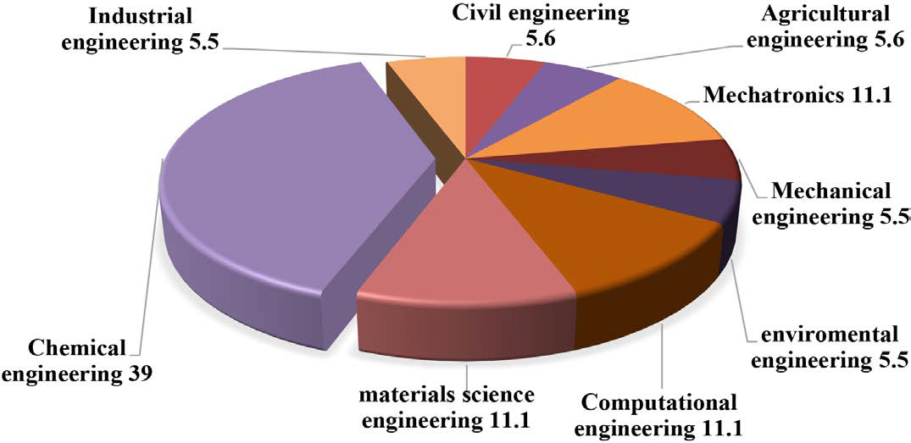[/graphic]
[label]Figure 3[/label]. [caption]Vocational interest for the surveyed students who choose engineering as a university major.[/caption][/figgrp]

[figgrp id="f4"][attrib]Note: Derived from research[/attrib].
[graphic href="?a08v37n1"]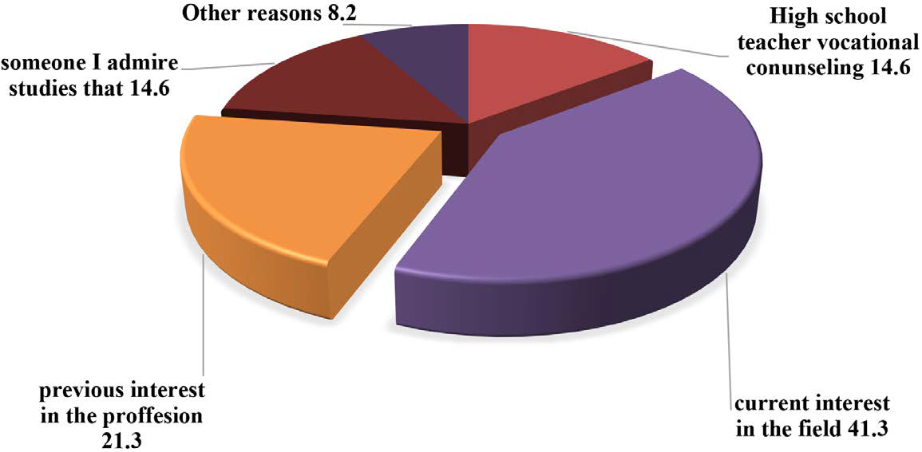[/graphic]
[label]Figure 4[/label]. [caption]Reasons students considered influenced them to choose a university major.[/caption][/figgrp]

[p]Maltese and co-workers have stated that “individuals who complete STEM degrees have quite varied histories and that the triggering of their interest happened across a wide age spectrum” (Maltese et al., 2014, p. 937) their study considered the background experience of their subjects, and the early motivation motivate students in STEM; they found that the students’ interest in STEM started before the 6th out ([xref ref-type="fig" rid="f4"]Figure 4[/xref]). For this purpose, a multichoice test was done with the possibility of honest answers. As a result of this question, a leading factor was the affinity they feel for this major, with 41.3% of the answers (the questionnaire answer textually said: “It is a profession I like a lot”). So they have a clear vision of their current academic interest. The following reason is highly related to the previously mentioned; they have considered interested in that major since they were children (21.3%); so in many cases, the selection of a major is related to the previous vocational interest in that field. Finally, the third leading reason is a tie with 14.6% of the answers; one of the reasons they gave is related to their vision of some majors in other people. Students state that someone they admire first studied that significant, and this factor influenced them to choose this university study plan. Students say that someone they admire may be a factor influencing them to choose this study plan.[/p]
[p]The other reason is the influence of high school teachers as counselors in the vocational process of choosing a university major. The reasons that led students to make this choice vary, considering their previous experiences. In this sense, grade ([xref ref-type="bibr" rid="r14"]Maltese et al., 2014[/xref])[/p]
[p]It is essential to mention that some other reasons, such as salary (6.80%), friends’ influence (1.4%), and family influence (0%), were asked but with minority results. From this result, it is possible to state that the students clearly define their vocational interests, which are the main factors driving them to choose a university study plan.[/p]
[p]The relation between students’ category group (based on the Costa Rican Chemistry Olympiad and their age) and their vocational interests in university majors are shown in [xref ref-type="table" rid="t4"]Table 4[/xref]. This table determined the percentage of students who selected university studies plan categories such as engineering, basic sciences, health sciences, and computer sciences, among others. As an actual result, the participants proposed no social or economic sciences as potential university majors, showing their affinity with STEM majors. This result would probably be related to the context in which the students were chosen and the camp’s effect on promoting scientific vocations that will be discussed later.[/p]

[tabwrap id="t4"][label]Table 4[/label]. [caption]Relation between students’ category group (based on the Costa Rican Chemistry Olympiad) and their vocational interests in university majors[/caption]
[table][thead][tr][th align="center"]Category[/th] | [th align="center"]Engineering (%)[/th] | [th align="center"]Basic Sciences (%) (Chemistry)[/th] | [th align="center"]Health Sciences (%)[/th] | [th align="center"]Computer Science (%)[/th] | [th align="center"]Other (%)[/th][/tr]
[/thead][tbody][tr][td align="center"]Initial[/td] | [td align="center"]33.3[/td] | [td align="center"]41.7 (33.3)[/td] | [td align="center"]8.3[/td] | [td align="center"]0.0[/td] | [td align="center"]16.7[/td][/tr]
[tr][td align="center"](13-15 years old)[/td] | [td align="center"] [/td] | [td align="center"] [/td] | [td align="center"] [/td] | [td align="center"] [/td] | [td align="center"] [/td][/tr]
[tr][td align="center"]Intermediate[/td] | [td align="center"]31.3[/td] | [td align="center"]31.3 (25.0)[/td] | [td align="center"]25.0[/td] | [td align="center"]12.5[/td] | [td align="center"]0.0[/td][/tr]
[tr][td align="center"](14-16 years old)[/td] | [td align="center"] [/td] | [td align="center"] [/td] | [td align="center"] [/td] | [td align="center"] [/td] | [td align="center"] [/td][/tr]
[tr][td align="center"]Advanced[/td] | [td align="center"]36.8[/td] | [td align="center"]52.6 (21.1)[/td] | [td align="center"]10.5[/td] | [td align="center"]0.0[/td] | [td align="center"]0.0[/td][/tr]
[tr][td align="center"](15-18 years old)[/td] | [td align="center"] [/td] | [td align="center"] [/td] | [td align="center"] [/td] | [td align="center"] [/td] | [td align="center"] [/td][/tr]
[tr][td align="center"]Total[/td] | [td align="center"]34.0[/td] | [td align="center"]42.6 (25.5)[/td] | [td align="center"]14.9[/td] | [td align="center"]4.3[/td] | [td align="center"]4.3[/td][/tr][/tbody][/table]
[fntable id="TFN4"]Note: Derived from research.[/fntable][/tabwrap]

[p]For the results shown in [xref ref-type="table" rid="t4"]Table 4[/xref], there is a clear trend toward selecting science and technology (engineering) university majors, but no clear correlation was found between age and affinity for university majors among the surveyed students. As a general result, engineering majors are preferred by 34% of the students with minor variations in the age range tested. Regarding chemistry majors, the students showed an unexpected diminution trend while older. The youngsters would choose chemistry at 33.3%, but when they grew, the selection decreased to 25% (intermediate) and 21.1% (advanced).[/p]

[/subsec][subsec][sectitle]Quimi Camp as a Vocational Inducer in STEM[/sectitle]

[p]We asked students about the Quimi Camp effect in selecting a specific university major. As shown in [xref ref-type="fig" rid="f5"]Figure 5[/xref], 65% of the participants indicate that Quimi Camp promotes the election of these scientific and engineering careers, while 35% state the opposite.[/p]
[p]To clarify this point, there was a further question to determine the effect of this camp on students’ motivation. The question was: Do you think that Quimi Camp contributes to reinforcing skills and creating favorable attitudes toward science? The totality (100%) of the surveyed students considered that the Quimi Camp contributes to this purpose. In this regard, Kong and co-workers concluded that students participating in science summer camps in the United States were more likely to choose STEM majors than students who did not. [xref ref-type="bibr" rid="r11"](Kong et al., 2014[/xref])[/p]
[p]The results let us think that the Quimi Camp promoted an essential effect on the vocational motivation for STEM university majors in[/p]

[figgrp id="f5"][attrib]Note: Derived from research[/attrib].
[graphic href="?a08v37n1"]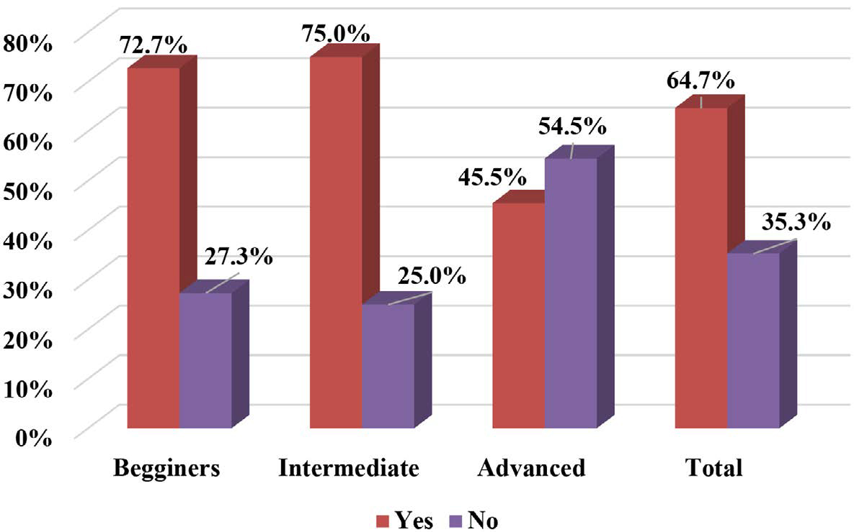[/graphic]
[label]Figure 5[/label]. [caption]Quimi Camp’s effect on the high school student’s election of university majors.[/caption][/figgrp]

[p]most of the students consulted, but some of them were not induced by this camp probably due to the previous vocational choices already made before the camp, as other studies have found ([xref ref-type="bibr" rid="r14"]Maltese et al., 2014[/xref].) This hypothesis can be proved by considering the young students from the beginners and intermediate category; they are under 16 years and their responses show a more binding effect of the Quimi Camp in their significant choice, while older students (advanced) are below the average result, where 55% answered negatively to the scientific promotion due to the Quimi Camp, which reinforces the idea that the significant election is typically done at earlier stages of school.[/p]

[/subsec][/sec][sec sec-type="conclusions"][sectitle]Conclusions[/sectitle]

[p]National events such as Costa Rican National Chemistry Olympiad and National Camps in Chemistry (called in Costa Rica as Quimi Camp) try to stimulate scientific vocations in science subjects such as chemistry. On the other hand, the work methodology in Quimi Camp incorporates a concept of interactivity, which includes transformative observation relationships between those who learn and learn objects. It is an observation that allows modifications, overlays, reflections, interrogations, and not just contemplations or games with exploration and manipulation instruments.[/p]
[p]From the results obtained, it is possible to determine that Quimi Camp promotes science and engineering student vocations. Also, it could undoubtedly influence the choice of the leading university in many areas of STEM. Nevertheless, under some circumstances, students have previous vocational options that have already been chosen.[/p]
[p]In summary, the final intention of Quimi Camp is to constitute inspirational places of education where children and adults coexist and transform with each other so that their ways of living become progressively more congruent in the space of coexistence.[/p]
[p]Quimi Camp is about being educated in a type of conversation supported by the primary emotion of recognition of the legitimacy of the other, where there is no room for competition that denies it. It is to spread science and technology on a human scale.[/p]

[subsec][sectitle]Funding[/sectitle]

[p]Ministry of Science, Innovation, Technology, and Telecommunications (MICITT), National Council for Scientific and Technological Research (CONICIT), Ministry of Public Education of Costa Rica (MEP), National Council of Rectors (CONARE), National University of Costa Rica (UNA), Distance State University (UNED).[/p]

[/subsec][/sec][sec][sectitle]Acknowledgments[/sectitle]

[p]Acknowledgment to teachers and students from high schools who, in one way or another, participated directly in the Quimi Camp.[/p]

[subsec][sectitle]Informed consent[/sectitle]

[p]It is declared that the participants were informed during the process of filling out the survey, and the data received correspond to anonymous surveys.[/p]

[/subsec][subsec][sectitle]Conflict of Interest[/sectitle]

[p]The authors declare no competing interests.[/p]

[/subsec][subsec][sectitle]Author contribution statement[/sectitle]

[p]All the authors declare that the final version of this paper was read and approved. The total contribution percentage for the conceptualization, preparation, and correction of this paper was as follows: M.S.B. 20 %, J.R.V.B. 20 %, G.P.M. 10 %, R.S.L. 20 %, A.R.Á. 20 %, K.B.C. 5 %, and R.C.H. 5 %.[/p]

[/subsec][subsec][sectitle]Data availability statement[/sectitle]

[p]The data supporting the results of this study will be made available by the corresponding author, (J.R.V.B.), upon a reasonable request.[/p][/subsec][/sec][/xmlbody]

[refs][sectitle]References[/sectitle]

[ref id="r1" reftype=“journal"][authors role="nd"][pauthor][surname]Antink-Meyer[/surname], [fname]A.[/fname][/pauthor], [pauthor][surname]Bartos[/surname], [fname]S.[/fname][/pauthor], [pauthor][surname]Lederman[/surname], [fname]J. S.[/fname][/pauthor], & [pauthor][surname]Lederman[/surname], [fname]N. G.[/fname][/pauthor] [/authors]([date dateiso="20160000" specyear="2016"]2016[/date]). [arttitle]Using science camps to develop understandings about scientific inquiry-Taiwanese students in a U.S. summer science camp[/arttitle]. [source]International Journal of Science and Mathematics Education[/source], [volid]14[/volid], [pages]29-53[/pages]. https://doi.org/[pubid idtype="doi"]10.1007/s10763-014-9576-3[/pubid][/ref]
[ref id="r2" reftype=“thesis"][authors role="nd"][pauthor][surname]Araújo[/surname], [fname]A.[/fname][/pauthor][/authors] ([date dateiso="20150000" specyear="2015"]2015[/date]). [source]Feira de ciências: contribuições para a alfabetização científica na educação básica [/source]([thesgrp][degree]Doctoral dissertation[/degree][/thesgrp]). [pubname]Universidad Federal do Ceará[/pubname], [publoc]Brasil[/publoc]. [pages]111-134[/pages].[/ref]
[ref id="r3" reftype=“journal"][authors role="nd"][pauthor][surname]Archer[/surname], [fname]L.[/fname][/pauthor], [pauthor][surname]Dewitt[/surname], [fname]J.[/fname][/pauthor], [pauthor][surname]Osborne[/surname], [fname]J.[/fname][/pauthor], [pauthor][surname]Dillon[/surname], [fname]J.[/fname][/pauthor], [pauthor][surname]Willis[/surname], [fname]B.[/fname][/pauthor], & [pauthor][surname]Wong[/surname], [fname]B.[/fname][/pauthor] [/authors]([date dateiso="20120000" specyear="2012"]2012[/date]). [arttitle]Science Aspirations, Capital, and Family Habitus How Families Shape Children’s Engagement and Identification With Science[/arttitle]. [source]American Educational Research Journal[/source], [volid]36[/volid]([issueno]1[/issueno]), [pages]107-124[/pages]. https://doi.org/[pubid idtype="doi"]10.3102/0002831211433290[/pubid][/ref]
[ref id="r4" reftype=“journal"][authors role="nd"][pauthor][surname]Bischoff[/surname], [fname]P. J.[/fname][/pauthor], [pauthor][surname]Castendyk[/surname], [fname]D.[/fname][/pauthor], [pauthor][surname]Gallagher[/surname], [fname]H.[/fname][/pauthor], [pauthor][surname]Schaumloffel[/surname], [fname]J.[/fname][/pauthor], & [pauthor][surname]Labroo[/surname], [fname]S.[/fname][/pauthor][/authors] ([date dateiso="20080000" specyear="2008"]2008[/date]). [arttitle]A Science Summer Camp as an Effective Way to Recruit High School Students to Major in the Physical Sciences and Science Education[/arttitle]. [source]International Journal of Environmental and Science Education[/source], [volid]3[/volid]([issueno]3[/issueno]), [pages]131-141[/pages].[/ref]
[ref id="r5" reftype="book"][authors role="nd"][pauthor][surname]Bogdan[/surname], [fname]R.[/fname][/pauthor] & [pauthor][surname]Biklen[/surname], [fname]S. K.[/fname][/pauthor] [/authors]([date dateiso="19980000" specyear="1998"]1998[/date]). [source]Qualitative Research for Education: An introduction to theories and methods[/source]. [pubname]Allyn and Bacon, Inc[/pubname].[/ref]
[ref id="r6" reftype="book"][authors role="nd"][pauthor][surname]Cohen[/surname], [fname]G. L.[/fname][/pauthor]; [pauthor][surname]Garcia[/surname], [fname]J.[/fname][/pauthor]; [pauthor][surname]Apfel[/surname], [fname]N.[/fname][/pauthor]; & [pauthor][surname]Master[/surname], [fname]A.[/fname][/pauthor][/authors] ([date dateiso="20060000" specyear="2006"]2006[/date]). [source]Reducing the racial achievement gap: a social-psychological intervention. Science[/source], [volid]313[/volid]([issueno]5791[/issueno]), [pages]1307-1310[/pages]. https://doi. org/[pubid idtype="doi"]10.1126/science.1128317[/pubid][/ref]
[ref id="r7" reftype=“journal"][authors role="nd"][pauthor][surname]Dabney[/surname], [fname]K. P.[/fname][/pauthor], [pauthor][surname]Tai[/surname], [fname]R. H.[/fname][/pauthor], [pauthor][surname]Almarode[/surname], [fname]J. T.[/fname][/pauthor], [pauthor][surname]Miller-Friedmann[/surname], [fname]J. L.[/fname][/pauthor], [pauthor][surname]Sonnert[/surname], [fname]G.[/fname][/pauthor], [pauthor][surname]Sadler[/surname], [fname]P. M.[/fname][/pauthor], & [pauthor][surname]Hazari[/surname], [fname]Z.[/fname][/pauthor] [/authors]([date dateiso="20120000" specyear="2012"]2012[/date]). [arttitle]Out-of-School Time Science Activities and Their Association with Career Interest in STEM[/arttitle]. [source]International Journal of Science Education[/source], Part [part]B[/part], [volid]2[/volid]([issueno]1[/issueno]), [pages]63-79[/pages]. https://doi. org/[pubid idtype="doi"]10.1080/21548455.2011.629455[/pubid][/ref]
[ref id="r8" reftype="book"][authors role="nd"][cauthor]Fundación Aqbuae[/cauthor].[/authors] ([date dateiso="20170000" specyear="2017"]2017[/date]). [source]Informe de impacto de EscueLab 2017[/source], [publoc]España[/publoc].[/ref]
[ref id="r9" reftype=“journal"][authors role="nd"][pauthor][surname]Fields[/surname], [fname]D. A.[/fname][/pauthor] [/authors]([date dateiso="20090000" specyear="2009"]2009[/date]). [arttitle]What do Students Gain from a Week at Science Camp? Youth perceptions and the design of an immersive, research-oriented astronomy camp[/arttitle]. [source]International Journal of Science Education[/source], [volid]31[/volid]([issueno]2[/issueno]), [pages]151-171[/pages]. https:// doi.org/[pubid idtype="doi"]10.1080/09500690701648291[/pubid][/ref]
[ref id="r10" reftype="book"][authors role="nd"][pauthor][surname]Krapp[/surname], [fname]A.[/fname][/pauthor], [pauthor][surname]Hidi[/surname], [fname]S.[/fname][/pauthor], & [pauthor][surname]Renninger[/surname], [fname]K. A.[/fname][/pauthor] [/authors]([date dateiso="19920000" specyear="1992"]1992[/date]). [source]Interest, learning, and development[/source]. [publoc]Hillsdale, NJ[/publoc]: [pubname]Lawrence Erlbaum Associates, Inc[/pubname]. https:// doi.org/[pubid idtype="doi"]10.1002/acp.2350080510[/pubid][/ref]
[ref id="r11" reftype=“journal"][authors role="nd"][pauthor][surname]Kong[/surname], [fname]X.[/fname][/pauthor], [pauthor][surname]Dabney[/surname], [fname]K. P.[/fname][/pauthor], & [pauthor][surname]Tai[/surname], [fname]R. H.[/fname][/pauthor] [/authors]([date dateiso="20140000" specyear="2014"]2014[/date]). [arttitle]The Association Between Science Summer Camps and Career Interest in Science and Engineering [/arttitle]. [source]International Journal of Science Education[/source], Part [part]B[/part], [volid]4[/volid]([issueno]1[/issueno]), [pages]54-65[/pages]. https://doi.org/[pubid idtype="doi"]10.1080/21548455.2012.760856[/pubid][/ref]
[ref id="r12" reftype=“journal"][authors role="nd"][pauthor][surname]Leblebicioglu[/surname], [fname]G.[/fname][/pauthor], [pauthor][surname]Metin[/surname], [fname]D.[/fname][/pauthor], [pauthor][surname]Capkinoglu[/surname], [fname]E.[/fname][/pauthor], [pauthor][surname]Cetin[/surname], [fname]P. S.[/fname][/pauthor], [pauthor][surname]Eroglu Dogan[/surname], [fname]E.[/fname][/pauthor], & [pauthor][surname]Schwartz[/surname], [fname]R.[/fname][/pauthor] [/authors]([date dateiso="20170000" specyear="2017"]2017[/date]). [arttitle]Changes in Students’ Views about Nature of Scientific Inquiry at a Science Camp[/arttitle]. [source]Science & Education[/source], [volid]26[/volid]([issueno]7-9[/issueno]), [pages]889-917[/pages]. https://doi.org/[pubid idtype="doi"]10.1007/s11191-017-9941-z[/pubid][/ref]
[ref id="r13" reftype=“journal"][authors role="nd"][pauthor][surname]Lindner[/surname], [fname]M.[/fname][/pauthor] & [pauthor][surname]Kubat[/surname], [fname]C.[/fname][/pauthor] [/authors]([date dateiso="20140000" specyear="2014"]2014[/date]). [arttitle]Science Camps in Europe--Collaboration with Companies and School, Implications and Results on Scientific Literacy[/arttitle]. [source]Science Education International[/source], [volid]25[/volid]([issueno]1[/issueno]), [pages]79-85[/pages].[/ref]
[ref id="r14" reftype=“journal"][authors role="nd"][pauthor][surname]Maltese[/surname], [fname]A. V.[/fname][/pauthor]; [pauthor][surname]Melki[/surname], [fname]C. S.[/fname][/pauthor]; & [pauthor][surname]Wiebke[/surname], [fname]H. L.[/fname][/pauthor][/authors] ([date dateiso="20140000" specyear="2014"]2014[/date]). [arttitle]The Nature of Experiences Responsible for the Generation and Maintenance of Interest in STEM[/arttitle]. [source]Science Education[/source], [volid]98[/volid]([issueno]6[/issueno]), [pages]937-962[/pages]. https://doi.org/[pubid idtype="doi"]10.1002/sce.21132[/pubid][/ref]
[ref id="r15" reftype=“journal"][authors role="nd"][cauthor]Ministry of Public Education of Costa Rica[/cauthor]. [/authors]([date dateiso="20180000" specyear="2018"]2018[/date]). [arttitle]Informe Nacional Bachillerato 2017. Rendimiento y niveles de desempeño[/arttitle]. [source]Dirección de Gestión y Evaluación de la Calidad, Departamento de Evaluación Académica y Certificación[/source].[/ref]
[ref id="r16" reftype=“thesis"][authors role="nd"][pauthor][surname]Pérez[/surname], [fname]A.[/fname][/pauthor] [/authors]([date dateiso="20120000" specyear="2012"]2012[/date]). [source]Actitudes hacia la Ciencia en Primaria y Secundaria[/source] ([thesgrp]Doctoral dissertation[/thesgrp]). [pubname]Universidad de Murcia, Facultad de Educación, Departamento de Psicología Evolutiva y de la Educación, Murcia[/pubname], [publoc]España[/publoc]. [url]http://hdl.handle.net/10803/120484[/url][/ref]
[ref id="r17" reftype="book"][authors role="nd"][cauthor]Programa Estado de la Nación[/cauthor][/authors]. ([date dateiso="20170000" specyear="2017"]2017[/date]). [source]Sexto informe estado de la educación / PEN.[/source] Cap [issueno]6[/issueno], [pages]277-296[/pages]. [publoc]San José, Costa Rica[/publoc]. [url]https://repositorio.conare.ac.cr/bitstream/handle/20.500.12337/665/804.%20Sexto%20Informe%20del%20Estado%20de%20 l a %20Educaci%c3%b3n_VI%20 Informe%20Estado%20de%20la%20Educaci%c3%b3n%202017_Libro%20completo. pdf?sequence=1&isAllowed=y[/url][/ref]
[ref id="r18" reftype=“journal"][authors role="nd"][pauthor][surname]Retana[/surname], [fname]D. A.[/fname][/pauthor], [pauthor][surname]Bartolomé[/surname], [fname]B.[/fname][/pauthor], & [pauthor][surname]Camacho[/surname], [fname]M. M.[/fname][/pauthor] [/authors]([date dateiso="20180000" specyear="2018"]2018[/date]). [arttitle]Science and Technology Fairs of Costa Rica and their contributions to Secondary Education[/arttitle]. [source]Journal Actualidades Investigativas en Educación[/source], [volid]18[/volid]([issueno]2[/issueno]), [pages]1-43[/pages]. https://doi.org/[pubid idtype="doi"]10.15517/aie.v18i2.33170[/pubid][/ref]
[ref id="r19" reftype=“journal"][authors role="nd"][pauthor][surname]Rivas[/surname], [fname]F.[/fname][/pauthor] [/authors]([date dateiso="20070000" specyear="2007"]2007[/date]). [arttitle]¿Conducta y asesoramiento vocacional en el mundo de hoy? [/arttitle][source]Electronic Journal of Research in Educational Psychology[/source], [volid]5[/volid]([issueno]1[/issueno]). [pages]5-14[/pages]. https://doi.org/[pubid idtype="doi"]10.25115/ejrep.v5i11.1233[/pubid][/ref]
[ref id="r20" reftype=“journal"][authors role="nd"][pauthor][surname]Robbins[/surname], [fname]M. E.[/fname][/pauthor], & [pauthor][surname]Schoenfisch[/surname], [fname]M. H.[/fname][/pauthor] [/authors]([date dateiso="20050000" specyear="2005"]2005[/date]). [arttitle]An Interactive Analytical Chemistry Summer Camp for Middle School Girls[/arttitle]. [source]Journal of Chemical Education[/source], [volid]82[/volid]([issueno]10[/issueno]), [pages]1486[/pages]. https://doi.org/[pubid idtype="doi"]10.1021/ed082p1486[/pubid][/ref]
[ref id="r21" reftype=“journal"][authors role="nd"][pauthor][surname]Sadler[/surname], [fname]T. D.[/fname][/pauthor]; [pauthor][surname]Burgin[/surname], [fname]S.[/fname][/pauthor]; [pauthor][surname]McKinney[/surname], [fname]L.[/fname][/pauthor]; & [pauthor][surname]Ponjuan[/surname], [fname]L.[/fname][/pauthor] [/authors]([date dateiso="20100000" specyear="2010"]2010[/date]). [arttitle]Learning Science through Research Apprenticeships: A Critical Review of the Literature[/arttitle]. [source]Journal of Research in Science Teaching[/source], [volid]42[/volid]([issueno]7[/issueno]), [pages]235-256[/pages]. https://doi. org/[pubid idtype="doi"]10.1002/tea.20326[/pubid][/ref][/refs] [/doc]

