[doc sps="1.8" acron="uniciencia" jtitle="Uniciencia" stitle="Uniciencia" issn="2215-3470" pissn="1011-0275" eissn="2215-3470" pubname="Universidad Nacional, Costa Rica" license="http://creativecommons.org/licenses/by-nc-nd/3.0" volid="37" issueno="1" dateiso="20231200" season="Jan/Dec" order="12" fpage="212" lpage="227" pagcount="16" doctopic="oa" language="en"]DOI:[doi]10.15359/ru.37-1.12[/doi]
[toctitle]Artículo[/toctitle]

[doctitle language="en"]Functional Education as a Nexus between Agricultural and Industrial Revolution: An Epidemiological Modeling Approach[/doctitle]
[doctitle language="es"]La educación funcional como nexo entre la revolución agrícola y la industrial: Un enfoque de modelado epidemiológico[/doctitle]
[doctitle language="pt"]A Educação Funcional como Elo entre as Revoluções Agrícola e Industrial: Uma Abordagem de Modelagem Epidemiológica[/doctitle]

[author role="nd"][fname]Abayomi Ayotunde[/fname] [surname]Ayoade[/surname][xref ref-type="aff" rid="aff1"] ¹[/xref] [authorid authidtp="orcid"]0000-0003-3470-0147[/authorid][/author]
[author role="nd"][fname]Srinivasarao[/fname] [surname]Thota[/surname] [xref ref-type="aff" rid="aff2"]²[/xref] [authorid authidtp="orcid"]0000-0002-3265-5656[/authorid][/author]

[normaff id="aff1" ncountry="Nigeria" norgname="University of Lagos" icountry="NG"][label]¹[/label] [orgdiv2]Department of Mathematics[/orgdiv2], [orgdiv1]Faculty of Science[/orgdiv1], [orgname]University of Lagos[/orgname], [city]Lagos[/city], [country]Nigeria[/country]. Corresponding Author [email]ayoadeabbayomi@gmail.com[/email], https://orcid.org/0000-0003-3470-0147[/normaff]
[normaff id="aff2" ncountry="India" norgname="Amrita Vishwa Vidyapeetham" icountry="IN"][label]²[/label] [orgdiv2]Department of Mathematics[/orgdiv2], [orgdiv1]Amrita School of Physical Sciences[/orgdiv1], [orgname]Amrita Vishwa Vidyapeetham[/orgname], [city]Amaravati[/city], [zipcode]Andhra Pradesh 522503[/zipcode], [country]India[/country]. [email]t_srinivasarao@av.amrita.edu[/email], https://orcid.org/0000-0002-3265-5656[/normaff]

[xmlabstr language="en"][sectitle]Abstract [/sectitle]
[p]Education has been regarded as a major route to economic prosperity. Its potentials, if properly exploited, have the tendency to revolutionize a nation’s productivity, income, and development.[/p]
[sec][sectitle](Objetive) [/sectitle][p]In this work, a mathematical model was formulated, and an epidemiological modeling approach was explored to derive the necessary and sufficient conditions for agricultural and industrial transformation in Nigeria in terms of education. The use of mathematics to quantify such a phenomenon is relatively new.[/p]
[/sec][sec][sectitle](Methodology)[/sectitle][p] Ample mathematics theorems were employed to test for the existence, boundedness, and positivity of the model’s solutions which are basic features of a valid epidemiological model. The model was solved to derive the equilibrium points, and the analytic threshold that governed revolution in industry and agriculture in terms of education was derived. Stability and sensitivity analyses were conducted via the stability theory of nonlinear differential equations and normalized forward sensitivity index, respectively. Simulations were later conducted using the Maple software to validate the analytical results.[/p]
[/sec][sec][sectitle](Results)[/sectitle][p] A government expenditure of 25% on education with or without corruption did not make education functional. Also, an increase in expenditure on education to 65% but with corruption of more than 30% retarded functional education. In general, education became functional when government investment in education attained 60%, with corruption levels lower than 20%.[/p]
[/sec][sec][sectitle](Conclusions)[/sectitle][p] Both the analytical and numerical results linked agricultural transformation and industrial revolution through functional education to massive investment in education and victory over corruption.[/p][/sec][/xmlabstr]
[kwdgrp language="en"][sectitle]Keywords:[/sectitle] [kwd]education[/kwd]; [kwd]revolution[/kwd]; [kwd]model[/kwd]; [kwd]equilibrium points[/kwd]; [kwd]expenditure[/kwd]; [kwd]corruption[/kwd]; [kwd]simulation[/kwd][/kwdgrp]

[xmlabstr language="es"][sectitle]Resumen[/sectitle]
[p]La educación ha sido considerada como una ruta importante hacia la prosperidad económica. Sus potencialidades, si se explotan adecuadamente, tienden a revolucionar la productividad, los ingresos y el desarrollo de una nación.[/p]
[sec][sectitle](Objetivo)[/sectitle][p] En este trabajo se formuló un modelo matemático y se exploró un enfoque de modelado epidemiológico para derivar las condiciones necesarias y suficientes para la transformación agrícola e industrial en Nigeria en términos de educación. El uso de las matemáticas para cuantificar tal fenómeno es bastante nuevo.[/p]
[/sec][sec][sectitle](Metodología)[/sectitle][p] Se emplearon amplios teoremas matemáticos para comprobar la existencia, la delimitación y la positividad de las soluciones del modelo, características básicas de un modelo epidemiológico válido. Se resolvió el modelo para derivar los puntos de equilibrio y se derivó el umbral analítico que rigió la revolución en la industria y la agricultura en términos de educación. Los análisis de estabilidad y sensibilidad se realizaron mediante la teoría de estabilidad de ecuaciones diferenciales no lineales y el índice de sensibilidad directo normalizado, respectivamente. Posteriormente se realizaron simulaciones a través de un software de arce para validar los resultados analíticos.[/p]
[/sec][sec][sectitle](Resultados)[/sectitle][p] Un gasto público del 25 % en educación con corrupción o sin ella no hizo que la educación fuera funcional. Asimismo, un aumento del gasto en educación al 65 %, pero con una corrupción de más del 3 0% retrasó la educación funcional. En general, la educación se volvió funcional cuando la inversión del gobierno en educación alcanzó 60 % con un nivel de corrupción inferior al 20 %.[/p]
[/sec][sec][sectitle](Conclusiones)[/sectitle][p] Tanto los resultados analíticos como los numéricos vincularon la transformación agrícola y la revolución industrial a través de la educación funcional con la inversión masiva en educación y la victoria sobre la corrupción.[/p][/sec][/xmlabstr]
[kwdgrp language="es"][sectitle]Keywords:[/sectitle] [kwd]Educación[/kwd]; [kwd]revolución[/kwd]; [kwd]modelo[/kwd]; [kwd]puntos de equilibrio[/kwd]; [kwd]gasto[/kwd]; [kwd]corrupción[/kwd]; [kwd]simulación[/kwd][/kwdgrp].

[xmlabstr language="pt"][sectitle]Resumo[/sectitle]
[p]A educação tem sido considerada como um importante caminho para a prosperidade econômica. Seu potencial, se devidamente explorado, tende a revolucionar a produtividade, a renda e o desenvolvimento de uma nação.[/p]
[sec][sectitle](Objetivo)[/sectitle][p] Este artigo formulou um modelo matemático e explorou uma abordagem de modelagem epidemiológica para derivar as condições necessárias e suficientes para a transformação agrícola e industrial na Nigéria em termos de educação. O uso da matemática para quantificar tal fenômeno é relativamente novo.[/p]
[/sec][sec][sectitle](Metodologia)[/sectitle][p] Extensos teoremas matemáticos foram usados para testar a existência, a delimitação e a positividade das soluções do modelo, que são características básicas de um modelo epidemiológico válido. O modelo para derivar pontos de equilíbrio foi resolvido e o limiar analítico que orientou a revolução na indústria e na agricultura em termos de educação foi derivado. As análises de estabilidade e sensibilidade foram realizadas utilizando-se a teoria da estabilidade das equações diferenciais não lineares e o índice de sensibilidade direta normalizada, respectivamente. Posteriormente, foram realizadas simulações por meio de um software Maple para validação dos resultados analíticos. [/p]
[/sec][sec][sectitle](Resultados) [/sectitle][p]Um gasto público de 25% em educação com ou sem corrupção não tornou a educação funcional. Da mesma forma, um aumento nos gastos com educação para 65%, mas com uma corrupção de mais de 30%, atrasou a educação funcional. No geral, a educação tornou-se funcional quando o investimento do governo em educação atingiu 60%, com um nível de corrupção abaixo de 20%.[/p]
[/sec][sec][sectitle](Conclusões)[/sectitle][p] Tanto os resultados analíticos quanto numéricos ataram a transformação agrícola e a revolução industrial através da educação funcional com o investimento maciço na educação e a vitória sobre a corrupção.[/p][/sec][/xmlabstr]
[kwdgrp language="pt"][sectitle]Palavras-chave:[/sectitle] [kwd]educação[/kwd]; [kwd]revolução[/kwd]; [kwd]modelo[/kwd]; [kwd]pontos de equilíbrio[/kwd]; [kwd]gastos[/kwd]; [kwd]corrupção[/kwd]; [kwd]simulação[/kwd][/kwdgrp]

[hist]Received: [received dateiso="20220606"]Jun/6/2022[/received]
Accepted: [accepted dateiso="20230124"]Jan/24/2023[/accepted]
Published: Jun/1/2023[/hist]

[xmlbody][sec sec-type="intro"][sectitle]1. Introduction[/sectitle]

[p]The importance of education in a society cannot be overemphasized. It is so necessary for development that the quality of people and the level of transformation are functions of the quality of education. The quality of education, however, is determined by its ability to meet the desires of society. Transformation is brought about by education only when education is functional. Functional education, therefore, is the education that places emphasis on the ability to carry out productive tasks rather than education that intends to produce ideological conformity ([xref ref-type="bibr" rid="r22"]Maduegbunam & Okafor, 2014[/xref]). Functional education highlights practice more than theory and stands for utility and practicality. It has brought about an unprecedented transformation in terms of the agricultural and industrial revolution in some countries of the world ([xref ref-type="bibr" rid="r31"]Vries, 1994[/xref]).[/p]
[p]The Industrial Revolution is a complex set of economic, technological, and social changes that occurred over a substantial period. The first country to experience the industrial revolution was Britain in the eighteenth century ([xref ref-type="bibr" rid="r24"]Mohajan, 2019[/xref]). The emergence of the industrial revolution was attributed to British authority and wealth as an empire, stable government, and spirit of individual freedom and capitalism ([xref ref-type="bibr" rid="r15"]Ferreira et al., 2015[/xref]). Another important factor that led to the first industrial revolution in Britain was the agricultural revolution of the eighteenth century. The changes in the methods of farming and stock breeding that characterized the agricultural transformation led to a significant increase in food production. This implies that British agriculture could feed more people at lower prices with less labor ([xref ref-type="bibr" rid="r17"]Groumpos, 2021[/xref]).[/p]
[p]Industrial Revolution had many advantages, and many nations that have not gone through it typically have a life expectancy below fifty years of age, infant mortality approaching 20%, a diet that cannot guarantee good health, and a per capita income of lower than the amount a high school student in America would spend on his/her prom [xref ref-type="bibr" rid="r14"](Digital History, n.d[/xref]; [xref ref-type="bibr" rid="r16"]Francks, 2021[/xref]). Many people who reside in non-industrial nations such as Nigeria and Algeria, Bangladesh, or Haiti usually cannot read or write, never see a doctor, record at least a death of one child before the age of five, and rarely get enough to eat. On the contrary, people who reside in most industrial countries have far special lives that usually comprise homes with central heating, one or more computers, and cars with air conditioning, a dishwasher, and several televisions. Even most of the poorest people in industrialized nations like America eat meat quite a lot of time a week and have access to minimum health care, electricity, and indoor plumbing [xref ref-type="bibr" rid="r14"](Digital History, n.d[/xref]; [xref ref-type="bibr" rid="r32"]Wikipedia, n.d[/xref]; [xref ref-type="bibr" rid="r18"]Hoppit, 1987[/xref]).[/p]
[p]The industrial revolution is a function of the availability of natural resources such as fertile soil, an excess of money to invest, a significant working force, men and women of energy, ambition, and talent, with administrative abilities, and favorable government policy ([xref ref-type="bibr" rid="r23"]Menon & Fink, 2019[/xref]; [xref ref-type="bibr" rid="r19"]Kapas, 2008[/xref]). Nigeria boasts some of the conditions required for the industrial revolution. For instance, Nigeria is blessed with abundant natural resources and a significant workforce with men and women of energy, but its educational system is far from being functional to properly tap the resources and harness the potentials of the teeming working force ([xref ref-type="bibr" rid="r9"]Ayoade & Farayola, 2021[/xref]). The dream of the nation to join the league of industrialized countries after sixty years of independence becomes a mirage because of the state of its educational system.[/p]
[p]The education sector is ill-funded to the extent that the UNESCO recommendation of 26% of the national budget to finance the education of the Third World has become a tall dream as less than 3% of the national budget is allocated to education in Nigeria ([xref ref-type="bibr" rid="r29"]Thom-Otuya & Inko-tariah, 2016[/xref]). Elites and educationists are becoming increasingly worried as no university in Nigeria is ranked among the top fifty universities in Africa, and none is among the top three thousand universities in the world (Thom-Otuya & Inko-tariah, 2016). The poor performance of the education sector eventually pushes other sectors of the economy to a state of inevitable collapse ([xref ref-type="bibr" rid="r8"]Ayoade & Farayola, 2020a[/xref]).[/p]
[p]The place of education in national transformation has been studied over the years ([xref ref-type="bibr" rid="r25"]Mpofu, 2013[/xref]; [xref ref-type="bibr" rid="r30"]Turkkahraman, 2012[/xref]; [xref ref-type="bibr" rid="r20"]Kayani et al., 2017[/xref]). Furthermore, the roles of industries and agriculture in national development have also been the subject of intense study ([xref ref-type="bibr" rid="r12"]Diao et al., 2010[/xref]; [xref ref-type="bibr" rid="r3"]Agarwal & Agarwal, 2017[/xref]; [xref ref-type="bibr" rid="r1"]Adenomon & Oyejola, 2013[/xref]). However, much attention has not been paid to the impact of education on the growth of industry and agriculture. In particular, the use of mathematics to study the role of education in the growth of industry and agriculture is relatively new and rare in the literature. It is on this note that the present study attempts to examine a nexus between the industrial and agricultural revolutions in Nigeria in terms of functional education from the mathematical point of view.[/p]

[subsec][sectitle]Model Formulation[/sectitle]

[subsec][sectitle]The study derived its theoretical foundation from the structural change theory.[/sectitle]

[p]This theory was developed by Arthur [xref ref-type="bibr" rid="r21"]Lewis in 1954[/xref] and called it “economic development with unlimited supplies of labor” (Lewis, 1954). The theory states that an economy is made up of two sectors. One is the traditional (agricultural or subsistence) sector, while the other is the modern (capitalist, industrial, or manufacturing) sector. This gives rise to the two-sector model. The theory also assumes that the development of an economy depends on the growth of the two sectors. Mathematically, y=f (AGRIC, IND), where; y=economic development, AGRIC = agricultural sector, and IND = industrial sector. The theory was recently adopted by [xref ref-type="bibr" rid="r26"]Taiwo & Muftau (2018[/xref]) to study the impact of agricultural financing schemes on agricultural output in Nigeria.[/p]
[p]The structural change theory was able to simplify the complexity of the real world as the development truly depended on the growth of agriculture and industry in the short run. However, the theory failed to consider other sectors of the economy that enhanced the optimality of the agricultural and industrial sectors. These two sectors are interrelated. The agricultural sector employs capital inputs, labor expertise, and also a final consumer of the output of the industrial sector, while the industrial sector employs labor and output of the agricultural sector. The point of convergence or common denominator for the two sectors is labor because both employ labor in the production process. However, the quality of labor is a function of the quality of education, while the quality of education is a function of the quality of all the factors of education. Therefore, the revolution in agricultural and industrial sectors is a function of the performance of the education sector, and the performance of the education sector itself is a function of the policies of the government.[/p]
[p]Hence, contrary to Lewis’ view, development is not just a function but a function of a function or a composite function. The present work will, therefore, use a mathematical modeling approach as in [xref ref-type="bibr" rid="r4"]Ayoade et al. (2019[/xref]), Ayoade et al. (2020b), Ayoade & Farayola (2021), [xref ref-type="bibr" rid="r2"]Adenuga et al. (2021[/xref]), and Ayoade & Agboola (2022a) to examine a nexus between agricultural and industrial revolution in Nigeria in terms of a functional education by incorporating the education sector and government policies on education into the Lewis’ model. The transfer diagram of the new model is in Figure [xref ref-type="fig" rid="f1"]1[/xref].[/p]

[figgrp id="f1"][attrib]Note: derived from research.[/attrib]
[graphic href="?a12v37n1"]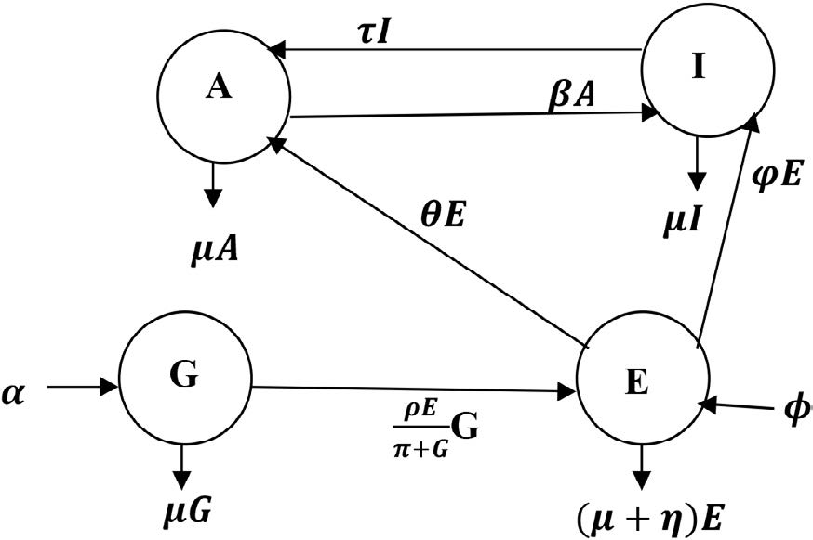[/graphic]
[label]Figure 1[/label]. [caption]Transfer diagram of the model.[/caption][/figgrp]

[p]The model is made up of four compartments of levels of government G(t), education sector E(t), agricultural sector A(t), and industrial sector I(t). Politicians are recruited into the levels of government at the rate 𝛼, while individuals are recruited into the levels of education at the rate 𝜙. The government releases funds to the education sector, but since human beings are involved in the disbursement and management of the funds, part of them may be diverted, and the purpose for which they were released may be defeated before the they get to the sector. Therefore, the rate of influence of government on education may not be linear and is, thus, expressed as G. The education sector supplies labor to the agricultural and industrial sectors at the rates 𝜃 and 𝜑 respectively. The agricultural sector supplies[/p]
[p]raw materials to the industries at the rate 𝛽, while the industrial sector supplies inputs to agriculture at the rate 𝜏. It is assumed that the following occurs at the same rate 𝜇: level of dropouts from the education compartment E(t) represented by 𝜇E, the level of retrenchment from the industrial compartment I(t) represented by 𝜇I, the level at which the able-bodied leave farming activities from the agricultural compartment A(t) represented by 𝜇A, and the rate at which changes in government put different politicians into governance at different times represented by 𝜇G since general elections hold every four years. Also, when the funds released by the government finally reaches the education sector, there is a tendency for misappropriation of the funds since human beings are involved in their management. This would constitute a leakage to the growth of the sector, and the rate of leakages is represented by 𝜂E. These assumptions and the transfer diagram are translated into the following set of first-order ordinary differential equations.[/p]

[p][graphic href="?a12v37n1"]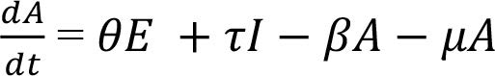[/graphic] (1)[/p]
[p][graphic href="?a12v37n1"]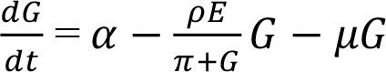[/graphic] (2)[/p]
[p][graphic href="?a12v37n1"][/graphic] (3)[/p]
[p][graphic href="?a12v37n1"]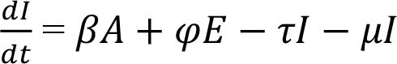[/graphic] (4)[/p]

[p]with initial conditions[/p]

[p]A (0) = A0, G (0) = G0, E (0) = E0, I (0) = I0.[/p]

[p]The nomenclatures for the parameters are displayed in [xref ref-type="table" rid="t1"]Table 1[/xref].[/p]

[tabwrap id="t1"][label]Table 1[/label]. [caption]Definitions for the model parameters[/caption]
[table][tbody][tr][td align="center"]Parameters Description[/td] | [td align="center"]Symbol[/td][/tr]
[tr][td align="left"]Rate of influx of politicians into political offices[/td] | [td align="center"]𝛼[/td][/tr]
[tr][td align="left"]Rate of influx of individuals into schools[/td] | [td align="center"]𝜙[/td][/tr]
[tr][td align="left"]Rate of embezzlement among the officials who handle fund disbursements to the education sector[/td] | [td align="center"]𝜋[/td][/tr]
[tr][td align="left"]Rate of supply of labor to A(t) from E(t)[/td] | [td align="center"]𝜃[/td][/tr]
[tr][td align="left"]Rate of supply of raw materials from A(t)to I(t)[/td] | [td align="center"]𝛽[/td][/tr]
[tr][td align="left"]Rate of funding education sector[/td] | [td align="center"]𝜌[/td][/tr]
[tr][td align="left"]Rate of supply of inputs from I(t)to A(t)[/td] | [td align="center"]𝜏[/td][/tr]
[tr][td align="left"]Rate of supply of labor to I(t)from E(t)[/td] | [td align="center"]𝜑[/td][/tr]
[tr][td align="left"]Rate of leakages in each of the compartments[/td] | [td align="center"]𝜇[/td][/tr]
[tr][td align="left"]Rate of embezzlement in the education sector[/td] | [td align="center"]𝜂[/td][/tr][/tbody][/table]
[fntable id="TFN1"]Note: derived from research.[/fntable][/tabwrap]

[/subsec][/subsec][subsec][sectitle]Basic Features[/sectitle]

[subsec][sectitle]Existence of solutions[/sectitle]

[p]Well-posedness of a model is a function of the existence of solutions of the model. If there exist solutions, the dynamics of the model can be predicted by dealing with the model solutions or its approximate solutions. The popular Derrick and Grossman theorem, which has been used in numerous studies, for example, see [xref ref-type="bibr" rid="r5"]Ayoade et al. (2020b[/xref]) and [xref ref-type="bibr" rid="r2"]Adenuga et al. (2021[/xref]), shall be used to verify the existence of solutions for the proposed model.[/p]
[p]Lemma 1 ([xref ref-type="bibr" rid="r2"]Adenuga et al 2021[/xref]). Let Ω represent a region [graphic href="?a12v37n1"][/graphic][graphic href="?a12v37n1"]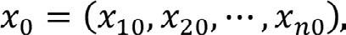[/graphic] and assuming the Lipschitzian criterion [graphic href="?a12v37n1"][/graphic] is fulfilled by ƒ(t, x), whenever (t, x₁), and (t, x₂) are in Ω where k is nonnegative. Then, there exists a unique continuous vector solution x (t) in the interval t - t₀ ≤ 𝛿 such that 𝛿 > 0. It is necessary to consider that the condition is fulfilled based on the requirement that for i, j = 1, 2, 3, . . . are continuous and bounded in Ω.[/p]

[p]Theorem 1. The model solutions with initial conditions A(0)≥0, G(0) ≥0, E(0) ≥0, I(0) ≥0 exists as well as unique in for all t ≥ 0.[/p]
[p]Proof. The RHS of the model can be written as:[/p]

[p][graphic href="?a12v37n1"]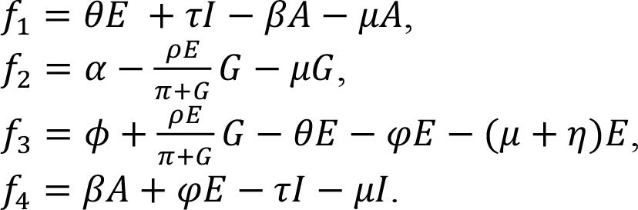[/graphic][/p]

[p]It is straightforward to establish that [graphic href="?a12v37n1"]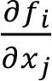[/graphic]are continuous and deduce that [graphic href="?a12v37n1"]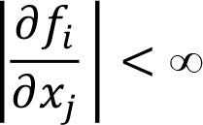[/graphic]for i, j = 1, 2,..., 4, where x₁ = A, x2 = G, x3 = E, and x4 = I. By Lemma 1, the model has unique solutions.[/p]

[/subsec][subsec][sectitle]Invariant region[/sectitle]

[p]The boundedness property of the model shall be used to establish the invariant region. Here,[/p]
[p]N (t) = A (t) + G (t) + E (t) + I (t) which follows that[/p]
[p][graphic href="?a12v37n1"]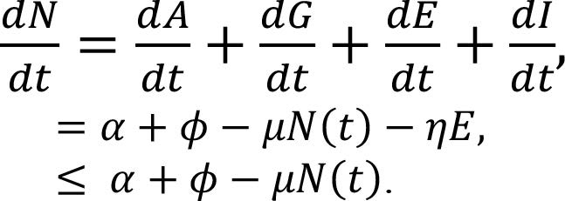[/graphic][/p]

[p]The solution for the inequality can be generally expressed as[/p]
[p][graphic href="?a12v37n1"]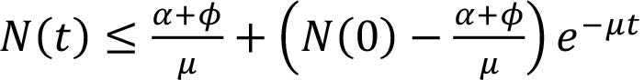[/graphic][/p]
[p]The initial value is N (0), i.e., N (t) =N (0) at t = 0.[/p]

[p]Further, it is deduced that [graphic href="?a12v37n1"]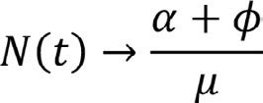[/graphic] as t ⟶ ∞. Hence, N (t) remains bounded as [graphic href="?a12v37n1"]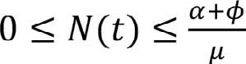[/graphic] . Thus, the region of feasibility for the model is nonnegative and is given as[/p]
[p][graphic href="?a12v37n1"]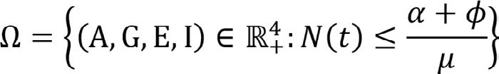[/graphic][/p]

[/subsec][subsec][sectitle]Positivity of solutions[/sectitle]

[p]The solutions of the model must be positive since it monitors real-life phenomena.[/p]

[p]Theorem 2. The solutions of the system preserve positivity.[/p]
[p]Proof. Suppose {A (t), G (t), E (t), I (t)} denotes the final solutions to the variables of the model for t ≥ 0 with positive initial conditions {A (0) > 0, G (0) > 0, E (0) > 0, I (0) > 0}.[/p]
[p]From (1),[/p]

[p][graphic href="?a12v37n1"]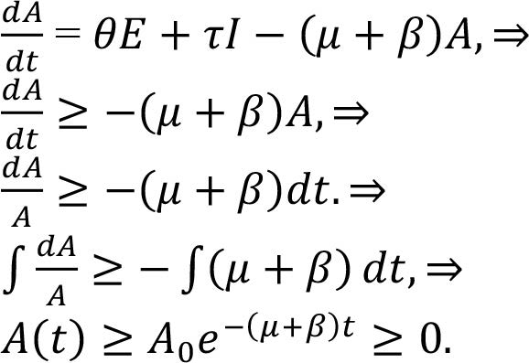[/graphic] (5)[/p]

[p]Also, consider (2),[/p]
[p][graphic href="?a12v37n1"]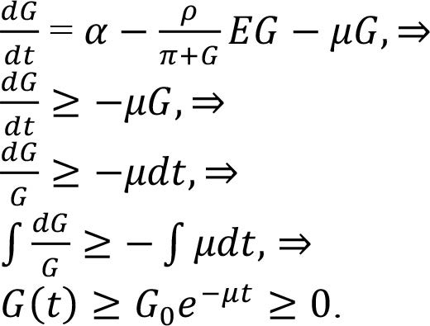[/graphic] (6)[/p]

[p]In (3),[/p]

[p][graphic href="?a12v37n1"]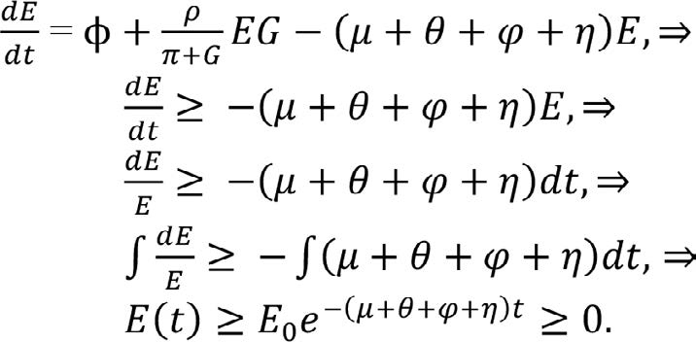[/graphic] (7)[/p]

[p]Lastly, in (4),[/p]

[p][graphic href="?a12v37n1"]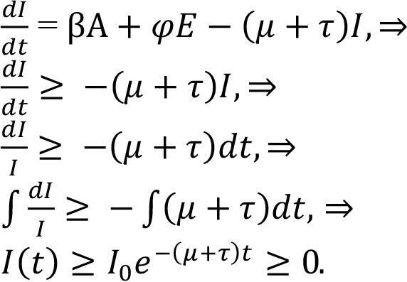[/graphic] (8)[/p]

[p]Since ek is nonnegative for all k then, the solutions for A (t), G (t), E (t), and I (t) are positive.[/p]

[/subsec][/subsec][subsec][sectitle]Qualitative Analysis[/sectitle]

[subsec][sectitle]Equilibria[/sectitle]

[p]Two equilibria are associated with the epidemiological modeling - disease-free equilibrium (DFE) and the endemic equilibrium (EE). Equilibrium is at the DFE when the infection is virtually non-existence in the population, while it is at the EE when the population is plagued with the disease.[/p]
[p]In the present analysis, transformation in agriculture and industry is anchored on functional education, while functional education itself is anchored on adequate funding by the government. Therefore, there exist two equilibria as well - education poor funding equilibrium (EPE) and education adequate funding equilibrium (EAE). It is assumed, as in epidemic modeling, that EPE exists when there is total neglect of the education sector to the degree that the rate of funding education is zero, i.e., 𝜌 = 0, while EAE exists when 𝜌 > 0. Hence, the system (1)-(4) allows an education poor funding equilibrium (EPE)[/p]

[p]Σ0 = (A0, G0, E0, I0) with coordinates[/p]

[p][graphic href="?a12v37n1"]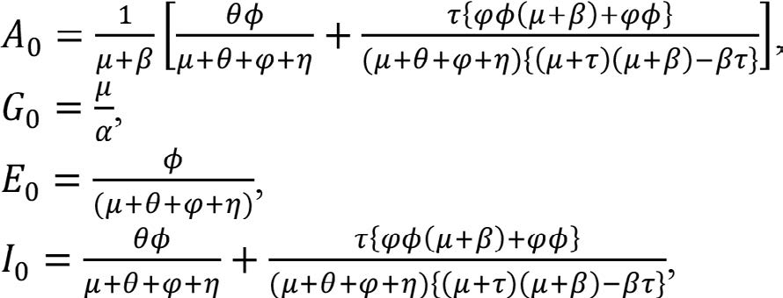[/graphic][/p]

[p]and an education adequate funding equilibrium (EAE)[/p]

[p]Σ* = (A*, G*, E*, I*) with coordinates[/p]

[p][graphic href="?a12v37n1"]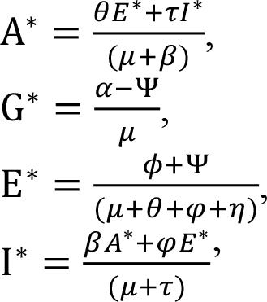[/graphic][/p]

[p]where[/p]
[p][graphic href="?a12v37n1"]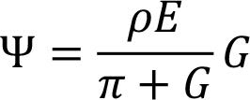[/graphic][/p]

[/subsec][subsec][sectitle]Transformation Ratio, R_{T}[/sectitle]

[p]In epidemiology, the basic reproduction ratio R₀ measures the average number of secondary infections that a typical infectious individual is able to produce in a completely susceptible population ([xref ref-type="bibr" rid="r13"]Diekmann et al., 1990[/xref]). If R₀ > 1, they are able to infect at least one person, and the disease takes off in the population; but if R₀ < 1, they are unable to infect a single individual, and the disease dies out or fails to take off in the population. In the present analysis, transformation ratio R_{T} measures the functionality of education in terms of the transformation in agricultural and industrial sectors. Transformation in agricultural and industrial sectors is a function of functional education, while functional education itself is a function of government policies. Transformation in agriculture and industry in terms of functional education, therefore, depends on the rate of funding education (𝜌), the level of corruption among the officials who handle fund disbursements to the education sector (𝜋), the rate of dropouts (𝜇) and the rate of misappropriation of funds in the education sector (𝜂). Transformation ratio RT is therefore defined as the ratio of the product of the rates of funding education (𝜌) and the level of corruption among the officials who handle fund disbursements to the education sector (𝜋) to the sum of the rates of dropouts (𝜇) and the misappropriation of funds in the education sector (𝜂), i.e.,[/p]

[p][graphic href="?a12v37n1"]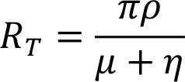[/graphic] (9)[/p]

[p]In (9), the transformation ratio parameter (RT) is inversely related to the sum of the rates of dropouts (𝜇) and the misappropriation of funds in the education sector (𝜂), if the rate of funding education (𝜌) is constant. The implication is that education would be functional, and the functionality would translate into an agricultural and industrial revolution if there is a decrease in the rates of dropouts (𝜇) and misappropriation of funds in the education sector (𝜂), even if the rate of funding education (𝜌) is constant; otherwise, an injection of funds (𝜌) into the education sector might not result in functional education. So, a decrease in (𝜇) and (𝜂) with an increase in (𝜌) and a decrease in (𝜋) will guarantee functional education. On the other hand, an increase in (𝜇) and (𝜂) with a decrease in (𝜌) and an increase in (𝜋) will frustrate functional education. Following the epidemiological modeling principle as applied in [xref ref-type="bibr" rid="r7"]Ayoade & Aliu (2022b[/xref]), [xref ref-type="bibr" rid="r10"]Ayoade & Farayola (2022c[/xref]) and [xref ref-type="bibr" rid="r6"]Ayoade & Agboola (2022a[/xref]), education becomes functional, and the functionality informs the agricultural and industrial revolution if R_{T} > 1; otherwise, education does not reach the level of revolutionizing agricultural and industrial sectors (i.e., R_{T} < 1).[/p]

[/subsec][subsec][sectitle]Stability of the Education Poor Funding Equilibrium, Σ₀[/sectitle]

[p]One of the equilibria that are identified with the model is education poor funding equilibrium (Σ₀) which exists when there is total neglect of the education sector to the degree that the rate of funding education is assumed zero, i.e., 𝜌 = 0. Poor funding equilibrium in quantific terms means that the education sector is neglected, and it is measured in terms of the nondimensional quantity R_{T}. It exists when R_{T} < 1. We shall examine the stability of (Σ₀) following the epidemiological modeling approach to establish the conditions that can instigate (Σ₀). Theorem 3. The education poor funding equilibrium of the model is stable if RT < 1; otherwise, it is unstable.[/p]
[p]Proof. The education poor funding equilibrium is stable, and R_{T} < 1 if it is shown that all the eigenvalues of the Jacobian matrix of the system (1)-(4) are negative. If the system (1)-(4) is linearized, then, it becomes[/p]

[p][graphic href="?a12v37n1"]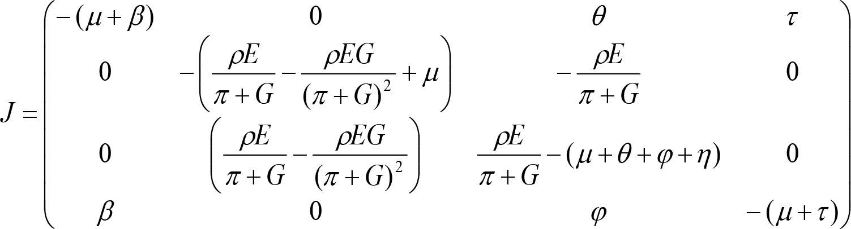[/graphic] (10)[/p]

[p]Evaluating (10) about the education neglect equilibrium Σ0, i.e., when the rate of funding education is zero (𝜌 = 0), then, (10) becomes[/p]

[p][graphic href="?a12v37n1"]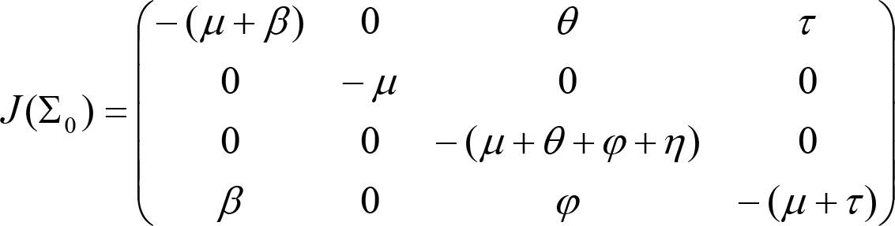[/graphic]. (11)[/p]

[p]In (11),[/p]

[p][graphic href="?a12v37n1"]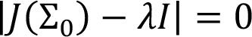[/graphic] is evaluated to[/p]

[p][graphic href="?a12v37n1"]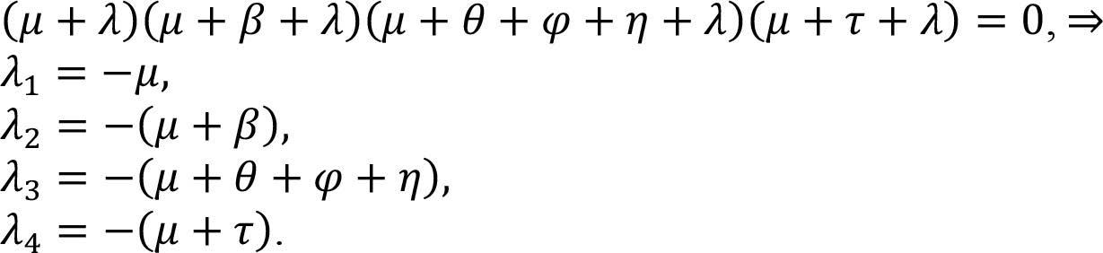[/graphic] (12)[/p]

[p]Since all the eigenvalues are negative, the education poor funding equilibrium (Σ0) of the model is stable. The stability of the education poor funding equilibrium (Σ0) implies that education would continue to be dysfunctional unless there are favorable perturbations in the values of the model parameters.[/p]

[p]Stability of the Education Adequate Funding Equilibrium, Σ*[/p]

[p]Education adequate funding equilibrium (Σ*) exists when the education sector is receiving the needed attention from the government, i.e., when 𝜌 > 0. It is measured in terms of R_{T} and exists when R_{T} > 1. We shall establish the conditions that can instigate (Σ*).[/p]
[p]Theorem 4. The education adequate funding equilibrium of the model is stable if R_{T} > 1; otherwise, it is unstable.[/p]
[p]Proof. The education adequate funding equilibrium is stable, and R_{T} > 1 if it is established that all the eigenvalues of the Jacobian matrix of the model are less than zero.[/p]
[p]At EAE, when the rate of funding education is greater than zero, i.e., 𝜌 > 0, (10) becomes[/p]

[p][graphic href="?a12v37n1"]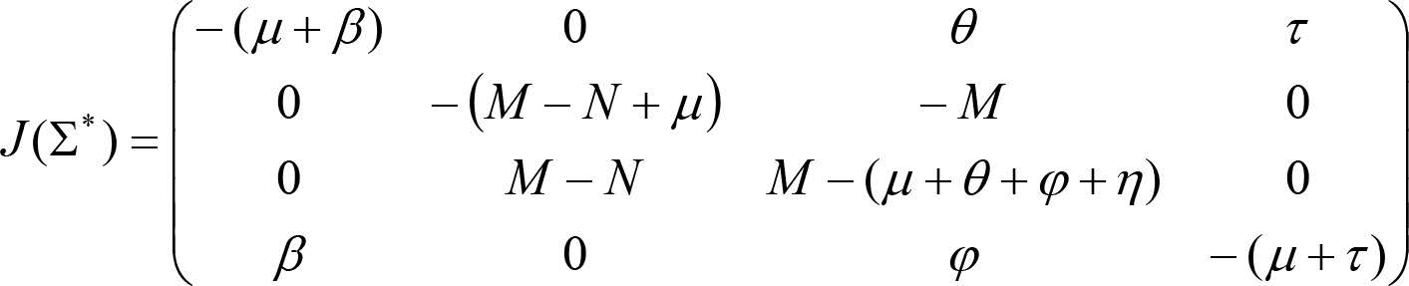[/graphic] (13)[/p]

[p]where[/p]
[p][graphic href="?a12v37n1"]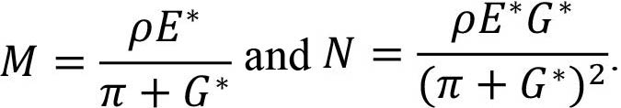[/graphic][/p]

[p]In (13),[/p]

[p][graphic href="?a12v37n1"]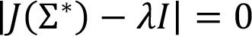[/graphic] is evaluated to[graphic href="?a12v37n1"][/graphic][/p] (14)

[p]where[/p]

[p][graphic href="?a12v37n1"]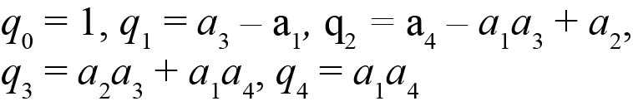[/graphic][/p]
[p]and[/p]

[p][graphic href="?a12v37n1"]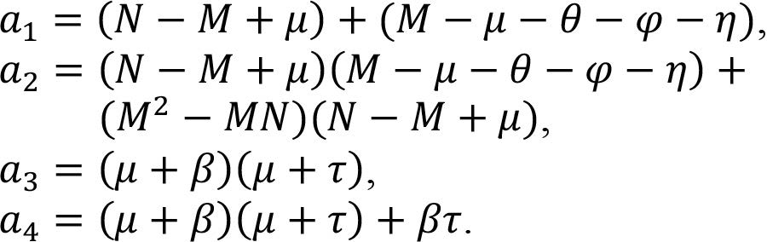[/graphic][/p]

[p]Going by the stability criterion of Routh-Hurtwitz in [xref ref-type="bibr" rid="r4"]Ayoade et al. (2019[/xref]), all the eigenvalues in (14) are less than zero if[/p]

[p][graphic href="?a12v37n1"]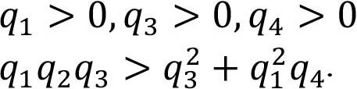[/graphic] and (15)[/p]

[p]Therefore, the education adequate funding equilibrium Σ* of the model is stable if the inequalities in (15) are true. The stability of Σ* implies that education would continue to be functional if the present state of the values of the model parameters that instigated functional education is sustained.[/p]

[/subsec][subsec][sectitle]Sensitivity Analysis[/sectitle]

[p]The contribution of education to agricultural and industrial sectors is quantified theoretically by computing the relative effects of key parameters on functional education (i.e., transformation ratio), following the formula of normalized forward sensitivity index ([xref ref-type="bibr" rid="r11"]Ayoade & Ibrahim, 2022d[/xref]).[/p]

[p].[graphic href="?a12v37n1"]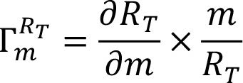[/graphic] (16)[/p]

[p]With (16), the indices of sensitivity for the key parameters with respect to the transformation ratio RT are derived in (17)-(20).[/p]

[p][graphic href="?a12v37n1"]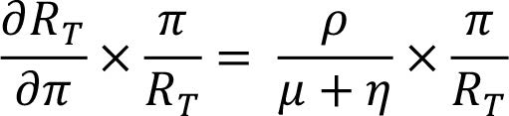[/graphic] (17)[/p]
[p][graphic href="?a12v37n1"]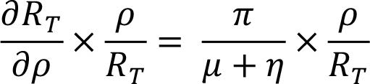[/graphic] (18)[/p]
[p][graphic href="?a12v37n1"]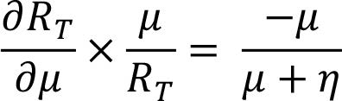[/graphic] (19)[/p]
[p][graphic href="?a12v37n1"]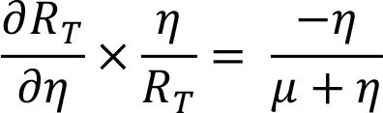[/graphic] (20)[/p]

[/subsec][/subsec][subsec][sectitle]Quantitative Analysis and Discussion[/sectitle]

[p]Simulation is conducted to verify the analytical results in section 3 and to confirm the stability nature of the model. It is achieved via the Maple software as well as a set of logical parameter values. With simulations, the transformation in agriculture and industry based on functional education, which has been computed in (9), is studied numerically. Further, the relative effects of the key parameters on functional education are revealed via indices of sensitivity for the major parameters. In the system (1)-(4), set 𝛼 = 0.1, 𝜙 = 0.3, 𝜋 = 0.45, 𝜃 = 0.4, 𝛽 = 0.2, 𝜌 = 0.25, 𝜏 = 0.5, 𝜑 = 0.3, 𝜇 = 0.075, 𝜂 = 0.1. Then, from (9), RT = 0.64, and the indices of sensitivity for the major parameters in (17)-(20) are shown in [xref ref-type="table" rid="t2"]Table 2[/xref].[/p]

[tabwrap id="t2"][label]Table 2[/label]. [caption]Indices of sensitivity for key parameters to transformation ratio RT[/caption]
[table][thead][tr][th align="center"]Parameters[/th] | [th align="center"]Sensitivity indices[/th][/tr]
[/thead][tbody][tr][td align="center"]𝜋[/td] | [td align="center"]1[/td][/tr]
[tr][td align="center"]𝜌[/td] | [td align="center"]1[/td][/tr]
[tr][td align="center"]𝜇[/td] | [td align="center"]-0.43[/td][/tr]
[tr][td align="center"]𝜂[/td] | [td align="center"]-0.57[/td][/tr][/tbody][/table]
[fntable id="TFN2"]Note: derived from research.[/fntable][/tabwrap]

[p]According to the meaning for R_{T} in subsection 3.2, the result R_{T} = 0.64 implies that, within the values chosen for the parameters, the agricultural and industrial revolution remains a tall dream because education is not functional. The poor state of education based on the result for the transformation ratio (R_{T}) could be linked to poor funding (𝜌), high rates of embezzlement by the government officials who disburse funds to the education sector (𝜋), misappropriation of funds in the education sector (𝜂) as well as a high rate of dropouts (𝜇).[/p]
[p]On a serious note, the situation in Nigeria affirms the result R_{T} = 0.64 which indicates the poor state of Nigerian education. In the first place, education is ill-funded in Nigeria to the degree that the UNESCO recommendation of 26% of the state budget to finance the education of the Third World has become a tall dream as less than 3% of the national budget is allocated to education in Nigeria ([xref ref-type="bibr" rid="r29"]Thom-Otuya & Inko-tariah, 2016[/xref]). Worst still, the little amount set aside for education is usually diverted, awfully misused, and unaccounted for ([xref ref-type="bibr" rid="r8"]Ayoade & Farayola, 2020a[/xref]).[/p]
[p]Nigeria becomes the second most corrupt country in West Africa in 2021 [xref ref-type="bibr" rid="r27"](The Nairametrics, 2021[/xref]). Given the current level of corruption in Nigeria, the amount of funds released for education might be cornered before disbursements, while the little that gets to the sector might even be used for the purposes for which those funds are not released. China is one country that has attained industrialization through purposeful investment in education.[/p]
[p]Besides, the indiscriminate closure of schools due to incessant industrial actions has pushed education into a state of an inevitable collapse in Nigeria and forced many students out of schools. It is on record that university teachers in Nigeria embark on strikes 16 times in 23 years [xref ref-type="bibr" rid="r28"](The Punch, 2022[/xref]). Public universities in Nigeria were closed down for 9 months in 2020 due to a strike by the university teachers [xref ref-type="bibr" rid="r28"](The Punch, 2022[/xref]). Further, academic activities in Nigerian public universities have been suspended for more than 4 months in 2022 (since February 14, 2022) due to another industrial action by the university lecturers [xref ref-type="bibr" rid="r28"](The Punch, 2022[/xref]).[/p]
[p]As regards the sensitivity indices for some parameters in [xref ref-type="table" rid="t2"]Table 2[/xref], parameters with positive indices are directly related to the transformation ratio (RT). For example, the index +1 for 𝜌 indicates that an increase in government spending on education increases the performance of Nigerian education by 100%. On the other hand, parameters with negative indices are inversely related to the transformation ratio (RT). For example, the index -0.57 for 𝜂 indicates that a 57% reduction in the misappropriation of funds in the education sector improves Nigerian education by 57%. It is therefore deduced from the sensitivity indices for the parameters that, to facilitate a revolution in industry and transformation in agriculture, the Nigerian government must invest heavily in education (𝜌) and fight corruption with all seriousness (𝜂).[/p]
[p]To examine the stability properties of the system that were stated in subsections 3.3 and 3.4, the transformation ratio (RT) is evaluated at various values of the key parameters. The outcomes of the computation are shown in [xref ref-type="table" rid="t3"]Table 3[/xref].[/p]

[tabwrap id="t3"][label]Table 3[/label]. [caption]Results of stability for functional education model[/caption]
[table][tbody][tr][td align="center"]S/No[/td] | [td align="center"]𝜋[/td] | [td align="center"]𝜌[/td] | [td align="center"]𝜇[/td] | [td align="center"]𝜂[/td] | [td align="center"]RT[/td] | [td align="center"]Nature of Stability[/td][/tr]
[tr][td align="center"]1[/td] | [td align="center"]0.45[/td] | [td align="center"]0.25[/td] | [td align="center"]0.075[/td] | [td align="center"]0.10[/td] | [td align="center"]0.64[/td] | [td align="center"]Unstable[/td][/tr]
[tr][td align="center"]2[/td] | [td align="center"]0.50[/td] | [td align="center"]0.35[/td] | [td align="center"]0.075[/td] | [td align="center"]0.30[/td] | [td align="center"]0.47[/td] | [td align="center"]Unstable[/td][/tr]
[tr][td align="center"]3[/td] | [td align="center"]0.55[/td] | [td align="center"]0.45[/td] | [td align="center"]0.075[/td] | [td align="center"]0.50[/td] | [td align="center"]0.43[/td] | [td align="center"]Unstable[/td][/tr]
[tr][td align="center"]4[/td] | [td align="center"]0.60[/td] | [td align="center"]0.55[/td] | [td align="center"]0.075[/td] | [td align="center"]0.75[/td] | [td align="center"]0.40[/td] | [td align="center"]Unstable[/td][/tr]
[tr][td align="center"]5[/td] | [td align="center"]0.20[/td] | [td align="center"]0.60[/td] | [td align="center"]0.075[/td] | [td align="center"]0.01[/td] | [td align="center"]1.41[/td] | [td align="center"]Stable[/td][/tr]
[tr][td align="center"]6[/td] | [td align="center"]0.19[/td] | [td align="center"]0.65[/td] | [td align="center"]0.075[/td] | [td align="center"]0.009[/td] | [td align="center"]1.47[/td] | [td align="center"]Stable[/td][/tr]
[tr][td align="center"]7[/td] | [td align="center"]0.18[/td] | [td align="center"]0.70[/td] | [td align="center"]0.075[/td] | [td align="center"]0.008[/td] | [td align="center"]1.52[/td] | [td align="center"]Stable[/td][/tr]
[tr][td align="center"]8[/td] | [td align="center"]0.10[/td] | [td align="center"]0.65[/td] | [td align="center"]0.075[/td] | [td align="center"]0.30[/td] | [td align="center"]0.17[/td] | [td align="center"]Unstable[/td][/tr]
[tr][td align="center"]9[/td] | [td align="center"]0.50[/td] | [td align="center"]0.30[/td] | [td align="center"]0.075[/td] | [td align="center"]0.09[/td] | [td align="center"]0.90[/td] | [td align="center"]Unstable[/td][/tr][/tbody][/table]
[fntable id="TFN3"]Note: derived from research.[/fntable][/tabwrap]

[p]In [xref ref-type="table" rid="t3"]Table 3[/xref], S/No. 1 is the base that gives the initial result for the transformation ratio (i.e., RT = 0.64). From S/No. 2 to S/No. 4, it is observed that, as an increase in government spending on education (𝜌) is accompanied by an increase in both (𝜋) and (𝜂), the embezzlement of funds allocated for education and misappropriation of funds in the education sector respectively, education remains dysfunctional. The model is unstable at these points (S/No. 2 - S/No. 4) as RT = <1. On the other hand, in S/No. 5 S/No. 7, as an increase in (𝜌) is matched with a decrease in both (𝜋) and (𝜂), education becomes functional as RT = >1. The model becomes stable in the region within S/No. 5 and S/No. 7.[/p]
[p]Further, an increase in (𝜌) with a decrease in (𝜋) but an increase (𝜂) in S/No. 8 makes education dysfunctional as the model moves to unstable regions with RT = <1. In the same manner, an increase in (𝜌) with an increase in (𝜋) but a decrease in (𝜂) in S/No. 9 also makes education dysfunctional as the model remains in an unstable region with RT = <1.[/p]
[p]The results of the stability analysis in [xref ref-type="table" rid="t3"]Table 3[/xref] complement the result of the sensitivity analysis in [xref ref-type="table" rid="t2"]Table 2[/xref]. It is deduced from simulations in [xref ref-type="table" rid="t3"]Table 3[/xref] that, to make education functional and to translate functionality in education to an agricultural and industrial revolution in Nigeria, the government must invest heavily in education (𝜌) and fight corruption not only among the people that disburse funds to the education sector (𝜋) but also among the school administrators (𝜂).[/p]
[p]With the aid of the Maple software, we are able to generate plots to visualize the functionality of education in terms of agricultural and industrial transformation. In [xref ref-type="fig" rid="f2"]Figure 2[/xref], it is observed that an increase in the educational sector is accompanied by an increase in the agricultural and industrial sectors. This shows that the government is investing heavily in education, and the investment is impacting the sector positively which, in turn, instigates transformation in agricultural and industrial sectors. On the other hand, in [xref ref-type="fig" rid="f3"]Figure 3[/xref], a rise in the educational sector is accompanied by a fall in the agricultural and industrial sectors. The implication is that either the education sector is poorly funded or the funds released to the sector are diverted and embezzled, which is frustrating growth in the agricultural and industrial processes.[/p]

[figgrp id="f2"][attrib]Note: derived from research[/attrib].
[graphic href="?a12v37n1"]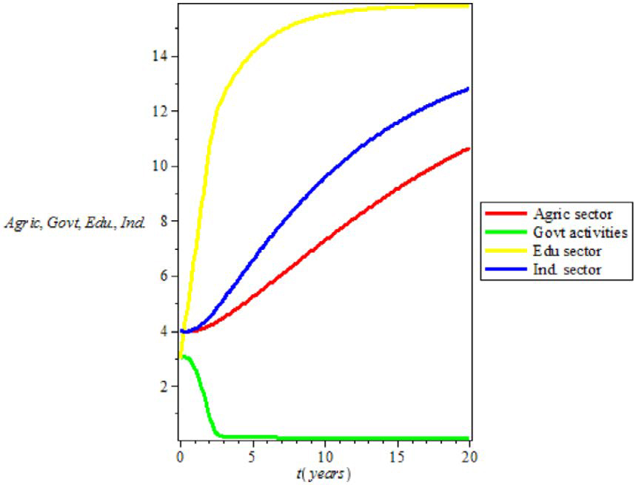[/graphic]
[label]Figure 2[/label]. [caption]Impact of Education when R_T>1[/caption][/figgrp]

[figgrp id="f3"][attrib]Note: derived from research[/attrib]
[graphic href="?a12v37n1"]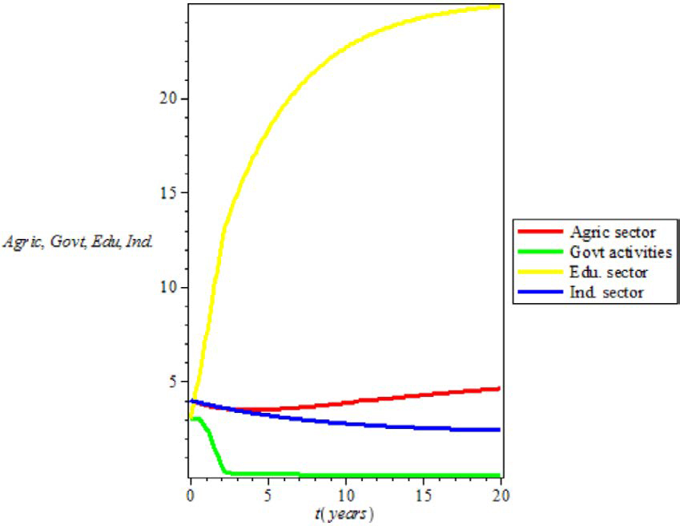[/graphic]
[label]Figure 3[/label]. [caption]Impact of Education when R_T<1[/caption][/figgrp]

[/subsec][/sec][sec sec-type="conclusions"][sectitle]Conclusions[/sectitle]

[p]Agricultural transformation and industrial revolution are major indices of prosperity that have been fostered through functional education in some countries of the world. Given abundant natural resources and significant human capital, a model has been developed to characterize the necessary and sufficient conditions for revolution in industry and transformation in agriculture in Nigeria through functional education. Functional education is the education that highlights practice more than theory and stands for utility and practicality. It is education that places emphasis on the ability to carry out productive tasks rather than education that intends to produce ideological conformity. Ample mathematics theorems have been employed to show that the solutions for the model exist, and are positive and bounded. The model equilibria have been derived, and the analytic threshold for revolution in industry and agriculture through functional education has been computed and used to examine the stability nature of the system equilibria. The sensitivity study of some major parameters has been performed, and the simulations have been conducted to determine the region where the increase in government expenditure on education resulted in functional education and facilitated a revolution in industry and agriculture, and the region where expansion in government expenditure on education had no effect on education.[/p]
[p]It was found from the results that transformation in agriculture and revolution in industry through functional education depend on massive investment in education and victory over corruption. The study found massive investment in education the necessary condition for functional education, and victory over corruption the sufficient condition. Nigeria can make a revolution in agriculture and industry happen through its education if the country could borrow a leaf from China. China is one country in the world that has achieved significant breakthroughs in technology by investing massively in education and by making corruption unattractive through severe penalties.[/p]

[subsec][sectitle]Conflict of Interest[/sectitle]

[p]The authors declare no competing interests.[/p]

[/subsec][subsec][sectitle]Authors’contribution statement[/sectitle]

[p]Both authors declare that the final version of the paper was read and approved. The total percentage contribution to the conceptualization, preparation, validation, reviewing, and editing of this article was as follows: A.A.A 75% and S.T 25%.[/p]

[/subsec][subsec][sectitle]Data availability statement[/sectitle]

[p]Data sharing is not applicable since no new data was created or analyzed in this study[/p][/subsec][/sec][/xmlbody].

[refs][sectitle]References[/sectitle]

[ref id="r1" reftype=“journal"][authors role="nd"][pauthor][surname]Adenomon[/surname], [fname]M.[/fname][/pauthor], & [pauthor][surname]Oyejola[/surname], [fname]B. A.[/fname][/pauthor] [/authors]([date dateiso="20130000" specyear="2013"]2013[/date]). [arttitle]Impact of agriculture and industrialization on GDP in Nigeria: evidence from VAR and SVAR models[/arttitle]. [source]International Journal of Analysis and Application[/source], [volid]1[/volid]([issueno]1[/issueno]), [pages]40-78[/pages]. [url]https://mpra.ub.unimuenchen.de/75268/[/url][/ref]
[ref id="r2" reftype=“journal"][authors role="nd"][pauthor][surname]Adenuga[/surname], [fname]J. I.[/fname][/pauthor]; [pauthor][surname]Ajide[/surname], [fname]K. B.[/fname][/pauthor]; [pauthor][surname]Odeleye[/surname], [fname]A. T.[/fname][/pauthor]; & [pauthor][surname]Ayoade[/surname], [fname]A. A.[/fname][/pauthor] [/authors]([date dateiso="20210000" specyear="2021"]2021[/date]). [arttitle]Abundant natural resources, ethnic diversity and inclusive growth in sub-Saharan Africa: a mathematical approach[/arttitle]. [source]Application and Applied Mathematics[/source], [volid]16[/volid]([issueno]2[/issueno]), [pages]1221-1247[/pages].[/ref]
[ref id="r3" reftype=“journal"][authors role="nd"][pauthor][surname]Agarwal[/surname], [fname]H.[/fname][/pauthor], & [pauthor][surname]Agarwal[/surname], [fname]R.[/fname][/pauthor] [/authors]([date dateiso="20170000" specyear="2017"]2017[/date]). [arttitle]First industrial revolution and second industrial revolution: technological differences and the differences in banking and financing of the firms[/arttitle]. [source]Saudi Journal of Humanities and Social Sciences[/source], [volid]2[/volid]([issueno]11A[/issueno]), [pages]1062-1066[/pages].[/ref]
[ref id="r4" reftype=“journal"][authors role="nd"][pauthor][surname]Ayoade[/surname], [fname]A. A.[/fname][/pauthor], [pauthor][surname]Farayola[/surname], [fname]P. I.[/fname][/pauthor] & [pauthor][surname]Lamidi[/surname], [fname]T. O.[/fname][/pauthor] [/authors]([date dateiso="20190000" specyear="2019"]2019[/date]). [arttitle]Dynamics and stability analysis of party switching in politics of Nigeria: a mathematical approach. [/arttitle][source]Daffoldil International University Journal of Science and Technology[/source],[volid]14[/volid]([issueno]1[/issueno]), [pages]53-60[/pages].[/ref]
[ref id="r5" reftype=“journal"][authors role="nd"][pauthor][surname]Ayoade[/surname] [fname]A. A.[/fname][/pauthor], [pauthor][surname]Folaranmi[/surname] [fname]R.[/fname][/pauthor], & [pauthor][surname]Latunde[/surname] [fname]T.[/fname][/pauthor] [/authors]([date dateiso="20200000" specyear="2020b"]2020b[/date]). [arttitle]Mathematical analysis of the implication of the proposed rise in the retirement age on the unemployment situation in Nigeria[/arttitle]. [source]Athens Journal of Sciences[/source], [volid]7[/volid]([issueno]1[/issueno]), [pages]29-42[/pages]. https://doi. org/[pubid idtype="doi"]10.30958/ajs.7-1-3[/pubid][/ref]
[ref id="r6" reftype=“journal"][authors role="nd"][pauthor][surname]Ayoade[/surname], [fname]A. A.[/fname][/pauthor], & [pauthor][surname]Agboola[/surname], [fname]S. O.[/fname][/pauthor] [/authors]([date dateiso="20220000" specyear="2022a"]2022a[/date]). [arttitle]Mathematical analysis of the causes of examination malpractices in Nigeria: an epidemic modeling approach.[/arttitle] [source]Journal of Science and Mathematics Letters[/source], [volid]10[/volid]([issueno]1[/issueno]), [pages]44-54[/pages].[/ref]
[ref id="r7" reftype=“journal"][authors role="nd"][pauthor][surname]Ayoade[/surname], [fname]A. A.[/fname][/pauthor] & [pauthor][surname]Aliu[/surname], [fname]O[/fname][/pauthor][/authors]. ([date dateiso="20220000" specyear="2022b"]2022b[/date]). [arttitle]COVID-19 outbreak and mitigation by movement restrictions: a mathematical assessment of economic impact on Nigerian households[/arttitle]. [source]Journal of Quality Measurement and Analysis[/source], [volid]18[/volid]([issueno]2[/issueno]), [pages]29-44[/pages].[/ref]
[ref id="r8" reftype=“journal"][authors role="nd"][pauthor][surname]Ayoade[/surname], [fname]A. A.[/fname][/pauthor], & [pauthor][surname]Farayola[/surname], [fname]P. I.[/fname][/pauthor][/authors] ([date dateiso="20200000" specyear="2020a"]2020a[/date]). [arttitle]Dynamics of examination malpractice among the players in Nigeria[/arttitle]. [source]Daffodil International University Journal of Science and key Technology[/source], [volid]15[/volid]([issueno]2[/issueno]), [pages]28-32[/pages][/ref]
[ref id="r9" reftype=“journal"][authors role="nd"][pauthor][surname]Ayoade[/surname], [fname]A. A.[/fname][/pauthor], & [pauthor][surname]Farayola[/surname], [fname]P. I.[/fname][/pauthor] [/authors]([date dateiso="20210000" specyear="2021"]2021[/date]). [arttitle]A mathematical modeling of economic restoration through agricultural revitalisation in Nigeria[/arttitle]. [source]Journal of Quality Measurement and Analysis[/source], [volid]17[/volid]([issueno]1[/issueno]), [pages]79-91[/pages].[/ref]
[ref id="r10" reftype=“journal"][authors role="nd"][pauthor][surname]Ayoade[/surname], [fname]A. A.[/fname][/pauthor] & [pauthor][surname]Farayola[/surname], [fname]P. I.[/fname][/pauthor] [/authors]([date dateiso="20220000" specyear="2022c"]2022c[/date]). [arttitle]A mathematical model to address out-of-school children menace for actualisation of sustainable development in Nigeria.[/arttitle] [source]Journal of Science and Arts[/source], [volid]22[/volid]([issueno]3[/issueno]), [pages]677-692[/pages].[/ref]
[ref id="r11" reftype=“journal"][authors role="nd"][pauthor][surname]Ayoade[/surname], [fname]A.A.[/fname][/pauthor] & [pauthor][surname]Ibrahim[/surname], [fname]M.O.[/fname][/pauthor] [/authors]([date dateiso="20220000" specyear="2022d"]2022d[/date]). [arttitle]Analysis of transformation dynamics and mitigation of COVID-19 in Nigeria: an insight from a mathematical model[/arttitle]. [source]The Aligarh Bulletin of Mathematics[/source], [volid]41[/volid]([issueno]1[/issueno]), [pages]81-106[/pages].[/ref]
[ref id="r12" reftype="book"][authors role="nd"][pauthor][surname]Diao[/surname], [fname]X.[/fname][/pauthor], [pauthor][surname]Hazell[/surname], [fname]P.[/fname][/pauthor], & [pauthor][surname]Thurlow[/surname], [fname]J.[/fname][/pauthor] [/authors]([date dateiso="20100000" specyear="2010"]2010[/date]). [source]The role of agriculture in African development World Development[/source], [volid]38[/volid]([issueno]10[/issueno]), [pages]1375-1383[/pages]. https://doi.org/[pubid idtype="doi"]10.1016/j.worlddev.2009.06.011[/pubid][/ref]
[ref id="r13" reftype=“journal"][authors role="nd"][pauthor][surname]Diekmann[/surname], [fname]O.[/fname][/pauthor], [pauthor][surname]Heesterbeek[/surname], [fname]J. A. J.[/fname][/pauthor], & [pauthor][surname]Metz[/surname], [fname]J. A. J.[/fname][/pauthor] [/authors]([date dateiso="19900000" specyear="1990"]1990[/date]). [arttitle]On the definition and the computation of the basic reproduction ratio R0 in models for infectious diseases in heterogeneous populations[/arttitle]. [source]Journal of Mathematical Biology[/source], [volid]28[/volid]([issueno]4[/issueno]), [pages]365-382[/pages]. https://doi.org/[pubid idtype="doi"]10.1007/BF00178324[/pubid][/ref]
[ref id="r14" reftype="book"][authors role="nd"][cauthor]Digital History[/cauthor][/authors]. ([date dateiso="00000000" specyear="n.d."]n.d.[/date]). [source]The industrial revolution[/source]. [url]https://www.digitalhistory.uh.edu/teachers/ lesson_plans/pdfs/unit7_1.pdf[/url][/ref]
[ref id="r15" reftype=“journal"][authors role="nd"][pauthor][surname]Ferreira[/surname], [fname]P.C.[/fname][/pauthor], [pauthor][surname]Pessoa[/surname], [fname]S.[/fname][/pauthor], & [pauthor][surname]dos Santos[/surname], [fname]M.R.[/fname][/pauthor] [/authors]([date dateiso="20150000" specyear="2015"]2015[/date]). [arttitle]Globalization and the industrial revolution[/arttitle]. [source]Macroeconomics Dynamics[/source], [volid]1[/volid]([issueno]3[/issueno]), 77-90. https://doi.org/[pubid idtype="doi"]10.1017/S1365100514000509[/pubid][/ref]
[ref id="r16" reftype=“journal"][authors role="nd"][pauthor][surname]Francks[/surname], [fname]P.[/fname][/pauthor] [/authors]([date dateiso="20210000" specyear="2021"]2021[/date]). [arttitle]The reconceptualisation of the industrial revolution and why it matters for Japanese studies[/arttitle]. [source]Japan Forum[/source], [volid]6[/volid]([issueno]2[/issueno]), [pages]1-25[/pages]. https://doi.org/[pubid idtype="doi"]10.1080/09555803.2021.2002388[/pubid][/ref]
[ref id="r17" reftype=“journal"][authors role="nd"][pauthor][surname]Groumpos[/surname], [fname]P. P.[/fname][/pauthor][/authors] ([date dateiso="20210000" specyear="2021"]2021[/date]). [arttitle]A critical historical and scientific overview of all industrial revolution [/arttitle][source]IFAC PapersOnLine[/source], [volid]54[/volid]([issueno]13[/issueno]), [pages]464-471[/pages]. https://doi.org/[pubid idtype="doi"]10.1016/j.ifacol.2021.10.492[/pubid][/ref]
[ref id="r18" reftype=“journal"][authors role="nd"][pauthor][surname]Hoppit[/surname], [fname]J.[/fname][/pauthor][/authors] ([date dateiso="19870000" specyear="1987"]1987[/date]). [arttitle]Understanding the industrial revolution[/arttitle]. [source]The Historical Journal[/source], [volid]30[/volid], [pages]211224[/pages]. https://doi.org/[pubid idtype="doi"]10.1017/S0018246X00021993[/pubid][/ref]
[ref id="r19" reftype=“journal"][authors role="nd"][pauthor][surname]Kapas[/surname], [fname]J.[/fname][/pauthor] [/authors]([date dateiso="20080000" specyear="2008"]2008[/date]). [arttitle]Industrial revolutions and the evolution of the firm’s organization: a historical perspective[/arttitle]. [source]Journal of Innovation Economics & Management[/source], [volid]1[/volid]([issueno]2[/issueno]),[pages]15-33[/pages]. https://doi. org/[pubid idtype="doi"]10.3917/jie.002.0015[/pubid][/ref]
[ref id="r20" reftype="book"][authors role="nd"][pauthor][surname]Kayani[/surname], [fname]M. M.[/fname][/pauthor], [pauthor][surname]Akbar[/surname], [fname]R. A.[/fname][/pauthor], [pauthor][surname]Faisal[/surname], [fname]S.[/fname][/pauthor], [pauthor][surname]Kayani[/surname], [fname]A.[/fname][/pauthor], & [pauthor][surname]Ghuman[/surname], [fname]M. A.[/fname][/pauthor][/authors] ([date dateiso="20170000" specyear="2017"]2017[/date]). [source]Analysis of socio-economic benefits of education in developing countries: an example of Pakistan. Bulletin of Education and Research[/source], [volid]39[/volid]([issueno]2[/issueno]), [pages]75-92[/pages].[/ref]
[ref id="r21" reftype=“journal"][authors role="nd"][pauthor][surname]Lewis[/surname], [fname]W. A.[/fname][/pauthor] [/authors]([date dateiso="19540000" specyear="1954"]1954[/date]). [arttitle]Economic development with unlimited supplies of labour[/arttitle]. [source]The Manchester School[/source], [volid]22[/volid]([issueno]2[/issueno]), [pages]139-199[/pages]. https://doi. org/[pubid idtype="doi"]10.1111/j.1467-9957.1954.tb00021.x[/pubid][/ref]
[ref id="r22" reftype=“journal"][authors role="nd"][pauthor][surname]Maduegbunam[/surname], [fname]T. O.[/fname][/pauthor], & [pauthor][surname]Okafor[/surname], [fname]N. M.[/fname][/pauthor] [/authors]([date dateiso="20140000" specyear="2014"]2014[/date]). [arttitle]Functional education: an essential tool for bridging the gap in education in Nigeria[/arttitle]. [source]Academic Discourse: An International Journal[/source], [volid]15[/volid]([issueno]1[/issueno]), [pages]193-198[/pages][/ref]
[ref id="r23" reftype=“journal"][authors role="nd"][pauthor][surname]Menon[/surname], [fname]J.[/fname][/pauthor], & [pauthor][surname]Fink[/surname], [fname]A.[/fname][/pauthor] [/authors]([date dateiso="20190000" specyear="2019"]2019[/date]). [arttitle]The fourth industrial revolution and its implications for regional economic integration in ASEAN[/arttitle]. [source]Journal of Asian Economic Integration[/source], [volid]1[/volid]([issueno]1[/issueno]) [pages]32-47[/pages]. https://doi.org/[pubid idtype="doi"]10.1177/2631684618821566[/pubid][/ref]
[ref id="r24" reftype=“journal"][authors role="nd"][pauthor][surname]Mohajan[/surname], [fname]H. K.[/fname][/pauthor] [/authors]([date dateiso="20190000" specyear="2019"]2019[/date]). [arttitle]The first industrial revolution: creation of a new global human era[/arttitle]. [source]Journal of Social Sciences and Humanities[/source], [volid]5[/volid]([issueno]4[/issueno]), [pages]377-387[/pages][/ref]
[ref id="r25" reftype=“journal"][authors role="nd"][pauthor][surname]Mpofu[/surname], [fname]J.[/fname][/pauthor] [/authors]([date dateiso="20130000" specyear="2013"]2013[/date]). [arttitle]Relevance of formal education to third world countries national development[/arttitle]. [source]IOSR Journal of Research & Method in Education[/source],[volid]1[/volid]([issueno]5[/issueno]), [pages]64-70[/pages]. https://doi. org/[pubid idtype="doi"]10.9790/7388-0156470[/pubid][/ref]
[ref id="r26" reftype=“journal"][authors role="nd"][pauthor][surname]Taiwo[/surname], [fname]I.[/fname][/pauthor] & [pauthor][surname]Muftau[/surname], [fname]I. A.[/fname][/pauthor] [/authors]([date dateiso="20180000" specyear="2018"]2018[/date]). [arttitle]Impact of agricultural financing schemes on agricultural output in Nigeria[/arttitle]. [source]Ilorin Journal of Finance[/source], [volid]2[/volid]([issueno]2[/issueno]), [pages]111-122[/pages].[/ref]
[ref id="r27" reftype="book"][authors role="nd"][cauthor]The Nairametrics[/cauthor][/authors](January 28, [date dateiso="20210000" specyear="2021"]2021[/date]). [source]Nigeria, now 2nd most corrupt country in West Africa-Transparency International[/source]. [moreinfo]Retrieved September 30, 2021[/moreinfo], from [url]https://nairametrics. com/2021/01/28/nigeria-now-2nd-most-corrupt-country-in-west-africa-transparency-international/[/url][/ref]
[ref id="r28" reftype="book"][authors role="nd"][cauthor]The Punch[/cauthor][/authors](May 15, [date dateiso="20220000" specyear="2022"]2022[/date]). [source]ASUU embarks on 16 strikes in 23 years, FG, lecturers Disagrees over 13-year MOU[/source]. [moreinfo]Retrieved May 21, 2022[/moreinfo], from [url]https://punchng.com/asuu-embarks-on16-strikes-in-23-years-fg-lecturers-disagreeover-13-year-mou/[/url][/ref]
[ref id="r29" reftype=“journal"][authors role="nd"][pauthor][surname]Thom-Otuya[/surname], [fname]B. E. N.[/fname][/pauthor], & [pauthor][surname]Inko-tariah[/surname], [fname]D. C.[/fname][/pauthor] [/authors]([date dateiso="20160000" specyear="2016"]2016[/date]). [arttitle]Quality education for national development: the Nigerian experience[/arttitle]. [source]African Education Research Journal[/source], [volid]4[/volid]([issueno]3[/issueno]), [pages]101-108[/pages].[/ref]
[ref id="r30" reftype=“journal"][authors role="nd"][pauthor][surname]Turkkahraman[/surname], [fname]M.[/fname][/pauthor] [/authors]([date dateiso="20120000" specyear="2012"]2012[/date]). [arttitle]The role of education in the societal development[/arttitle]. [source]Journal of Educational and Instructional Studies[/source], [volid]2[/volid]([issueno]4[/issueno]), [pages]38-41[/pages].[/ref]
[ref id="r31" reftype=“journal"][authors role="nd"][pauthor][surname]Vries[/surname], [fname]J. D.[/fname][/pauthor] [/authors]([date dateiso="19940000" specyear="1994"]1994[/date]). [arttitle]The industrial revolution and the industrious revolution[/arttitle]. [source]The Journal of Economic History[/source], [volid]54[/volid]([issueno]2[/issueno]), [pages]249-270[/pages]. https://doi. org/[pubid idtype="doi"]10.1017/S0022050700014467[/pubid][/ref]
[ref id="r32" reftype="book"][authors role="nd"][cauthor]Wikipedia[/cauthor][/authors]. ([date dateiso="00000000" specyear="n.d."]n.d.[/date]). [source]Industrial revolution[/source]. [url]https://en.wikipedia.org/wiki/Industrial_Revolution[/url][/ref][/refs][/doc]

